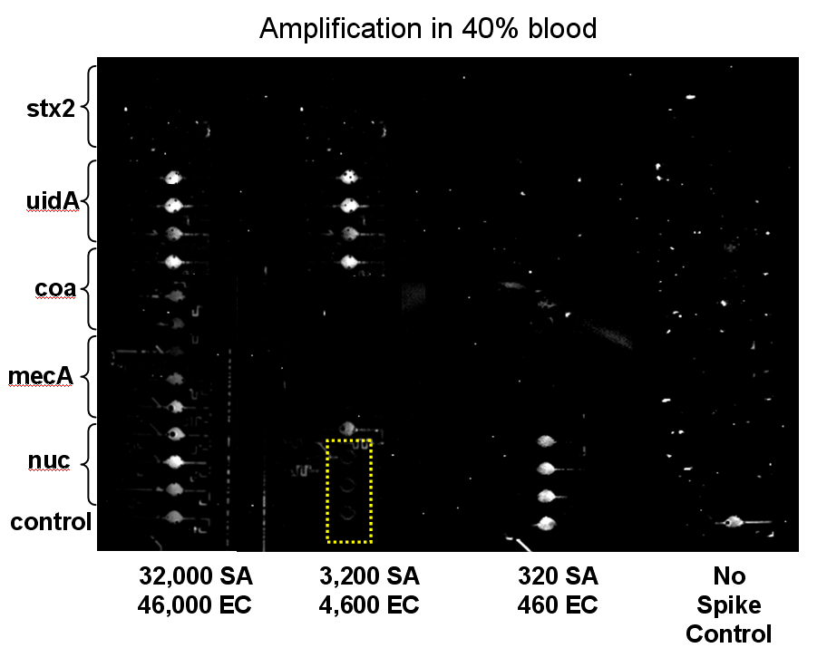
CFU/RXN
Fig S3. Card loaded with sample consisting of blood as 40% of amplification reaction, image after a 90 min incubation. Image was taken using a high exposure camera. Wells marked in yellow dashed lines did not fill properly with sample. Each column of 16 wells was loaded with a different dilution of SA (S. aureus) and EC (E. coli) CFU, listed below each column. The column on the right was loaded with a non-spiked control.

