Synthesis and active manipulation of magnetic liquid beads
Ajeet Singh Yadav¹, Fariba Malekpour Galogahi¹, Aditya Vashi¹, Du Tuan Tran¹, Gregor S Kijanka¹, Haotian Cha¹, Kamalalayam Rajan Sreejith¹ and Nam-Trung Nguyen^{1, *}
¹Queensland Micro- and Nanotechnology Centre, Griffith University, 170 Kessels Road, Nathan, QLD 4111, Australia.
*Corresponding author
Table S1: Mass ratio of liquid bead and solid bead

Mass ratio of liquid bead and solid bead
Density of TMPTMA (g/ cm³) | = 1.1
Density of HFE 7500 oil(g/ cm³) | = 1.6
Mass of solid bead(density$×$volume) (g) | = $5.75959×{10}^{-7}$
Volume of solid bead (cm³) | = $5.23599×{10}^{-7}$
Volume of shell (cm³) | = $4.58149×{10}^{-7}$
Volume of core (cm³) | = $6.54498×{10}^{-8}$
Mass of core-shell bead(density$×$volume) (g) | = $6.08684×{10}^{-7}$
Mass Ratio(solid bead/liquid bead) | = 0.946236559

Table S2: Ratio of volumes available in solid and core-shell beads for magnetite particles

Volume ratio of a solid and liquid beads
Solid bead | Liquid bead | Volume Ratio
Radius outer (mm)= 0.05 | Radius outer (mm)= 0.05 | Volume (solid): Volume (shell of the core-shell bead) = 0.875
Radius inner (mm) = 0 | Radius inner (mm)= 0.025
Volume(particle)(mm³) = 0.000523599 | Volume(shell)(mm³) =0.000458

Figure S3: Motion of magnetic liquid beds represented by (a) displacement versus distance from magnet, (b) velocity versus distance from magnet and (c) acceleration versus distance from magnet graphs.

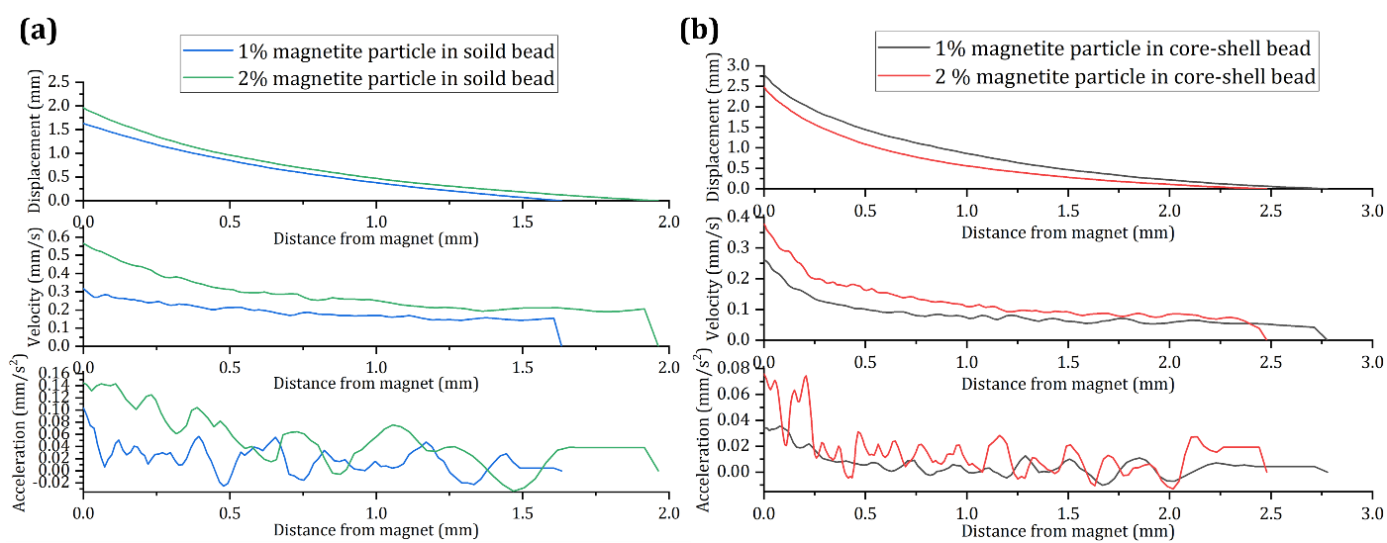
Figure S3: Motion of magnetic liquid beads: (a) Displacement, velocity, and acceleration versus distance from magnet for 1 and 2%(wt) magnetite particle containing solid beads [2]. (b) Displacement, velocity, and acceleration versus distance from magnet for 1 and 2%(wt) magnetite particle containing core-shell beads

Video S4: Video demonstrating sorting of magnetic liquid beads from non-magnetic beads.

Video S5: Video showing response of beads collected from outlet 1 in presence of the magnet.

Video S6: Video showing response of beads collected from outlet 2 in presence of the magnet.

Video S7: Video showing 2D self-assembly of magnetic liquid beads in presence of magnet.

