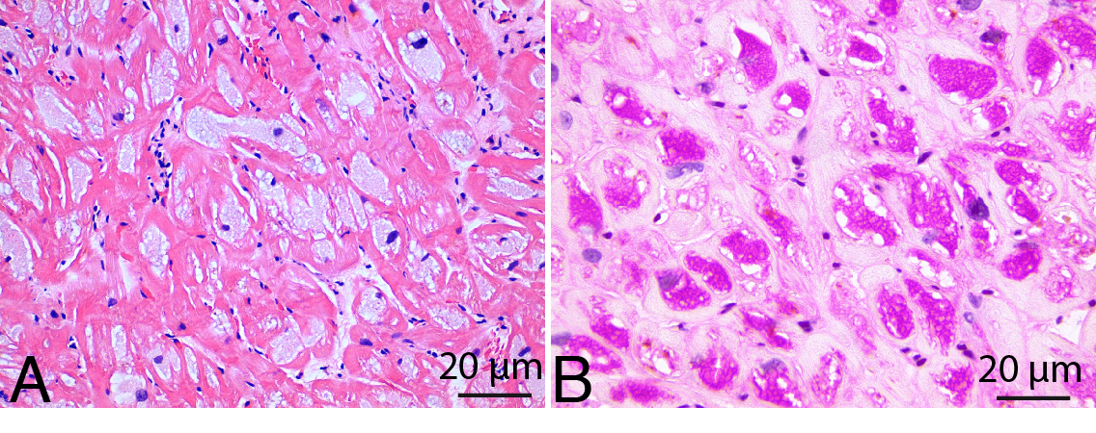
Suppl. Figure 1. Endomyocardial biopsy of patient 2 demonstrating vaculation of the cardiomyocytes. (A) Hematoxylin and eosin staining. (B) The vacuoles show storage of PAS positive material.

