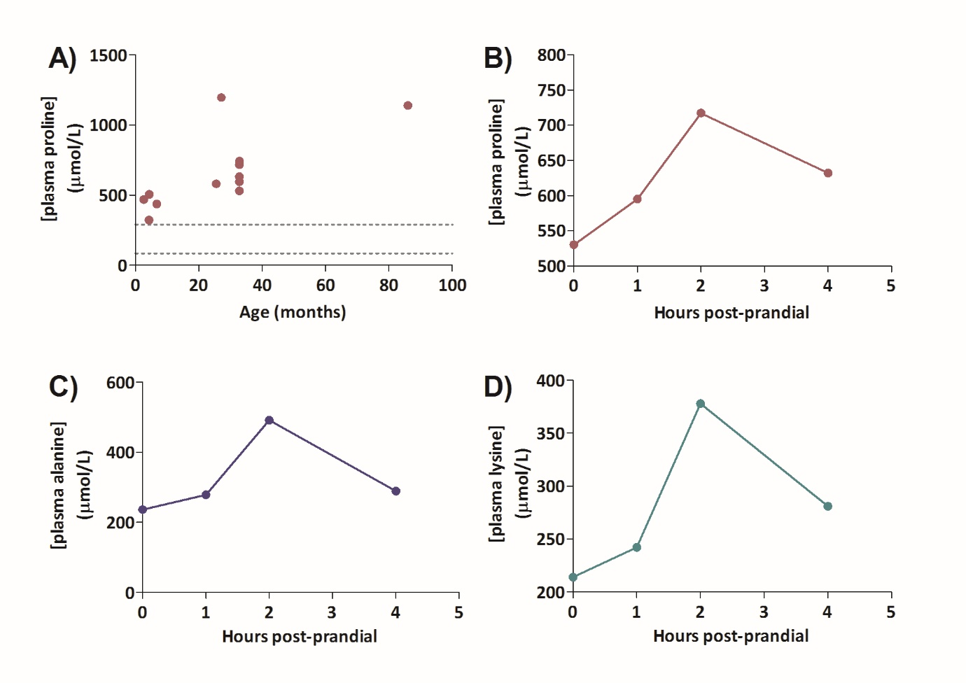Supplementary Figure 2: Variation in plasma amino acids with age and post-prandial. (A) Plasma proline concentrations in patient 1 over time. Multiple data points at 32.8 months represent pre- and post-prandial samples. Dotted lines represent reference ranges. (B, C and D) Plasma concentrations in patient 1 in response to feeding showing proline (ref: 85 – 290 µmol/L), alanine (ref: 150 – 450 µmol/L) and lysine (ref: 100 – 300 µmol/L), respectively. Samples were taken after a six hour fast and 1, 2, and 4 hours after eating.

