Target journal: Boundary-Layer Meteorology

Using the sensible heat flux eddy covariance based exchange coefficient to calculate latent heat from moisture mean gradients over snow
Sergi González-Herrero¹, Armin Sigmund², Michael Haugeneder^{1,2}, Océane Hames^{1,2}, Hendrik Huwald², Joel Fiddes¹, Michael Lehning^{1,2}
¹WSL Institute for Snow and Avalanche Research (SLF), Davos, Switzerland
²School of Architecture, Civil and Environmental Engineering, Ecole Polytechnique Fédérale de Lausanne, Lausanne, Switzerland

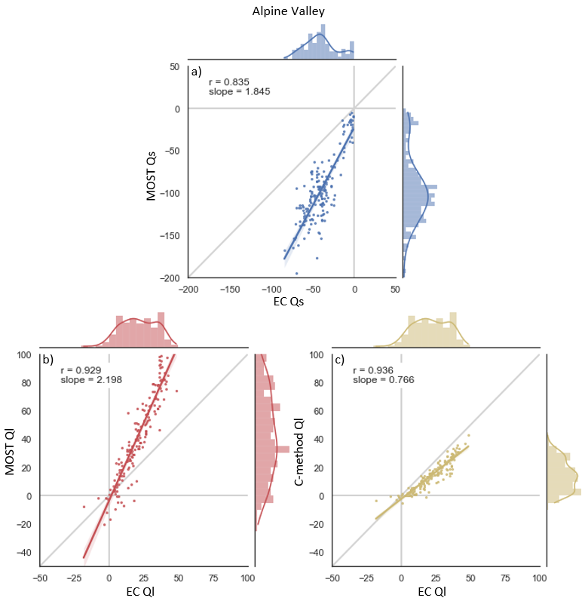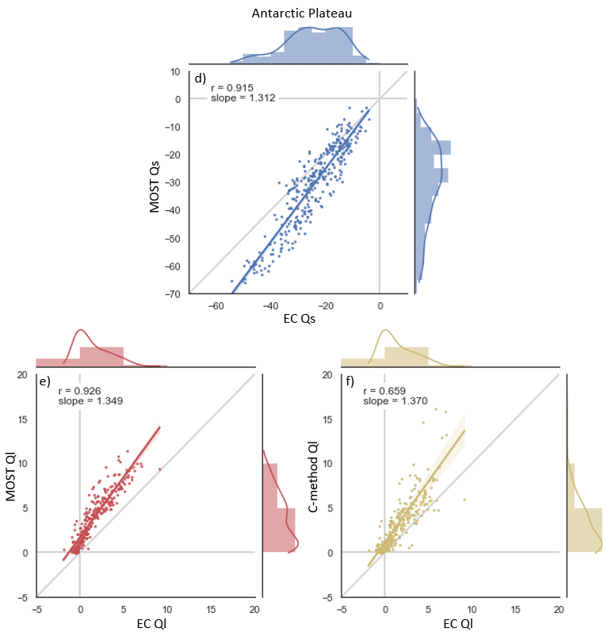
Figure S1. Scatter plot and regression fit of MOST and EC Qs (a,d), MOST and EC Ql (b,e) and the new method and EC Ql (c,f) for the Alpine Valley (a,b,c) and the Antarctic plateau (d,e,f) datasets. MOST calculations shown in this figure use Holtslag stability correction and the estimated roughness length.

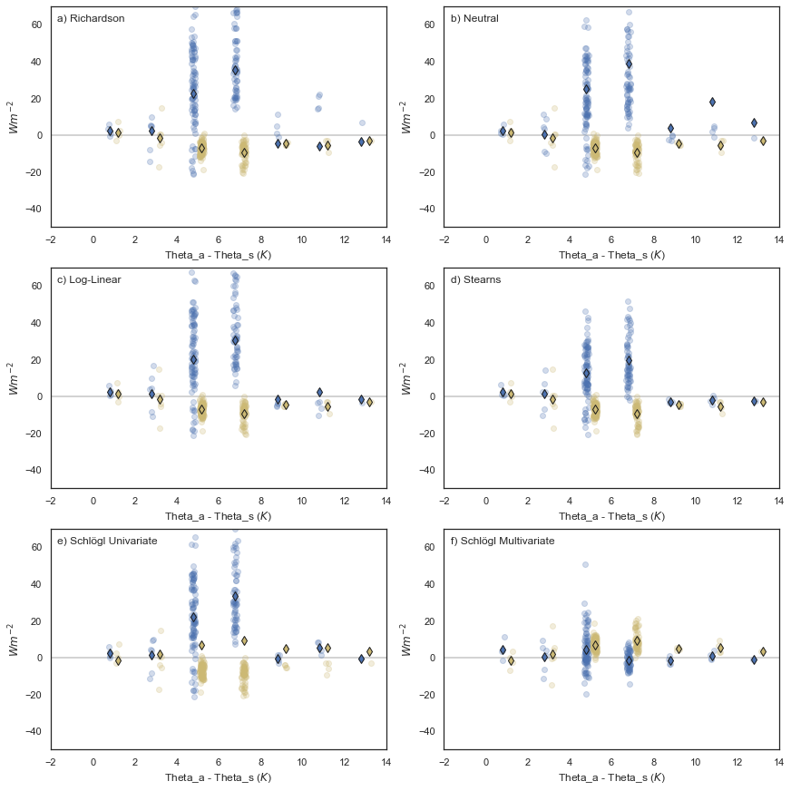
Figure S2. As in Figure 4a but for different stability corrections.
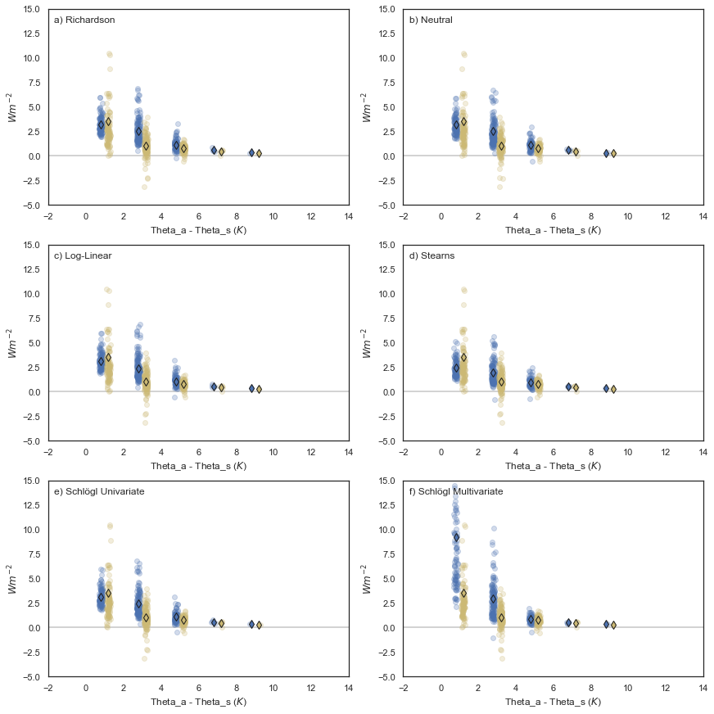
Figure S3. As in Figure 4c but for different stability corrections.

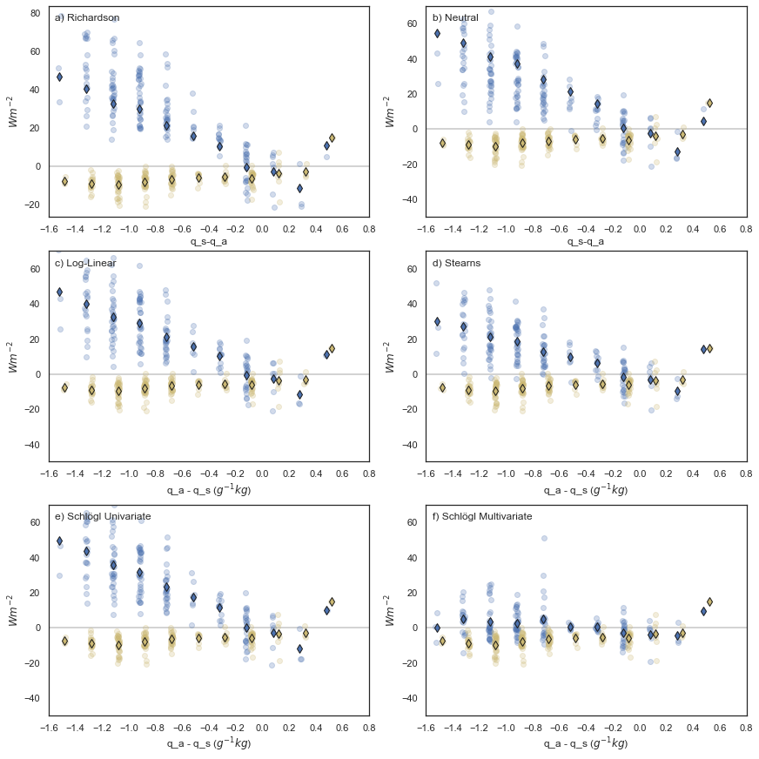
Figure S4. As in Figure 4b but for different stability corrections.

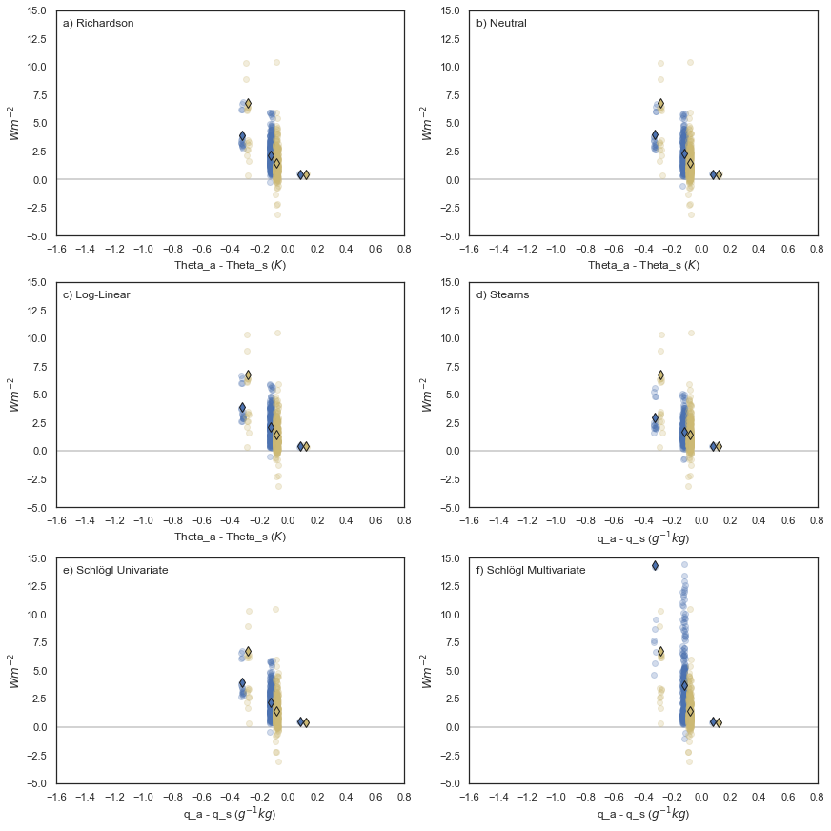
Figure S5. As in Figure 4d but for different stability corrections.

