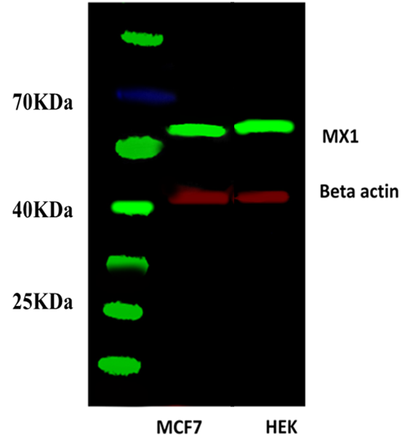

Supplementary Figure (1) Evaluation of MX1 primary antibody specificity by WB. This shows a single specific band at predicted size ( ~64KDa ).

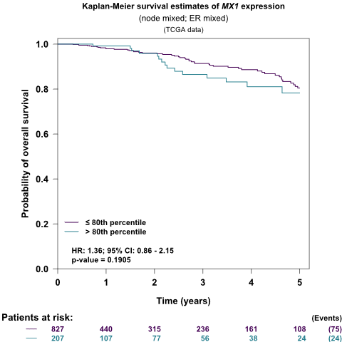

Supplementary Figure (2) Kaplan–Meier survival plots showing the association between MX1 RNA-seq data and patients’ outcome in publicly available dataset TCGA (n=1034) Breast Cancer Gene-Expression Miner v4.4 (bc-GenExMiner v4.4)

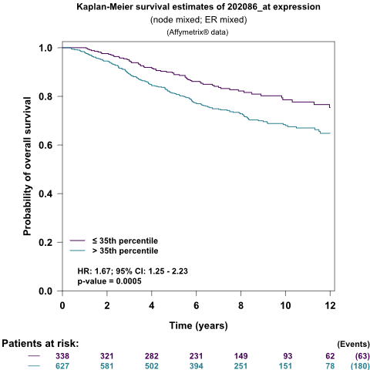

Supplementary Figure (3) Kaplan–Meier survival plots showing the association between MX1 DNA microarray data and patients’ outcome in publicly available datasets Affymetrix (n= 4904) Breast Cancer Gene-Expression Miner v4.4 (bc-GenExMiner v4.4)

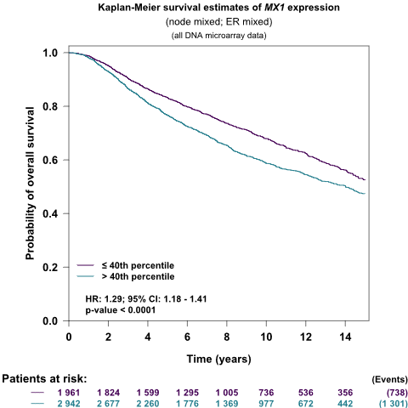

Supplementary Figure (4) Kaplan–Meier survival plots showing the association between all MX1 DNA microarray data and patients’ outcome in publicly available datasets (n= 10001) Breast Cancer Gene-Expression Miner v4.4 (bc-GenExMiner v4.4)

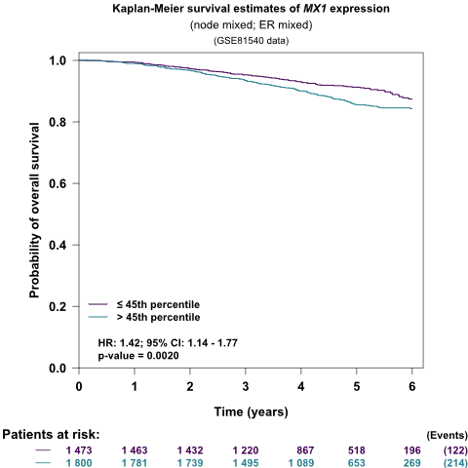

Supplementary Figure (5) Kaplan–Meier survival plots showing the association between MX1 RNA-seq data and patients’ outcome in publicly available dataset GSE81540 (n=3678) Breast Cancer Gene-Expression Miner v4.4 (bc-GenExMiner v4.4)

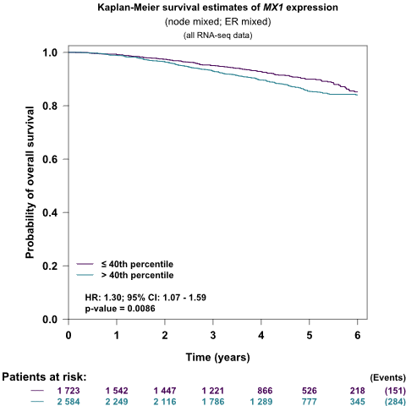

Supplementary Figure (6) Kaplan–Meier survival plots showing the association between all MX1 RNA-seq data and patients’ outcome in publicly available datasets (n= 4712) Breast Cancer Gene-Expression Miner v4.4 (bc-GenExMiner v4.4)

