SUPPLEMENT

Factors associated with twenty-year risks of breast cancer-specific mortality in the SEER Registry

Supplemental Figures: 3

Supplemental Figure 1: Flow diagram of patient population
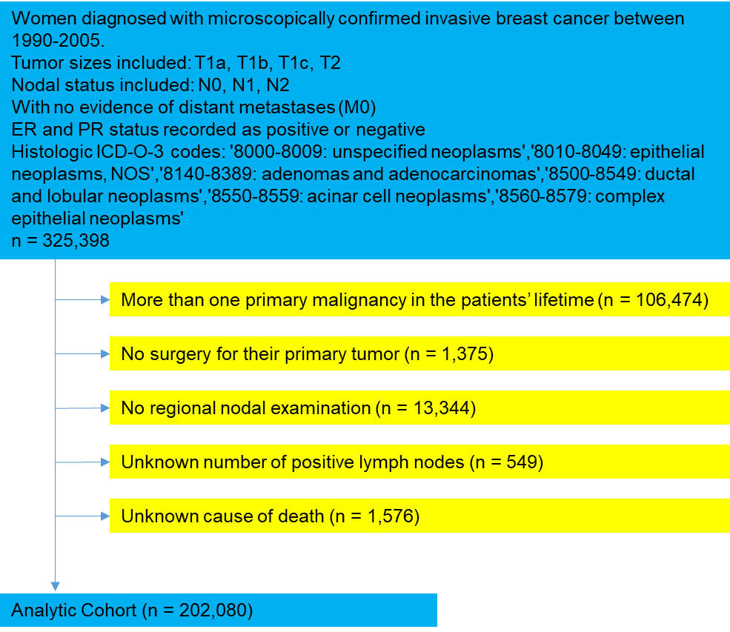Abbreviations: ICD-O-3, international classification of diseases for oncology – 3rd edition; NOS, not otherwise specified.

Supplemental Figure 2: Unadjusted risk of breast cancer-specific death according to tumor grade among patients with a) N0 HR-positive breast cancer and b) N0 HR-negative breast cancer starting from year 5 after diagnosis. HR, hormone receptor; y, years
a.
b.
Supplemental Figure 3: Unadjusted risk of non-breast cancer-specific death by a) nodal status and by HR status, b) tumor size and HR status among patients with N0 breast cancer, and c) tumor grade and HR status among patients with N0 breast cancer starting from year 5 after diagnosis. HR, hormone receptor; non-BCSM, non-breast cancer specific mortality; y, years
a.
c.
b.

