Racial disparities in second-line treatment and overall survival among patients with metastatic breast cancer
Kristen D. Whitaker, Xiaoliang Wang, Mustafa Ascha, Timothy N. Showalter, Heather G. Lewin, Gregory S. Calip, Lori J. Goldstein

SUPPLEMENT

Supplemental Figure 1. Proportion of 2L treatment by race/ethnicity group, stratified by 1L CDK 4/6 inhibitors use
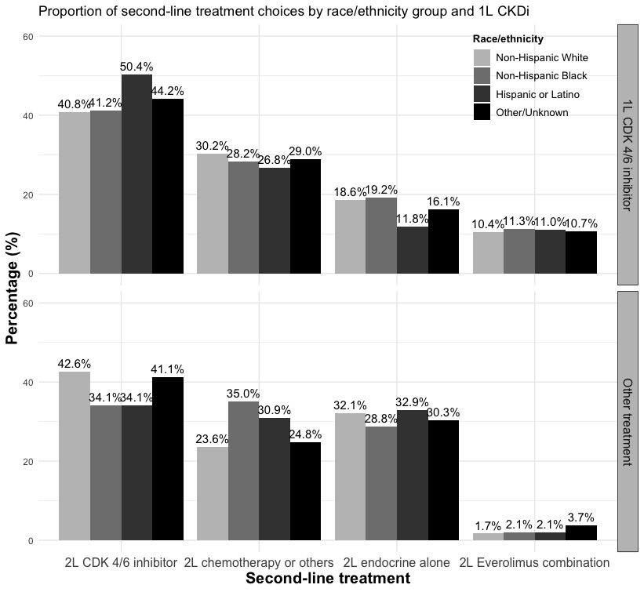

Supplemental Figure 2. Kaplan-Meier curve of real-world overall survival by race and 1L CDK 4/6 inhibitors use

1L CDK 4/6 use
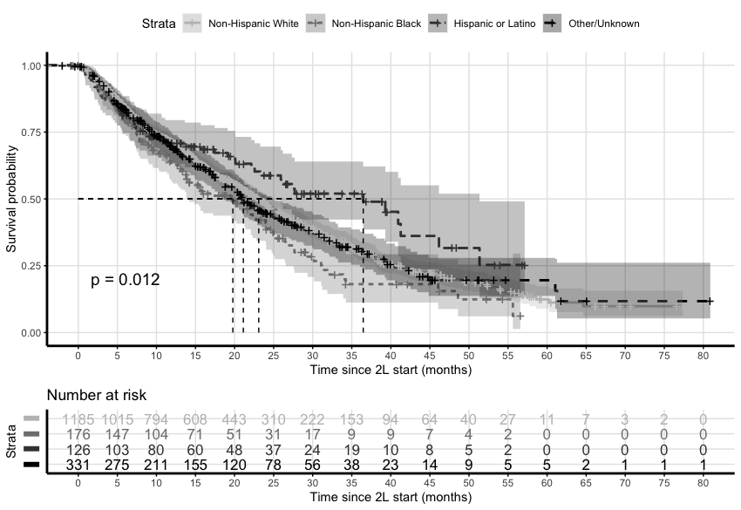

1L others
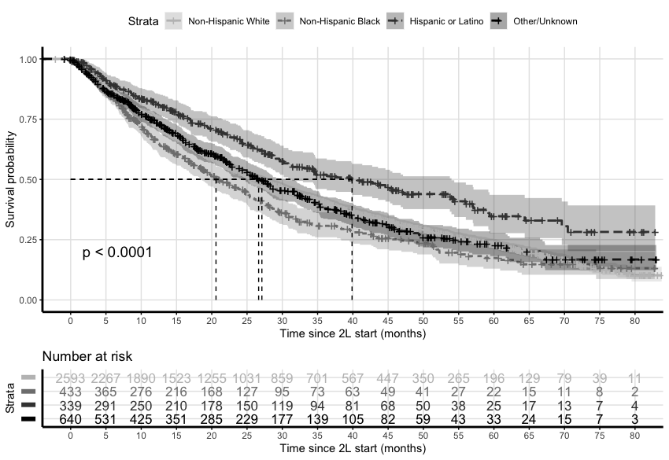

Supplemental Table 1. Sensitivity analyses of associations between race and likelihood of receiving different 2L treatment
Race | Primary analysisª |  |  |  | Omit variables^{b} |  |  | Complete case analysis^{a,c}
Race | N | OR (95% CI) | p-value |  | OR (95% CI) | p-value |  | N | OR (95% CI) | p-value
2L chemotherapy or other (reference group)
Non-Hispanic White | 974 | - | - |  | - | - |  | 636 | - | -
Non-Hispanic Black | 202 | - | - |  | - | - |  | 132 | - | -
Hispanic or Latino | 139 | - | - |  | - | - |  | 70 | - | -
Other/Unknown | 257 | - | - |  | - | - |  | 151 | - | -
2L CDKi
Non-Hispanic White | 1594 | 1.00 (ref) | - |  | 1.00 (ref) | - |  | 1046 | 1.00 (ref) | -
Non-Hispanic Black | 221 | 0.80 (0.63 - 1.02) | 0.069 |  | 0.82 (0.65 - 1.03) | 0.090 |  | 151 | 0.86 (0.65 - 1.13) | 0.279
Hispanic or Latino | 180 | 0.90 (0.68 - 1.19) | 0.446 |  | 0.91 (0.70 - 1.17) | 0.452 |  | 94 | 0.93 (0.66 - 1.33) | 0.708
Other/Unknown | 413 | 1.08 (0.88 - 1.32) | 0.465 |  | 1.06 (0.87 - 1.28) | 0.579 |  | 241 | 1.05 (0.82 - 1.35) | 0.683
2L Endocrine alone
Non-Hispanic White | 1056 | 1.00 (ref) | - |  | 1.00 (ref) | - |  | 658 | 1.00 (ref) | -
Non-Hispanic Black | 159 | 0.90 (0.69 - 1.17) | 0.423 |  | 0.93 (0.72 - 1.19) | 0.565 |  | 96 | 0.91 (0.67 - 1.24) | 0.541
Hispanic or Latino | 127 | 0.97 (0.72 - 1.32) | 0.870 |  | 1.00 (0.76 - 1.33) | 0.983 |  | 51 | 0.85 (0.57 - 1.27) | 0.430
Other/Unknown | 249 | 0.94 (0.75 - 1.17) | 0.566 |  | 0.98 (0.79 - 1.22) | 0.874 |  | 133 | 0.98 (0.74 - 1.29) | 0.879
2L Everolimus
Non-Hispanic White | 168 | 1.00 (ref) | - |  | 1.00 (ref) | - |  | 113 | 1.00 (ref) | -
Non-Hispanic Black | 29 | 1.07 (0.68 - 1.70) | 0.763 |  | 1.20 (0.77 - 1.85) | 0.426 |  | 20 | 1.18 (0.70 - 1.99) | 0.532
Hispanic or Latino | 21 | 1.26 (0.73 - 2.16) | 0.409 |  | 1.26 (0.76 - 2.08) | 0.380 |  | 12 | 1.26 (0.66 - 2.41) | 0.485
Other/Unknown | 60 | 1.28 (0.89 - 1.84) | 0.178 |  | 1.47 (1.05 - 2.07) | 0.027 |  | 30 | 1.24 (0.80 - 1.95) | 0.338
CDKi=cyclin-dependent kinase 4/6 inhibitor; cOR=crude odds ratio; aOR=adjusted odds ratio

ª Adjusted for age at metastatic diagnosis, stage at initial diagnosis, practice type, 1L treatment group, duration of 1L treatment, progression within 6 month of 1L start, ECOG status at 2L start, number and sites of metastasis and insurance group; Race reference group: White; 2L treatment reference group: 2L chemotherapy and others.
^{b} Adjusted for age at metastatic diagnosis, stage at initial diagnosis, practice type, 1L treatment group, duration of 1L treatment, progression within 6 month of 1L start, and number and sites of metastasis; Race reference group: White; 2L treatment reference group: 2L chemotherapy and others.
^{c} Patients with missing ECOG status or insurance group are excluded from the analysis.

Supplemental Table 2 Sensitivity analysis for the associations between rwOS and race by 2L treatment group
 | Primary analysisª |  |  |  |  | Omit variables^{b} |  |  | Complete case analysis^{a,c}
 | N | adjusted HR  (95% CI) | p-value |  |  | adjusted HR  (95% CI) | p-value |  | N |  | adjusted HR  (95% CI) | p-value
Overall
Non-Hispanic White | 3792 | 1.00 (ref) | - |  | 1.00 (ref) |  | - |  |  | 2453 | 1.00 (ref) | -
Non-Hispanic Black | 611 | 1.16^{d} (1.04 - 1.31) | 0.009 |  | 1.18^{d} (1.06 - 1.32) |  | 0.003 |  |  | 399 | 1.05^{d} (0.91 - 1.21) | 0.500
Hispanic or Latino | 467 | 0.70^{d} (0.60 - 0.81) | <0.001 |  | 0.71^{d} (0.61 - 0.82) |  | <0.001 |  |  | 227 | 0.75^{d} (0.61 - 0.92) | 0.006
Other or Unknown | 979 | 1.03^{d} (0.93 - 1.13) | 0.600 |  | 1.04^{d} (0.94 - 1.14) |  | 0.400 |  |  | 555 | 1.03^{d} (0.91 - 1.17) | 0.600
Stratified
2L Chemotherapy or other
Non-Hispanic White | 974 | 1.00 (ref) | - |  | 1.00 (ref) |  | - |  |  | 636 | 1.00 (ref) | -
Non-Hispanic Black | 202 | 0.97 (0.79 - 1.18) | 0.727 |  | 0.97 (0.80 - 1.18) |  | 0.775 |  |  | 132 | 0.84 (0.65 - 1.08) | 0.172
Hispanic or Latino | 139 | 0.84 (0.65 - 1.09) | 0.187 |  | 0.88 (0.70 - 1.11) |  | 0.284 |  |  | 70 | 0.85 (0.61, 1.19) | 0.343
Other or Unknown | 257 | 1.07 (0.90 - 1.27) | 0.449 |  | 1.06 (0.90 - 1.26) |  | 0.484 |  |  | 151 | 0.92 (0.73 - 1.15) | 0.471
2L CDKi
Non-Hispanic White | 1594 | 1.00 (ref) | - |  | 1.00 (ref) |  | - |  |  | 1046 | 1.00 (ref) | -
Non-Hispanic Black | 221 | 1.31 (1.07 - 1.61) | 0.010 |  | 1.33 (1.09 - 1.62) |  | 0.005 |  |  | 151 | 1.18 (0.90 - 1.54) | 0.220
Hispanic or Latino | 180 | 0.64 (0.48 - 0.85) | 0.002 |  | 0.64 (0.49 - 0.84) |  | 0.001 |  |  | 94 | 0.64 (0.44 - 0.93) | 0.019
Other or Unknown | 413 | 0.92 (0.77 - 1.09) | 0.338 |  | 0.94 (0.80 - 1.11) |  | 0.482 |  |  | 241 | 0.97 (0.77 - 1.21) | .765
2L Endocrine alone
Non-Hispanic White | 1056 | 1.00 (ref) | - |  | 1.00 (ref) |  | - |  |  | 658 | 1.00 (ref) | -
Non-Hispanic Black | 159 | 1.31 (1.07 - 1.62) | 0.010 |  | 1.33 (1.08 - 1.63) |  | 0.006 |  |  | 96 | 1.26 (0.95 - 1.67) | 0.107
Hispanic or Latino | 127 | 0.64 (0.48 - 0.85) | 0.002 |  | 0.63 (0.48 - 0.82) |  | <0.001 |  |  | 51 | 0.71 (0.45 - 1.13) | 0.148
Other or Unknown | 249 | 1.14 (0.95 - 1.36) | 0.158 |  | 1.13 (0.95 - 1.35) |  | 0.167 |  |  | 133 | 1.19 (0.93 - 1.52) | 0.157
2L Everolimus combination
Non-Hispanic White | 168 | 1.00 (ref) | - |  | 1.00 (ref) |  | - |  |  | 113 | 1.00 (ref) | -
Non-Hispanic Black | 29 | 1.55 (0.91 - 2.65) | 0.140 |  | 1.40 (0.85 - 2.30) |  | 0.185 |  |  | 20 | 1.71 (0.83 - 3.52) | 0.148
Hispanic or Latino | 21 | 0.60 (0.27 - 1.37) | 0.230 |  | 0.58 (0.26 - 1.30) |  | 0.183 |  |  | 12 | 0.32 (0.09 - 1.09) | 0.068
Other or Unknown | 60 | 1.17 (0.78 - 1.77) | 0.451 |  | 1.28 (0.88 - 1.88) |  | 0.195 |  |  | 30 | 0.96 (0.56 - 1.64) | 0.879

ª Adjusted for age at metastatic diagnosis, stage at initial diagnosis, practice type, insurance type, 1L treatment group, duration of 1L treatment, progression within 6 month of 1L start, ECOG performance status at 2L start ,and number and sites of metastasis; Race reference group: White.
^{b} Adjusted for age at metastatic diagnosis, stage at initial diagnosis, practice type, 1L treatment group, duration of 1L treatment, progression within 6 month of 1L start, and number and sites of metastasis; Race reference group: White; 2L treatment reference group: 2L chemotherapy and others.
^{c} Patients with missing ECOG status or insurance group are excluded from the analysis.
^{d} Overall survival analysis for all patients who received 2L treatment was additionally adjusted for 2L treatment group.

