Supplementary Table 1 Van Nuys classification of breast DCIS (54)
DCIS grade 1 | Nuclear size < 2X RBC and without comedo-type necrosis
DCIS grade 2 | Nuclear size < 2X RBC and with focal comedo-type necrosis
DCIS grade 3 | Nuclear size ≥ 2X RBC with- or without comedo-type necrosis

 | Supplementary Table 2 Definition of molecular subtypes for IBC, according to surrogate IHC markers (10, 11)
 | Luminal A |  |  | Hormone receptors (ER and/or PR) positive, HER2-negative, a low level of proliferation according to the Ki67 proliferation index. Luminal A tumors are low-grade, tend to grow slowly, and have the best prognosis.
 | Luminal B  HER2-negative |  |  | Hormone receptors (ER and/or PR) positive, HER2-negative, and with higher levels of Ki67 proliferation index, than luminal A tumors.
 | Luminal B  HER2-positive |  |  | Hormone receptors (ER and/or PR) positive, HER2-positive, and any value level of Ki67 proliferation index.
 | HER2-enriched |  |  | Hormone receptors (ER and PR) negative, HER2-positive, and any value level of Ki67 proliferation index.
 | TPN |  |  | Hormone receptors (ER and PR) and HER2-negative, any value level of Ki67 proliferation index.
 | Supplementary Table 3 Details of antibodies and HER2 SISH probe (34)
 | Antibody and HER2 probe |  | Clone |  | Reference Id. | Vendor | Dilution | Incubation time
 | Anti-Ki67 |  | MIB-1 |  | M724001-2 | Agilent | 1:200 | 20 min.
 | Anti-Human estrogen receptor α |  | EP1 |  | M364301-2 | Agilent | 1:50 | 30 min.
 | Anti-Human progesterone receptor |  | PR 636 |  | M356901-2 | Agilent | 1:100 | 30 min.
 | Anti-HER2/ErbB2 |  | D8F12 |  | #4290 | Cell Signaling | 1:200 | 60 min.
 | HER2 SISH |  | Ventana HER2 Dual ISH DNA probe cocktail |  | 8314373001 | Ventana (Roche) | Ready to use | 60 min.
 | Supplementary Table 4 IHC procedure Dako Autostainer
Step 1 |  | Antigen retrieval was achieved in a PT-Link station by immersion into EnVision™ FLEX Target Retrieval Solution high pH (K8004, Agilent) by the heating program at 97°C for 20 minutes
Step 2 |  | Endogenous peroxidase activity was quenched by incubating the slides in EnVision™ FLEX peroxidase blocking reagent (K8000, Agilent) for 5 minutes
Step 3 |  | For HER2 IHC, in addition, non-specific staining was inhibited by Animal-Free blocking Solution 1x (#15019) for 30 minutes
Step 4 |  | Primary antibodies Ki67 (1:200), ER (1:50), and PR (1:100) were diluted in EnVision™ FLEX Antibody Diluent (K8006, Agilent); antibody HER2 (1:200) was diluted in SignalStain® Antibody Diluent (#8112, Cell Signaling); and slides were incubated with primary antibodies for 20-60 minutes (table 3) at room temperature
Step 5 |  | For ER and PR IHC, rabbit (K800921-2, Agilent) and mouse Linker (K800221-2, Agilent) were added respectively for 15 minutes for signal amplification after primary antibody incubation
Step 6 |  | Incubation with the ready‐to‐use secondary buffered solution (k8002, EnVision FLEX /HRP, Agilent) for 20 minutes
Step 7 |  | Sections were reacted with 3.30‐diaminobenzidine tetrahydrochloride (DAB) solution for 10 minutes
Step 8 |  | Counterstain with Hematoxylin (Link) (k8008, Agilent) for 5 minutes

Supplementary Table 5a Distribution of age and extent among subtypes, calculated and classified in the manner of 2011 St. Gallen recommendations
 | Luminal A |  | Luminal B  HER2- negative |  | Luminal B  HER2-positive |  | HER2  enriched |  | TPN
 | Age (yrs) | Extent (mm) | Age (yrs) | Extent (mm) | Age  (yrs) | Extent (mm) | Age  (yrs) | Extent (mm) | Age  (yrs) | Extent (mm)
Minimum | 36 | 4 | 35 | 3 | 33 | 0.7 | 34 | 3.5 | 38 | 5
Maximum | 87 | 80 | 74 | 120 | 76 | 115 | 83 | 150 | 88 | 80
Median | 57 | 18 | 53 | 20 | 55 | 30 | 55 | 30 | 61 | 30
Mean | 57 | 23.8 | 55 | 27.2 | 55 | 34 | 57 | 40.6 | 63 | 36.3
Supplementary Table 5b Distribution of age and extent among subtypes, calculated and classified in the manner of 2013 St. Gallen recommendations
 | Luminal A |  | Luminal B  HER2- negative |  | Luminal B  HER2-positive |  | HER2  enriched |  | TPN
 | Age (yrs) | Extent (mm) | Age (yrs) | Extent (mm) | Age  (yrs) | Extent (mm) | Age  (yrs) | Extent (mm) | Age (yrs) | Extent (mm)
Minimum | 35 | 4 | 38 | 3 | 33 | 0.7 | 34 | 3.5 | 38 | 5
Maximum | 87 | 120 | 75 | 120 | 76 | 115 | 83 | 150 | 88 | 80
Median | 55 | 18 | 57 | 22 | 55 | 30 | 55 | 30 | 61 | 30
Mean | 56 | 24.2 | 57 | 27.2 | 55 | 34 | 57 | 40.6 | 63 | 36.3

Supplementary Flowchart 1a Distribution of subtypes in line with 2011 St. Gallen recommendations
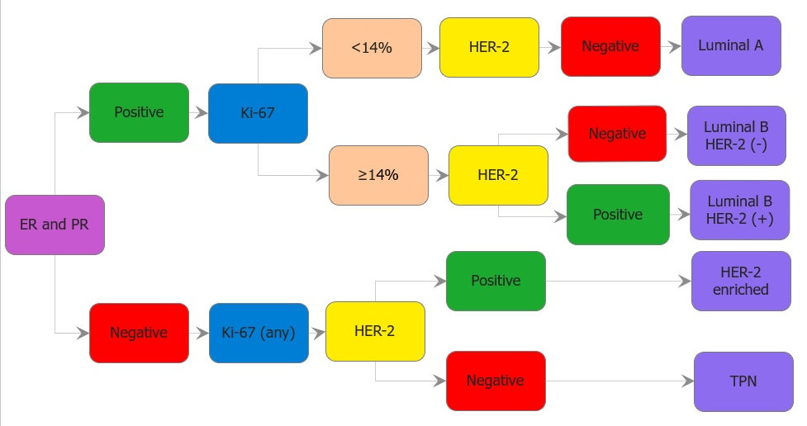

Supplementary Flowchart 1b Distribution of subtypes in line with 2013 St. Gallen recommendations
