SUPPLEMENTARY MATERIAL
Journal name: Breast Cancer Research and Treatment

CORRELATION BETWEEN BREAST CANCER SUBTYPES DETERMINED BY IMMUNOHISTOCHEMISTRY AND N-COUNTER PAM-50 ASSAY: A REAL-WORLD STUDY

Authors
Sara. Lopez-Tarruella¹, María. Del Monte-Millán², Marta. Roche-Molina³, Yolanda. Jerez², Isabel. Echavarria Diaz-Guardamino², Blanca. Herrero Lopez³, Salvador. Gamez Casado³, Iván. Marquez-Rodas², Enrique. Alvarez³, María. Cebollero⁴, Tatiana. Massarrah², Inmaculada. Ocaña³, Ainhoa. Arias³, José Ángel García Saenz⁵, Fernando Moreno Anton⁵, Clara Olier Garate⁶, Diana Moreno Muñoz⁶, David. Marrupe Gonzalez⁷, Miguel.Ángel Lara Alvarez⁸, Santos Enrech⁹, Coralia Bueno Muiño¹⁰, Miguel Martín^{1*}

Authors’ affiliations
¹ Medical Oncology Department, Hospital General Universitario Gregorio Marañón, Instituto de Investigación Sanitaria Gregorio Marañon (IiSGM), CIBERONC, Geicam, Universidad Complutense, 28007 Madrid, Spain
² Medical Oncology Department, Hospital General Universitario Gregorio Marañón, Instituto de Investigación Sanitaria Gregorio Marañón (IiSGM), CiberOnc, Madrid, Spain
³ Medical Oncology Department, Hospital General Universitario Gregorio Marañón Instituto de Investigación Sanitaria Gregorio Marañón (IiSGM), Madrid, Spain
⁴ Pathology Service, Hospital General Universitario Gregorio Marañón, Madrid, Spain
⁵ Medical Oncology Department, Hospital Clínico San Carlos, Instituto de Investigación Sanitaria San Carlos (IdISSC), CIBERONC, Madrid, Spain
⁶ Medical Oncology Department, Hospital Universitario Fundación Alcorcón, Alcorcon, Spain,
⁷Dept. Oncologia, Hospital Universitario de Móstoles, Mostoles, Spain,
⁸ Medical Oncology Department, Hospital Universitario Infanta Leonor, Universidad Complutense, Madrid, Spain
⁹ Medical Oncology Department, Hospital Universitario de Getafe, Madrid, Spain
¹⁰ Medical Oncology Department, Hospital Infanta Cristina (Parla), Fundación de Investigación Biomédica del H.U. Puerta de Hierro, Majadahonda, 28009 Madrid, Spain

*Corresponding author; mmartin@geicam.org

Supplementary Fig. 1 Number of Prosigna® tests performed by country and centralized from 2014 to 2020

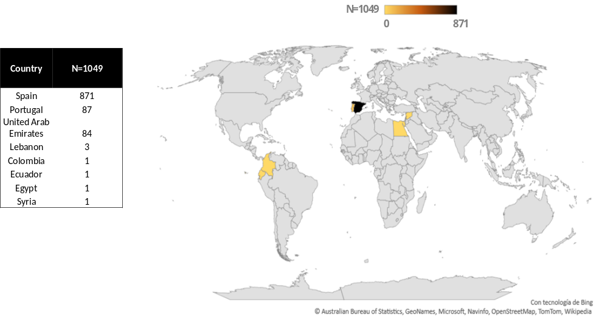

Supplementary Fig. 3 Sankey graphs for each proxy correlation and the intrinsic subtype in the Luminal population a) Proxy 1: Cheang; b) Proxy 2: Prat and c) Proxy 3: Maisonneuve [5, 6, 7] (LumA, luminal A; LumB, luminal B; IHC, immunohistochemistry).

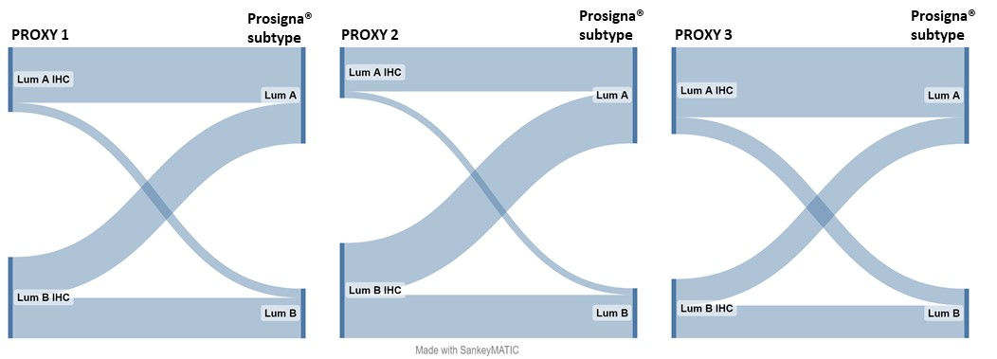

Supplementary Fig. 6 Sankey graphs for each proxy subtype correlation and the Prosigna® ROR in luminal tumors in node-negative patients a) Proxy 1: Cheang; b) Proxy 2: Prat and c) Proxy 3: Maisonneuve [5, 6, 7] (LumA, luminal A; LumB, luminal B; ROR, Risk of Recurrence).

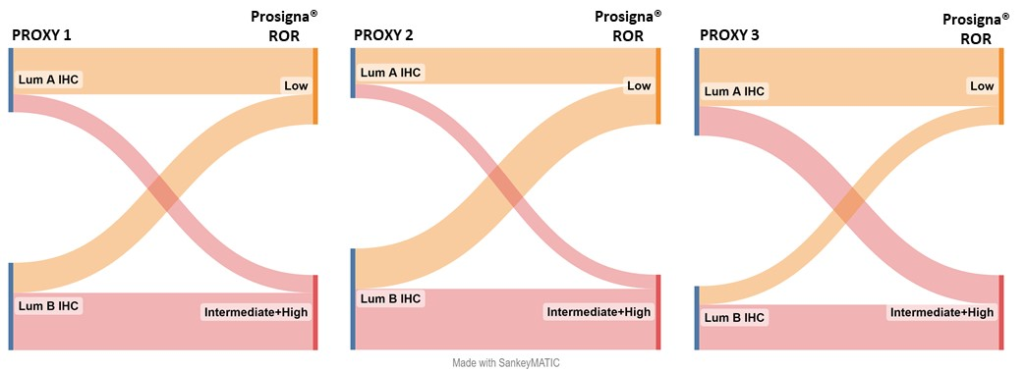

Supplementary Table 5. (Suppl material) Concordance between Prosigna® assay and IHC classifications depending on the risk of recurrence (ROR): a) Low ROR (0-40); b) Intermediate (41-60) + High ROR (61-100) in node –negative Luminal patients aged 50 or older.

Proxy 1  (n=275) | LOW ROR
Proxy 1  (n=275) | Lum A | Lum B
Lum A | 165 (60%) | 0 (0%) | Kappa | 95% CI | Accuracy | Sensitivity | Specificity
Lum B | 109 (40%) | 1 (0%) | 0,011 | (-0.010 – 0.032) | 0,60 | 0,60 | 1,00
Proxy 2  (n=264) | LOW ROR
Proxy 2  (n=264) | Lum A | Lum B
Lum A | 116 (44%) | 0 (0%) | Kappa | 95% CI | Accuracy | Sensitivity | Specificity
Lum B | 147 (56%) | 1 (0%) | 0,006 | (-0.005 – 0.017) | 0,45 | 0,45 | 1,00
Proxy 3  (n=275) | LOW ROR
Proxy 3  (n=275) | Lum A | Lum B
Lum A | 203 (74%) | 1 (0%) | Kappa | 95% CI | Accuracy | Sensitivity | Specificity
Lum B | 71 (26%) | 0 (0%) | -0,007 | (-0.020 – 0.006) | 0,75 | 0,75 | -
Proxy 1  (n=306) | INTERMEDIATE+HIGH ROR
Proxy 1  (n=306) | Lum A | Lum B
Lum A | 35 (11%) | 42 (14%) | Kappa | 95% CI | Accuracy | Sensitivity | Specificity
Lum B | 47 (15%) | 182 (59%) | 0,244 | (0.125 – 0.363) | 0,71 | 0,43 | 0,81
Proxy 2  (n=297) | INTERMEDIATE+HIGH ROR
Proxy 2  (n=297) | Lum A | Lum B
Lum A | 30 (10%) | 31 (10%) | Kappa | 95% CI | Accuracy | Sensitivity | Specificity
Lum B | 50 (17%) | 186 (63%) | 0,265 | (0.145 – 0.384) | 0,73 | 0,38 | 0,86
Proxy 3  (n=303) | INTERMEDIATE+HIGH ROR
Proxy 3  (n=303) | Lum A | Lum B
Lum A | 46 (15%) | 78 (26%) | Kappa | 95% CI | Accuracy | Sensitivity | Specificity
Lum B | 36 (12%) | 143 (47%) | 0,182 | (0.076 – 0.290) | 0,63 | 0,56 | 0,65

Supplementary Fig. 7) Prosigna® ROR distribution by Ki67 risk group in node negative luminal samples (Prosigna®) (ROR, Risk of Recurrence)

