Supplemental Materials Figure S1. Quality of life (EQ-5D-5L) before and after each zoledronate infusion.
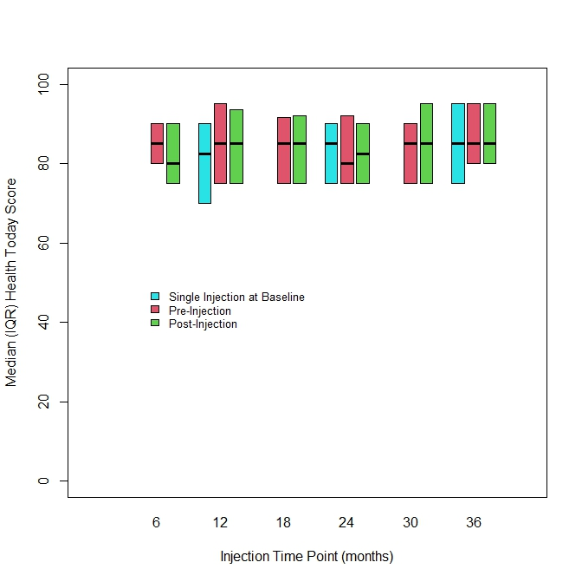

Supplemental Materials Table S1. Randomised trials with adjuvant 6-monthly zoledronate. APR = Acute phase reactions; BMD = Bone mineral density; DFS = Disease-free survival; EBC = Early breast cancer; OS = Overall survival.
Study | Eligibility | Randomization Arms | Primary Endpoint | BMD | Toxicity | DFS and OS
Zoledronate Versus No Zoledronate
ABCSG-12  Gnant et al. (3)  Gnant et al. (11) | Premenopausal women with endocrine-receptor-positive EBC (stage I–II) breast cancer receiving goserelin (3·6 mg every 28 days) (n=1803) | Tamoxifen (n=451) Anastrozole (n=453)  Tamoxifen plus zoledronate 4 mg every 6 months for 3 years (n=449) Anastrozole plus zoledronate (n=450) | Primary endpoint: DFS  Secondary endpoints: Recurrence free survival, overall survival and change in BMD | At 5 years:  No zoledronate arm:  -6.3%  Zoledronate arm: 4% | APR: 30% of patients receiving zoledronate  Renal: Not reported  ONJ: Not reported  Hypocalcaemia: Not reported | At 76 months (3):  Zoledronate arm:  27% improvement in DFS  41% improvement in OS  At 7.8 years (11):  DFS 88% versus 85%, (P = 0.203)  No OS benefit
Upfront Zoledronate Versus Delayed Zoledronate
N03CC (Alliance)  Wagner-Johnston et al. (13) | Postmenopausal women with EBC who have completed tamoxifen and starting letrozole (n=551) | Upfront zoledronate (4 mg IV every 6 months) (n=274)  Delayed zoledronate started if post-baseline BMD T-score < -2.0 or fracture (n=277)  15% of 277 received zoledronate | Primary endpoint: change in BMD  Secondary: Incidence of Osteoporosis and Fractures | At 12 months:  Upfront: gain of 3.6%  Delayed: loss of 1.6% | APR:  Upfront- 57%  Delayed- 33%  Creatinine elevation: Upfront- 4%  Delayed- 1%  ONJ:  Upfront- 0.2%  Delayed- 0%  Hypocalcaemia: not reported | Not reported
Z-FAST  Brufsky et al. (12) | Postmenopausal women with receptor–positive EBC receiving adjuvant letrozole were randomized to receive up-front or delayed-start zoledronic acid. Delayed-start ZA was administered | Upfront zoledronate (4 mg IV every 6 months for 5 years) (n=301)  Delayed zoledronate started if lumbar spine (LS) or total hip (TH) T score fell below −2.0 or a nontraumatic fracture occurred (n=301)  16.3% of 301 received zoledronate | Primary endpoint: Change in BMD  Secondary endpoints: Non traumatic fractures and DFS | At 5 years:  Upfront: loss of 2 %  Delayed: loss of 25.7% | APR:  Upfront: 47%  Delayed: 45.3%  Renal impairment: Upfront: 2%  Delayed: 1.3%  ONJ: 0.16% | At 5 years:  DFS  Upfront: 95.7%  Delayed: 93%  OS  Upfront: 97.7%  Delayed: 98.7%
ZO-FAST  Eidtmann et al. (5) | Postmenopausal women with receptor–positive EBC receiving adjuvant letrozole for 5 years | Upfront zoledronate (4 mg IV every 6 months for 5 years) (n=524)  Delayed zoledronate started if T-score fell below -2.0, nontraumatic clinical fracture, or if an asymptomatic fracture detected by spinal X-ray at the 36- month assessment. (n=536)  27% of 536 received zoledronate | Primary endpoint: change in BMS after 12 months.  Secondary endpoints: change in total BMD at each assessment, 3-year fracture incidence and DFS | At 4 years:  Upfront: +4.3  Delayed: -5.4% | APR:  Upfront: 46.6%  Delayed: 45.6%  Renal: Not reported  ONJ: 0.1%  Hypocalcaemia: Not reported | At 4 years:  DFS  Upfront: 99%  Delayed: 98%  OS  Upfront: 95%  Delayed: - 93.9%
KCSG-BR06-01  Kim et al. (14) | Premenopausal women aged >40 years with EBC receiving chemotherapy | Upfront zoledronate (4 mg IV, starting on the day of first adjuvant chemotherapy, every 6 months for 12 months (n=57)  Delayed zoledronate started if; atraumatic fracture or 6 month follow-up BMD T-score -2.5 standard deviations (SDs) at either the LS or total hip (n=59)  Does not report how many received zoledronate | Primary endpoint: change in BMD at 12 months  Secondary endpoints: changes in bone turnover markers and adverse effects of zoledronate in combination with chemotherapy | Upfront: -1.1%  Delayed: -7.5% | APR: Numbers not reported  Renal: Not reported  ONJ: 0  Hypocalcaemia: Not reported | Not reported
Takahashi et al. (15) | Postmenopausal women with receptor–positive EBC receiving adjuvant letrozole for 5 years | Upfront zoledronate (4 mg or an adjusted dose based on renal function IV every 6 months for 5 years) (n=97)  Delayed zoledronate started if post baseline LS (L2–L4) BMD decreases to YAM -2.0SD or less, or a nontraumatic clinical fracture occurred. (n=97)  Does not report how many received zoledronate | Primary endpoint: change in BMD at 12 months  Secondary endpoints: change in bone turnover markers, fracture at 3 years and DFS | Upfront: of the pts who already had bone loss at baseline, 22.2% recovered BMD to normal and 0% developed osteopenia  Delayed: 5.1% of pts who had bone loss at baseline recovered BMD to normal and 5% developed osteopenia. | APR  Upfront: 33.2%  Delayed: 11.4%  Renal: Not reported  ONJ:0  Hypocalcaemia: Not reported | Not reported
Supplemental Materials Table S2. Number of infusions of zoledronate received.
Randomized to single dose | 107 | # receiving correct allocation = 104
# received more than single = 3
- Received > 1 in error (2) -verbal orders by MO
- Received >1 pt choice (1)-switch to SOC
Total = 107
Randomized to SOC | 104 | # receiving correct allocation = 57
 |  | # receiving less than allocation = 47
 |  | Total = 104
TOTAL PATIENTS | 211 | 211
Doses of zoledronate received:
1 | 119
2 | 10
3 | 2
4 | 6
5 | 7
6 | 10
7 | 57
TOTAL PATIENTS | 211

Supplemental Materials Table S3. Variables incorporated into FRAX score and Quality of life (EQ-5D-5L) at baseline.
Variable |  | N | All Patients | Single Zoledronate Infusion Arm | Q6-Monthly Infusion Arm
N |  |  | 211 | 107 | 104
Variables Incorporated Into FRAX Score
Confirmed RA | N (%) Yes | 211 | 6 (2.8) | 4 (3.7) | 2 (1.9)
Previous fracture | N (%) Yes | 209 | 7 (3.4) | 4 (3.8) | 3 (2.9)
Hip fracture | N (%) Yes | 209 | 27 (12.9) | 11 (10.4) | 16 (15.5)
Current smoker | N (%) Yes | 209 | 9 (4.3) | 3 (2.8) | 6 (5.8)
Alcohol | N (%) Yes | 210 | 7 (3.3) | 4 (3.7) | 3 (2.9)
Secondary osteoporosis | N (%) Yes | 211 | 1 (0.5) | 0 | 1 (1.0)
Corticosteroids | N (%) Yes | 211 | 1 (0.5) | 0 | 1 (1.0)
Previous oral steroids | N (%) Yes | 211 | 1 (0.5) | 0 | 1 (1.0)
Type I diabetes | N (%) Yes | 211 | 1 (0.5) | 1 (0.9) | 0
Osteogenesis imperfecta | N (%) Yes | 211 | 0 (0) | 0 | 0
Hyperthyroidism | N (%) Yes | 211 | 1 (0.5) | 0 | 1 (1.0)
Premature menopause | N (%) Yes | 211 | 6 (2.8) | 4 (3.7) | 2 (1.9)
Chronic malnutrition | N (%) Yes | 211 | 1 (0.5) | 1 (0.9) | 0
Chronic liver disease | N (%) Yes | 211 | 3 (1.4) | 2 (1.9) | 1 (1.0)
Quality of Life at Baseline
Mobility | N (%) None  Slight  Moderate | 194 | 139 (71.7)  43 (22.2)  12 (6.2) | 69 (70.4)  24 (24.5)  5 (5.1) | 70 (72.9)  19 (19.8)  7 (7.3)
Self-care | N (%) None  Slight  Moderate  Severe | 194 | 179 (92.3)  11 (5.7)  2 (1.0)  2 (1.0) | 91 (92.9)  6 (6.2)  1 (1.0)  0 (0) | 88 (91.7)  5 (5.2)  1 (1.0)  2 (2.1)
Usual activities | N (%) None  Slight  Moderate  Severe  Extreme | 194 | 100 (51.6)  13 (6.7)  13 (6.7)  1 (0.5)  1 (0.5) | 52 (53.1)  37 (37.8)  8 (8.2)  1 (1.0)  0 (0) | 48 (50.0)  42 (43.8)  5 (5.2)  0 (0)  1 (1.0)
Pain | N (%) None  Slight  Moderate  Severe  Extreme | 194 | 74 (38.1)  90 (46.4)  27 (13.9)  2 (1.0)  1 (0.5) | 36 (36.7)  47 (48.0)  13 (13.3)  2 (2.0)  0 (0) | 38 (39.6)  43 (44.8)  14 (14.6)  0 (0)  1 (1.0)
Anxiety/Depression | N (%) None  Slight  Moderate  Severe  Extreme | 194 | 104 (53.6)  72 (37.1)  14 (7.2)  2 (1.0)  2 (1.0) | 60 (61.2)  32 (32.7)  6 (6.1)  0 (0)  0 (0) | 44 (45.8)  40 (41.7)  8 (8.3)  2 (2.1)  2 (2.1)
Health today | Median (IQR) | 194 | 80 (70, 90) | 85 (70, 90) | 80 (70, 90)

Supplemental Materials Table S4. Bisphosphonate-associated toxicity, breast cancer recurrence and study treatment discontinuation outcomes within year 1 after randomisation.
Variable |  | All Patients | Single Infusion Arm | Q6-Monthly Infusion Arm | p-value
Toxicities Within 1 Year
Any bisphosphonate-associated toxicity | N (%) Yes | 163 (77.3) | 82 (76.6) | 81 (77.9) | 0.87
Acute Phase Reactions
Acute phase reaction | N (%) Yes | 162 (76.8) | 82 (76.6) | 80 (76.9) | 1.00
Consequence of Acute Phase Reaction
Needed medical att.  Oncologist  Family physician  Attended ER  Required hospitalisation | N (%) Yes | 16 (7.6)  6 (2.8)  8 (3.8)  4 (1.9)  0 (0) | 9 (8.4)  4 (3.7)  4 (3.7)  2 (1.9)  0 | 7 (6.7)  2 (1.9)  4 (3.9)  2 (1.9)  0 | 0.80  0.68  1.00  1.00  -
Other Bisphosphonate-Associated Toxicities
Renal  Femur  Hypocalcemia  Atrial Fibrillation | N (%) Yes | 1 (0.5)  0 (0)  5 (2.4)  0 (0) | 0  0  1 (0.9)  0 | 1 (1.0)  0  4 (3.9)  0 | 0.49  -  0.21  -
ONJ  Mouth Pain  Mouth Sores  Fractures  Shorter  Osteoporosis | N (%) Yes | 0 (0)  15 (7.1)  1 (0.5)  1 (0.5)  8 (3.8)  0 (0) | 0  10 (9.4)  1 (0.9)  1 (0.9)  5 (4.7)  0 | 0  5 (4.8)  0  0  3 (2.9)  0 | -  0.28  1.00  1.00  0.72  -
BR Ca Recurrence  Bone Mets | N (%) Yes | 1 (0.5)  2 (1.0) | 1 (0.9)  1 (0.9) | 0  1 (0.9) | 1.00  1.00
Discontinued Study Treatment | N (%) Yes | 16 (7.6) | 3 (2.8) | 13 (12.5) | 0.009

