Online Resources
Table S1. Baseline demographics and clinical characteristics of women aged ≥65 years with HR+/HER2− or HR+/HER2+ mBC (SEER-17, excluding Alaska Native Tumor Registry, 2010–2013 and 2015–2018).
 | HR+/HER2− cohort |  |  | HR+/HER2+ cohort
Characteristic | Pre-2015ª  (n = 2198) | Post-2015^{b}  (n = 2830) | p-value | Pre-2015ª  (n = 419) | Post-2015^{b}  (n = 623) | p-value
Age at diagnosis, years  Mean (SD)  Median (range) | 75.0 (7.5)  74 (65–100) | 75.2 (7.6)  74 (65–100) | 0.419 | 74.2 (7.5)  73 (65–96) | 73.8 (7.4)  72 (65–100) | 0.443
Age at diagnosis, n (%)  65–74 years  ≥ 75 years | 1169 (53.2)  1029 (46.8) | 1488 (52.6)  1342 (47.4) | 0.670 | 239 (57.0)  180 (43.0) | 378 (60.7)  245 (39.3) | 0.242
Race and ethnicity, n (%)  Non-Hispanic White  Non-Hispanic Black  Non-Hispanic Asian or Pacific Islander, American Indian/Alaska native or Unknown  Hispanic | 1684 (76.6)  228 (10.4)  131 (6.0)  155 (7.1) | 2068 (73.1)  317 (11.2)  203 (7.2)  242 (8.6) | 0.028 | 312 (74.5)  45 (10.7)  24 (5.7)  38 (9.1) | 445 (71.4)  75 (12.0)  49 (7.9)  54 (8.7) | 0.501
SEER geographic region^{c}, n (%)  Big metro/metro/urban  Less urban/rural | 1937 (88.1)  261 (11.9) | 2469 (87.2)  361 (12.8) | 0.346 | 365 (87.1)  54 (12.9) | 551 (88.4)  72 (11.6) | 0.518
SEER registry site^{d}, n (%)  California  Connecticut  Georgia  Hawaii  Iowa  Kentucky  Louisiana  New Jersey  New Mexico  Seattle (Puget Sound)  Utah | 828 (37.7)  129 (5.9)  255 (11.6)  38 (1.7)  94 (4.3)  133 (6.1)  140 (6.4)  357 (16.2)  45 (2.0)  132 (6.0)  47 (2.1) | 1065 (37.6)  162 (5.7)  337 (11.9)  52 (1.8)  120 (4.2)  179 (6.3)  214 (7.6)  426 (15.1)  56 (2.0)  151 (5.3)  68 (2.4) | 0.863 | 154 (36.8)  28 (6.7)  45 (10.7)  NR  17 (4.1)  22 (5.3)  39 (9.3)  61 (14.6)  NR  22 (5.3)  15 (3.6) | 235 (37.7)  27 (4.3)  87 (14.0)  NR  25 (4.0)  48 (7.7)  45 (7.2)  99 (15.9)  NR  18 (2.9)  18 (2.9) | 0.124
Median household income, n (%)  < $55,000  $55,000 – $64,999  $65,000 – $74,999  ≥ $75,000 | 572 (26.0)  613 (27.9)  376 (17.1)  637 (29.0) | 632 (22.3)  471 (16.6)  742 (26.2)  985 (34.8) | < 0.001 | 124 (29.6)  108 (25.8)  69 (16.5)  118 (28.2) | 151 (24.2)  88 (14.1)  134 (21.5)  250 (40.1) | < 0.001
Marital status, n (%)  Single (never married)  Married/unmarried living with domestic partner  Divorced/separated/widowed  Unknown | 301 (13.7)  776 (35.3)  987 (44.9)  134 (6.1) | 401 (14.2)  1064 (37.6)  1212 (42.8)  153 (5.4) | 0.238 | 53 (12.6)  158 (37.7)  180 (43.0)  28 (6.7) | 107 (17.2)  245 (39.3)  238 (38.2)  33 (5.3) | 0.125
ªPre-2015 consists of patients diagnosed between 2010–2013 (with follow-up to December 31, 2014).
^{b}Post-2015 consists of patients diagnosed between 2015–2018 (with follow-up to December 31, 2019).
^{c“}Missing/unknown” excluded in each model due to low number of patients in this category.
^{d}”Alaska Natives” excluded in each model due to low number of patients in this category.
HER2, human epidermal growth factor receptor 2; HR, hormone receptor; mBC, metastatic breast cancer; SD, standard deviation; SEER, Surveillance, Epidemiology, and End Results.; NR = not reported owing to NCI data suppression policy for small cell sizes.

Table S2. Landmark BCSS rates for patients with HR+/HER2− and HR+/HER2+ mBC diagnosed pre- and post-2015
 | HR+/HER2− mBC |  | HR+/HER2+ mBC
 | Pre-2015ª  (n = 5313) | Post-2015^{b}  (n = 6175) | Pre-2015ª  (n = 1463) | Post-2015^{b}  (n = 1799)
Patients with event^{c}, n (%) | 2723 (51.3) | 2563 (41.5) | 621 (42.5) | 675 (37.5)
Patients censored, n (%) | 2590 (48.8) | 3612 (58.5) | 842 (57.6) | 1124 (62.5)
Median BCSS, months (95% CI) | 35 (33–37) | 39 (38–42) | 45 (42–50) | 50 (45–NE)
BCSS rate, % (95% CI)  6-month  12-month  18-month  24-month  36-month  48-month | 84.8 (83.8–85.7)  77.8 (76.6–78.9)  70.0 (68.7–71.2)  62.7 (61.3–64.0)  48.6 (47.1–50.1)  38.5 (36.8–40.1) | 86.0 (85.1–86.8)  78.8 (77.8–79.8)  71.6 (70.4–72.8)  65.2 (63.9–66.5)  52.8 (51.2–54.2)  44.5 (42.8–46.3) | 85.3 (83.4–87.1)  80.5 (78.3–82.4)  75.4 (73.1–77.6)  69.9 (67.4–72.2)  57.7 (54.9–60.5)  47.7 (44.3–50.9) | 84.6 (82.9–86.2)  79.9 (78.0–81.7)  74.9 (72.7–76.8)  70.5 (68.3–72.7)  59.9 (57.2–62.5)  50.7 (47.5–53.8)
ªPre-2015 consists of patients diagnosed between 2010–2013 (with follow-up to December 31, 2014).
^{b}Post-2015 consists of patients diagnosed between 2015–2018 (with follow-up to December 31, 2019).
^{c}Events were defined as deaths from breast cancer.
BCSS, breast cancer-specific survival; CI, confidence interval; HER2, human epidermal growth factor receptor 2; HR, hormone receptor; mBC, metastatic breast cancer; NE, not estimable.

Table S3. Median BCSS by baseline demographic characteristics for patients diagnosed with HR+/HER2− or HR+/HER2+ mBC from 2010–2019.
Median BCSS, months (95% CI) | HR+/HER2− mBC  (n = 14,614) | HR+/HER2+ mBC  (n = 4097)
Overall | 37 (36–38) | 48 (46–51)
Age at diagnosis  18-44 years  45-64 years  65-84 years  ≥ 85 years | 46 (43–49)  40 (38–42)  35 (33–36)  20 (17–23) | 84 (71–109)  50 (47–55)  34 (30–39)  15 (10–19)
Race and ethnicityª  Non-Hispanic White  Non-Hispanic Black  Non-Hispanic Asian or Pacific Islander | 38 (37–39)  28 (27–30)  42 (38–46) | 50 (47–55)  36 (32–39)  49 (42–60)
Median household income  < $55,000  ≥ $75,000 | 33 (31–35)  41 (39–43) | 43 (38–47)  51 (46–60)
ª“American Indian/Alaska Native/Unknown” and “Hispanic.”
BCSS, breast cancer-specific survival; CI, confidence interval; HER2, human epidermal growth factor receptor 2; HR, hormone receptor; mBC, metastatic breast cancer.

Table S4. Multivariable Cox regression analysis of breast cancer-specific survival (BCSS) in patients aged aged ≥65 years with HR+/HER2− or HR+/HER2+ mBC.
Characteristic | HR+/HER2− cohort |  |  | HR+/HER2+ cohort
 | n = 5028 |  |  | n = 1042
 | HR | 95% CI | p-value | HR | 95% CI | p-value
Study period  Pre-2015ª  Post-2015^{b}  Adjusted Post-2015^{b,c} | Reference  0.873  0.893 | 0.807–0.944  0.824–0.967 | <0.001  0.006 | Reference  1.016  1.047 | 0.852–1.210  0.872–1.256 | 0.862  0.623
Age at diagnosis  65-74 years  ≥ 75 years | Reference  1.35 | 1.25–1.47 | <0.001 | Reference  1.48 | 1.23–1.77 | <0.001
Race and ethnicity  Non-Hispanic White  Non-Hispanic Black  Non-Hispanic Asian or Pacific Islander, American Indian/Alaska Native or Unknown  Hispanic | Reference  1.14  0.81  0.93 | 1.00–1.29  0.67–0.97  0.79–1.08 | 0.056  0.025  0.332 | Reference  1.13  1.03  1.02 | 0.84–1.50  0.71–1.48  0.73–1.42 | 0.420  0.881  0.901
SEER geographic region^{d}  Big metro/metro/urban  Less urban/rural | Reference  0.92 | 0.80–1.06 | 0.243 | Reference  0.97 | 0.70–1.35 | 0.873
SEER registry site^{e}  California  Connecticut  Georgia  Hawaii  Iowa  Kentucky  Louisiana  New Jersey  New Mexico  Seattle (Puget Sound)  Utah | Reference  0.86  1.01  1.13  1.02  1.08  0.90  1.02  1.24  0.92  1.00 | 0.71–1.04  0.87–1.16  0.82–1.56  0.83–1.25  0.89–1.30  0.75–1.09  0.90–1.16  0.94–1.65  0.76–1.10  0.76–1.31 | 0.128  0.946  0.440  0.847  0.446  0.285  0.732  0.126  0.356  0.978 | Reference  0.74  1.33  1.78  0.68  1.36  1.15  0.95  1.14  1.25  1.23 | 0.46–1.19  0.99–1.79  0.86–3.71  0.40–1.15  0.92–2.00  0.79–1.68  0.71–1.26  0.62–2.09  0.81–1.95  0.75–2.02 | 0.207  0.057  0.123  0.152  0.125  0.456  0.711  0.678  0.318  0.421
Median household income  < $55,000  $55,000 - $64,999  $65,000 - $74,999  ≥ $75,000 | Reference  0.96  0.91  0.87 | 0.84–1.10  0.78–1.06  0.74–1.01 | 0.592  0.227  0.061 | Reference  1.05  0.81  0.96 | 0.77–1.43  0.58–1.14  0.70–1.31 | 0.745  0.230  0.803
Marital Status  Single (never married)  Married/unmarried living with domestic partner  Divorced/separated/widowed  Unknown | Reference  0.82  1.04  0.91 | 0.72–0.93  0.92–1.17  0.74–1.11 | 0.002  0.571  0.333 | Reference  0.79  1.25  0.98 | 0.60–1.05  0.95–1.63  0.64–1.50 | 0.107  0.106  0.929
ªPre-2015 consists of patients diagnosed between 2010–2013 (with follow-up to December 31, 2014).
^{b}Post-2015 consists of patients diagnosed between 2015–2018 (with follow-up to December 31, 2019).
^{c}Multivariable adjusted hazard ratio. Results were adjusted for age at diagnosis, race and ethnicity, SEER geographic region, SEER registry site, median household income, and marital status.
^{d}“Missing/unknown” excluded in each model due to low number of patients in this category.
^{e}“Alaska Natives” excluded in each model due to low number of patients in this category.
CI, confidence interval; HER2, human epidermal growth factor receptor 2; HR, hazard ratio; HR+, hormone receptor-positive; mBC, metastatic breast cancer; SEER, Surveillance, Epidemiology, and End Results.

Fig. S1 Kaplan–Meier breast cancer-specific survival curves for patients aged aged ≥65 years and diagnosed with HR+/HER2− (A) or HR+/HER2+ (B) mBC pre- or post-2015
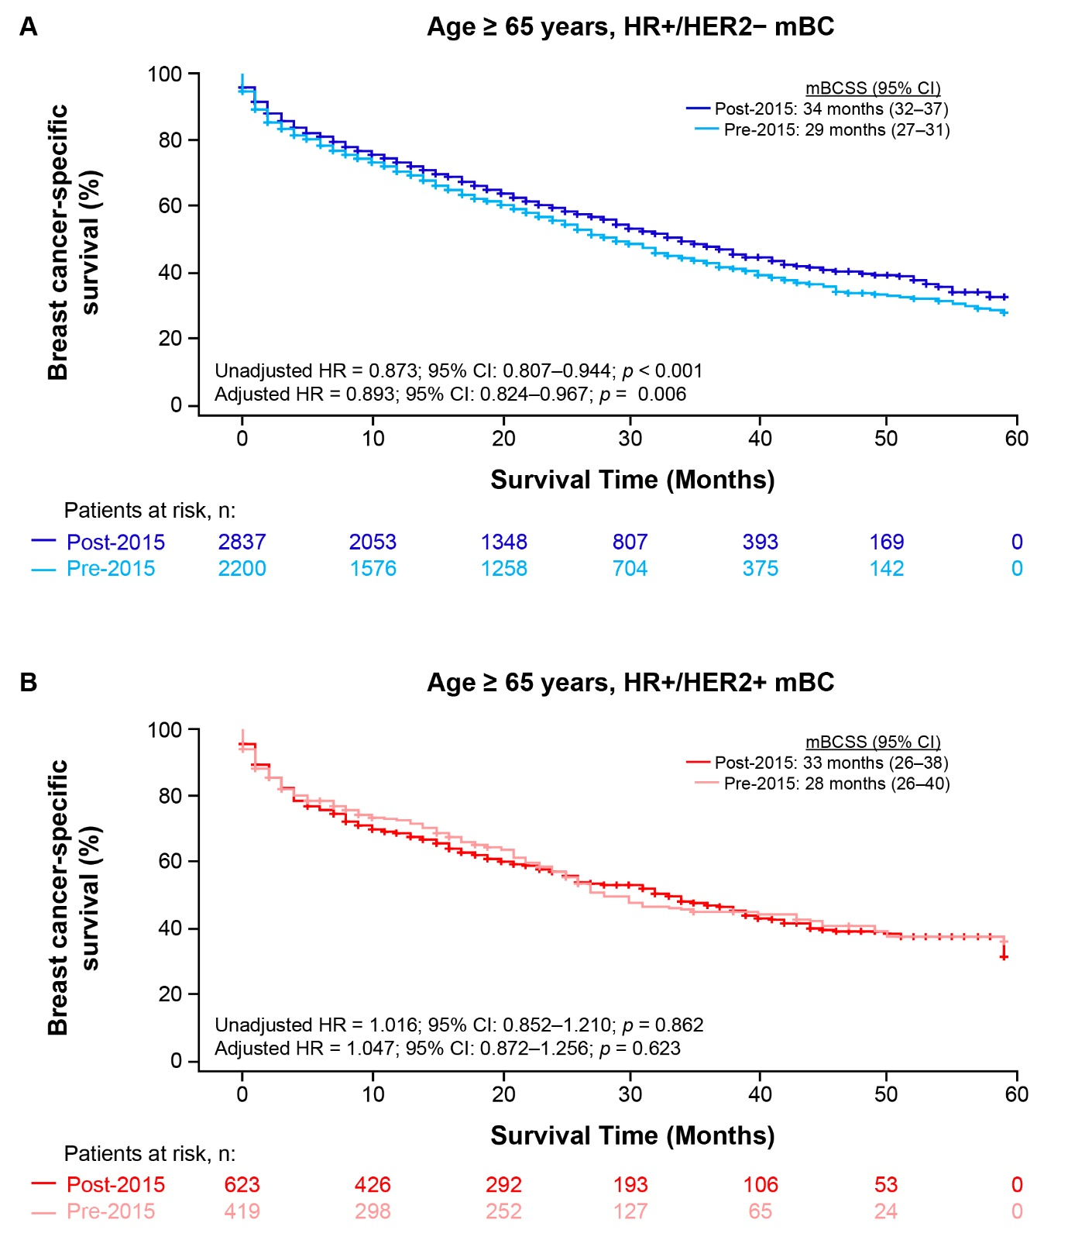
CI, confidence interval; HER2, human epidermal growth factor receptor 2; HR, hazard ratio; HR+, hormone receptor-positive; mBC, metastatic breast cancer; mBCSS, median breast cancer-specific survival; SEER, Surveillance, Epidemiology, and End Results.

