The cytokine profile correlates with less tumor-infiltrating lymphocytes in luminal A breast cancer

Eri Ishikawa¹, Takahiro Watanabe^{1, 2}, Takako Kihara¹, Mamiko Kuroiwa³, Miki Komatsu³, Sayaka Urano³, Masayuki Nagahashi³, Seiichi Hirota¹ and Yasuo Miyoshi³

¹ Department of Surgical Pathology, School of Medicine, Hyogo Medical University, Nishinomiya City, Hyogo, Japan
² Department of Clinical Pathology, Chibune General Hospital, Osaka, Japan
³ Department of Surgery, Division of Breast and Endocrine Surgery, School of Medicine, Hyogo Medical University, Nishinomiya City, Hyogo, Japan

Correspondence to: Yasuo Miyoshi
Department of Surgery, Division of Breast and Endocrine Surgery, School of Medicine, Hyogo Medical University, Mukogawa-cho 1-1, Nishinomiya City, Hyogo 663-8501, Japan.
Tel: +81 798456374. Fax: +81 798456252, e-mail: ymiyoshi@hyo-med.ac.jp

Supplementary Information S1
Neoadjuvant chemotherapy (NAC) involved sequential administration of taxane and anthracycline (n=11), taxane (n=3), and others (n=2). The duration of NAC ranged from 1 month to 45 months (median, 6 months), and trastuzumab plus pertuzumab was combined with chemotherapy in three cases. Maintenance therapy with trastuzumab and pertuzumab after combination therapy with chemotherapy was applied to the patient treated for 45 months. Aromatase inhibitors (n=7), ovarian function suppression plus tamoxifen (n=2), and fulvestrant (n=1) were administered for 1–10 months (median, 2 months) as neoadjuvant endocrine therapy (NET).

Supplementary Information S2
In the hotspot method, we microscopically identified lesions containing lymphocyte infiltration using a low-power field (×40) and a medium-power field (×100), and the area with the highest lymphocyte infiltration was selected for counting. Lymphocytes and plasma cells were selected; however, neutrophils, eosinophils, and macrophages were excluded in the peri- and intra-tumoral stromal regions. TIL levels were identified as the percentage of areas containing lymphocytes and plasma cells in the entire tumor and adjacent stroma, following a previously described method [13]. In the average method, TIL levels were evaluated using the International TILs Working Group 2014 [14]. Briefly, we determined the area occupied by mononuclear inflammatory cells over the total intratumoral stromal area and obtained the percentage of the full assessment of the tumor area as the average TILs.

Supplementary Information S3
The Bio-Plex Pro Human Cytokine GI 27-plex Panel measures cytokines (interleukin (IL)-1β, IL-1 receptor antagonist (IL-1ra), IL-2, IL-4, IL-5, IL-6, IL-7, IL-8, IL-9, IL-10, IL-12 (p70), IL-13, IL-15, IL-17, interferon (IFN)-γ, and tumor necrosis factor alpha (TNF-a), chemokines (chemokine C-C motif ligand 2 (CCL2) [monocyte chemotactic protein 1, MCP-1], CCL3 [macrophage inflammatory protein-1α, MIP-1a], CCL4 [MIP-1b], CCL5 [RANTES], C-X-C motif chemokine ligand 10 (CXCL10) [interferon gamma-induced protein 10, IP-10], and Eotaxin), and growth factors (fibroblast growth factor [FGF] basic, granulocyte colony stimulating factor [G-CSF], granulocyte macrophage colony stimulating factor [GM-CSF], homodimer of platelet-derived growth factor B homodimer [PDGF-bb], and vascular endothelial growth factor [VEGF]). In this study, we successfully obtained data as for eotaxin, IL-1ra, IL-4, IL-8, IL-9, IL-12, IL-17, IP-10, MCP-1, MIP-1b, PDGF-bb, RANTES, and TNF-a. As the measured concentrations were below the lower limit of the detection range in more than three-quarters of the cases, data on other factors were excluded.

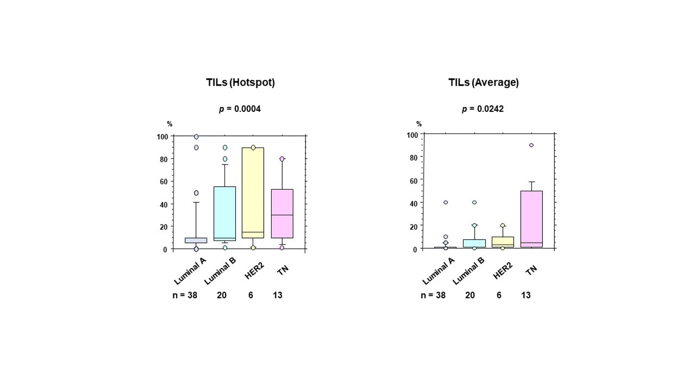

Supplementary Fig. 1
Tumor-infiltrating lymphocyte levels in each breast cancer subtype.
Tumor-infiltrating lymphocyte (TIL) levels evaluated hotspots or the average of the entire tumor area in each subtype. Subtypes were classified as follows; Luminal A, estrogen receptor (ER)-positive/human epidermal growth factor 2 (HER2)-negative and Ki67 <25%; Luminal B, ER-positive/HER2-negative and Ki67 ≥25%; HER2, HER2-positive; TN, ER-negative/HER2-negative. Boxplots represent the lower and upper quartiles by boxes, and the maximum, median, and minimum values are represented by horizontal lines.

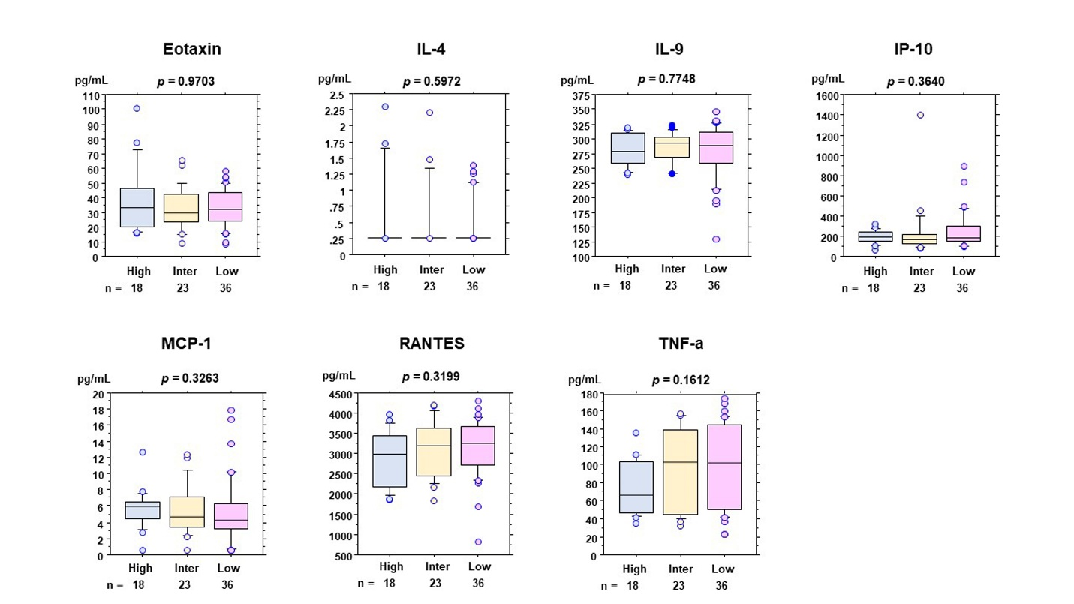

Supplementary Fig. 2
Expression levels of cytokines, chemokines, and growth factors according to tumor-infiltrating lymphocyte levels.
Expression levels of each variable were not significantly associated with tumor-infiltrating lymphocytes (TILs) according to TIL levels. TIL levels were classified as high (≥50%), intermediate (≥10%, <50%), or low (<10%). Boxplots represent the lower and upper quartiles by boxes, and the maximum, median, and minimum values are represented by horizontal lines.

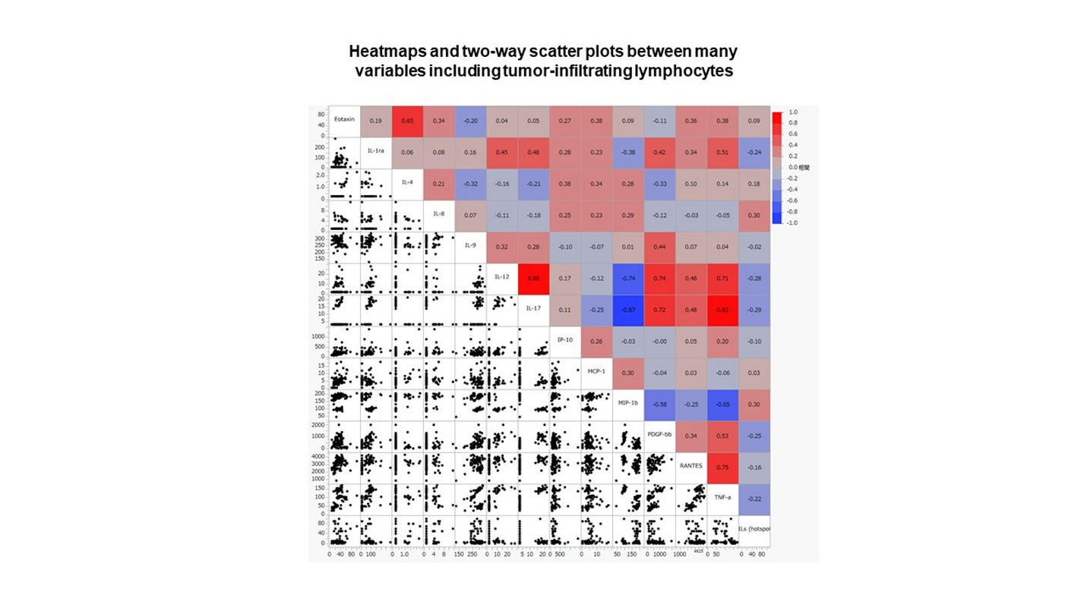

Supplementary Fig. 3
Correlation coefficient between cytokines, chemokines, and growth factors.
Heatmaps and two-way scatter plots of several variables. Red and blue represent the positive and negative correlations in each sample, respectively. Color density indicates the levels of correlation coefficients, as shown in the legends.

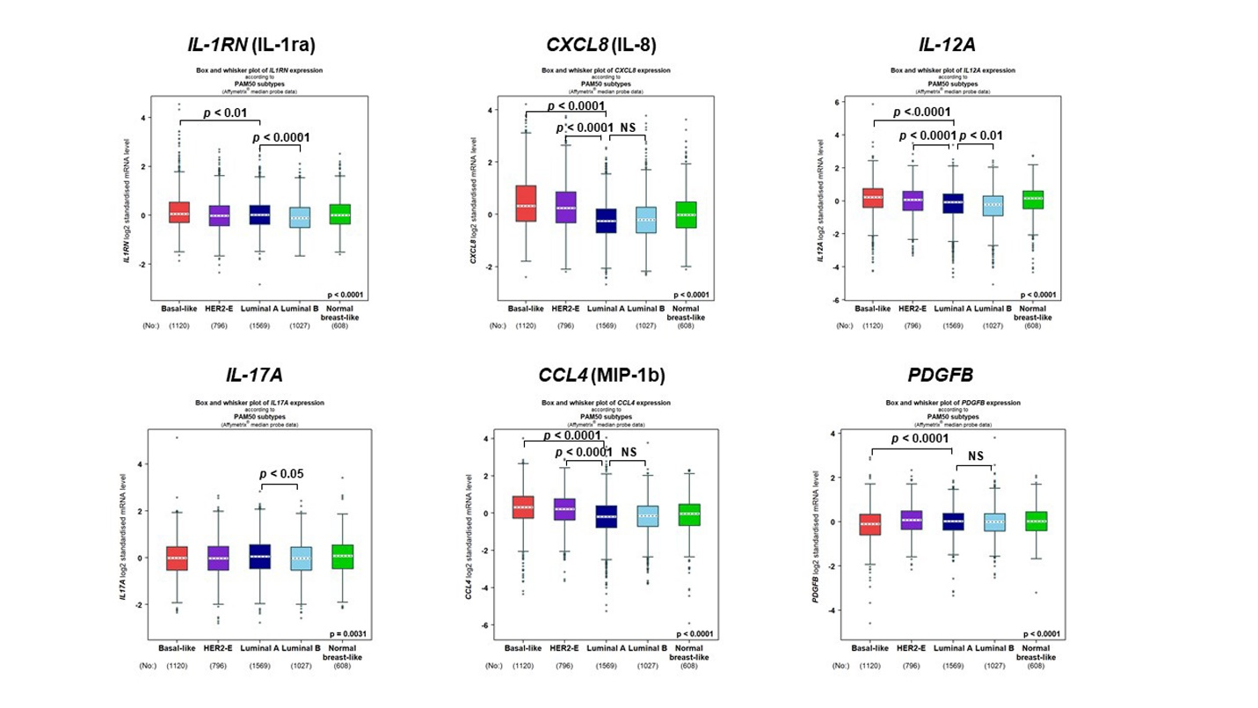

Supplementary Fig. 4
mRNA expression levels of six genes in public datasets.
The mRNA expression levels of IL-1RN (IL-1ra), CXCL8 (IL-8), IL-12A, IL-17A, CCL4 (MIP-1b), and PDGFB were compared in each breast cancer molecular subtype classified by PAM50 in public datasets. NS, not significant.

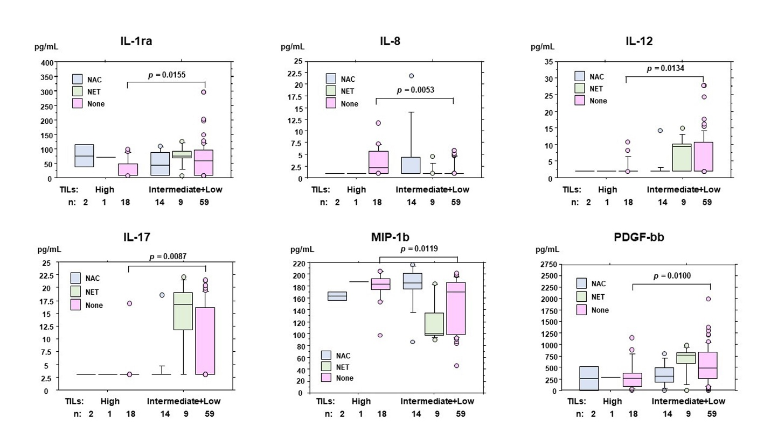

Supplementary Fig. 5
Expression levels of six variables by tumor-infiltrating lymphocyte levels according to neoadjuvant therapies.
The expression levels of six variables in the tumor-infiltrating lymphocyte (TIL)-high and TIL-intermediate plus low groups were represented in patients with neoadjuvant chemotherapy (NAC) or neoadjuvant endocrine therapy (NET), and without neoadjuvant therapy (None). TIL-high, ≥50%; TILs-intermediate+low, <50%. Boxplots represent the lower and upper quartiles by boxes, and the maximum, median, and minimum values are represented by horizontal lines.

