Supplementary information

Appendices
Appendix I. The late treatment toxicity questionnaire

Supplementary tables
Table 1. Baseline characteristics of responders and non-responders to questionnaires
Table 2. Response rates to questionnaires
Appendix I. The late treatment toxicity questionnaire.
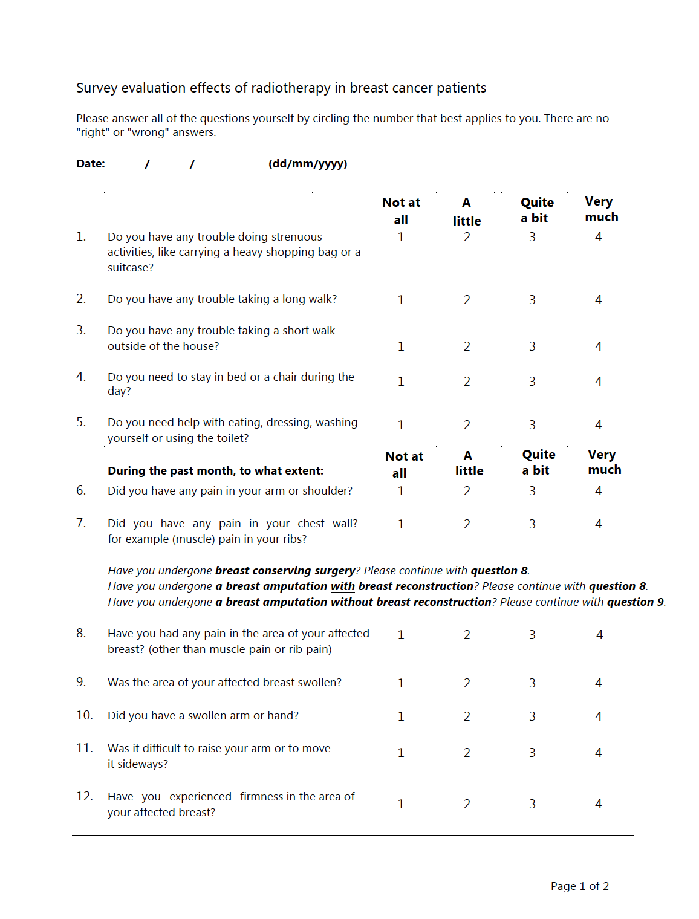

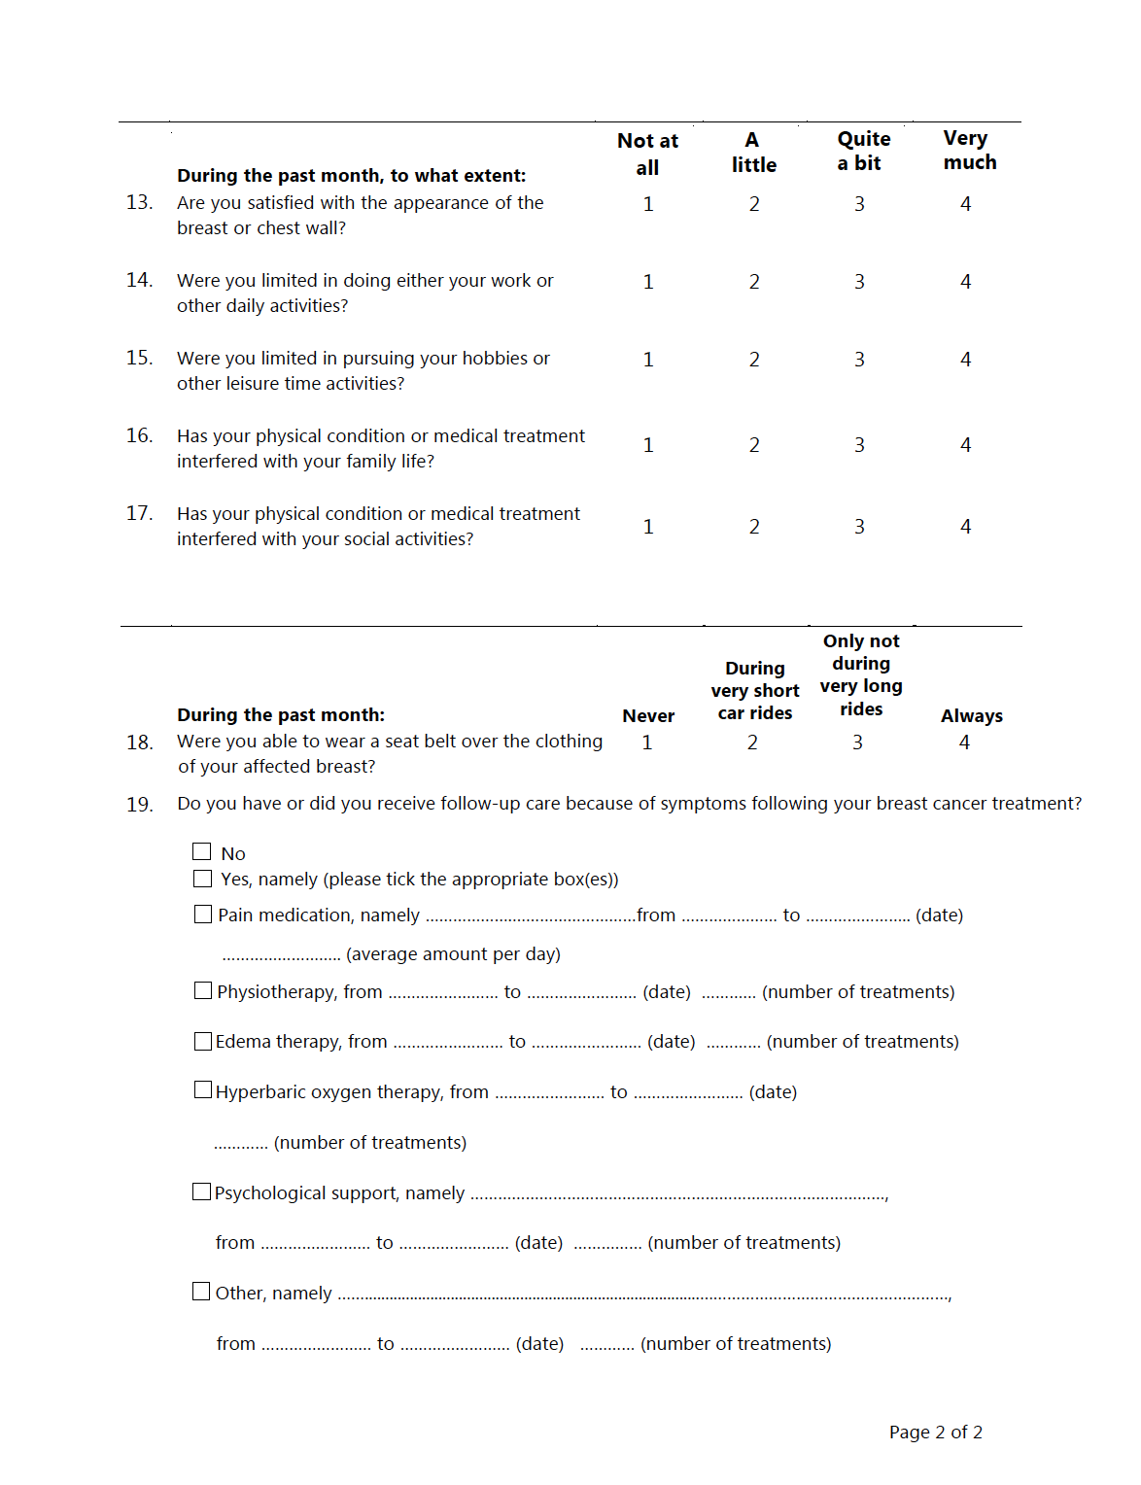

Supplementary Table 1. Baseline characteristics of responders and non-responders to questionnaires.
 | Responders |  | Non-responders
 | n = 84 (95.5%) |  | n=4 (4.5%)
Patient characteristics ª
Age, mean (SD) | 48.3 | (7.4) | 42.8 | (5.1)
Tumor characteristics
T-stadium, No. (%)
0 + In situ | 11 | (13.1) | 2 | (50.0)
1 | 30 | (35.7) | 1 | (25.0)
3 | 22 | (26.2) | 1 | (25.0)
3 + 4 | 19 | (22.6) | 0 | (0.0)
X + Unknown | 2 | (2.4) | 0 | (0.0)
N-stadium, No. (%)
0 | 19 | (22.6) | 2 | (50.0)
1 | 50 | (59.5) | 2 | (50.0)
2 + 3 | 11 | (13.1) | 0 | (0.0)
X | 4 | (4.8) | 0 | (0.0)
Treatment characteristics
Neo-adjuvant systemic therapy, No. (%)
Chemotherapy | 52 | (61.9) | 3 | (75.0)
Endocrine therapy | 11 | (13.1) | 1 | (25.0)
Immunotherapy | 10 | (11.9) | 1 | (25.0)
Adjuvant systemic therapy, No. (%)
Chemotherapy | 45 | (40.5) | 1 | (25.0)
Endocrine therapy | 68 | (81.0) | 3 | (75.0)
Immunotherapy | 15 | (17.9) | 1 | (25.0)
Axillary treatment, No. (%)
No axillary treatment | 2 | (2.4) | 0 | (0.0)
Sentinel node and/or MARI | 69 | (82.1) | 4 | (100.0)
ALND | 13 | (15.5) | 0 | (0.0)
Radiotherapy^{b}, No. (%)
Local radiotherapy without boost | 14 | (16.7) | 0 | (0.0)
Local radiotherapy with boost | 1 | (1.2) | 0 | (0.0)
Locoregional radiotherapy without boost | 59 | (70.2) | 3 | (75.0)
Locoregional radiotherapy with boost | 1 | (1.2) | 0 | (0.0)
Other (e.g. regional lymph nodes only) | 9 | (10.7) | 1 | (25.0)
Time between mastectomy and DIEP reconstruction in months
Median, range | 0 | (0-62) | 0 | (0-12)
Abbreviations: ALND = Axillary lymph node dissection; DIEP = Deep Inferior Epigastric artery Perforator; IQR = Inter quartile range; MARI = Marking the axillary lymph node with radioactive iodine seeds; SD = Standard deviation.
ª Due to non-response to the questionnaires, data pertaining to BMI and smoking were unavailable.
^{b} Including radiation therapy on periclavicular and/or axillary lymph nodes

Supplementary Table 2. Response rates to questionnaires.

 | IBR |  | DBR
 | n | (%) |  | n | (%)
EORTC-QLQ-C30/BR23
6 months post-mastectomy | 34 | (61) |  | 20 | (63)
12 months post-mastectomy | 33 | (59) |  | 17 | (53)
6 months post-reconstruction | 34 | (61) |  | 17 | (53)
12 months post-reconstruction | 33 | (59) |  | 14 | (44)
Long term | 35 | (63) |  | 16 | (50)
BREAST-Q
Long term | 26 | (46) |  | 15 | (47)
Late Treatment Toxicity
Long term | 37 | (66) |  | 16 | (50)
Abbreviations: DBR = delayed breast reconstruction, IBR = immediate breast reconstruction

