Online Resource 1 - Supplementary Information

Article title: Triaging mammography with Artificial Intelligence: An implementation study

Journal name: Breast Cancer Research and Treatment

Author names: Sarah M. Friedewald MD*♰✉¹, Marcin Sieniek PhD*✉², Sunny Jansen PhD*✉²,
Fereshteh Mahvar MEng², Timo Kohlberger PhD², David Schacht MD MPH¹, Sonya Bhole MD¹,
Dipti Gupta MD¹, Shruthi Prabhakara PhD², Scott Mayer McKinney MSc², Stacey Caron MSN¹,
David Melnick BSc¹, Mozziyar Etemadi MD PhD¹, Samantha Winter PhD²,
Thidanun Anusoya MEng², Alejandra Maciel MSc², Luca Speroni¹,
Martha Sevenich MD MPH¹, Arnav Agharwal MSc², Rubin Zhang BSc², Gavin Duggan PhD², Shiro Kadowaki MD MBA², Atilla P. Kiraly PhD², Jie Yang PhD², Basil Mustafa MEng²,
Yossi Matias PhD², Greg S. Corrado PhD², Daniel Tse MD✉², Krish Eswaran PhD²
& Shravya Shetty MSc²

* contributed equally
♰ corresponding author: sarah.friedewald@nm.org
✉ may be contacted by readers: sarah.friedewald@nm.org, msieniek@google.com, sajansen@google.com, tsed@google.com

¹ Northwestern University, Feinberg School of Medicine, 420 E Superior St, Chicago, IL 60611
² Google Health, 1600 Amphitheatre Pkwy, Mountain View, CA 94043

Corresponding author: Sarah M. Friedewald, MD 312-472-0460 sarah.friedewald@nm.org Lynn Sage Comprehensive Breast Center Room 4-2304 250 E. Superior St. Chicago, IL 60657

Caption describing content of this file: This file contains supplementary information regarding the manuscript. It includes:
- Supplementary Methods. Additional description of the AI model used in the study
- Supplementary Simulations. Results from supplementary analysis (simulations)
- Supplementary Tables
- Supplementary Figures

Supplementary Methods

AI model
A variant of the deep learning model ensemble described by McKinney at al.⁹ was used in the study. To simplify deployment, the ensemble included the lesion model and case model but did not contain the “breast-level” model. Unlike in the original publication, breast cancer diagnosis (any malignancy subtype) within 15 months of screening was used as ground truth when training the model (though confirming a negative label still required a negative screening follow-up after at least 21 months), in order to balance the ability to learn from cancers missed by radiologists in the original dataset with the need for the findings to be actionable in this study. In contrast with 500-fold test-time augmentation used in the original research paper, in this study - to balance the computational cost, latency and accuracy - components of the ensemble were run 20 times on randomly perturbed patient images and predictions from those runs were averaged.

Operating point
The model produces an uncalibrated score between 0 and 1, where higher scores correspond to an estimated higher probability of breast cancer. Therefore, a threshold (“operating point”) had to be selected such that cases with scores above that threshold were considered prioritized by the algorithm. In choosing the operating point, we strived to balance the diagnostic sensitivity of the “Priority” categorization with the site's logistical ability to accommodate immediate interpretation and same-visit additional imaging. To do so, we used a retrospective dataset acquired between 2000 and 2018 at the same institution. We selected an operating point that would have prioritized 14.4% of historical screening cases and captured 77% of biopsy-confirmed cancers diagnosed within 12 months of the examination, as estimated using the retrospective cohort. This trade-off was deemed clinically meaningful and operationally feasible. Once selected, the operating point was fixed and not changed for the duration of the study. Depending on the goals of the facility and the predictive ability of AI used, a potentially different operating point could be chosen. See Supplementary Simulations for a simulation of the impact of choosing a more specific operating point.

User training and interface
The cloud Application Programming Interface (API) only returned a binary Priority/Non-priority result to the site. An on-premises client sent an email notification to the study coordinator who subsequently notified a radiologist designated for immediate reading on that day that a case was prioritized. This flow is depicted in Supplementary Figure 1. Neither an explanation for why a case was prioritized nor any localization information were given to minimize the influence the AI might have on the radiologist's interpretation. Radiologists were given a formal user guide (which included indications and contraindications, possible results and AI’s stand-alone diagnostic accuracy as measured on the retrospective dataset from the same site) and were trained in the experimental workflow.

Supplementary Simulations
In addition to prospectively obtained primary results of the study, we also retrospectively performed two simulations after the study had concluded.

Quantifying the impact of the AI compared to random prioritization
The AI-modified workflow involved a composite intervention, which included using the AI to prioritize cases, reading screening mammograms of prioritized cases within 30 minutes of acquisition and then offering same-visit diagnostic workup to those patients who required additional imaging.

To better isolate the benefit of AI prioritization from the benefit of the real-time workflow, we performed a Monte Carlo (MC) simulation with 1000 runs in which the same fraction of control group mammograms (29%) was randomly selected for same-visit review, while their outcomes remained unchanged. To estimate the sensitivity of random prioritization in predicting the need for additional imaging, a biopsy or a cancer diagnosis, point estimates and confidence intervals from each MC run (established in the same manner as for the non-simulated results) were averaged. To estimate the effect size, the mean, 2.5th percentile and 97.5th percentile of the difference between sensitivities of random prioritization and AI prioritization across MC runs were computed.

An estimate of the sensitivity of the random prioritization compared to actual screening outcomes in the control group is reported in the fourth row of Supplementary Table 2. Compared to random prioritization, AI prioritized 45% [95% CI 0-84] more cases that needed additional imaging, 130% more cases that needed biopsy [95% CI 37-208] and 245% more cancers [95% CI 114-245]. Therefore, AI prioritization meaningfully increases the fraction of prioritized biopsies and cancers compared to random selection.

Simulating the impact of a more specific prioritization
As mentioned in the Discussion, the operating point selected on the retrospective data resulted in a meaningfully higher fraction of cases prioritized prospectively than expected based on historical data from that site. Instantly reviewing 29% of the screening cases may not be practical for every site, so - in this retrospective simulation - we evaluated four, more specific operating points corresponding to prioritization rates of 25%, 20%, 15% and 10% of the experimental group cases by the AI. Hypothetical sensitivity of the AI (should these operating points be used in the study), compared to the actual screening outcomes in the experimental group, is depicted in the last four rows of Supplementary Table 2. Adjusting the AI's score threshold from prioritizing 29% of the screening examinations to 25% would result in 1 cancer being missed by the AI. However, decreasing the threshold to 10% still resulted in only one unprioritized cancer and 32% of patients who needed a biopsy obtaining a same-visit interpretation. Therefore, the technique can be adapted to better weigh institution-specific trade-offs and preferences.

In an ongoing deployment, an operating point like this could also be arrived at by making iterative adjustments based on prospectively acquired data. This approach was not taken in our protocol, to simplify the study conduct and analysis.

Supplementary Tables
Group | AI result | Radiologist recommendation after screening | Radiologist recommendation after diagnostic workup | Final pathology
392 Control Group  Standard workflow (Figure 2)  AI results do not impact participant or radiologist workflow | 114  Would have been prioritized by AI (if in experimental group; results presented for comparison)  29% (114/392)  (AI results do not impact participant or radiologist workflow) | 20  Additional imaging needed (BIRADS 0)  18% (20/114) | 9 Tissue diagnosis needed (BIRADS 4 or 5) | 3 Cancer
 |  |  |  | 6 Benign
 |  | 20  Additional imaging needed (BIRADS 0)  18% (20/114) | 7 Annual Screening (BIRADS 1 or 2) | N/A
 |  | 20  Additional imaging needed (BIRADS 0)  18% (20/114) | 3 Short term follow-up  (BIRADS 3) | N/A
 |  | 20  Additional imaging needed (BIRADS 0)  18% (20/114) | 1 No diagnostic workup | N/A
 |  | 94  Annual Screening (BIRADS 1 or 2)  82% (94/114) | N/A | 1 Cancer (detected on screening MRI)
 | 275  Not Prioritized by AI  70% (275/392)  (AI results do not impact participant or radiologist workflow) | 36  Additional imaging needed (BIRADS 0)  13% (36/275) | 6 Tissue diagnosis needed (BIRADS 4 or 5) | 0 Cancer
 |  |  |  | 6 Not cancer
 |  | 36  Additional imaging needed (BIRADS 0)  13% (36/275) | 22 Annual Screening (BIRADS 1 or 2) | N/A
 |  | 36  Additional imaging needed (BIRADS 0)  13% (36/275) | 6 Short term follow-up  (BIRADS 3) | N/A
 |  | 36  Additional imaging needed (BIRADS 0)  13% (36/275) | 2 No diagnostic workup | N/A
 |  | 239  Annual Screening (BIRADS 1 or 2)  87% (239/275) | N/A | 1 Benign (detected on screening MRI)
 | 3  AI error result  1% (3/392) | 3  Annual Screening (BIRADS 1 or 2) | N/A | N/A
Supplementary Table 1. Diagnostic outcomes of screening examinations in control group. For the control group, AI results were computed for the purpose of post-hoc analysis only. This table presents the diagnostic outcomes for control participants after screening, additional imaging and tissue biopsy stratified by AI prioritization categorization. Screening mammograms were assigned BIRADS category 1 (negative), 2 (benign) or 0 (incomplete - additional imaging needed) after radiologist review. Participants with a BIRADS 0 after screening obtained additional diagnostic imaging. After additional diagnostic imaging, a final BIRADS category was assigned as 1 (negative), 2 (benign), 3 (probably benign), 4 (suspicious), 5 (highly suggestive of malignancy). Participants with a final BIRADS 4 or 5 obtained tissue biopsy. For 3 participants, AI integration with site software failed due to a software error resulting in a post-hoc AI result of “error”. Two participants obtained tissue biopsy during the study follow-up period for findings detected on screening MRI. This table shows that the proportion of cases prioritized by AI (29%) in the control group was similar to that in the experimental group (28%, Table 2). BIRADS = Breast Imaging Reporting & Data System.

 | % Participants that were prioritized by AI | % Participants recommended for additional imaging after screening (BIRADS 0) that were prioritized by AI | % Participants recommended for tissue biopsy after additional imaging (BIRADS 4,5) that were prioritized by AI | % Participants with biopsy-proven cancer that were prioritized by AI
 | (participants who were prioritized by AI) / (all participants) | (# participants recommended for additional imaging who were prioritized by AI) / (# participants recommended for additional imaging) | (# participants recommended for tissue biopsy who were prioritized by AI) /  (# participants recommended for tissue biopsy) | (# participants with biopsy-proven cancer who were prioritized by AI) /  (# participants with biopsy-proven cancer)
- Prospective study results
Experimental group (AI as used in the study) | 28% [24 - 33]  (131/463) | 42% [31 - 53]  (33/79) | 67% [41 - 87]  (12/18) | 100% [29 - 100]  (3/3)
Control group | 29% [25 - 34]  (114/392) | 36% [23 - 50]  (20/56) | 60% [32 - 84]  (9/15) | 100% [29 - 100]  (3/3)
Combined  (whole study) | 29% [26 - 32]  (245/855) | 39% [31 - 48]  (53/135) | 64% [45 - 80]  (21/33) | 100% [54 - 100]  (6/6)
- Retrospective simulation: Quantifying the impact of the AI compared to random prioritization (Supplementary Simulations)
Simulated random prioritization on the control group | 29% [24 - 34] | 29% [17 - 42] | 29% [11 - 56] | 29% [3 - 85]
- Retrospective simulation: SImulating the impact of more specific prioritization (Supplementary Simulations)
Simulated operating point 1 on the experimental group | 25% [21 - 29] | 38% [27 - 50] | 53% [29 - 76] | 100% [29 - 100]
Simulated operating point 2 on the experimental group | 20% [17 - 24] | 25% [16 - 37] | 42% [20 - 67] | 67% [9 - 99]
Simulated operating point 3 on the experimental group | 15% [12 - 19] | 22% [13 - 33] | 37% [16 - 62] | 67% [9 - 99]
Simulated operating point 4 on the experimental group | 10% [8 - 13] | 16% [9 - 27] | 32% [13 - 57] | 67% [9 - 99]
Supplementary Table 2: Proportion of participants who were prioritized by AI compared to the outcomes of their mammography screening and results of Supplementary Simulations. 95% confidence intervals for binomial proportions are shown in brackets. a. The first three rows correspond to the results of the prospective study. In the experimental group, the AI prioritized 42% of participants ultimately recommended for additional imaging, 67% of participants ultimately recommended for biopsy, and 100% of participants ultimately diagnosed with breast cancer. Similar proportions were observed in post-hoc analysis of the control group. b. The “Simulated random prioritization” row corresponds to a retrospective simulation performed on the control group and described in Supplementary Simulations: Quantifying the impact of the AI compared to random prioritization. The simulation showed that random prioritization would prioritize a substantially lower proportion of biopsies and cancers compared to AI prioritization. c. The “Simulated operating point” rows correspond to the retrospective simulation performed on the experimental group in Supplementary Simulations: Simulating the impact of more specific prioritization, and use score thresholds modeled after study conclusion. The post-hoc simulation examines the simulated AI prioritization rate at more specific operating point thresholds. The simulation showed that selecting a more specific operating point that prioritized only 10% of the participants would still have selected 2 of 3 experimental group cancers. BIRADS = Breast Imaging Reporting & Data System.

Supplementary Figures
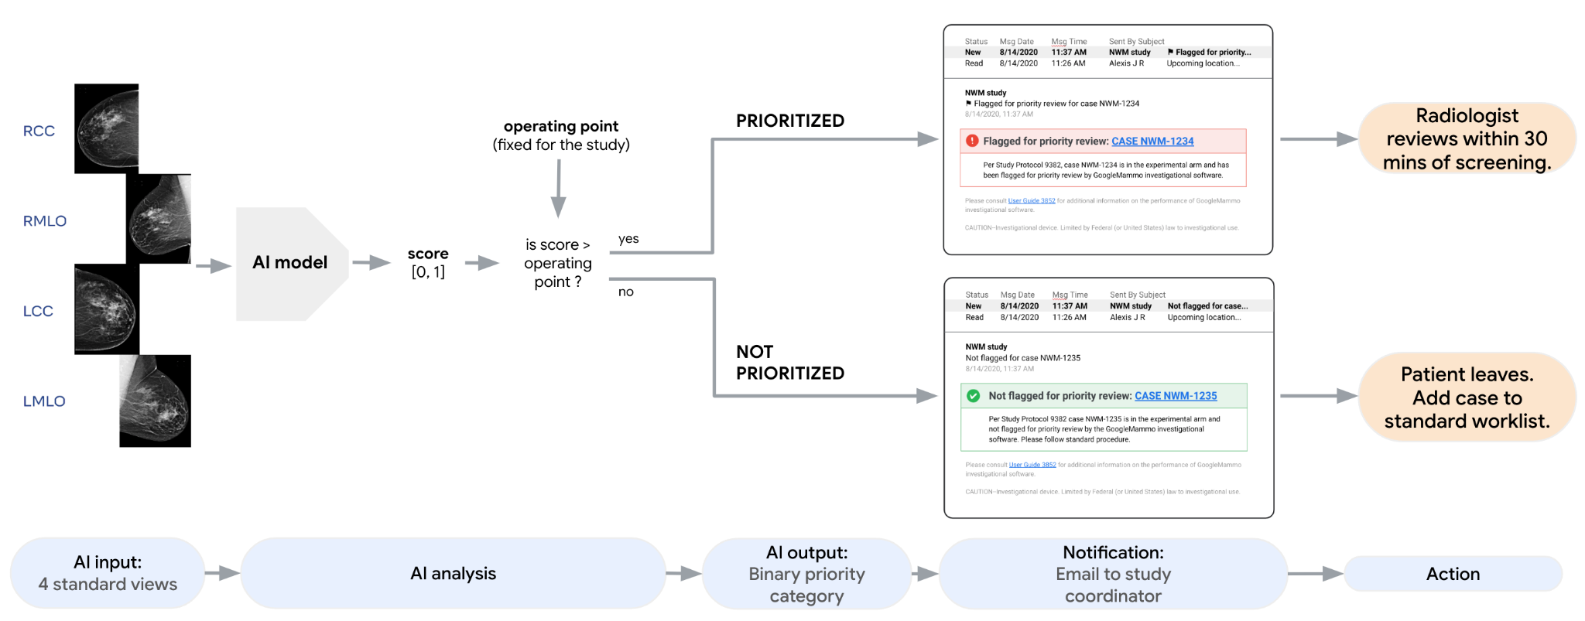
Supplementary Figure 1: Graphical representation of the AI prioritization flow, including the AI's input, algorithm, output and email notification format. All case IDs and date/times are fake. The 4 standard mammography views (right craniocaudal (RCC), right mediolateral oblique (RMLO), left craniocaudal (LCC), left mediolateral oblique (RMLO)) are used as input to the AI system. As described in Supplemental Methods, the AI model produces an uncalibrated score between 0 and 1, where higher scores correspond to an estimated higher probability of breast cancer. A fixed threshold (“operating point”) was selected and used to determine whether a case was prioritized or not. Although this operating point was selected and fixed for the duration of the study, in future implementations different operating points can be selected to adapt to various clinical settings. In the study, email notification was used to communicate prioritization status, using de-identified participant data to maintain confidentiality. More streamlined notification processes with fewer manual steps could be considered in future implementations. For prioritized participants, a radiologist reviewed their screening examinations within 30 minutes. In the event that a radiologist was not available within 30 minutes, the case was added to the standard review worklist, which includes all cases from the institution's screening program (not restricted to study participants). For non-prioritized participants, the case was added to the standard review worklist.

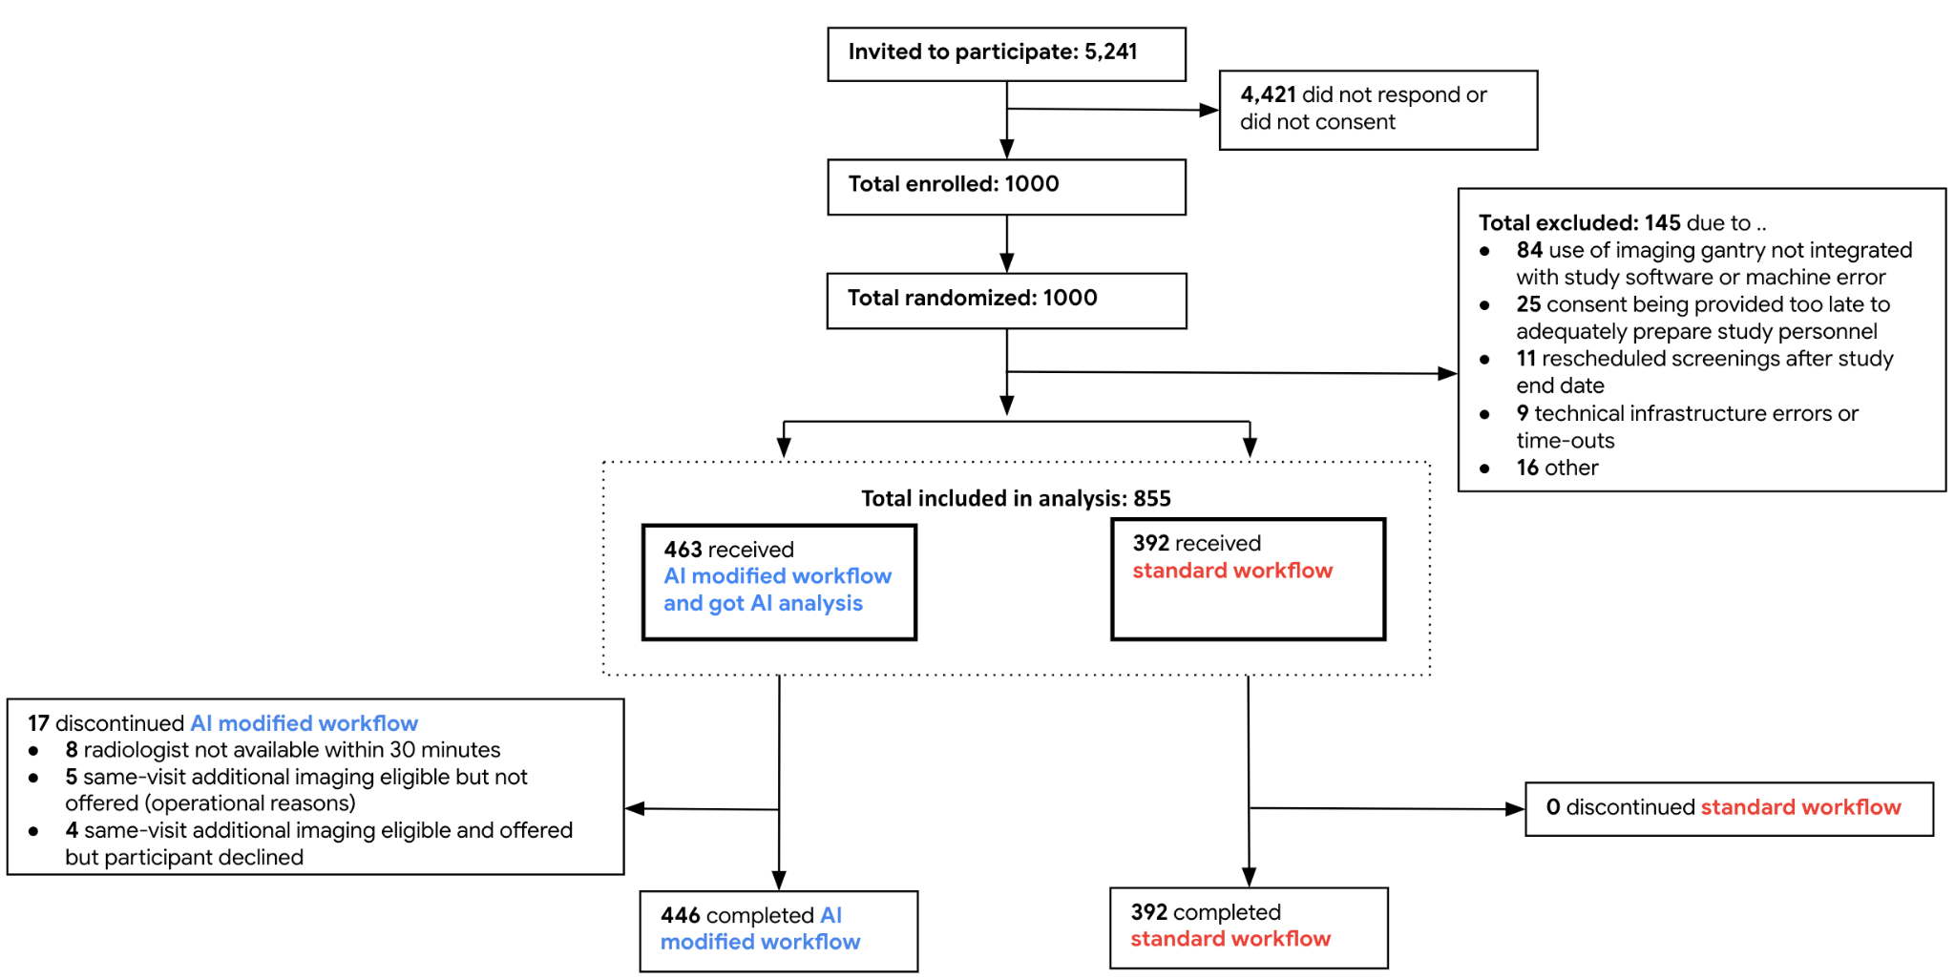
Supplementary Figure 2: CONSORT participant flow diagram. A total of 1000 participants were enrolled in the study. 145 participants were excluded; the most common reason for exclusion was use of imaging gantry that was not integrated with study software or machine error. After exclusions, the final study cohort used for analysis was 855 participants. Within this final cohort, 392 participants were randomized into the control group and followed the standard-of-care workflow, while 463 were randomized into the experimental group and followed the AI-modified workflow. 17 participants in the experimental group discontinued the AI-modified workflow due to: radiologist was not available to review the images within 30 mins (n=8 participants), same-visit additional imaging was not able to be offered due to operational limitations (n=5 participants), or patient declined same-visit additional imaging (n=4 participants).
As shown in the dashed box, a modified intent-to-treat (mITT) analysis was employed. In this approach, some exclusions that occurred after randomization were not included in the final analysis, because these exclusions precluded any AI analysis to be performed (during or after the study), affected both control and experimental groups similarly, and were not expected to bias results or interpretation. Our mITT approach did include in the analysis the participants who discontinued the AI modified workflow (e.g., if they declined same-visit workup, or if radiologists were not available for immediate review). There are fewer participants in the control compared to the experimental group because for the first 100 study participants, a higher proportion was allocated to the experimental group.

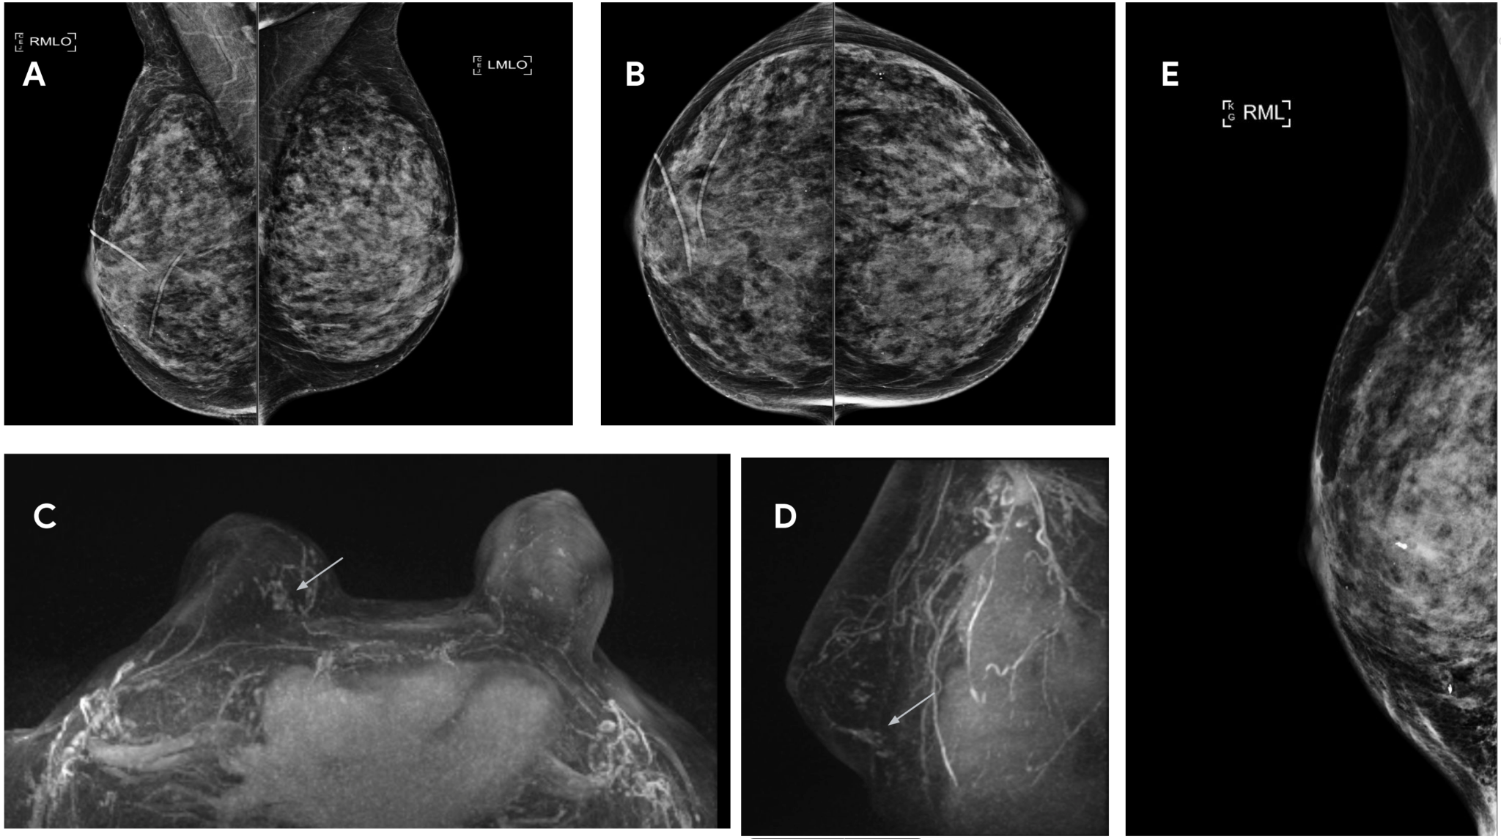
Supplementary Figure 3: Images in a 72-year-old woman with breast cancer, a participant in the control group whose cancer was detected on screening MRI performed due to breast density, but not on the screening mammogram. When analyzing control group cases, the AI prioritized this case due to suspicion of cancer. A. Negative screening mammogram, MLO views. B. Negative screening mammogram, CC views. C. Screening MRI maximum intensity projection (MIP) right breast non mass enhancement lower inner quadrant (arrow) axial view. D. Screening MRI maximum intensity projection (MIP) right breast non-mass enhancement (arrow) sagittal view. E. Post procedure mammogram after two MRI-guided biopsies and placement of clips. Final pathology after right breast needle localization lumpectomy: Ductal carcinoma in situ (DCIS), nuclear grade 2, cribriform and solid types, with focal necrosis and lobular extension. The authors affirm that human research participants provided informed consent for publication of the images in Figures 3a-e.

