Supplementary Data

Supplementary Table 1 Univariate Analysis
Characteristic | N | HR¹ | 95% CI² | p value
Type (n=199):  ADC  Chemo  Clinical Trial/Novel Combinations  Hormone Therapy  mAB  TKI-based therapy | 17  82  29  13  7  50 | —  0.72  0.62  0.36  0.30  0.42 | —  0.34, 1.51  0.29, 1.32  0.12, 1.06  0.09, 0.95  0.19, 0.92 | 0.022  0.4
Tx line total | 199 | 1.03 | 0.96, 1.09 | 0.4
T-DXd stop reason  POD  TOX | 162  37 | 0.35 | 0.21, 0.57 | <0.001
HR positive  No  Yes | 79  120 | 1.03 | 0.70, 1.51 | 0.9
Brain metastases before event  No  Yes | 99  100 | 1.16 | 0.81, 1.66 | 0.4
De novo MBC  No  Yes | 117  72 | 1.37 | 0.96, 1.97 | 0.086
¹HR = Hazard ratio, ²CI = Confidence interval

Supplementary Table 2 Chemotherapy Regimens Administered Post-T-DXd

Subtype derived | Tx line avg | Pts receiving | Median survival time (months) (95% CI)
Anthracycline | 8.62 | 8 | 2.7 (2.0, —)
Capecitabine | 9.00 | 1 | 2.5 (—, —)
Eribulin | 8.33 | 3 | 3.2 (—, —)
Etoposide | 16.00 | 1 | 1.4 (—, —)
Gemcitabine + Cisplatin | 6.00 | 1 | 11 (—, —)
Paclitaxel + Carboplatin | 7.00 | 1 | — (—, —)
Paclitaxel + Trastuzumab + Pertuzumab | 5.75 | 4 | 5.9 (5.3, —)
Trastuzumab + CMF | 10.33 | 3 | 3.3 (2.5, —)
Trastuzumab + Capecitabine | 7.80 | 5 | — (6.7, —)
Trastuzumab + Carboplatin | 5.00 | 2 | 6.0 (2.5, —)
Trastuzumab + Carboplatin + Bevacizumab | 10.00 | 1 | — (—, —)
Trastuzumab + Cyclophosphamide | 15.00 | 1 | 1.1 (—, —)
Trastuzumab + Doxorubicin | 9.00 | 3 | 2.8 (1.4, —)
Trastuzumab + Eribulin | 9.09 | 11 | 2.4 (1.4, —)
Trastuzumab + Eribulin + Pertuzumab | 4.00 | 1 | 9.4 (—, —)
Trastuzumab + Gemcitabine | 8.60 | 15 | 4.1 (3.0, —)
Trastuzumab + Irinotecan | 8.67 | 3 | 2.9 (2.8, —)
Trastuzumab + Ixabepilone | 10.00 | 1 | 4.0 (—, —)
Trastuzumab + Paclitaxel | 8.00 | 4 | 3.8 (1.3, —)
Trastuzumab + Taxol | 5.00 | 1 | 1.4 (—, —)
Trastuzumab + Vinorelbine | 7.55 | 11 | 4.6 (3.0, —)
Trastuzumab + Vinorelbine + Pertuzumab | 7.00 | 1 | 3.4 (—, —)
Vinorelbine | 11.00 | 1 | 3.0 (—, —)

Supplementary Table 3 Survival medians
Characteristic | 50% Percentile (months) (95% CI)
Overall survival per patient | 19 (15, 28)
Progression-free survival per patient | 6.5 (5.1, 9.1)
Progression-free survival per treatment | 3.7 (3.2, 4.2)
Progression-free survival per treatment by type  ADC  Chemo  Clinical trial/novel combinations  Hormone therapy  mAB  TKI-based therapy | 2.4 (1.3, –)  3.4 (2.8, 4.2)  4.2 (3.2, 7.6)  9.1 (2.0, –)  14 (3.2, –)  3.9 (3.3, 12)

Supplementary Table 4 HER2 IHC 2+ vs 3+
HER2 IHC | Pts | Post T-DXd Tx lines | Median survival time (months) (95% CI)
2+ | 27 | 2.33 | 6.3 (5.5, 10)
3+ | 54 | 2.52 | 6.5 (4.7, 11)

Supplementary Table 5: Post-treatment HER2 status
Characteristic | 50% percentile PFS (months) (95% CI) | p value¹
Post-T-DXd HER2 Negative  No  Yes | 9.1 (4.5, –)  4.4 (3.5, –) | 0.1
¹Log-rank test

Supplementary Table 6 Univariate Analysis for de novo MBC
Characteristic | N | HR¹ | 95% CI² | p value
Type:  ADC  Chemo  Clinical Trial/Novel Combinations  Hormone Therapy  mAB  TKI-based Therapy | 4  33  12  6  3  14 | —  1.64  1.63  1.47  0.46  1.13 | —  0.40, 6.78  0.40, 6.72  0.27, 8.11  0.09, 2.42  0.23, 5.49 | 0.7
Tx Line Total | 72 | 1.04 | 0.94, 1.15 | 0.5
T-DXd Stop Reason  POD  TOX | 62  10 | 0.42 | 0.27, 0.63 | <0.001
HR Positive  No  Yes | 22  50 | 1.21 | 0.74, 1.98 | 0.5
Brain Metastases Before Event  No  Yes | No  Yes | 1.05 | 0.62, 1.79 | 0.9
¹HR = Hazard Ratio, ²CI = Confidence Interval

Supplementary Table 7 Hormone Therapy Regimens Administered Post-T-DXd
Subtype | Number of Patients Receiving (n=13)
AI + CDK 4/6 inhibitor | 2
Fulvestrant + CDK 4/6 inhibitor | 1
AI alone | 1
AI + Trastuzumab | 3
Fulvestrant + Trastuzumab | 2
Fulvestrant + CDK4/6 inhibitor + Trastuzumab | 2
Tamoxifen + Trastuzumab + Pertuzumab | 1
AI + Capecitabine + Trastuzumab | 1

Supplementary Figure 1: PFS on Post-T-DXd Therapies Stratified by HR status and De Novo MBC Status
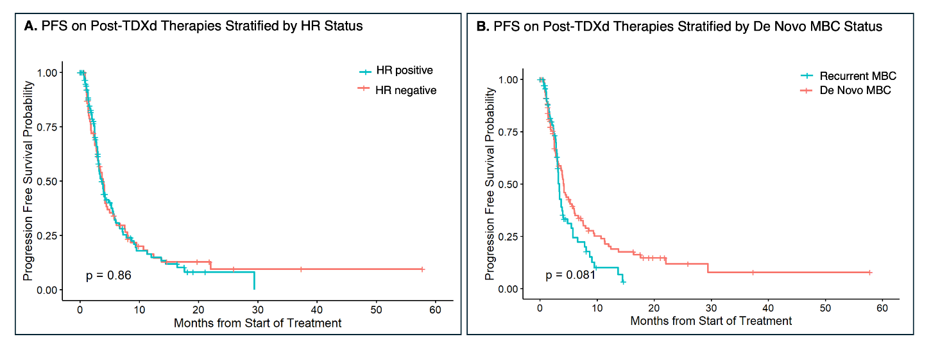
Supplementary Figure 1 Legend: A) Kaplan–Meier analysis of progression-free survival on post-T-DXd therapies stratified by hormone receptor status, B) Kaplan–Meier analysis of PFS stratified by de novo versus recurrent metastatic breast cancer

