Supplementary figures and tables
[Supplementary Table 1. Univariate hazard ratios. MD = mammographic density]
 |  | HR
CBI | Yes | 0.61 (0.36 – 1.02), p=0.061
CBI | No | REF
Age group | <50 | 1.17 (0.46 – 3.00), p=0.743
Age group | 50-69 | REF
Age group | 70+ | 0.99 (0.58 – 1.71), p=0.981
period | 2014-2018 | REF
period | 2019-2022 | 0.91 (0.54 – 1.51), p=0.704
MD_gp | A/B | REF
MD_gp | C/D | 1.67 (0.99 – 2.81), p=0.053
Stage | 0 | REF
Stage | 1/2a | 0.43 (0.25 – 0.76), p=0.003
Stage | 2b/3 | 0.38 (0.15 – 0.96), p=0.039
Phenotype group | ER/PR+ HER2+/- | REF
Phenotype group | ER/PR-HER2+/- | 2.11 (1.05 – 4.21), p=0.035

[Supplementary Table 2. Time from index diagnosis and detection characteristics of locoregional events]
 | CBI group (n = 24) | Non-CBI group (n = 36)
Median time from index diagnosis (months) | 33 | 24.5
Contrast-directed | 13 | 11

[Supplementary Table 3. Radiotherapy use by index surgery type and morphology. BCS = breast conserving surgery]
Group | BCS (N = 903) | Mastectomy (N = 201)
Invasive | 590/746 | 63/171
DCIS | 78/157 | 0/30

[Supplementary Figure 1. Observed locoregional event-free survival for each factor of interest in the adjusted hazards models. MD = mammographic density]
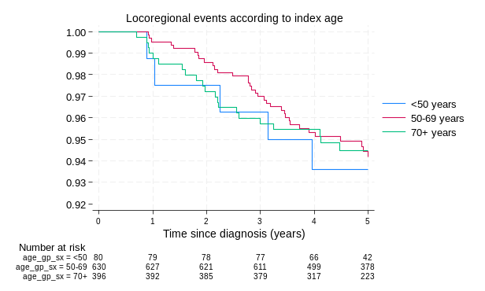 | 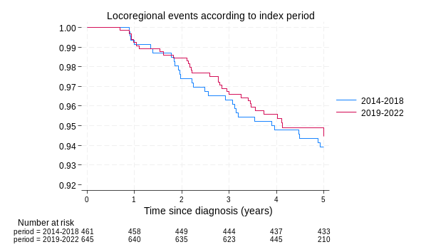
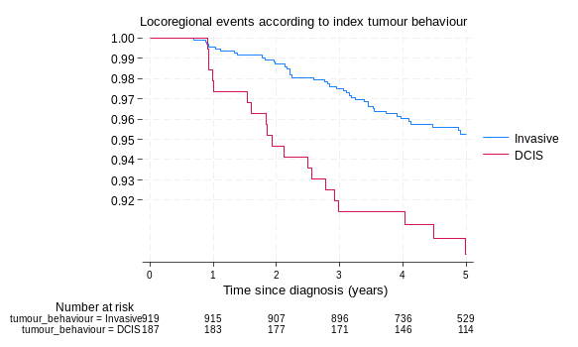 | 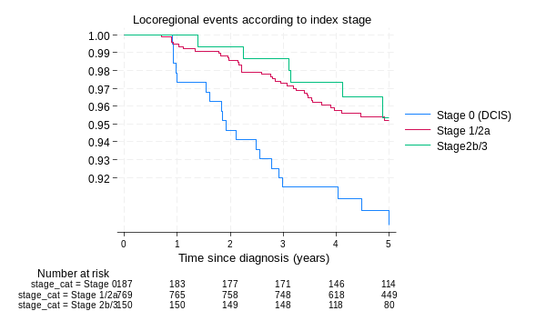
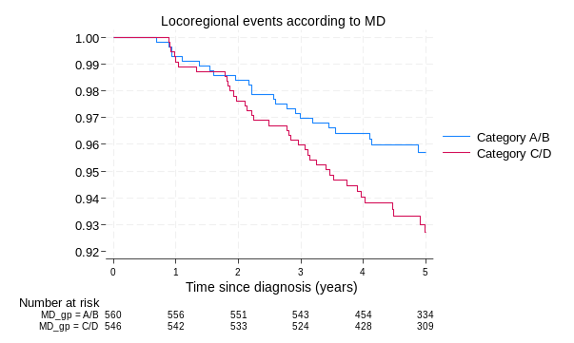 | 