Supplement to:

A retrospective, observational cohort study of treatment patterns and outcomes among patients with hormone receptor-positive/human epidermal growth factor receptor 2-negative metastatic breast cancer in the United States following endocrine therapy

Joyce O’Shaughnessy, MK Rehnquist, Natalia Sadetsky, Wendy Verret, Pelin Cinar, Nikoleta Sjekloca, Linda Nguyen, Rita Nanda, Priyanka Sharma

Table of Contents
Supplement Fig. 1 Study design 2
Supplement Table 1 Demographic and clinical characteristics by race/ethnicity 3

Supplement Fig. 1 Study design
1L, first-line; dx, diagnosis; ET, endocrine therapy; mBC, metastatic breast cancer.

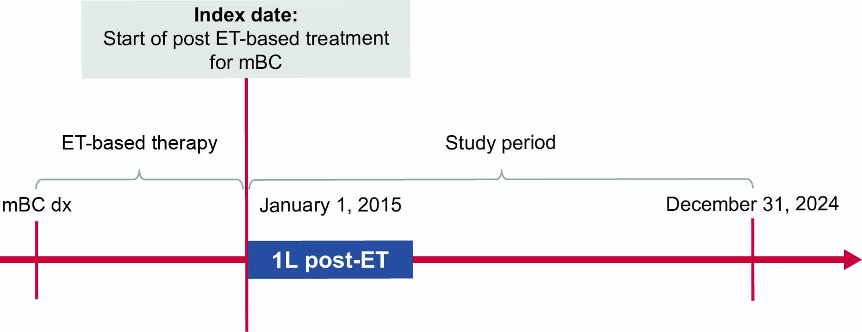

Supplement Table 1 Demographic and clinical characteristics by race/ethnicity
Variables | Non-Hispanic White (n = 3150) | Non-Hispanic Black (n = 519) | Non-Hispanic Asian (n = 88) | Hispanic/Latino (n = 370)
Median (IQR) age at mBC diagnosis, years | 64 (55–71) | 59 (49–66) | 59 (48–66) | 59 (50–66)
Median (IQR) BMI, kg/m² | 27 (23–31) | 29 (24–33) | 24 (21–27) | 26 (23–32)
Provider, n (%)
Academic | 390 (12) | 76 (15) | 8 (9) | 44 (12)
Community | 2534 (80) | 421 (81) | 77 (88) | 303 (82)
Academic and community | 226 (7) | 22 (4) | <5 | 23 (6)
Socioeconomic status, n (%)ª
1 – Lowest | 363 (12) | 169 (33) | 6 (7) | 108 (29)
2 | 512 (16) | 92 (18) | 12 (14) | 70 (19)
3 | 604 (19) | 95 (18) | 16 (18) | 54 (15)
4 | 735 (23) | 71 (14) | 16 (18) | 50 (14)
5 – Highest | 658 (21) | 37 (7) | 24 (27) | 44 (12)
Median (IQR) follow-up, months | 13 (5–22) | 10 (5–18) | 11 (6–21) | 13 (6–25)
Recurrent mBC, n (%) | 2161 (69) | 357 69) | 51 (58) | 241 (65)
De novo mBC, n (%) | 989 (31) | 162 (31) | 37 (42) | 129 (35)
Median (IQR) time from mBC diagnosis to initiating 1L post-ET, months | 20 (8–35) | 16 (6–30) | 17 (6–35) | 19 (7–37)
ECOG PS, n (%)^{b}
0 | 749 (24) | 116 (22) | 21 (24) | 102 (28)
1 | 1111 (35) | 176 (34) | 31 (35) | 121 (33)
2+ | 502 (16) | 102 (20) | 18 (21) | 45 (12)
Metastatic sites, n (%)^{c}
1 | 776 (25) | 104 (20) | 22 (25) | 100 (27)
2 | 1077 (34) | 168 (32) | 29 (33) | 123 (33)
3+ | 1244 (40) | 236 (46) | 34 (39) | 135 (37)
Bone metastasis, n (%) | 2675 (85) | 424 (82) | 71 (81) | 310 (84)
Brain metastasis, n (%) | 266 (8) | 48 (9) | 7 (8) | 38 (10)
Liver metastasis, n (%) | 1679 (53) | 283 (55) | 44 (50) | 177 (48)
Lung, n (%) | 999 (32) | 216 (42) | 35 (40) | 120 (32)
HER2 expression, n (%)^{d}
HER2 IHC0 | 869 (28) | 129 (25) | 19 (22) | 100 (27)
HER2 Low^{e} | 977 (31) | 194 (37) | 32 (36) | 100 (27)
BRCA 1/2 mutation, n (%)^{f} | 164 (9) | 29 (9) | <5 | 22 (10)
ªUnknown (n = 278, 55, 14, 44).
^{b}Unknown (n = 788, 125, 18, 102).
^{c}Unknown (n = 53, 11, 3, 12).
^{d}Unknown/not calculated (n = 1304, 196, 37, 170).
^{e}HER2 low = IHC 1+ or 2+/ISH‒.
^{f}Mutations could be germline or somatic.
1L, first-line; BMI, body mass index; BRCA 1/2, breast cancer gene 1 or 2; CPS, combined positive score; ECOG PS, Eastern Cooperative Oncology Group performance status; HER2, human epidermal growth factor receptor 2; IHC, immunohistochemistry; ISH, in situ hybridization; IQR, interquartile range; mBC, metastatic breast cancer.

