SUPPLEMENTAL TABLES AND FIGURES
Supplemental Table 1. Distribution of Women Aged ≥18 Years by Race/Ethnicity and TNBC Trial Availability
Counties by TNBC Trials Available | Total Counties | Overall | Asian & Pacific Islander | AIAN | Black | Hispanic | NHPI | Non-Hispanic White | Two or More Races | Other
1-3 Trials | 265 | 16,485,094 (12%) | 652,703 (7%) | 107,541 (10%) | 1,767,715 (11%) | 2,343,801 (10%) | 21,491 (9%) | 11,102,959 (14%) | 1,607,422 (11%) | 774,674 (9%)
4 or More Trials | 483 | 86,786,319 (65%) | 7,540,631 (86%) | 614,793 (54%) | 11,743,286 (71%) | 17,159,042 (76%) | 180,400 (76%) | 46,879,140 (59%) | 10,332,067 (72%) | 6,716,346 (79%)
No Trials | 2,396 | 29,957,106 (22%) | 572,979 (6%) | 415,583 (36%) | 2,955,602 (18%) | 3,040,641 (14%) | 35,347 (15%) | 21,997,962 (28%) | 2,344,331 (16%) | 971,617 (12%)
Data Source: U.S. Census Bureau²¹ and ClinicalTrials.gov²⁰

Supplemental Figure 1.
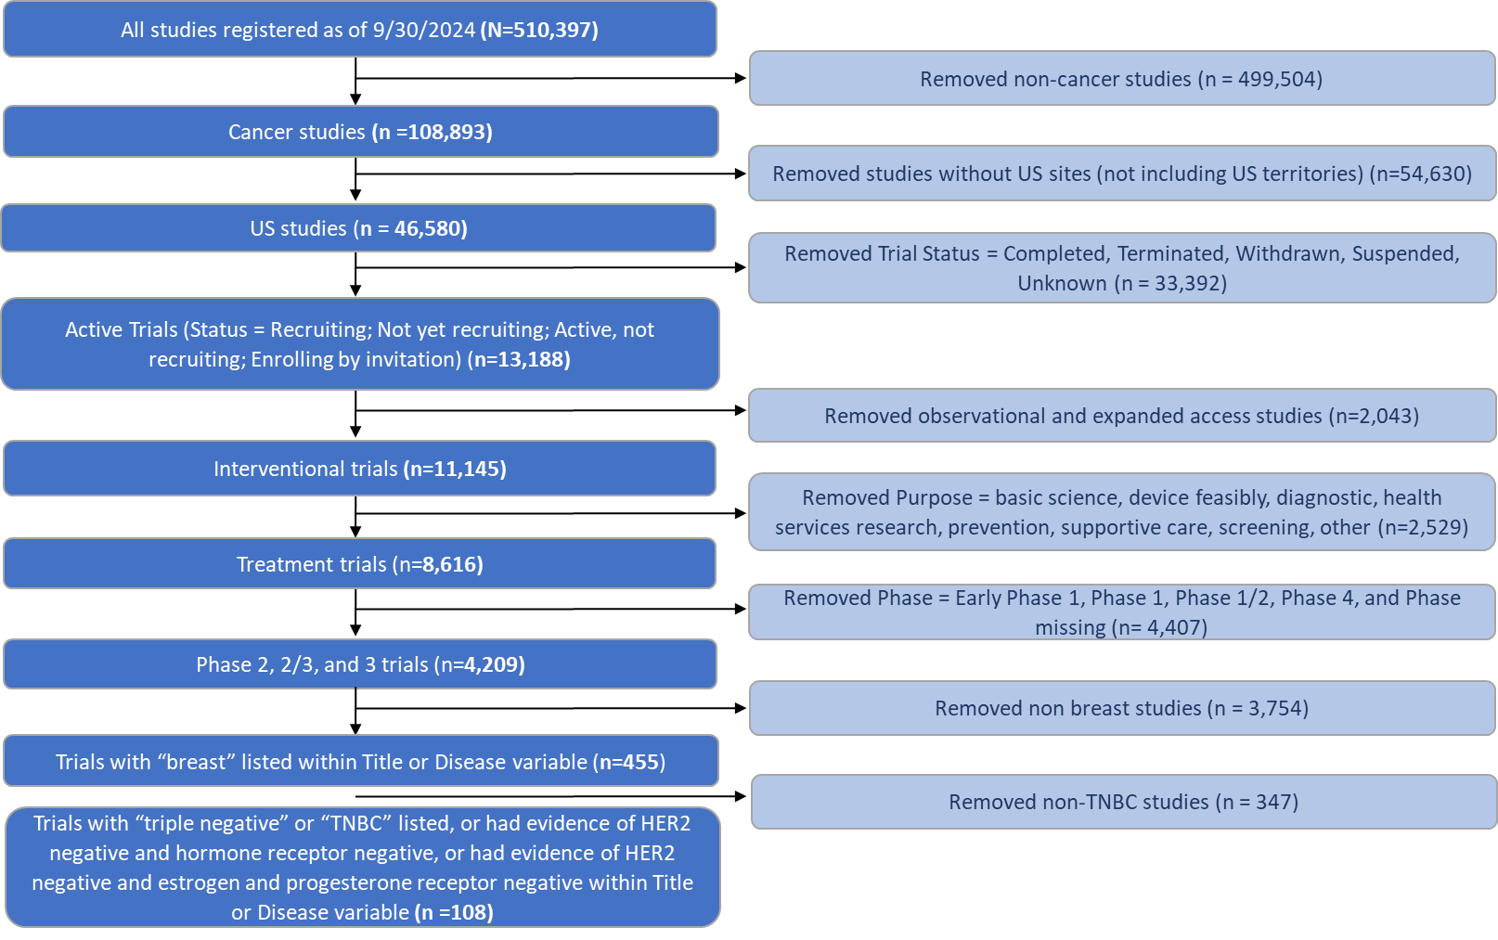
Process for identifying active TNBC clinical trials. ClinicalTrials.gov was searched using key words and exclusions as shown until 108 active triple negative breast cancer phase 2, 2/3, and 3 treatment trials in the United States were ultimately identified. Data source: ClinicalTrials.gov²⁰.

