ONLINE APPENDIX C
Robustness checks

Study 1

Figure C1: Polynomial regression (H1), Study 1

Study 2

Figure C2: Polynomial regression (H2), Study 2

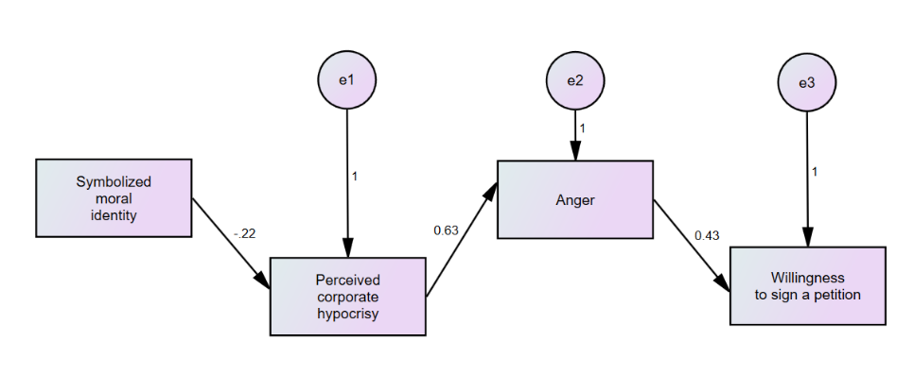
Figure C3: Path analysis (H2), Study 2

Study 3

Figure C4: Interaction effect with a moral identity dummy (H3), Study 3

Figure C5: Three-way interaction (CSR information, moral identity dummy, extraversion) predicting perceived corporate hypocrisy (H5a), Study 3

Figure C6: Three-way interaction (CSR information, moral identity dummy, neuroticism) predicting perceived corporate hypocrisy (H5b), Study 3

Figure C7: Path analysis with symbolized moral identity, Study 3, version 1
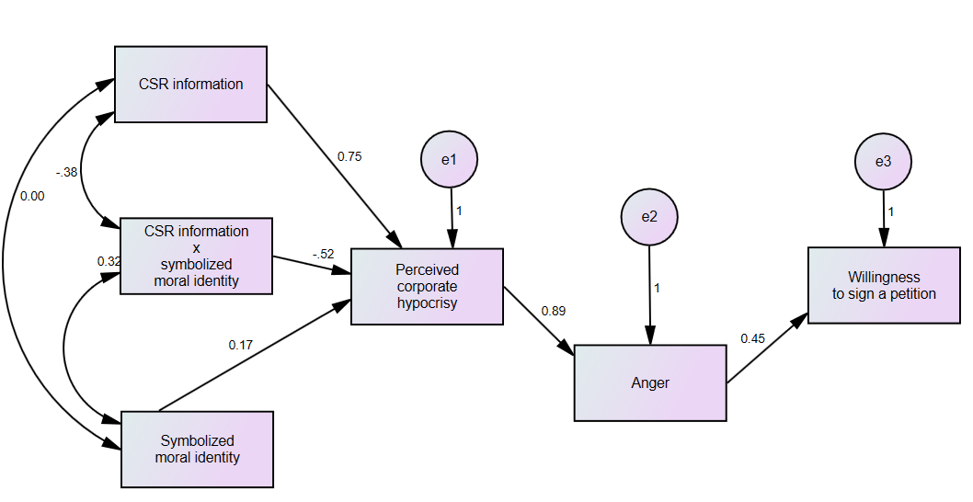

Figure C8: Path analysis with symbolized moral identity, Study 3, version 2
