Online Appendix (Proposed)
Study 2. Table 1A: Dictionary of Agentic and Communal Entrepreneurial Words
Agentic |  |  |  |  | Communal
ability | Convince* |  |  |  | anyone | group*
abl* | corporat* |  |  |  | access* | heard
aggressive | deal* |  |  |  | artisan* | household*
ahead | decide* |  |  |  | ask* | human*
arrogan* | discipline* |  |  |  | assembl* | humble*
attitude | driv* |  |  |  | assistan* | humility*
battle* | entrepreneur* |  |  |  | balance* | inner
became | empower* |  |  |  | begin* | join*
becom* | finish* |  |  |  | benefit* | local*
best | first |  |  |  | bring* | love*
better | force* |  |  |  | care* | meet*
big* | great |  |  |  | carry | member*
bring* | investor* |  |  |  | carrie* | need*
build* | lead* |  |  |  | child* | neighbor*
built | masculine |  |  |  | communicate* | network*
business* | own* |  |  |  | communit* | parent*
buy* | power/ful |  |  |  | couple* | passion*
capital | proficient |  |  |  | depend* | relationship*
ceo* | proud |  |  |  | external* | respond*
cfo* | report* |  |  |  | famil* | share*
challenge* | rule* |  |  |  | feel* | social*
choice* | succeed* |  |  |  | femini* | stories
confidence | success* |  |  |  | friend* | story
control* | told |  |  |  | give* | support*
want* | worth |  |  |  | together | team*

Table 2A. Summary of Entrepreneurship Corpuses Evaluated

Title | Word Count | Gender | Race | Verbal/ Written | Agentic | Communal | Percent | Year | Source
Black Women Entrepreneurs | About Her Business: Part 1 | 3448 | F | URM | V | 55.8 | 44.2 | 3.48 | 2019 | YouTube
Four Successful Entrepreneurs Share Their Best Tips | Women of Impact | 10519 | F | Maj | V | 60.0 | 40.0 | 3.40 | 2019 | YouTube
How I Turned My Hobby Into A Career”, With Tre’elle Tolbert of Tag It Brand It, LLC - an interview with Yitzi Weiner | 3120 | F | URM | W | 46.2 | 53.7 | 5.20 | 2019 | Medium Blog
From Avocation to VocationL How I Turned My Hobby Into A Career” With Dr. Glen Miller of Vera Roasting Company - An interview with Phil LaDuke | 3087 | M | URM | W | 58,0 | 42.0 | 3.10 | 2019 | Medium Blog
Private Talk For Entrepreneur Men - What We Talk About When No Women Are Around – R. D. Moran | 9411 | M | Maj | V | 60.0 | 40.0 | 3.75 | 2019 | YouTube
When Quitting your Startup is Sometimes the Best Option, Ray Newal | 1173 | M | Maj | W | 73.0 | 27.0 | 4.40 | 2018 | Medium Blog
So You Want To Be An Entrepreneur, Jenny Lawson, COO at Techstars | 852 | F | URM | W | 62.2 | 37.8 | 5.30 | 2018 | Medium Blog
The Year of the Male Entrepreneur with Purdeep Sangha | 3450 | M | URM | V | 70.6 | 39.4 | 3.85 | 2018 | Podcast
Reflection 2016 Male 1 (unpublished) | 1695 | M | Maj | W | 68.0 | 32.0 | 3.65 | 2016 | University Accelerator
Reflection 2016 Woman 1 (unpublished) | 1595 | F | Maj | W | 56.66 | 43.34 | 3.76 | 2016 | University Accelerator
Reflection 2016 Man 2 (unpublished) | 1922 | M | Maj | W | 63.8 | 36.2 | 4.26 | 2016 | University Accelerator
Reflection 1 2016 Woman 2 (unpublished) | 3491 | F | URM | W | 41.7 | 58.3 | 4.37 | 2016 | University Accelerator

Table 3A. Summary of University Websites

LIWC Descriptive Statistics
 | N | Minimum | Maximum | Mean | Std. Deviation
Word Count | 212 | 1.00 | 1532.00 | 393.15 | 250.02
Words/Sentence | 212 | 1.00 | 88.00 | 24.76 | 11.16
Six letter words | 212 | 0.00 | 53.85 | 36.29 | 6.05
Dictionary Words Used | 212 | 0.00 | 21.36 | 9.60 | 2.77
Agency Words Used | 212 | 0.00 | 15.87 | 5.27 | 2.10
Communal Words Used | 212 | 0.00 | 12.17 | 4.00 | 2.10
All Punctuations Used | 212 | 0.00 | 37.41 | 15.91 | 5.03
Period | 212 | 0.00 | 9.79 | 4.55 | 1.65
Comma | 212 | 0.00 | 12.80 | 4.76 | 2.25
Colon | 212 | 0.00 | 11.76 | .85 | 1.37
SemiColon | 212 | 0.00 | 2.99 | .09 | .31
Question Mark | 212 | 0.00 | 1.93 | .16 | .31
Exclamation | 212 | 0.00 | 2.70 | .21 | .43
Dash | 212 | 0.00 | 9.01 | 1.56 | 1.20
Quote | 212 | 0.00 | 4.50 | .32 | .63
Apostrophe | 212 | 0.00 | 5.08 | .95 | .88
Parentheses | 212 | 0.00 | 11.56 | .82 | 1.43
Location |  | % of sample
Midwestern Universities | 50 | 23.9
Northeastern Universities | 59 | 27.7
Southeast Universities | 54 | 25.4
Southwest Universities | 20 | 9.4
Western Universities | 29 | 13.6
Valid N (listwise) | 212

Study 2. Website Image Analysis

This analysis leans into the work of van Leeuwen (2008). His writings focus on different strategies used in the visual representation of social actors in images. Images, unlike words, “provide interpretations, ideologically colored angles, and they do not explicitly, but by suggestion, by connation, by appealing to the barely conscious, half-forgotten knowledge” (van Leeuwen, 2008, pp. 136).

Our analysis focused on the following strategies:
- Strategy of Distance. We maintain distance from the other and work closely with those we care about. This is reflected visually through a long shot for those that are not part of our in-group and a close up for those that matter.
- Strategy of Social Relation. The angle from which images are viewed reflects the relationship between the viewer and the object being viewed, specifically power and involvement. An image may show the person in it from above, at eye level, or from below, reflecting the vertical angle. It can also be frontal or from some degree of a side, reflecting the horizontal angel. Looking down on someone reflects higher power, while being below reflects less power. A direct, frontal angle connotes some equality and being face-to-face while a side angle connotes more of a sideline position.
- Strategy of Exclusion. In many cases, a lack of any racialized minorities in the image is a key approach. In some cases, technology can be used to remove actors from images. In other cases, this strategy involves marking racialized minorities as other by putting them into a different group completely, such as a toy company having an “ethnic” toy line, or factory workers being of all one race, while managers are majoritarian.
- Strategy of Roles. In any image, various roles are represented. A key distinction is between the agents, who are doing the action, and the patients, the person upon whom the action is done. Often, racialized minorities are in the role of the patient, not the agent. Even when in the role of an agent, for racialized minorities, these roles are often subservient or negative.
- Strategy of Individuals vs. Groups. Power can be reflected by the context of the actors within images. Often, racialized minorities are show in homogenized groups emphasizing that the members of the group are all the same and cannot be told apart. At the extreme, the group is made up of repeat images of identical actors.
- Strategy of Categorization. Some images clearly identify category based on standard attributes such as dress, hair, etc. This is cultural categorization. This does not need to be exaggerated to still help to mark outgroup versus ingroup but being exaggerated is possible. Biological categorization is another approach. This involves exaggerations of physical features to emphasis membership in a specific group. Often, these physical features have symbolic value.
These strategies are laid out in Figure 1A below.

Figure 1A: Visual Social Actor Network (van Leeuwen, 2008)
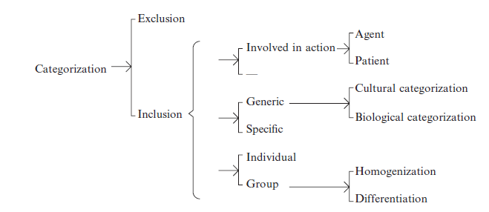

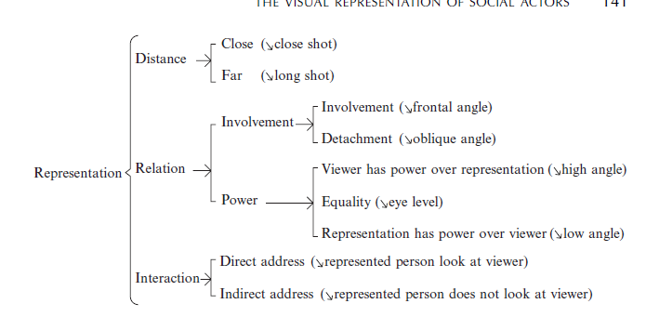

Study 3. Experimental Design

Manipulation Check Race and Gender Images and Video
Table 4A(a) Race Manipulation Check Images
Images / Responses | Racially Minoritized | Racial Majoritarian
URM Men Spokespersons | 69.2% | 30.8%
URM Women Spokespersons | 61.9% | 38.1%
White Men Spokespersons | 92.1% | 7.9%
White Women Spokespersons | 93.9% | 6.1%

Table 4A(b) Gender Manipulation Check Images
Images / Response | Men | Women
URM Men Spokespersons | 92.1% | 7.9%
URM Women Spokespersons | 6.0% | 94.0%
White Men Spokespersons | 98.6% | 1.4%
White Women Spokespersons | 4.0% | 96.0%

Table 4(c) Race Manipulation Check Videos
Videos / Response | Racially minoritized | Racial majoritarian
URM Men Spokespersons | 67.1% | 32.9%
URM Women Spokespersons | 76.8% | 23.2%
White Men Spokespersons | 6.1% | 93.9%
White Women Spokespersons | 9.2% | 90.8%

Table 4A(d) Gender Manipulation Check Videos
Images / Response | Men | Women
URM Men Spokespersons | 94.9% | 5.1%
URM Women Spokespersons | 6.5% | 93.5%
White Men Spokespersons | 96.5% | 3.5%
White Women Spokespersons | 14.6% | 85.4%

Table 5A: Website Manipulation Results
Website Spokesperson/Images | URM Men | White Men | URM Women | White Women
Correctly Identify Race | 96% | 80% | 94% | 90%
Correctly Identify Gender | 100% | 92% | 100% | 100%

https://www.youtube.com/watch?v=92EXnvLKmek (last viewed August 25, 2022)
https://www.youtube.com/watch?v=6yi20I-AcUg (last viewed August 25, 2022
https://medium.com/authority-magazine/from-avocation-to-vocation-how-i-turned-my-hobby-into-a-career-with-treelle-tolbert-of-tag-it-a3597daf602 (last viewed August 25, 2022)
https://medium.com/authority-magazine/from-avocation-to-vocation-how-i-turned-my-hobby-into-a-career-with-dr-f125e6e787cf (last viewed August 25, 2022)
https://www.youtube.com/watch?v=0ehKf2O0ysQ (last viewed August 25, 2022)
https://medium.com/techstars/getting-off-the-train-to-nowhere-610db87f165 (last viewed August 25, 2022)
https://medium.com/techstars/so-you-want-to-be-an-entrepreneur-e53cacb2f2c9 (last viewed August 25, 2022)
https://purdeepsangha.com/podcast/episode-43-the-year-of-the-male-entrepreneur/ (last viewed August 25, 2022)

