Supporting Online Materials

Figure A.1: Example decision screen for treatment UNICEF 50%
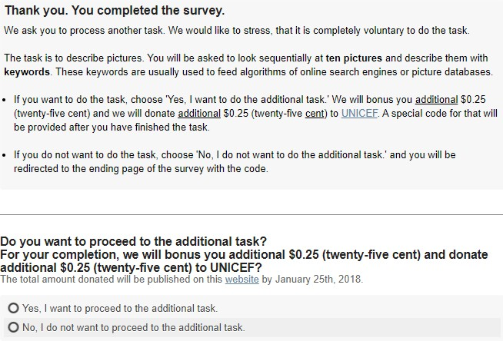

Figure A.2: Screenshot of task description for picture "Italia und Germania" (1828) by F. Overbeck
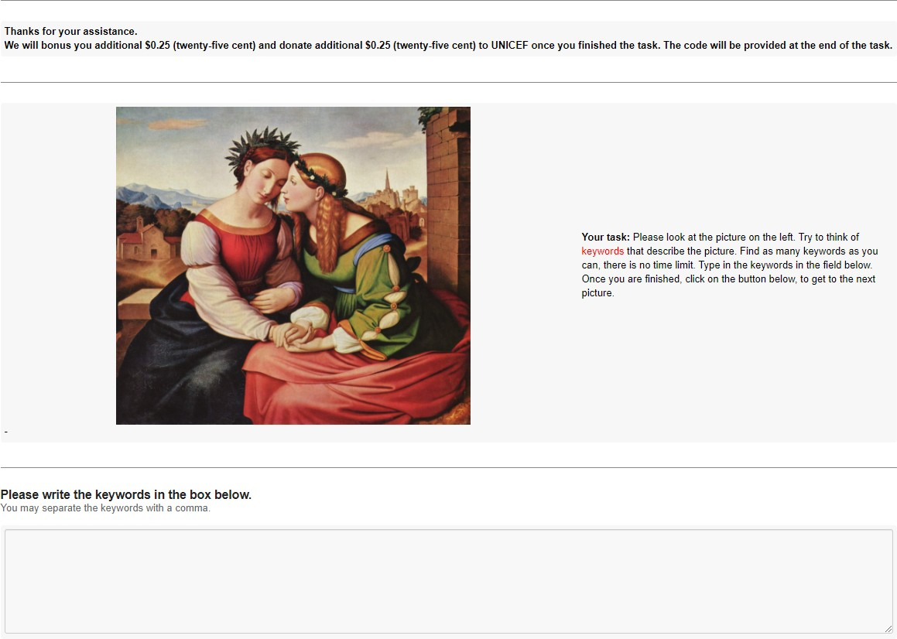

Notes: This is one example picture that we used for the additional job. In total gig-workers had to work on ten comparable pictures that were presented in a randomized order.

37

Table A.1: Balance table and randomization checks

Treatment | N | Age | Female |  | Risk: | ethical | Risk: financial |  | Machiavellianism |  | Altruism
 |  | Avg. SD | Avg. SD |  | Avg. | SD | Avg. SD |  | Avg. SD |  | Avg. SD
10%  UNICEF | 101 | 35.604 (11.264) | 0.505 | (0.502) | 2.573 | (1.171) | 2.756 | (1.282) | 55.663 | (8.581) | 56.168 | (12.563)
NRA | 107 | 37.916 (11.460) | 0.551 | (0.500) | 2.478 | (1.327) | 2.783 | (1.261) | 54.308 | (8.411) | 57.514 | (12.980)
50%  UNICEF | 103 | 38.000 (12.974) | 0.709 | (0.457) | 2.343 | (1.203) | 2.531 | (1.379) | 53.650 | (8.471) | 57.243 | (12.070)
NRA | 100 | 38.540 (12.463) | 0.580 | (0.496) | 2.638 | (1.353) | 2.878 | (1.406) | 54.440 | (8.118) | 58.740 | (14.889)
90%  UNICEF | 113 | 38.575 (12.793) | 0.549 | (0.500) | 2.479 | (1.239) | 2.794 | (1.259) | 54.133 | (7.224) | 57.301 | (13.365)
NRA | 103 | 41.903 (13.227) | 0.573 | (0.497) | 2.440 | (1.296) | 2.689 | (1.325) | 53.573 | (7.783) | 58.184 | (14.186)
100%  UNICEF | 108 | 36.741 (11.229) | 0.676 | (0.470) | 2.352 | (1.059) | 2.505 | (1.112) | 54.556 | (7.846) | 55.528 | (11.498)
NRA | 98 | 38.459 (12.985) | 0.633 | (0.485) | 2.645 | (1.362) | 2.842 | (1.478) | 53.092 | (8.946) | 58.857 | (13.571)
No Donation | 111 | 37.234 (12.295) | 0.613 | (0.489) | 2.302 | (1.223) | 2.592 | (1.267) | 54.180 | (9.300) | 56.541 | (13.728)
p-Value |  | .0560 | .065 |  | .3916 |  | .3862 |  | .6702 |  | .7469
Notes: p-Values are from a Kruskal-Wallis testing the null hypothesis that there is no difference between the treatments. p-Value for Female is the result of a
χ²-test.

Table A.2: Labor supply and comparison to baseline

Dependent variable:
 | Labor supply | Quantity | Accuracy | Time | Work efficiency
Ind. variables | (1) | (2) | (3) | (4) | (5)
Constant (Baseline) | 1.183*** | 45.490*** | 2.583*** | 329.176*** | -0.374**
 | (0.345) | (5.540) | (0.079) | (60.090) | (0.155)
UNICEF 100 % | -2.075*** | 1.863 | -0.068 | 29.297 | -0.023
 | (0.316) | (6.505) | (0.094) | (71.129) | (0.055)
NRA 100% | -3.221*** | -12.480** | -0.051 | -112.475** | -0.115
 | (0.381) | (6.163) | (0.097) | (44.438) | (0.076)
UNICEF 90% | -1.640*** | -0.946 | -0.028 | -223.419*** | 0.686***
 | (0.308) | (6.770) | (0.058) | (44.912) | (0.158)
NRA 90% | -1.947*** | -9.486 | -0.118 | -68.821 | -0.060
 | (0.321) | (5.872) | (0.087) | (46.378) | (0.064)
UNICEF 50% | -0.252 | -1.554 | -0.011 | -197.432*** | 0.873***
 | (0.340) | (4.540) | (0.057) | (41.132) | (0.187)
NRA 50% | -1.546*** | -3.075 | -0.119* | 12.621 | -0.057
 | (0.317) | (4.654) | (0.069) | (44.457) | (0.058)
UNICEF 10% | -0.175 | 2.613 | -0.016 | -219.016*** | 0.852***
 | (0.340) | (4.579) | (0.055) | (40.201) | (0.139)
NRA 10% | -1.028*** | -2.070 | -0.087 | -27.578 | -0.007
 | (0.325) | (4.491) | (0.058) | (45.411) | (0.046)
Female | 0.709*** | 8.930*** | 0.010 | -22.642 | 0.299***
 | (0.160) | (2.986) | (0.037) | (28.853) | (0.082)
Age | -0.005 | 0.108 | -0.002 | 4.218*** | -0.004
 | (0.006) | (0.106) | (0.002) | (1.253) | (0.004)
Altruism | 0.368*** | 3.111* | -0.033* | -28.469** | -0.041
 | (0.083) | (1.632) | (0.018) | (12.949) | (0.039)
Risk financial | 0.075 | -1.597 | -0.060*** | 23.745 | 0.053
 | (0.098) | (1.678) | (0.020) | (16.534) | (0.049)
Risk ethical | -0.041 | 1.094 | -0.101*** | -17.343 | 0.036
 | (0.108) | (1.876) | (0.022) | (15.226) | (0.044)
Machiavelianism | -0.003 | 1.257 | -0.005 | -5.270 | -0.010
 | (0.085) | (1.491) | (0.016) | (14.141) | (0.040)
N | 944 | 497 | 497 | 497 | 497
R² 0.162 |  | 0.042 | 0.176 | 0.166 | 0.204
Notes: Coefficients (robust standard errors in parentheses) of a logistic regression predicting labor supply (Model 1, Dependent variable: 1 if gig worker accepts the additional job, 0 if not.) and coefficients (robust standard errors in parentheses) of OLS regressions (Model 2-5). All models includes additional control variables: Female, Age, Altruism, Risk: financial, Risk: ethical, and Machiavellianism are z-standardized. Significance indicators: ∗∗∗ p < 0.01, ∗∗ p < 0.05, ∗ p < 0.1.

Table A.3: Constructs and measurement scales

Construct Measurement

Dependent variables Labor supply:
Job acceptance Willingness to accept additional job: 1 if gig-worker accepted additional task, 0 otherwise
Quantity Number of keywords a gig worker provided for ten pictures Completion time Seconds a gig worker needed to complete the ten pictures Accuracy Average rating of accuracy of two independent raters
Work efficiency Multidimensional efficiency measure: For every gig-worker we compute:
Accuracy Completion T ime
Quantity ·

Control variables
Female Response to "Please indicate your gender."
Age Response to the question "How old are you?"
Altruism Average response to 20 items in which gig workers have to rate the frequency with which they have engaged in altruistic behavior on a 5- point Likert scale (1=never; 5=very often). Source: Rushton, Chrisjohn, and Fekken (1981)
Risk: financial Average response to 5 items describing statements on risky financial behaviors. Gig workers are required to indicate the likelihood that they would engage in the described behavior on a 7-point Likert scale (1= extremely unlikely; 7= extremely likely) Source: Blais and Weber (2006)
Risk: ethical Average response to 5 items describing statements on risky ethical behav- iors. Gig workers are required to indicate the likelihood that they would engage in the described behavior on a 7-point Likert scale (1= extremely unlikely; 7= extremely likely) Source: Blais and Weber (2006)
Machiavellianism 20 items in which gig workers have to state their agreement with peoples behavior who are harming third parties to achieve a private gain on a 6-point Likert scale (1=strongly disagree; 6=strongly agree) Source: Christie and Geis (1970)

