Table 1: Case companies
 | AlcoholCo | ConsumerCo | MilkCo | ElectronicsCo
Industry | Alcoholic beverages | Consumer products | Diary  products | Consumer electronics
Home country | Netherlands | United Kingdom | Netherlands | Netherlands
Establishment | 1930s | 1930s | 1970s | 1940s
Ownership mode | Wholly-owned subsidiary | Wholly-owned subsidiary | Joint-venture | Wholly-owned subsidiary
Local employees | 500-1000 | 5000-10000 | 2000-5000 | 2000-5000

Table 2: Data sources
MNEs | Interviewees’ roles | Duration | Active in Indonesia | Archival sources
AlcoholCo | Twelve interviews with managers and directors | 12 hours | Period 1:  2 interviews  Period 2:  4 interviews  Period 3:  6 interviews | Global and local company websites and press releases, two books written about the company, annual reports, company search in the Jakarta Post and international media, LinkedIn post from local directors  Total sources: 34
ConsumerCo | Ten interviews with managers and directors | 9 hours | Period 1:  1 interview  Period 2:  3 interviews  Period 3:  6 interviews | Global and local company websites and press releases, a book written about the company, annual reports, company search in the Jakarta post and international media, LinkedIn post from local directors  Total sources: 29
MilkCo | Six interviews with managers and directors | 7 hours | Period 1:  1 interview  Period 2:  2 interviews  Period 3:  3 interviews | Global and local company websites and press releases, annual reports, company search in the Jakarta Post and international media, LinkedIn post from local directors.  Total sources: 24
ElectronicsCo | Six interviews with managers and directors | 7 hours | Period 1:  2 interviews  Period 2:  1 interview  Period 3:  3 interviews | Global and local company websites and press releases, annual reports, company search in the Jakarta Post, LinkedIn post from local directors
Local actors | Two interviews with government officials with knowledge of industry regulations
Local actors | Five interviews with consultants
Local actors | First secretary of home country embassy
Local actors | Four interviews with industry association representatives
Local actors | Representative of local NGO
Local actors | Nineteen interviews with other MNEs from Western countries

Table 3: Indonesia’s institutional environment in various political eras
 | “The New Order”  (1967-1998) | “The Reform Era”  (1998-2014) | “Post-Reform Era”  (2014-2024)
Political system | - Authoritarian-military regime  - Centralized control, marked by rent-seeking and corruption  - Power was concentrated in the hands of a small group of elites.  - This centralization allowed for patronage networks, where those close to the ruling elite could benefit economically. | - Suharto resigned amidst economic and political turmoil.  - Indonesia underwent a transition to a more democratic political system  - Following the 1999 election, a wide range of democratic reforms were implemented.  - The role of the military in the civilian sphere was eliminated, and freedom of the press and civil expression was guaranteed.  - Power decentralized, with increased regional autonomy and the devolution of power to district and provincial governments. | - Jokowi took office in 2014 and implemented a series of de-bureaucratization reforms, and the FDI climate is generally more open compared to earlier administrations.  - Investors still point at red tape, corruption, and an uncertain regulatory environment as the main challenges for conducting business in the country.  - The period revealed threats to democracy: the mobilization of religious tensions, oligarchy, and party cartelization, and has been described as a hybrid regime or as competitive authoritarianism.
Rent-seeking/  corruption | - Persuasive: primarily from the Suharto family and political cronies. | - Arbitrary: rampant, at all levels.  - The Corruption Eradication Commission was set up in 2003 to fight corruption in the country. | - Arbitrary: corruption remains rampant at the district level but has reduced at the central government.  - In 2019, the Corruption Eradication Commission had its authority to investigate alleged corruption reduced.
Bureaucracy | - Foreign investors had to navigate a bureaucratic, and sometimes opaque system. Licenses were obtained from the central government | - Each level of government requires regulations, which are often in conflict with each other.  - Licenses were needed from all levels of government (central, provincial, district) | - De-bureaucratization efforts improved the ‘ease of doing business’, and Indonesia dropped (improved) 76 places from 2013-2023.  - Omnibus law was implemented in 2020 to provide a one-stop shop for licenses, but its agency is understaffed, and investors often still require licenses from other governments.
FDI policies, licenses and attitudes | - Encouraged foreign investment in certain strategic sectors, (oil and gas, mining, and infrastructure) but many sectors were off-limits to foreign ownership. | - Post-Suharto, a series of short-lived, weak governments followed, resulting in a long period of increasingly inward-looking legal and regulatory reforms that narrowed the space for private-sector activity and discouraged investment. | - Protectionism remains a problem for foreign investors, but the economy has been more open to foreign investment than it was during the previous governments.
Economic and Social Outcomes | - Strong economic growth (average around 7%) up until the 1990s; later overshadowed by pervasive high-level corruption impacting the distribution of wealth. | - Efforts to improve governance, though corruption is still significant; decentralization leads to multiple layers of arbitrary corruption and regional disparities in development.  - GDP growth averaged approximately 5% per year | - Focus on infrastructure and social services; improved investment climate but corruption challenges remain.  - GDP growth averaged approximately 5% per year

Table 4. Core constructs: Corporate political activities in different regime types
Objective | Using CPA to survive and thrive under different regime types in foreign markets
Definition | MNEs adapt their CPA to evolving corruption practices during sudden political transitions in emerging markets. We identify the MNEs’ strategies and activities that allowed MNEs to navigate Indonesia’s political landscape during different time periods.
Strategy | Safeguarding | Transitioning | Embedding
Definition | Safeguarding strategy involves MNEs’ tactics to build pragmatic legitimacy by leveraging political connections and minimizing informal transaction costs with the regime. | Transitioning strategy involves partnering with competitors, leveraging political networks, and outsourcing corrupt practices to manage evolving power structures as well as transactional initiatives to reduce social instability. | Embedding strategy involves developing alternative tactics to ethically suspect practices through deeper integration with local communities, hiring local talent, and leveraging government partnerships that support national interests.
When is the strategy used? | Used under authoritarian regimes with pervasive corruption, such as during the ‘New Order Era’ in Indonesia | Used during periods of regime change, such as Indonesia’s ‘Reform Era’, when arbitrary corruption followed from a decentralization of corruption and fragmentation of power. | Used in democratic regimes or post-transition periods, such as the ‘Post-Reform Era’ in Indonesia, when transparency and community legitimacy became important, and arbitrary corruption thereby weakened.
Activities | Corporate protection shielded MNEs from corrupt demands by appointing local managers with political connections while avoiding direct involvement in unethical activities: AlcoholCo used political connections to fend off rent-seeking from Suharto’s family, while ConsumerCo and Alcohol recruited former politicians in subsequent time periods | Leveraging networks include the MNEs working and setting up an industry association and hiring lawyers to resolve corruption challenges. Two MNEs (AlcoholCo and ElectronicsCo) relied on home-country diplomatic channels, such as embassies to lobby the Indonesian government and drew on internal expertise from other MNE subunits, using managers with experience in politically unstable regions. | Sustainability-focused government partnerships aligned with government priorities to gain legitimacy and avoid corruption. All MNEs supported government interests as a way of championing local issues, securing access to high-level officials.
Activities | Avoidance allowed MNEs to avoid direct engagement in ethically suspect political activities by relying on local partners to handle sensitive interactions with the government or maintain low visibility. For instance, MilkCo’s local partner handled lobbying and bureaucratic challenges on the MNE’s behalf and Alcohol was initially able ‘fly under the radar’ before facing rent-seeking initiatives by the Suharto family. | Outsourcing corruption involves using local partners to handle permits and interactions with local officials, thus complying with strict home-country laws. ElectronicsCo managed localized corruption through its network partners and AlcoholCo relied on its local competitor to gain access to government officials. | Political alignment involves supporting government interests to build goodwill. For instance, AlcoholCo started exporting, MilkCo supported farming communities, and ElectronicsCo supported the government objective of increasing electricity in rural areas, at the request of the government.
Activities | Legitimacy building involved appointing host country citizens as the MNEs’ country leaders and senior managers to build and maintain local relationships with the President or his cabinet members to obtain business licenses and permits. This strategy continued by all MNEs throughout the different time periods. | De-escalation as protection included CSR initiatives, with the MNEs funding education, healthcare, and community support, to build goodwill with local communities and de-escalate conflicts, protecting their facilities from disruptions and riots. All MNEs, except for ElectronicsCo, who outsourced production, implemented these activities. | Strategic local hiring for sustainable business-community relations involved MNEs shifted to persistent community-building efforts and hiring local managers familiar with regional cultures. All MNEs, except for ElectronicsCo which outsourced production, engaged with formal and informal community leaders, supported local businesses, and invested in long-term projects to strengthen local legitimacy.

Figure 1. Data Structure

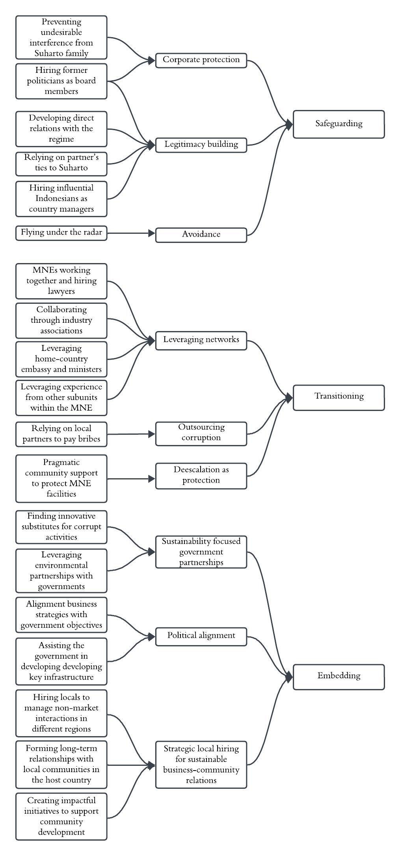
Figure 2. Regime-Corruption Interplay Framework

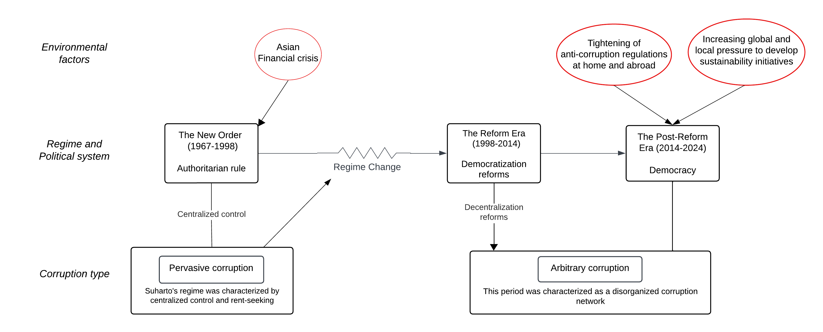

ONLINE APPENDIX: SUPPORTING QUOTES
Safeguarding
I worked at BKPN [government regulator] for a year so I have worked within the government, I took one year of sabbatical from [ConsumerCo] [….] This provided invaluable experience for navigating the political environment. (ConsumerCo)  Suharto asked [AlcoholCo’s commissioner] to become a minister in his cabinet. He became a minister but also received permission from Suharto to keep his role at [AlcoholCo]. Normally as a minister this is not allowed. (AlcoholCo)  In those years when a multinational made a lot of profit, the Suharto family would knock on your door for their stake. [...] In the end, everything boils down to government relations. Our president commissioner [head of advisory board] played an important role in protecting us from the Suharto family. He protected the company from a lot of undesirable interference […] Dealing with the government in Indonesia is like dealing with organized crime. Extortion. If you don’t pay you can close your business, just like with the mafia. (AlcoholCo) | Corporate protection
[MilkCo] is one of the companies that knows well how to do business in countries like Indonesia in which a local partner can be a big asset. The local partner had an important role, especially in terms of government relationships, lobbying, and understanding what is possible. That was the case when I first came there in the late 1980s, the partner played an important role in those things. They had direct links with President Suharto. There were a lot of things we couldn’t or didn’t want to do. They had a very important role. (MilkCo)  Obviously, there is still a lot of corruption in Indonesia. And because of the chance of corrupt practices, it was far better for us to keep a healthy distance with certain government officials. (ElectronicsCo) | Avoidance
Of course [we hire former politicians], obviously yes. You need an advisor from various fields, including government. They have their networks within the government. (ConsumerCo)  You need to do a mapping if you don’t map you don't know who is where and for these things to work which bolt and nut must be tightened or loosened. So, it's a bit of a whack here you need to the intricacy of a web. You hire from influential families to understand the pieces of the onion you must peel. (AlcoholCo)  We had several local Indonesians directors who knew, if you talk about the commercial side of the business, how to play the game. They understood how an outsider can profit from the market without engaging in corruption. I would usually go to the highest [Indonesian] manager of [ElectronicsCo Indonesia] and would ask could you at the next opportunity mention this (ElectronicsCo) | Legitimacy building
Transitioning
[…] it’s better to come to them via the industry association. That’s much more effective. After 1998, we started to work together a lot more, and we set up an association where we could discuss this and help each other and communicate our concerns to the government. (ConsumerCo)  The Dutch government and the embassy played an active role to support the Dutch industry. (ElectronicsCo)  At some point, the new mayor of a large city asked us to help him fund an Indonesian football team, which should put his region on the map in Asia. Of course, we couldn't pay for that. We got the ambassadors as well as Dutch ministers involved, who eventually helped lobby the government and as a result, we got the licenses. (AlcoholCo)  The easiest way for the bupati [regent] to get money in was by imposing local taxes. Before everything was handled in Jakarta. But after decentralization our factories required many new taxes. At some point we said, every large multinational puts 10,000 dollars into a fund to collectively prepare for such issues to hire lawyers. (AlcoholCo)  For these things [regime change], large multinationals are very useful. Corporate guidelines don’t tell you about how to deal with these issues. (AlcoholCo)  We had help from some of our colleagues who dealt with this kind of situation [regime change]. He spent six months here helping us deal with the difficulties we were facing. (ElectronicsCo) | Leveraging networks
For that you had third parties. That was the only way. These things were done through the installers or advising agencies, but directly we couldn't do that. That was impossible.” (ElectronicsCo)  [local competitor] still bribe a lot, but we can’t do that. There are anti-corruption laws even in Europe and the US. But they have a lot of backdoor channels with the local government and police. When the prohibition bill came … so, we use their network. They asked for a meeting with the government, and we showed up. They just sat in the back and were quiet during the meeting. We did the talking. (AlcoholCo) | Outsourcing corruption
After our offices were plundered during the riots and things calmed down, we initiated several social initiatives helping schools in the area. Mostly for protection. We did CSR on a higher level, supporting several projects at the central level. But we started very locally by providing food, medical care, and schools. This helped build good relations. (AlcoholCo)  Locally we had a lot of issues with the communities surrounding our factories. It has not been as bad as others, for instance [name competitor] had their factory destroyed by the locals. But we frequently had problems... you know complaints about whatever or small demonstrations. (MilkCo)  If you do not manage the community well, there will be rallies, they will storm right through the gate. Managing the community is especially important in this high-density area. (MilkCo)  We used to do some specific CSR projects in local communities since 2000, but it wasn’t consistent. Like it was mostly done in areas where it was really needed because of … challenging local communities. Now it’s much more consistent. (ConsumerCo) | De-escalation as protection
Embedding
We contribute a lot to the Indonesian economy, in terms of tax, income for people, buying local products. We are also the forerunner in terms of circular economy and safety - we are miles ahead of other firms. A country like Indonesia, has a lot to gain from that. So, when you sit down with the government, these things help and will work to your advantage. (MilkCo)  We have developed cross-sector partnerships with many government departments; our CSR team supports the government's sustainability objectives. By doing so, we have direct access to high-level government officials. We normally provide the funds, but the minister will speak at the opening events, and we can meet with him any time because we support their constituents. (ConsumerCo)  Of course, government relations are important at all levels, and the only way to make lobbying effective without paying bribes is to make sure we support their agenda as fully as possible. The best way to do this is to make sure nothing ends up in the pockets of the officials, but everything goes to the local communities. In many regions, we have made a real difference, we have been supporting them for many years now. (ConsumerCo)  They are literally asking for money sometimes. What we say is: this is our sustainability agenda, this is the intent, so help us. So, it’s because we consistently appear and say: we cannot breach our business conduct. This is our agenda, and this is your agenda, so we have this common ground. In the end, what we do is help them build their own reputation as a government, they want to be trusted by the people that voted for them right? (ConsumerCo) | Cross-sector partnerships
One of the government’s national goals is increasing exports, which are currently still very limited. Indonesia also tries to attract foreign currency through exports. We created goodwill because we penetrated two new markets this year. They are very happy with that because we also create awareness for Indonesia abroad. (AlcoholCo)  We helped support the government's goal of achieving universal electricity access. A large program that we ran was called Kampung Tarang, which basically means light up a village, and we used to go and light up villages and we would take out the old incumbent lambs to replace them with energy efficient light solutions. This would save the village probably 60% of their energy bill. (ElectronicsCo)  One of the most important things for a multinational is that you’re not seen as a company that is only here to profit from Indonesia. But you also come to bring something. [MilkCo] has the unique opportunity to do that by sharing the knowledge about how to deal with cows, we set up a good dairy cooperation, and to export that as well. We not only export milk powder but also knowledge. We send Dutch farmers here to support local farmers about how you can make sure your cows are healthy and the quality of your milk increases (MilkCo)  […] we support their agenda. Not by giving money but by aligning our agendas. We help educate children in so many schools about health and hygiene. It is not transactional. Because you do that, you must give us this, no no, not like that. But it helps to shape their overall view about us being a responsible company that really wants to do good for this country. So that helps (ConsumerCo) | Political alignment
Local governments are always more challenging to deal with. So, we need people in these regions with a lot of patience and good communication skills. We have tried to manage this with our people from Jakarta, but it did not work. So, we decided to hire people locally because it is easier for them, because of the language and culture. (ConsumerCo)  Once we build a factory, we’re in it for the long term. So very early on we need to get support from the local community, the residents, farmers but also very importantly, the informal leaders […] We do lots of community support activities, like helping them set up small businesses, and some of our staff teach sometimes at the local schools. (MilkCo) | Strategic local hiring for sustainable business-community relations

