Appendix A Countries appearing in fragile state sample anywhere in the time period

Afghanistan; Algeria; Angola; Azerbaijan; Bangladesh; Belarus; Benin; Bhutan; Bolivia; Bosnia and Herzegovina; Burkina Faso; Burundi; Cambodia; Cameroon; Cape Verde; Central African Republic; Chad; China; Colombia; Comoros; Congo; Cuba; Democratic Republic of the Congo; Djibouti; Dominican Republic; East Timor; Ecuador; Egypt; El Salvador; Equatorial Guinea; Eritrea; Ethiopia; Federated States of Micronesia; Fiji; Gabon; Gambia; Georgia; Guatemala; Guinea; Guinea-Bissau; Haiti; Honduras; India; Indonesia; Iran; Iraq; Israel; Ivory Coast; Jordan; Kenya; Kyrgyzstan; Laos; Lebanon; Lesotho; Liberia; Libya; Macedonia; Madagascar; Malawi; Maldives; Mali; Mauritania; Mexico; Moldova; Morocco; Mozambique; Myanmar; Namibia; Nepal; Nicaragua; Niger; Nigeria; North Korea; Pakistan; Papua New Guinea; Peru; Philippines; Russia; Rwanda; Sao Tome and Principe; Saudi Arabia; Senegal; Sierra Leone; Solomon Islands; Somalia; South Sudan; Sri Lanka; Sudan; Swaziland; Syria; Tajikistan; Tanzania; Thailand; Togo; Tunisia; Turkey; Turkmenistan; Uganda; Ukraine; Uzbekistan; Venezuela; Vietnam; Zambia; Zimbabwe

Appendix B Robustness of main model to natural log of independent variable

 | (1) | (2)
VARIABLES | Fragile | Non-fragile
New solar project _{t-1} | 0.0264** | -0.00115
 | (0.0115) | (0.00743)
∆ GDP (ln) _{t-1} | -0.515** | 0.0351
 | (0.223) | (0.0227)
Excluded groups _{t-1} | 0.0410 | 0.00275
 | (0.0365) | (0.00784)
Drought _{t-1} | 0.0418 | 0.0117
 | (0.135) | (0.0574)
Agricultural land | 0.00584 | -0.00360
 | (0.00722) | (0.00294)
Distance to capital | 7.78e-06 | -3.16e-05***
 | (1.78e-05) | (9.40e-06)
Population (ln) _{t-1} | -0.0380 | 0.0467***
 | (0.0299) | (0.0151)
Night lights _{t-1} | -0.159 | 0.0705
 | (0.316) | (0.110)
Regime type _{t-1} | -0.0609 | 0.0705***
 | (0.0550) | (0.0235)
Constant | 0.324 | -0.440**
 | (0.529) | (0.220)
Observations | 11,027 | 23,206
R-squared | 0.639 | 0.524
Control variables | YES | YES
Grid fixed effects | YES | YES
Year fixed effects | YES | YES
Lagged dependent variable | YES | YES
Panel matching | YES | YES
Standard errors are in parentheses and are clustered at the grid level. *** p<0.01, ** p<0.05, * p<0.1

Appendix C Distributions of dependent variable

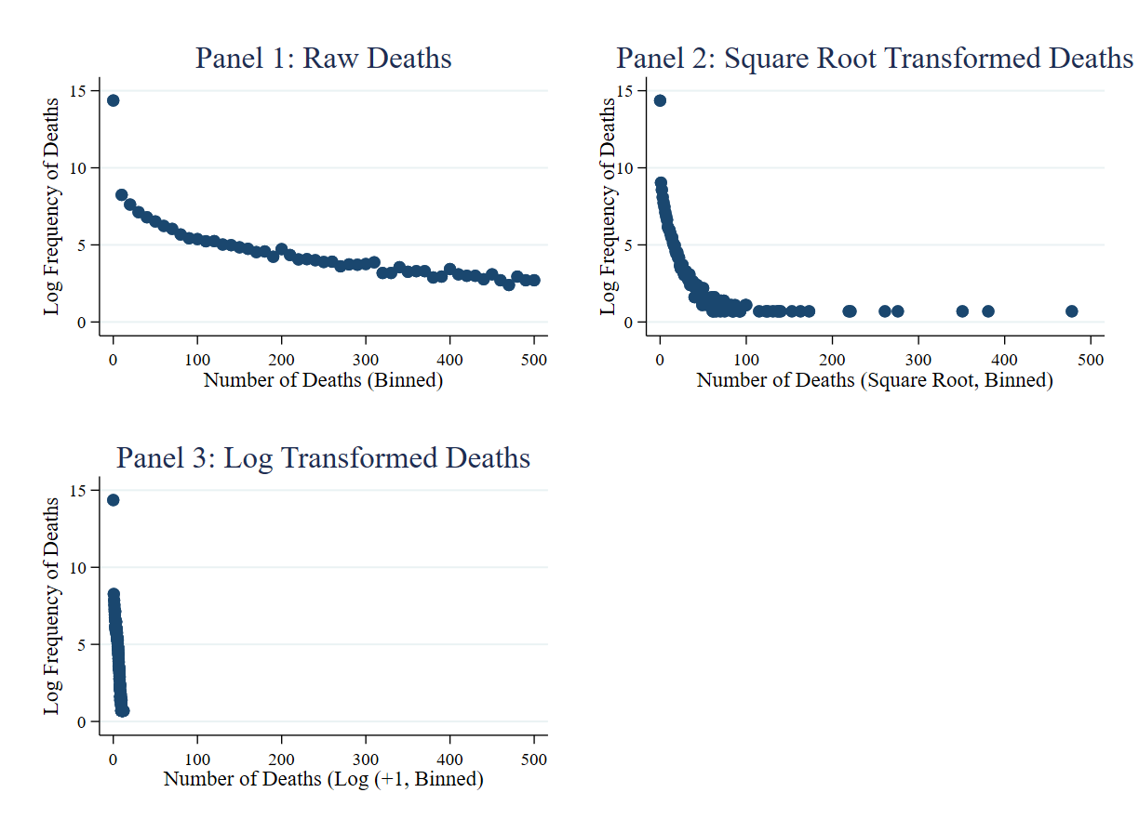

Appendix D Goldstein scale

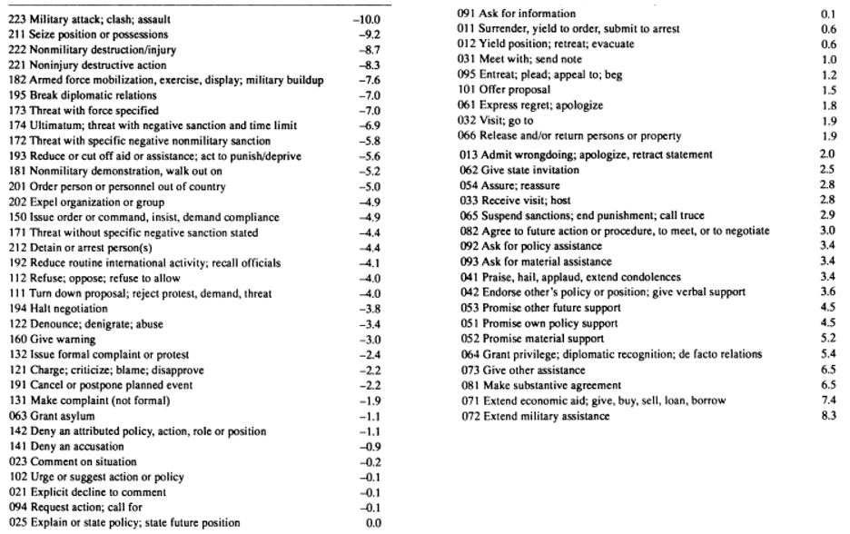
Appendix E Robustness to alternative approaches to time-invariant controls

 | (1) | (2)
VARIABLES | Interaction with linear time trend  Fragile | Interaction with time fixed effects  Fragile
New solar project _{t-1} | 0.0782** | 0.0834**
 | (0.0391) | (0.0396)
∆ GDP (ln) _{t-1} | -2.331** | -2.295**
 | (1.099) | (1.080)
Excluded groups _{t-1} | 0.289** | 0.271*
 | (0.142) | (0.147)
Drought _{t-1} | 0.476 | 0.563
 | (0.569) | (0.594)
Population (ln) _{t-1} | -0.0236 | -0.00312
 | (0.0784) | (0.0810)
Night lights _{t-1} | -0.00722 | 0.0490
 | (1.552) | (1.576)
Regime type _{t-1} | -0.0950 | -0.223
 | (0.191) | (0.210)
Distance to capital * year | 4.07e-08**
 | (2.05e-08)
Agricultural land * year | 9.17e-06
 | (1.21e-05)
Constant | -0.616 | -0.456
 | (1.624) | (1.588)
Observations | 11,027 | 11,027
R-squared | 0.509 | 0.512
Control variables | YES | YES
Grid fixed effects | YES | YES
Year fixed effects | YES | YES
Lagged dependent variable | YES | YES
Time invariant controls * year fixed effects | NO | YES
Standard errors are in parentheses and are clustered at the grid level. *** p<0.01, ** p<0.05, * p<0.1
Appendix F Robustness of main model to count variable

 | (1) | (2)
VARIABLES | Fragile | Non-fragile
Cumulative count of solar projects _{t-1} | 0.0462* | -0.00200
 | (0.0266) | (0.00307)
∆ GDP (ln) _{t-1} | -2.320** | 0.117
 | (1.097) | (0.0740)
Excluded groups _{t-1} | 0.288** | 0.0211
 | (0.142) | (0.0191)
Drought _{t-1} | 0.480 | 0.115
 | (0.569) | (0.161)
Agricultural land | 0.00732 | -0.00709
 | (0.0247) | (0.00961)
Distance to capital | 8.61e-05** | -8.30e-05***
 | (4.25e-05) | (2.48e-05)
Population (ln) _{t-1} | -0.0254 | 0.0933**
 | (0.0782) | (0.0410)
Night lights _{t-1} | 0.0291 | 0.392
 | (1.547) | (0.389)
Regime type _{t-1} | -0.0960 | 0.133**
 | (0.192) | (0.0660)
Constant | -0.0764 | -0.941
 | (1.612) | (0.646)
Observations | 11,027 | 23,206
R-squared | 0.509 | 0.417
Control variables | YES | YES
Grid fixed effects | YES | YES
Year fixed effects | YES | YES
Lagged dependent variable | YES | YES
Panel matching | YES | YES
Standard errors are in parentheses and are clustered at the grid level. *** p<0.01, ** p<0.05, * p<0.1

Appendix G Robustness of main model to different types of fixed effects

 | (1) | (2) | (3)
Variables | Country fixed effects | Country-year fixed effects | Region-year fixed effects
New solar project _{t-1} | 0.0783** | 0.0443* | 0.0544*
 | (0.0391) | (0.0228) | (0.0330)
∆ GDP (ln) _{t-1} | -2.331** | -0.175 | -2.303*
 | (1.099) | (0.329) | (1.201)
Excluded groups _{t-1} | 0.289** | 0.358 | 0.267*
 | (0.142) | (0.312) | (0.160)
Drought _{t-1} | 0.473 | -0.00904 | 0.561
 | (0.569) | (0.410) | (0.650)
Agricultural land | 0.00718 | 0.00680 | -0.00222
 | (0.0247) | (0.0150) | (0.0289)
Distance to capital | 8.15e-05** | -7.39e-05 | 1.74e-05
 | (4.10e-05) | (0.000249) | (5.59e-05)
Population (ln) _{t-1} | -0.0243 | -0.0572 | 0.0195
 | (0.0783) | (0.0993) | (0.0902)
Night lights _{t-1} | 0.000508 | 0.824 | 0.744
 | (1.549) | (1.709) | (1.705)
Regime type _{t-1} | -0.0961 | -0.237 | -0.270
 | (0.192) | (0.857) | (0.308)
Constant | -0.326 | 0.257 | -0.435
 | (1.627) | (1.583) | (1.605)
Observations | 11,027 | 14,046 | 14,046
R-squared | 0.509 | 0.602 | 0.280
Control variables | YES | YES | YES
Grid fixed effects | YES | YES | YES
Lagged dependent variable | YES | YES | YES
Panel matching | YES | YES | YES
Standard errors are in parentheses and are clustered at the grid level. *** p<0.01, ** p<0.05, *p<0.1

Appendix H Robustness of main model to double lags of “bad” controls

 | (1) | (2)
Variables | Fragile | Non-fragile
New solar project _{t-1} | 0.0939** | 0.0150
 | (0.0392) | (0.0321)
∆ GDP (ln) _{t-2} | -1.042* | -0.0155
 | (0.584) | (0.0534)
Excluded groups _{t-2} | 0.316** | 0.0493**
 | (0.130) | (0.0216)
Drought | 0.360 | 0.146
 | (0.593) | (0.156)
Agricultural land | 0.00569 | -0.00759
 | (0.0249) | (0.00954)
Distance to capital | 8.12e-05* | -7.96e-05***
 | (4.40e-05) | (2.49e-05)
Population (ln) _{t-2} | -0.0332 | 0.0934***
 | (0.0810) | (0.0357)
Night lights _{t-1} | 0.239 | 0.379
 | (1.612) | (0.416)
Regime type _{t-1} | -0.177 | 0.110*
 | (0.163) | (0.0669)
Constant | 0.0486 | -0.918
 | (1.642) | (0.568)
Observations | 10,765 | 22,551
R-squared | 0.514 | 0.421
Control variables | YES | YES
Grid fixed effects | YES | YES
Year fixed effects | YES | YES
Lagged dependent variable | YES | YES
Panel matching | YES | YES
Standard errors are in parentheses and are clustered at the grid level. *** p<0.01, ** p<0.05, * p<0.1

Appendix I Robustness to alternative matching techniques

 | (1)
Variables | Inverse Propensity Score Matching  Fragile contexts
New solar project _{t-1} | 11.24***
 | (1.941)
∆ GDP (ln) _{t-1} | -3.490
 | (12.62)
Excluded groups _{t-1} | -1.822
 | (1.320)
Drought _{t-1} | 31.36**
 | (13.03)
Agricultural land | 31.80***
 | (9.542)
Distance to capital | 0.0204***
 | (0.00262)
Population (ln) _{t-1} | -0.130
 | (0.202)
Night lights _{t-1} | 2,781**
 | (1,100)
Regime type _{t-1} | -64.45***
 | (10.63)
Constant | -978.0
 | (973.1)
Observations | 980,462
R-squared | 1.000
Control variables | YES
Grid fixed effects | YES
Year fixed effects | YES
Lagged dependent variable | YES
IPS matching | YES
Standard errors are in parentheses and are clustered at the grid level. *** p<0.01, ** p<0.05, * p<0.1

Appendix J Robustness of main model to controlling for different types of FDI

 | (1) | (2) | (3) | (4)
Variables | Number of FDI projects (fragile) | Amount of capital investment (fragile) | FDI indicator (fragile) | Energy FDI indicator (fragile)
New solar project _{t-1} | 0.0784** | 0.0799** | 0.0798** | 0.0772**
 | (0.0392) | (0.0394) | (0.0394) | (0.0391)
∆ GDP (ln) _{t-1} | -2.330** | -2.317** | -2.318** | -2.304**
 | (1.099) | (1.099) | (1.099) | (1.097)
Excluded groups _{t-1} | 0.289** | 0.289** | 0.289** | 0.289**
 | (0.142) | (0.142) | (0.142) | (0.142)
Drought _{t-1} | 0.477 | 0.475 | 0.474 | 0.468
 | (0.569) | (0.568) | (0.568) | (0.569)
Agricultural land | 0.00694 | 0.00594 | 0.00597 | 0.00671
 | (0.0247) | (0.0246) | (0.0247) | (0.0247)
Distance to capital | 8.12e-05** | 8.19e-05** | 8.20e-05** | 8.05e-05**
 | (4.10e-05) | (4.11e-05) | (4.11e-05) | (4.09e-05)
Population (ln) _{t-1} | -0.0242 | -0.0228 | -0.0228 | -0.0236
 | (0.0783) | (0.0783) | (0.0784) | (0.0779)
Night lights _{t-1} | 0.0207 | 0.0997 | 0.0875 | 0.0213
 | (1.549) | (1.549) | (1.548) | (1.544)
Regime type _{t-1} | -0.0979 | -0.107 | -0.107 | -0.0963
 | (0.191) | (0.191) | (0.191) | (0.191)
Number of FDI projects _{t-1} | -0.00212
 | (0.00536)
Capital investment (ln) _{t-1} |  | -0.00479
 |  | (0.00371)
FDI indicator _{t-1} |  |  | -0.115
 |  |  | (0.0955)
Energy FDI indicator _{t-1} |  |  |  | -1.330
 |  |  |  | (2.016)
Constant | -0.0633 | -0.137 | -0.0382 | -0.0605
 | (1.613) | (1.616) | (1.611) | (1.613)
Observations | 11,027 | 11,027 | 11,027 | 11,027
R-squared | 0.509 | 0.509 | 0.509 | 0.509
Control variables | YES | YES | YES | YES
Grid fixed effects | YES | YES | YES | YES
Year fixed effects | YES | YES | YES | YES
Lagged dependent variable | YES | YES | YES | YES
Panel matching | YES | YES | YES | YES
Fragile contexts only | YES | YES | YES | YES
Standard errors are in parentheses and are clustered at the grid level. *** p<0.01, ** p<0.05, * p<0.1

Appendix K Modeling conflict toward elites using a Tobit model

 | (1)
Variables | Conflict toward elites
New solar project _{t-1} | -0.196*
 | (0.119)
∆ GDP (ln) _{t-1} | -0.427
 | (0.542)
Excluded groups _{t-1} | -0.0543
 | (0.0662)
Drought _{t-1} | 0.127
 | (0.851)
Agricultural land | 0.00285**
 | (0.00138)
Distance to capital | 1.41e-05
 | (3.63e-05)
Population (ln) _{t-1} | -0.148***
 | (0.0212)
Night lights _{t-1} | 0.705***
 | (0.176)
Regime type _{t-1} | 0.172
 | (0.210)
Constant | 1.774*
 | (0.977)
Observations | 8,662
Grid fixed effects | NO
Year fixed effects | YES
Lagged dependent variable | YES
Panel matching | NO
Robust standard errors in parentheses. *** p<0.01, ** p<0.05, * p<0.1

