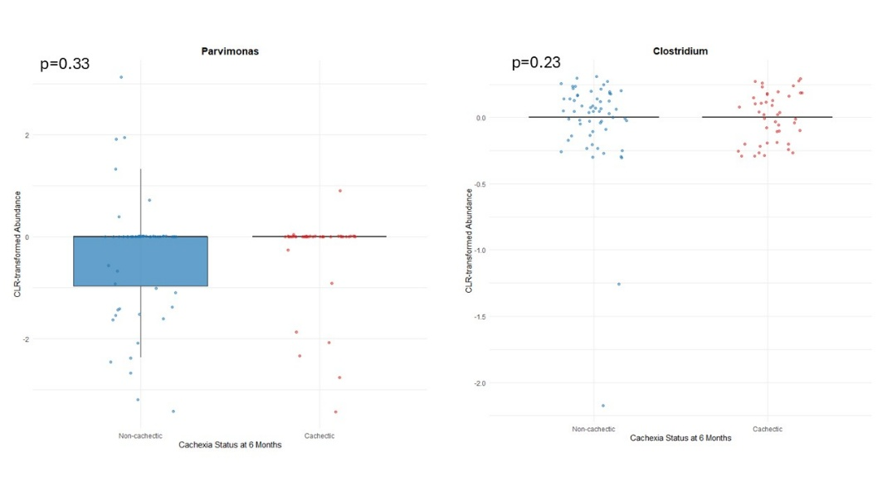
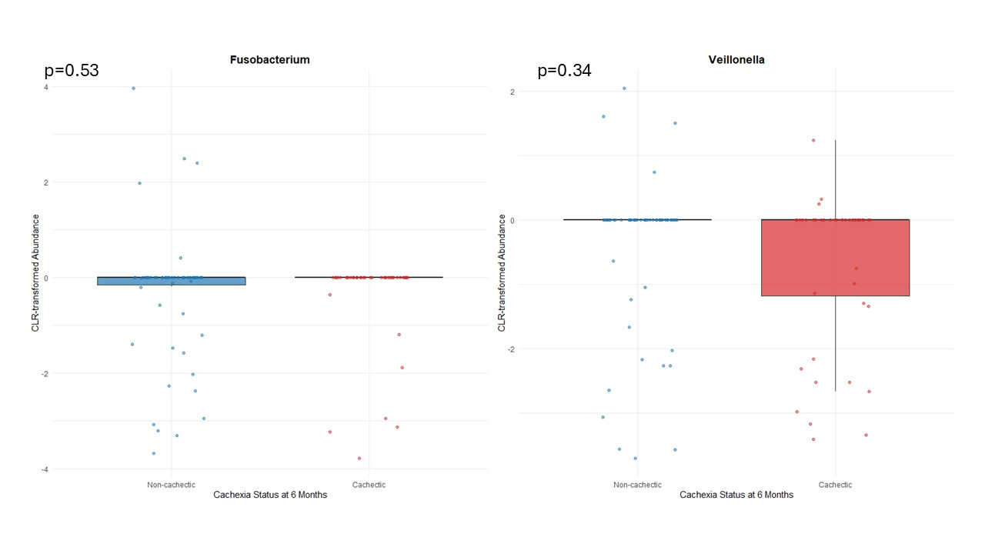
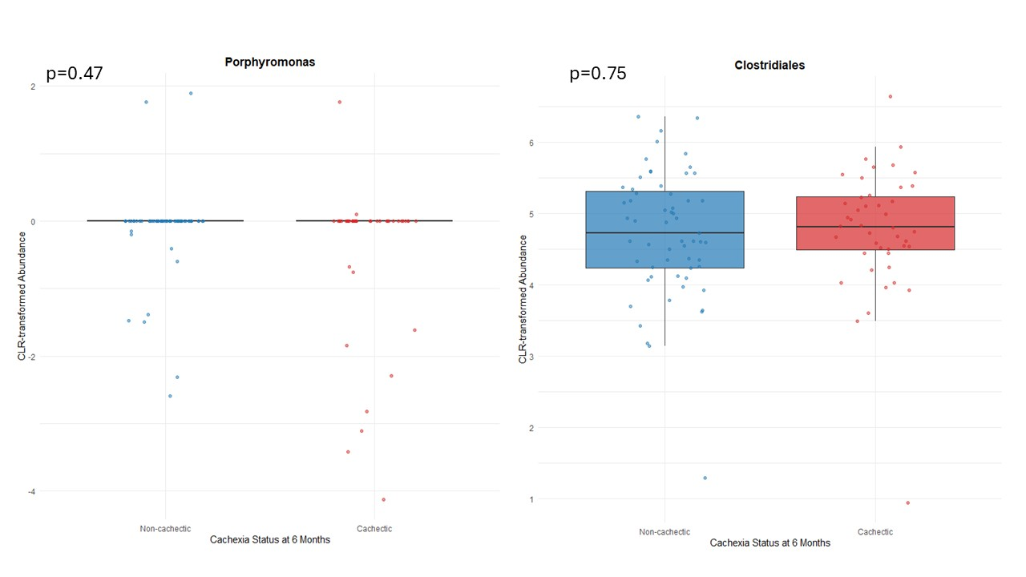
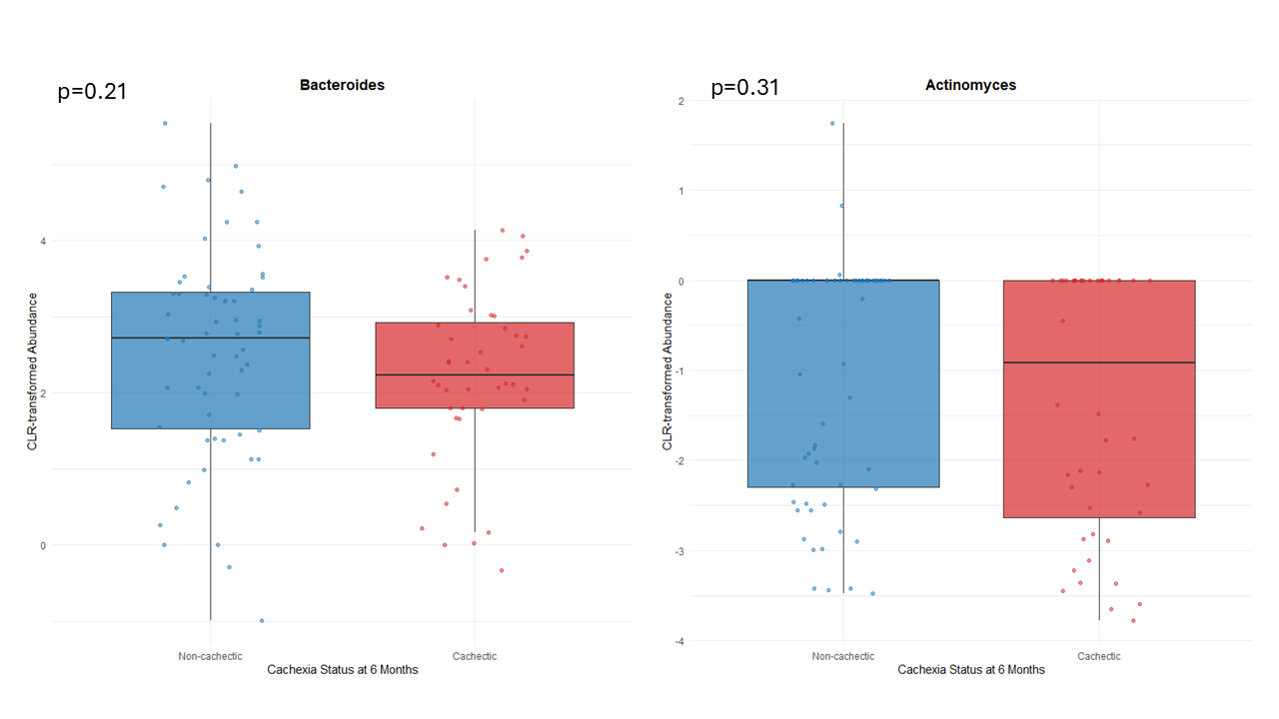
Supplemental Figure 1. Comparison of genus-level relative abundances of a priori selected bacteria between cachectic and non-cachectic patients.
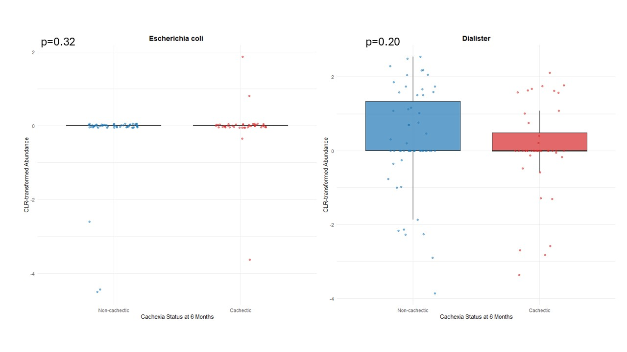

Wilcoxon rank sum test was used to compare genus-level relative abundances of a priori selected bacteria between cachectic and non-cachectic patients

