Supplementary Figure 1. Caregiver Definitions Derived from Behavioral Risk Factor Surveillance System Variables.
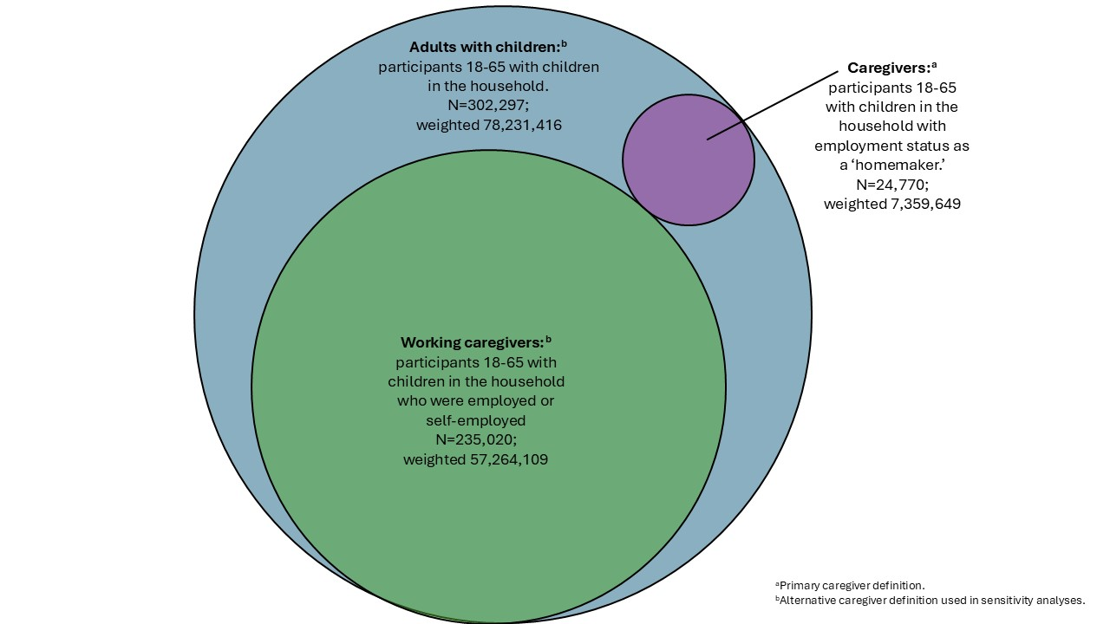

Supplementary Figure 2. Conceptual Framework of Child Caregiving.
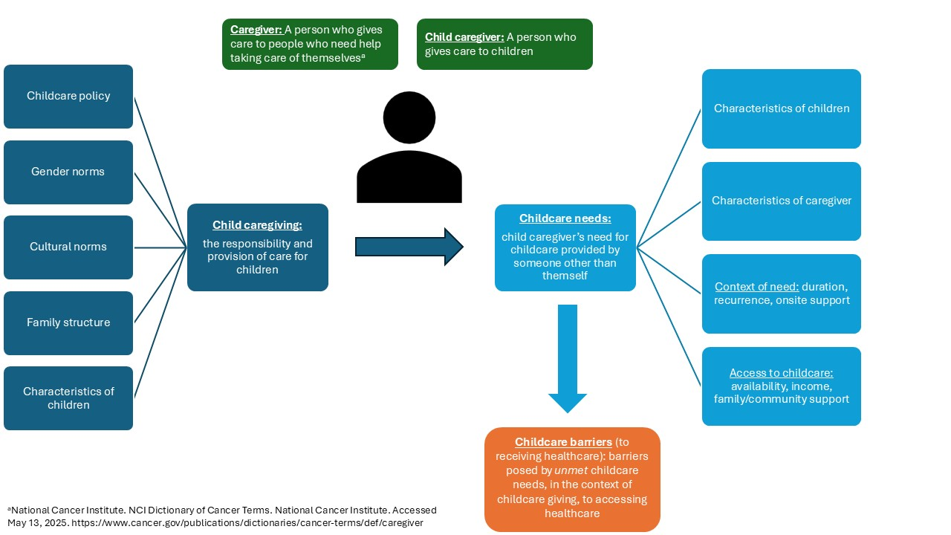

Supplementary Table 1. Baseline Characteristics of Caregivers and Non-caregivers Using Alternative Caregiver Definition of Adults aged 18-65 with Children.
Characteristic  Unweighted N, (weighted %) | Caregiversª,  N=302,297  (weighted N=78,231,416, 30.7%) | Non-Caregivers, N=1,014,851  (weighted N=257,405,003, 69.3%) | p-value
Mean age ± St. dev. | 38.1 ± 10.9 | 52.6 ± 19.1 | <0.001
Age group
18-29 | 44,278 (22.0) | 99,828 (18.7) | <0.001
30-39 | 93,908 (32.5) | 66,664 (10.2) | <0.001
40-49 | 103,229 (29.7) | 68,603 (8.4) | <0.001
50-64 | 60,882 (15.9) | 277,971 (27.3) | <0.001
65-74 | 0 (0) | 268,885 (19.0) | <0.001
≥75 | 0 (0) | 206,435 (13.5) | <0.001
Sex
Female | 166,984 (55.0) | 533,366 (49.7) | <0.001
Male | 135,313 (45.0) | 481,485 (50.3) | <0.001
Race/ethnicity
Non-Hispanic white | 194,777 (50.3) | 792,214 (63.6) | <0.001
Non-Hispanic Black | 26,895 (12.5) | 75,574 (11.3) | <0.001
Hispanic | 49,336 (25.9) | 75,711 (15.0) | <0.001
Asian/Pacific Islander | 11,389 (6.6) | 25,899 (5.8) | <0.001
American Indian/Alaska Native | 6,906 (1.1) | 14,554 (1.0) | <0.001
Other | 12,994 (3.6) | 30,899 (3.3) | <0.001
Yearly household income
<$25,000 | 30.873 (14.6) | 133,837 (18.4) | <0.001
$25,000-$50,000 | 55,217 (23.2) | 212,150 (26.2) | <0.001
$50,001-$100,000 | 74,404 (27.1) | 247,453 (29.6) | <0.001
$100,001-$200,000 | 71,957 (24.7) | 144,974 (19.4) | <0.001
>$200,000 | 27,385 (10.4) | 41,815 (6.4) | <0.001
Highest level of completed education
Less than high school | 22,280 (14.1) | 54,894 (10.7) | <0.001
High school/GED | 71,670 (27.0) | 255,478 (27.6) | <0.001
Some college | 77,616 (28.8) | 277,084 (30.9) | <0.001
College degree or higher | 129,943 (30.1) | 420,997 (30.8) | <0.001
Insurance
Commercial | 186,799 (60.2) | 387,214 (46.9) | <0.001
Medicare | 11,539 (4.6) | 385,522 (29.8) | <0.001
Medicaid | 32,572 (12.6) | 51,208 (6.7) | <0.001
Other public insurance | 30,064 (10.6) | 86,165 (9.6) | <0.001
Uninsured | 25,561 (12.0) | 41,970 (7.1) | <0.001
Marital Status
Single, divorced, separated, or widowed | 91,238 (33.6) | 479,611 (49.5) | <0.001
Married or partnered | 209,662 (66.4) | 522,558 (50.5) | <0.001
Preferred language
English | 280,971 (89.3) | 985,282 (94.6) | <0.001
Spanish | 21,074 (10.7) | 29,146 (5.4) | <0.001
Self-rated general health
Excellent | 61,679 (20.5) | 151,350 (16.2) | <0.001
Very good | 105,998 (32.7) | 333,673 (31.5) | <0.001
Good | 95,558 (33.1) | 330,187 (32.6) | <0.001
Fair | 31,148 (11.3) | 145,816 (14.7) | <0.001
Poor | 7,436 (2.5) | 50,682 (5.0) | <0.001
Interview year
2021 | 97,409 (31.0) | 317,776 (30.0) | <0.001
2022 | 101,556 (33.8) | 341,425 (34.9) | <0.001
2023 | 97,749 (33.2) | 335,922 (33.0) | <0.001
2024^{b} | 5,583 (2.0) | 19,728 (2.2) | <0.001

ªCaregivers were defined as adult between the ages of 18-65 who reported one or more child in the home.
^{b}Interview 2024 reflects data collected in 2024 for the 2023 BRFSS survey.

Supplementary Table 2. Baseline Characteristics of Caregivers and Non-caregivers Using Alternative Caregiver Definition of Working Adults aged 18-65 with Children.
Characteristic  Unweighted N, (weighted %) | Caregiversª, N=235,020  (weighted N=57,264,109, 29.6%) | Non-Caregivers, N=837,959  (weighted N=136,168,740, 70.4%) | p-value
Mean age ± St. dev. | 39.2 (10.2) | 54.6 (18.6) | <0.001
Age group
18-29 | 27,571 (17.1) | 68,101 (15.3) | <0.001
30-39 | 73,699 (33.6) | 53,882 (10.4) | <0.001
40-49 | 85,746 (32.7) | 52,463 (8.0) | <0.001
50-64 | 48,004 (16.6) | 213,883 (26.5) | <0.001
65-74 | 0 (0) | 242,323 (21.6) | <0.001
≥75 | 0 (0) | 187,892 (15.5) | <0.001
Sex
Female | 117,239 (48.6) | 428,120 (47.7) | <0.001
Male | 117,781 (51.4) | 409,839 (52.3) | <0.001
Race/ethnicity
Non-Hispanic white | 158,282 (53.4) | 674,479 (67.0) | <0.001
Non-Hispanic Black | 19,979 (12.5) | 56,726 (10.5) | <0.001
Hispanic | 33,575 (23.1) | 53,775 (13.3) | <0.001
Asian/Pacific Islander | 8,860 (6.6) | 19,454 (5.4) | <0.001
American Indian/Alaska Native | 4,771 (1.0) | 10,229 (0.9) | <0.001
Other | 9,553 (3.5) | 23,296 (3.0) | <0.001
Yearly household income
<$25,000 | 14,461 (9.2) | 79,790 (12.3) | <0.001
$25,000-$50,000 | 40,092 (21.0) | 180,150 (26.0) | <0.001
$50,001-$100,000 | 63,136 (29.1) | 228,646 (32.6) | <0.001
$100,001-$200,000 | 65,276 (28.5) | 136,730 (22.0) | <0.001
>$200,000 | 24,945 (12.1) | 39,171 (7.2) | <0.001
Highest level of completed education
Less than high school | 12,597 (10.6) | 32,851 (8.1) | <0.001
High school/GED | 50,020 (24.9) | 197,146 (26.2) | <0.001
Some college | 58,738 (20.1) | 225,340 (30.8) | <0.001
College degree or higher | 113,210 (35.5) | 379,234 (34.9) | <0.001
Insurance
Commercial | 164,816 (69.1) | 342,523 (50.7) | <0.001
Medicare | 5,105 (2.8) | 332,200 (30.9) | <0.001
Medicaid | 16,955 (8.5) | 25,260 (4.0) | <0.001
Other public insurance | 20,855 (9.3) | 65,261 (8.5) | <0.001
Uninsured | 16,994 (10.2) | 28,503 (5.9) | <0.001
Marital Status
Single, divorced, separated, or widowed | 63,864 (29.9) | 373,889 (45.5) | <0.001
Married or partnered | 170,235 (70.1) | 456,225 (54.5) | <0.001
Preferred language
English | 222,143 (91.6) | 818,807 (95.6) | <0.001
Spanish | 12,744 (8.4) | 18,917 (4.4) | <0.001
Self-rated general health
Excellent | 50,531 (21.6) | 131,182 (17.0) | <0.001
Very good | 88,433 (35.1) | 295,139 (34.0) | <0.001
Good | 73,494 (32.4) | 277,306 (33.2) | <0.001
Fair | 19,363 (9.4) | 104,366 (12.7) | <0.001
Poor | 2,910 (1.4) | 27,880 (3.2) | <0.001
Interview year
2021 | 75,169 (30.6) | 261,223 (29.9) | <0.001
2022 | 79,564 (34.2) | 280,779 (34.7) | <0.001
2023 | 76,047 (33.3) | 279,626 (33.2) | <0.001
2024^{b} | 4,240 (1.9) | 16,331 2.2 | <0.001

ªCaregivers were defined as adult between the ages of 18-65 who reported one or more child in the home and who reported being employed or self-employed in the BRFSS employment survey question.
^{b}Interview 2024 reflects data collected in 2024 for the 2023 BRFSS survey.

Supplementary Table 3. Adjusted Relative Risk of Colorectal Cancer Screening Adherence among Caregivers Stratified by Sex.
Caregiver Definition | Sex Distribution of Caregivers  N (weighted %) | Sex Distribution of Non-Caregivers  N (weighted %) | Adjusted Relative Risk (95% CI) among Caregivers  [Females] | Adjusted Relative Risk (95% CI) among Caregivers  [Males] | P-value of interaction term
‘Homemaker’ with children | Female: 23,534 (95.3)  Male: 1,236 (4.7) | Female: 676,816 (50.0)  Male: 615,562 (50.0) | 0.91  (0.84-0.98) | 0.99  (0.69-1.28) | 0.69
Adults with children | Female: 166,984 (55.0)  Male: 135,313 (45.0) | Female: 533,366 (49.7)  Male: 481,485 (50.3) | 0.92  (0.89-0.95) | 0.92  (0.89-0.94) | 0.32
‘Working caregivers’ | Female: 117,239 (48.6)  Male: 117,781 (51.4) | Female: 428,120 (47.7)  Male: 409,839 (52.3) | 0.92  (0.90-0.95) | 0.92  (0.89-0.95) | 0.20

