Supplementary
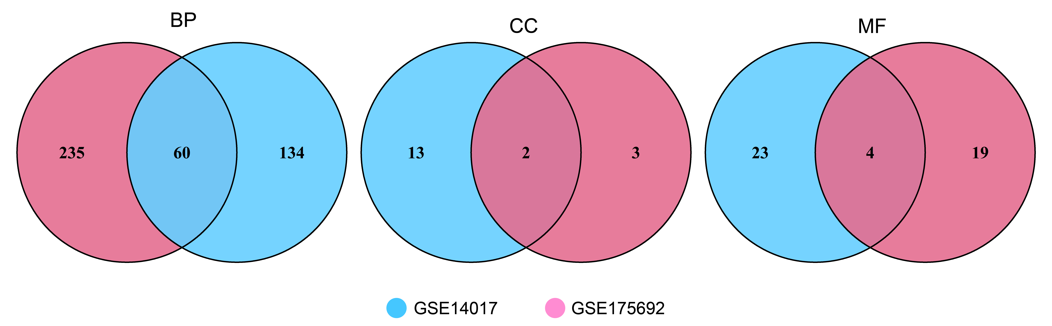
Figure S1 Venn Diagram of GO Enrichment Analysis

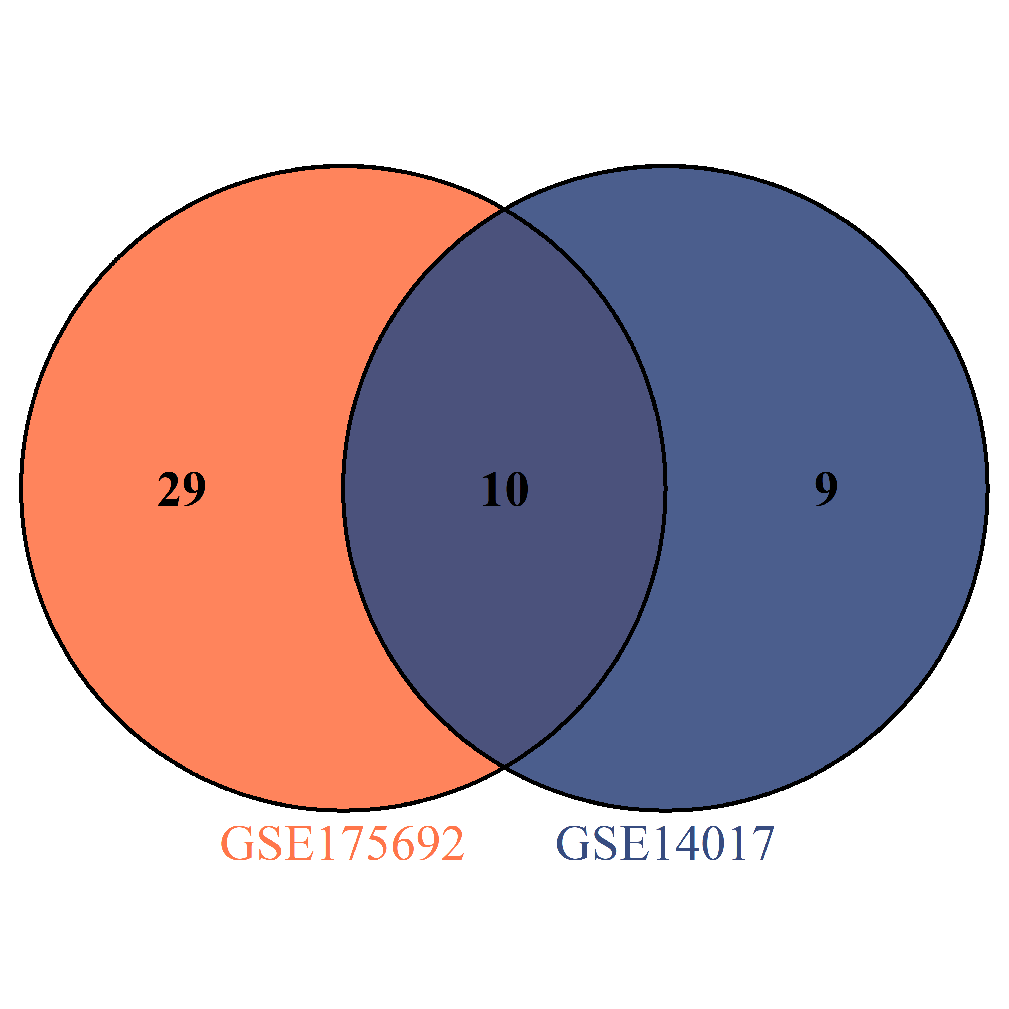
Figure S2 Venn Diagram of Enriched Pathways

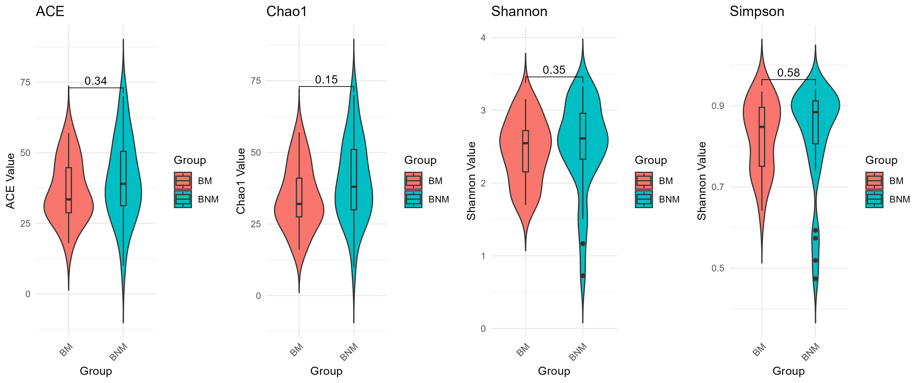
Figure S3 presents four α-diversity indices for two distinct groups (BM and BNM).
These indices—Chao1, Ace, Shannon, and Simpson—are employed to assess species richness and diversity within the samples. Chao1 and Ace primarily reflect species richness, while Shannon and Simpson focus on diversity. The p-value, a statistical measure used to determine whether observed results are attributable to random chance, indicates in this case that a value exceeding 0.05 signifies no significant differences in species richness and diversity between the BM and BNM groups.

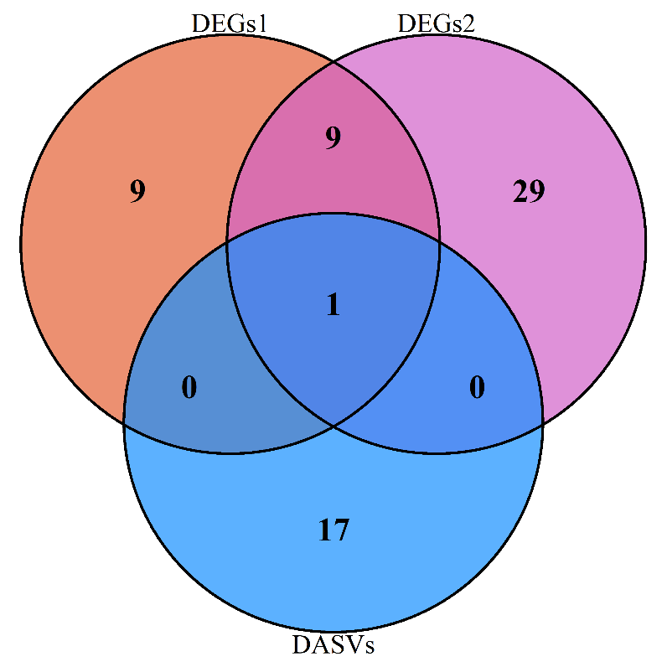
Figure S4 Venn diagram of KEGG enrichment pathway

