Supplementary document
Statistics
The interval from CMR until all cause of death or census was regarded as the follow-up period. The census was performed on 22nd May 2017. Log-log plots were inspected to ensure linearity with outcome data. Univariate and multivariate Cox proportional hazards regression was performed `with each variable standardized as the z score for the population studied, in order to allow for comparison between variables. Univariate and multivariate Cox proportional hazards regression was performed. Multivariate analysis was performed in a forward direction, for all variables with a statistically significant association with mortality in univariate analysis. C-statistics were used to perform receiver operator characteristics (ROC) curve analysis and Youden criterion was used to determine thresholds for the variables which demonstrated independent association to mortality. Kaplan-Meier plots were generated using the above-derived thresholds. Log-rank χ2 was calculated for the Kaplan Meier data. A p-value of 0.05 was considered statistically significant.
Receiver operating characteristic
Of the three variables independently associated with all-cause mortality, the area under the curve for predicting mortality for RV EF was 0.67, indexed RV mass 0.7 and IV septal angle 0.67 (S Fig 3). The Youden index derived threshold for RV EF was <=49%, indexed RV mass >17gram/m² and IV septal angle >139 ˚. Kaplan-Meier survival curves are presented in Figure 4. Pulmonary hypertension-HFpEF with RV EF less than or equal to 49% had a worse survival at 1-year (70% vs 96%), 3-years (44% vs 73%) and 5-years (26% vs 64%), than patients with a RV EF >49%, respectively (p=0.0001). In patients with an indexed RV mass >17gram/m² patients had a worse survival at 1-year (71% vs 93%), 3-years (39% vs 76%) and at 5-years (30% vs 60%) than patients with indexed RV mass <=17gram/m2 (p=0.0002). Patients with an inter-ventricular septal angle >139 ̊ had a worse survival at 1-year (71% vs 90%), 3-years (31% vs 74%) and at 5-years (25% vs 54%) than patients with an inter-ventricular septal angle <=139 ̊ (p=0.0001).

Supplementary Table 1. CMR assessment in the study population.
 | All | Alive (n=55) | Dead (n=61) | P-value
Left ventricular volume and function
LV EDVi (ml/m²) | 71.1±20.4 | 72.9±19.9 | 69.5±20.9 | 0.371
LV ESVi (ml/m²) | 24±11.1 | 24.2±10.8 | 23.8±11.4 | 0.860
LV EF (%) | 67±8.1 | 67.3±8.1 | 66.7±8.2 | 0.694
LV SVi (ml/m²) | 47.1±12.2 | 48.8±12.3 | 45.6±12 | 0.168
LV mass (gram/m²) | 58.5±18.2 | 56.7±17.3 | 60.3±19.1 | 0.306
LA volume indexed (ml/m²) | 73.8±27 | 66.5±19.1 | 80.3±31.2 | 0.005
Right ventricular volume and function
RV EDVi (ml/m²) | 93.4±34.2 | 85.3±32.6 | 100.7±34.3 | 0.014
RV ESVi (ml/m²) | 48.8±20.3 | 42.3±19.3 | 54.7±19.5 | <0.001
RV SVi (ml/m²) | 44.6±18.1 | 43±17 | 46±19.1 | 0.376
RV EF (%) | 50±10 | 51±10 | 45±9 | 0.002
RV mass (gram/m²) | 19.6±9.8 | 16±6.3 | 22.9±11.3 | <0.001
Other metrics
IV septal angle (˚) | 138.2±10.4 | 134.8±9.2 | 141.2±10.6 | <0.001
PA systolic area (cm²) | 925.8±254 | 866.3±230.4 | 979.5±264 | 0.016
PA diastolic area(cm²) | 827.8±222.1 | 764.6±203.1 | 884.8±224.6 | 0.003
PA relative area change (%) | 12±7.3 | 13.6±7.2 | 10.6±7.2 | 0.027

Supplementary Table 3. Cox regression for all the clinical and imaging variables associated with mortality.
 | Uni-variate |  |  |  | Multi-variate
 | HR | 95% CI | Wald | P | HR | 95% CI | Wald | P
Age (yrs) | 1.33 | 0.99 to 1.78 | 3.6 | 0.057
Gender (Male) | 2.74 | 1.63 to 4.61 | 14.5 | <0.001
Atrial fibrillation | 2.11 | 1.11 to 3.98 | 5.3 | 0.021
LA volume (ml/m²)* | 1.32 | 1.07 to 1.64 | 6.7 | 0.010
RV EDV (ml/m²) | 1.30 | 1.03 to 1.64 | 4.8 | 0.029
RV SV (ml/m²)* | 1.47 | 1.17 to 1.85 | 11.1 | <0.001
RV EF (%) | 0.58 | 0.44 to 0.78 | 13.6 | <0.001 | 0.64 | 0.47 to 0.87 | 8.0 | <0.001
RV mass (gram/m²)* | 1.55 | 1.26 to 1.9 | 17.4 | <0.001 | 1.46 | 1.18 to 1.8 | 12.4 | <0.001
IV septal angle (˚) | 1.58 | 1.23 to 2.03 | 12.9 | <0.001 | 1.48 | 1.12 to 1.94 | 7.8 | <0.001
PA systolic area (cm²) | 1.29 | 1.02 to 1.64 | 4.6 | 0.038
PA diastolic area (cm²) | 1.39 | 1.1 to 1.75 | 7.6 | 0.006
PA relative area change (%) | 0.71 | 0.54 to 0.93 | 6.3 | 0.012
*indexed for body surface area.

S. Figure 1. Demonstrates right ventricular and left ventricular segmentation in a patient with no PH.
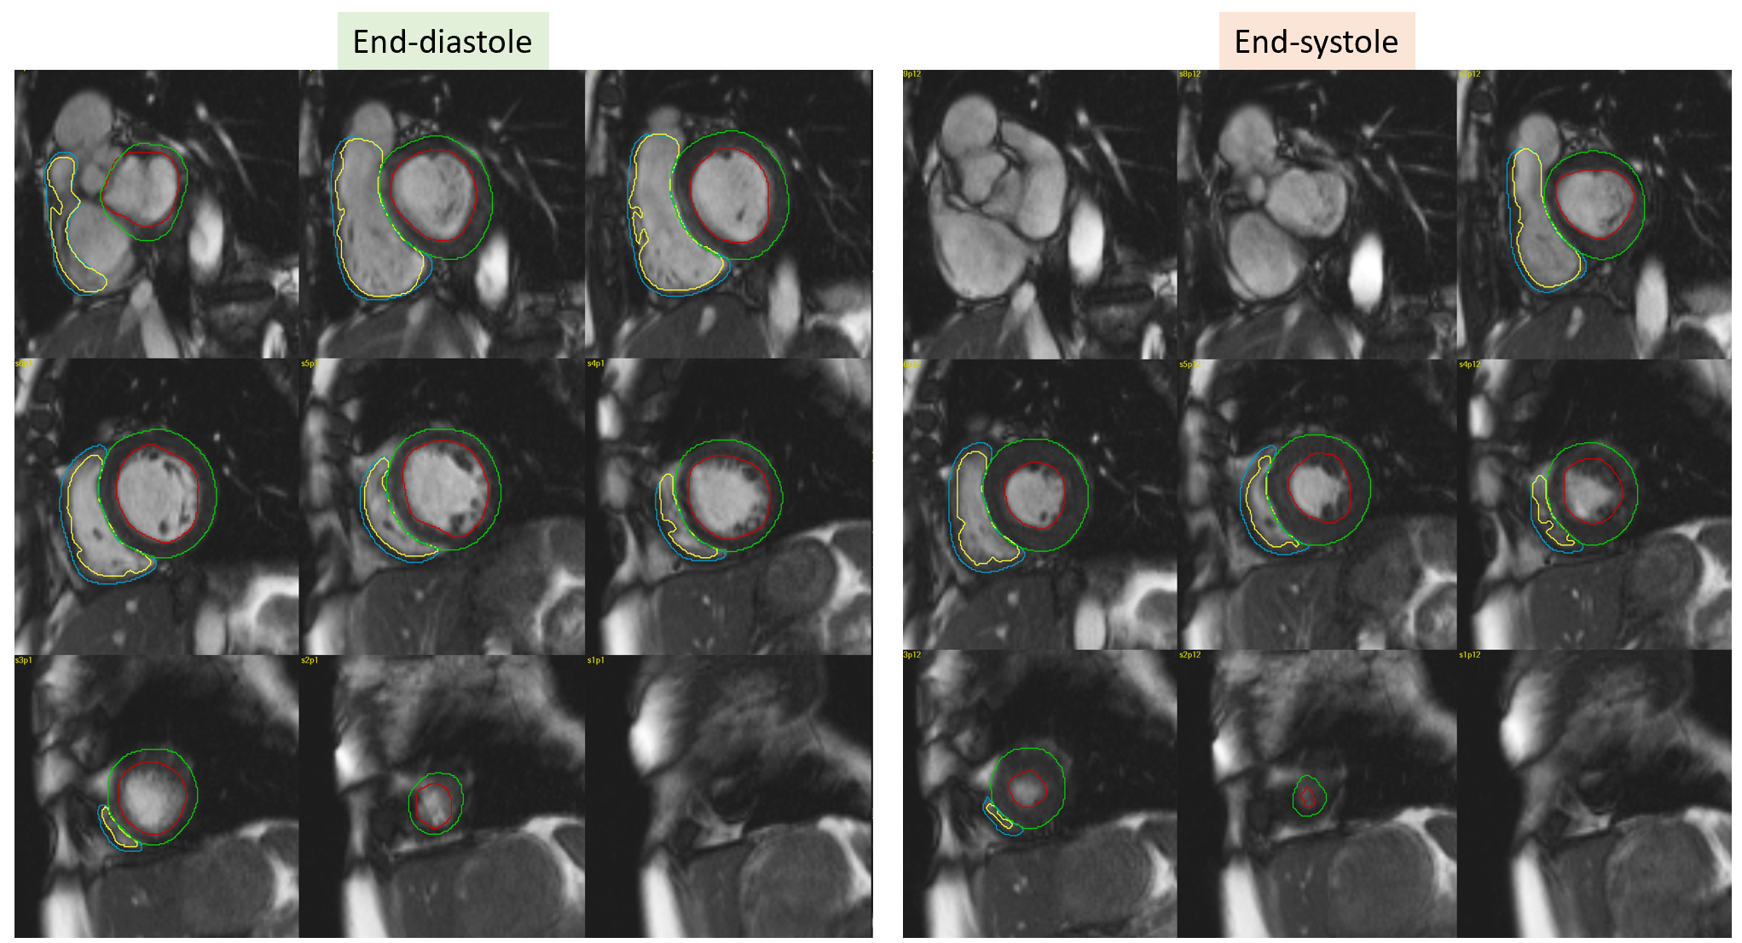
S. Figure 2. Demonstrates right ventricular and left ventricular segmentation in a HFpEF-PH patient.
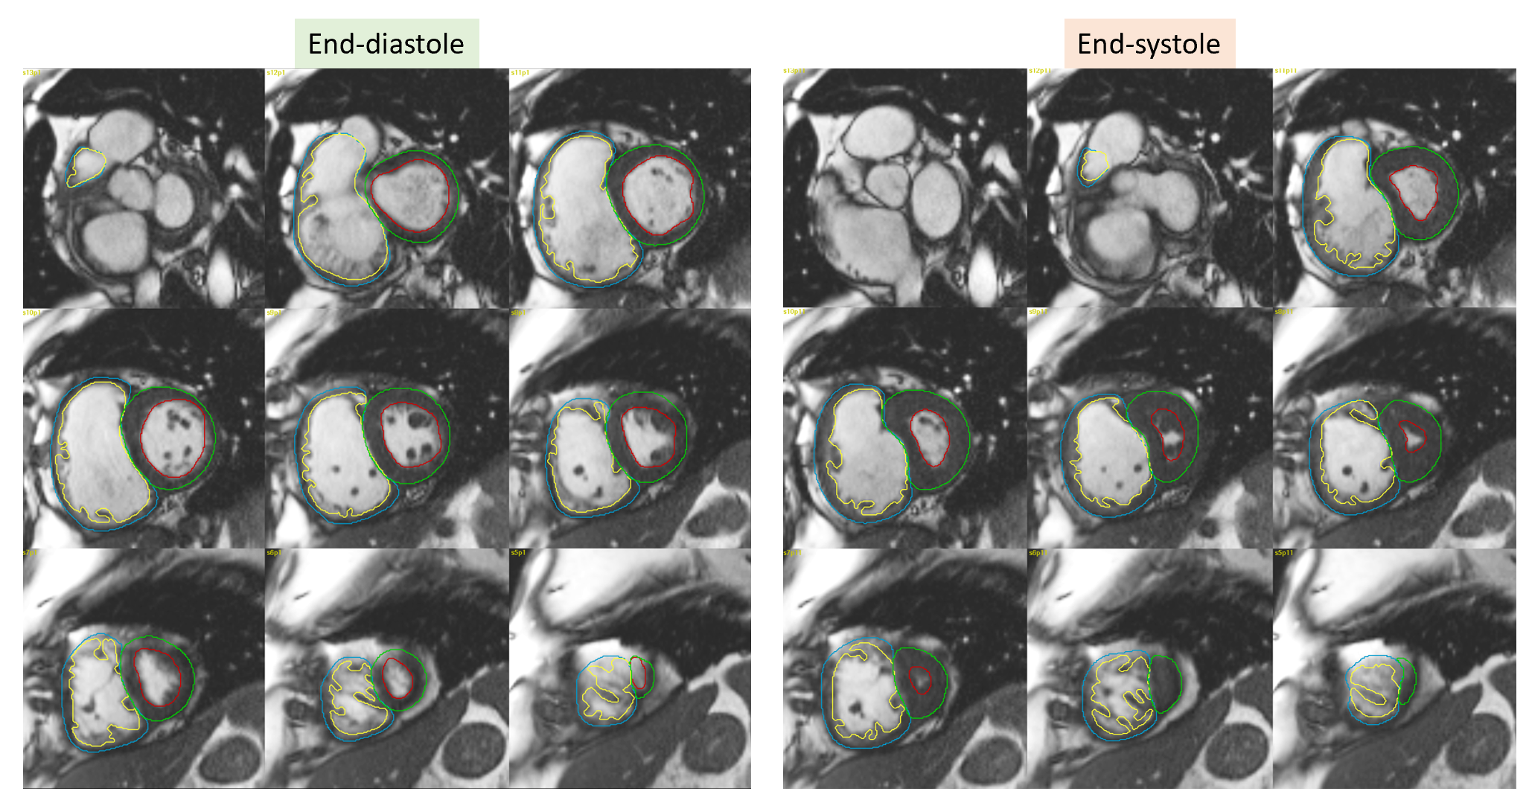

S. Figure 3. C-statistics - receiver operating characteristic curve (ROC) analysis results.
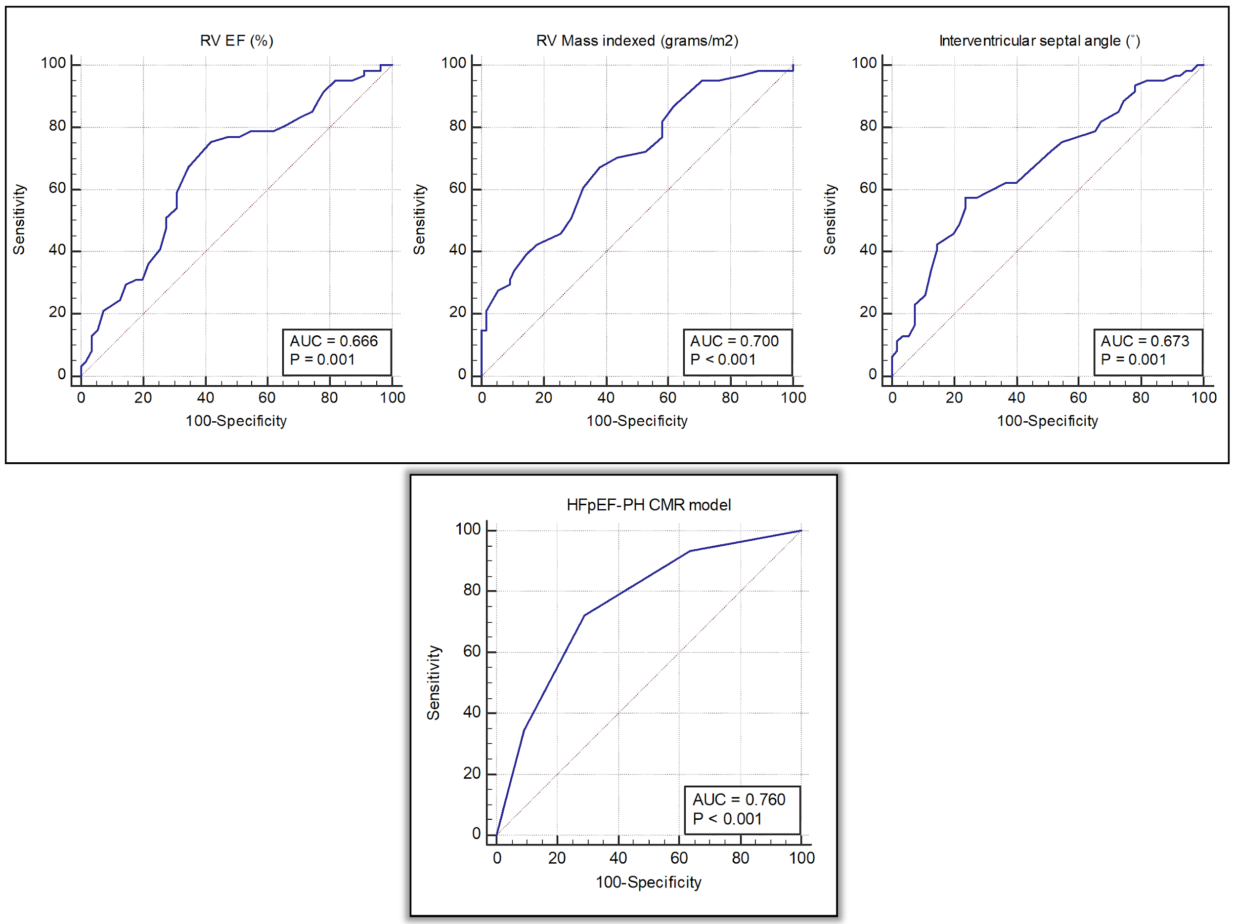

References
1. Kramer CM, Barkhausen J, Flamm SD, Kim RJ, Nagel E. Standardized cardiovascular magnetic resonance imaging (CMR) protocols, society for cardiovascular magnetic resonance: board of trustees task force on standardized protocols. J Cardiovasc Magn Reson Off J Soc Cardiovasc Magn Reson. 2008 Jan 7;10(1):35.
2. Khan MA, Yang EY, Zhan Y, Judd RM, Chan W, Nabi F, et al. Association of left atrial volume index and all-cause mortality in patients referred for routine cardiovascular magnetic resonance: a multicenter study. J Cardiovasc Magn Reson Off J Soc Cardiovasc Magn Reson. 2019 07;21(1):4.
3. Johns CS, Kiely DG, Rajaram S, Hill C, Thomas S, Karunasaagarar K, et al. Diagnosis of Pulmonary Hypertension with Cardiac MRI: Derivation and Validation of Regression Models. Radiology. 2018 Oct 23;180603.
4. Swift AJ, Rajaram S, Condliffe R, Capener D, Hurdman J, Elliot C, et al. Pulmonary artery relative area change detects mild elevations in pulmonary vascular resistance and predicts adverse outcome in pulmonary hypertension. Invest Radiol. 2012 Oct;47(10):571–7.
5. Swift AJ, Capener D, Johns C, Hamilton N, Rothman A, Elliot C, et al. Magnetic Resonance Imaging in the Prognostic Evaluation of Patients with Pulmonary Arterial Hypertension. Am J Respir Crit Care Med. 2017 15;196(2):228–39.
6. Johns CS, Wild JM, Rajaram S, Tubman E, Capener D, Elliot C, et al. Identifying At-Risk Patients with Combined Pre- and Postcapillary Pulmonary Hypertension Using Interventricular Septal Angle at Cardiac MRI. Radiology. 2018;289(1):61–8.

