Supplementary material

1.
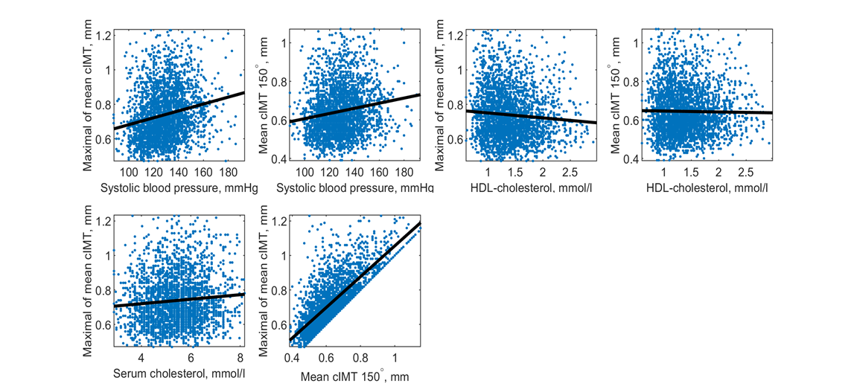

Supplementary material 1. Examples of scatterplots between risk factors, systolic blood pressure, HDL-cholesterol and serum cholesterol and ultrasound variables Maximal of mean cIMT and Mean cIMT 150º, and between the two ultrasound variables

