Agreement of wall shear stress distribution between two core laboratories using three-dimensional quantitative coronary angiography
Short title: Inter Corelab agreement of wall shear stress

Shigetaka Kageyama, MD¹,# Vincenzo Tufaro, MD^{2,3,4},# Ryo Torii, PhD⁵, Grigoris Karamasis, MD⁶, Roby D Rakhit, MD^{7,12}, Eric K. W. Poon, PhD⁸, Jean-Paul Aben, MSc⁹, Andreas Baumbach, MD, PhD^{2,3,10}, Patrick W. Serruys, MD, PhD^{1,11}, Yoshinobu Onuma, MD, PhD¹, Christos V. Bourantas, MD, PhD^{2,3,12}
#Equally contributed to the writing of the manuscript

Supplemental materials
Table 1s. Overview and mathematical description of the shear stress metrics
Shear stress metric | Description | Mathematical formula
Time-averaged WSS (TAWSS), Pa | Shear stress averaged over the cardiac cycle | $$\frac{1}{T}\int_{0}^{T}{\left|τ_{w}(x,t)\right|dt}$$
Oscillatory shear index (OSI) | Ratio between backward and forward going shear stress | $$0.5\left(1-\frac{\left|\int_{0}^{T}{τ_{w}(x,t)dt}\right|}{\int_{0}^{T}{\left|τ_{w}(x,t)\right|dt}}\right)$$
Relative residence time (RRT), Pa⁻¹ | Relative time that a blood particle resides at a certain location at the vessel wall | $$\frac{1}{TAWSS(x)\left\{1-2 OSI\left(x\right)\right\}}$$
Transverse WSS (transWSS), Pa | Shear stress vector in perpendicular direction to the main flow direction | $$\frac{1}{T}\int_{0}^{T}{\left|τ_{w}(x,t)∙p(x)\right|dt}$$
Cross-flow index (CFI) | The transWSS normalized for the time-averaged wall shear stress | $$\frac{1}{T}\int_{0}^{T}{\left|\frac{τ_{w}(x,t)}{\left|τ_{w}(x,t)\right|}∙p(x)\right|dt}$$
(𝑥,𝑡) is the instantaneous shear stress vector for each node 𝑥 and time 𝑡. The cardiac cycle time is T. 𝑝(𝑥) is the vector indicating the cross flow direction which is perpendicular to both the surface normal 𝑛(𝑥) and the mean wall shear stress vector. Abbreviation: WSS, wall shear stress.

Figure 1s. Intercolab variability of 3D-QCA analysis metrics in bifurcated and non-bifurcated modes.
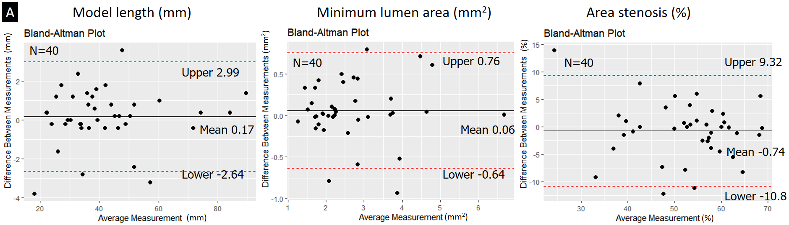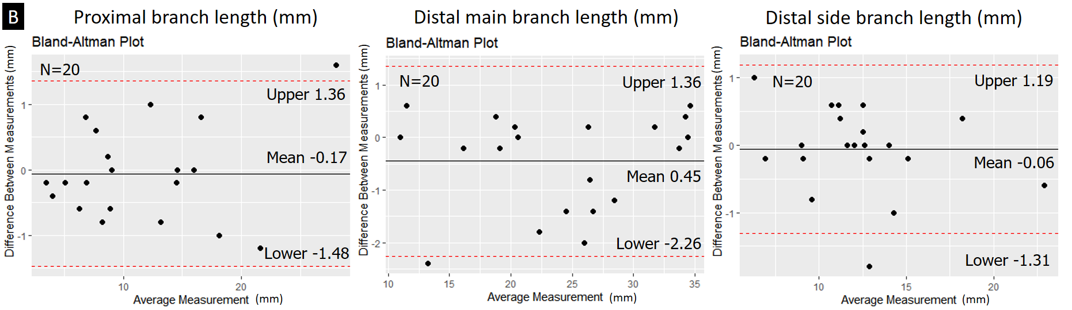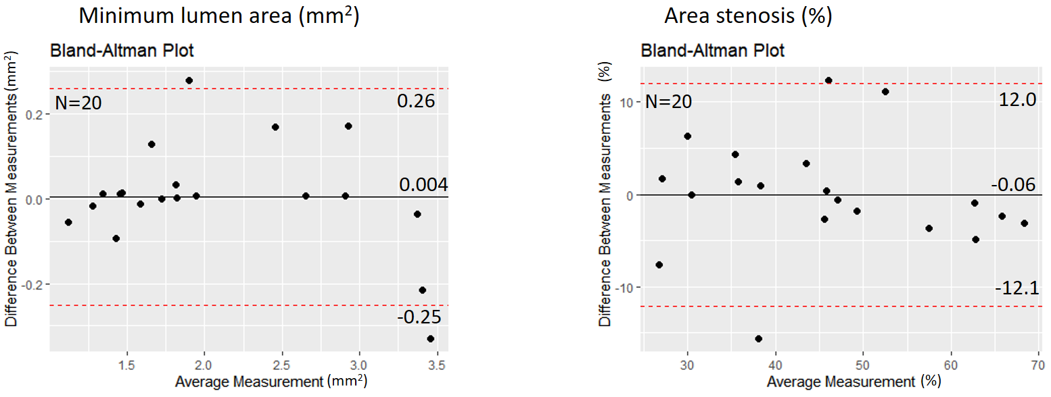
Comparison of 3D-QCA components in Bland-Altman Plot; A: straight models (n=40) and B: bifurcation models (n=20).
Abbreviations: 3D, three-dimensional; QCA, quantitative coronary angiography.

