Supplementary Material

Table S1: Pearson's Correlation Coefficients and P-values
Method Comparison | Pearson's r | P-value | Correlation Strength
2D-PCstandard vs. 2D-PCMVAAo | 0.413 | 0.040 | Moderate
2D-PCstandard vs. 2D-PCMVdirect | 0.798 | <0.001 | Strong
2D-PCstandard vs. Volumetric | 0.126 | 0.540 | Weak
2D-PCstandard vs. 4D-flowstandard | 0.836 | <0.001 | Strong
2D-PCstandard vs. 4D-flowMVAAo | 0.075 | 0.790 | Weak
2D-PCstandard vs. 4D-flowMVdirect | 0.661 | 0.007 | Moderate
2D-PCMVAAo vs. 2D-PCMVdirect | 0.360 | 0.077 | Weak
2D-PCMVAAo vs. Volumetric | -0.129 | 0.539 | Weak
2D-PCMVAAo vs. 4D-flowstandard | 0.671 | 0.006 | Moderate
2D-PCMVAAo vs. 4D-flowMVAAo | 0.310 | 0.261 | Weak
2D-PCMVAAo vs. 4D-flowMVdirect | 0.699 | 0.004 | Moderate
2D-PCMVdirect vs. Volumetric | 0.351 | 0.085 | Weak
2D-PCMVdirect vs. 4D-flowstandard | 0.751 | 0.001 | Strong
2D-PCMVdirect vs. 4D-flowMVAAo | 0.230 | 0.409 | Weak
2D-PCMVdirect vs. 4D-flowMVdirect | 0.639 | 0.010 | Moderate
Volumetric vs. 4D-flowstandard | 0.314 | 0.255 | Weak
Volumetric vs. 4D-flowMVAAo | 0.364 | 0.183 | Weak
Volumetric vs. 4D-flowMVdirect | 0.255 | 0.360 | Weak
4D-flowstandard vs. 4D-flowMVAAo | 0.320 | 0.246 | Weak
4D-flowstandard vs. 4D-flowMVdirect | 0.523 | 0.046 | Moderate
4D-flowMVAAo vs. 4D-flowMVdirect | 0.212 | 0.449 | Weak
Correlation strength classification: r ≥ 0.9: excellent; r = 0.7-0.89: strong; r = 0.4-0.69: moderate; r < 0.4: weak

Figure S0. Heatmap of correlation coefficients and p-values for MVR volume measurements across various CMR flow quantification methods.
The correlation matrix includes data exclusively from the 15 patients who underwent both 2D-PC and 4D-flow acquisition. Pearson correlation coefficients (r) are displayed between pairs of methods, with a color scale ranging from -1 (negative correlation, blue) to 1 (positive correlation, red). P-values are annotated on the heatmap. (Correlation classifications: r ≥ 0.9, excellent correlation; r = 0.7–0.89, strong correlation; r = 0.4–0.69, moderate correlation; r = 0.1–0.39, weak correlation).
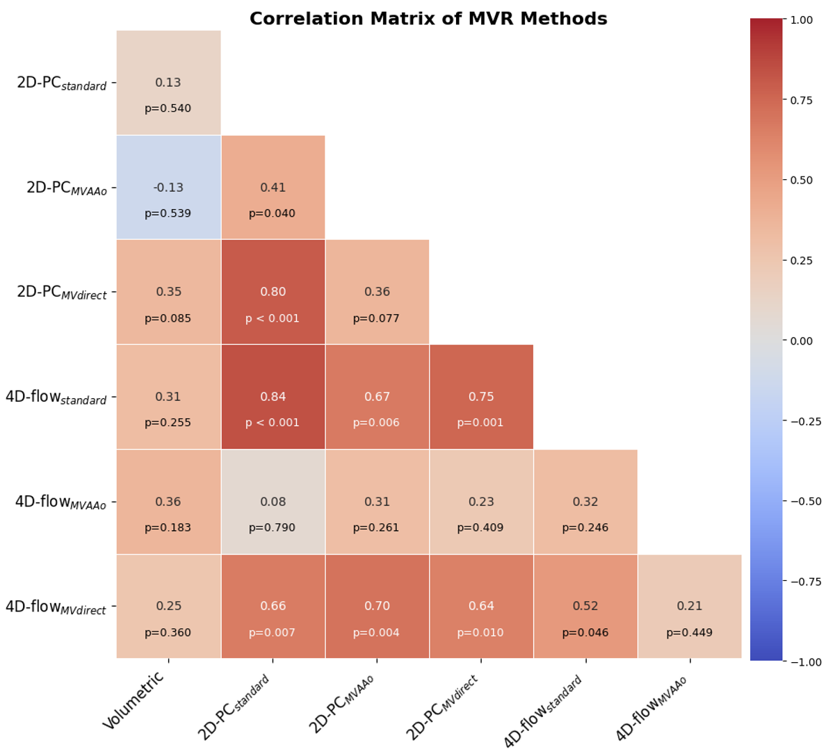

Scatter Plots for Pearson's Correlation
The following scatter plots show the relationships between different MVR quantification methods. These correlation plots correspond to the Bland-Altman plots presented in Figure 5 of the main manuscript.
Figure S2: Scatter plots showing correlations between different methods for quantifying mitral valve regurgitation. Each plot shows the linear relationship between two methods with the correlation coefficient (r) and p-value indicated.
