Supplement
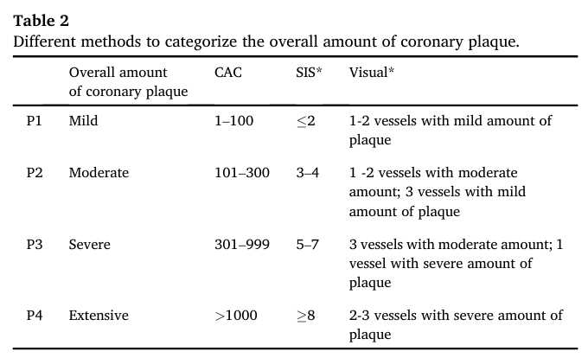
S1. CAD-RADS 2.0 Classification

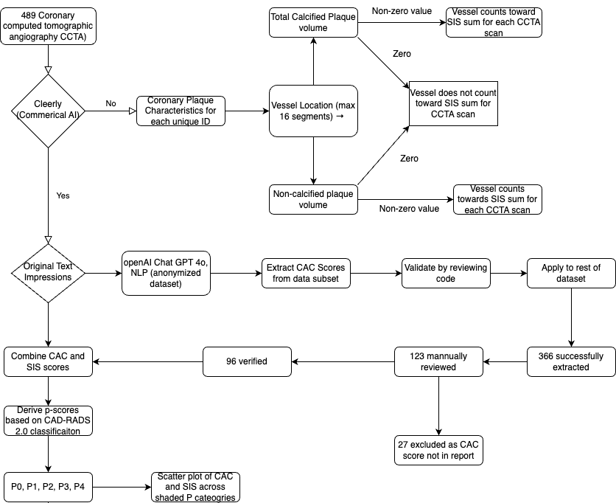

S2: Flowchart illustrating the methodological workflow of the study.

