Supplemental material

Changes in CMR-derived ventricular strain, fibrosis progression
and outcomes in hypertrophic cardiomyopathy

Alberto Aimo MD PhD^{1,2}, Andrea Barison MD PhD^{1,2}, Annamaria Del Franco MD PhD³, Chrysanthos Grigoratos MD PhD ^{1,2}, Alessandro Parlato MD⁴, Chiara Zocchi MD³, Giovanni Donato Aquaro MD PhD⁵, Giorgia Panichella MD⁶, Carmelo De Gori MD⁷, Ignazio Gueli MD PhD ², Alessandro Folgheraiter MD⁸, Antonio De Luca MD⁸, Marco Merlo MD PhD ⁸, Michele Emdin MD PhD ^{1,2}, Gianfranco Sinagra MD PhD ⁸, Iacopo Olivotto MD PhD ^{3,6,9}, Giancarlo Todiere MD PhD ²
1. Interdisciplinary Center for Health Sciences, Scuola Superiore Sant’Anna, Pisa, Italy; 2. Cardiology Division, Fondazione Toscana Gabriele Monasterio, Pisa, Italy; 3. Cardiomyopathy Unit, Careggi University Hospital, Florence, Italy; 4. Cardiology Division, University Hospital of Pisa, Pisa, Italy; 5. Academic Radiology Unit, Department of Surgical Medical and Molecular Pathology and Critical Area, University of Pisa, Pisa, Italy; 6. Department of Experimental and Clinical Medicine, University of Florence, Italy; 7. Radiology Division, Fondazione Toscana Gabriele Monasterio, Pisa, Italy; 8. Cardiology Division, University Hospital of Trieste, Trieste, Italy; 9. Cardiology Unit, Meyer Children’s Hospital IRCCS, Florence, Italy.

Supplemental Figure 1. Flowchart of patient selection.

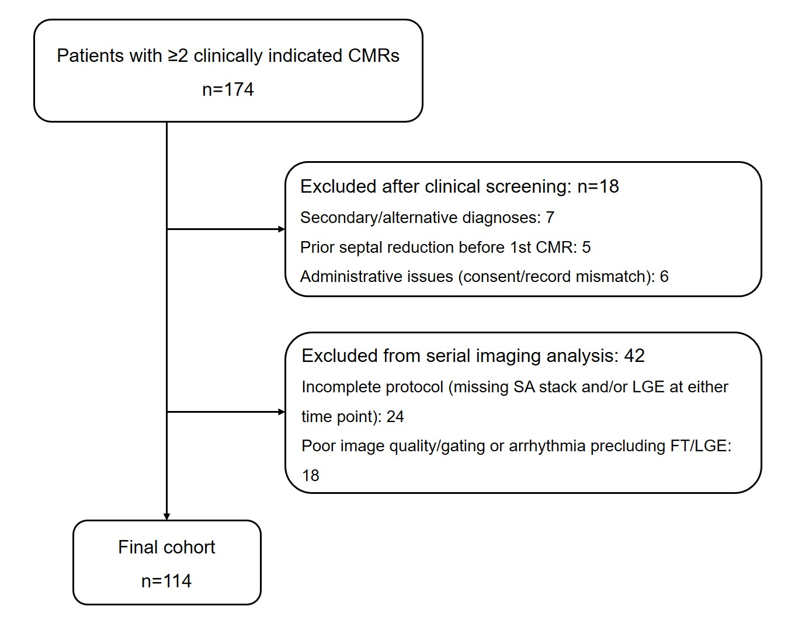

CMR, cardiovascular magnetic resonance; FT, feature-tracking; LGE, late gadolinium enhancement; SA, short-axis.

Supplemental Table 1. Patient characteristics: obstructive vs. non-obstructive disease.

 | Obstructive HCM  n=16 (14%) | Non-obstructive HCM  n=98 (86%) | p
Men, n (%) | 12 (75) | 71 (72) | 0.832
Age (years) | 59 (49-69) | 49 (35-59) | 0.018
Palpitations, n (%) | 6 (38) | 29 (30) | 0.525
Unexplained syncope, n (%) | 1 (6) | 5 (5) | 0.849
Angina, n (%) | 6 (38) | 19 (19) | 0.104
Dyspnea on effort, n (%) | 10 (63) | 26 (27) | 0.004
Atrial fibrillation, n (%) | 3 (19) | 16 (16) | 0.809
NSVT, n (%)* | 3 (25) | 11 (16) | 0.444
Family history of SCD, n (%)* | 1 (8) | 11 (16) | 0.514
LVOT gradient (mmHg) | 15 (3-46) | 5 (2-10) | 0.028
Maximal LV wall thickness (mm) | 20 (17-22) | 17 (15-19) | 0.012
Left atrial diameter (mm) | 41 (35-44) | 38 (34-43) | 0.530
HCM score (%) | 2 (2-3) | 2 (2-3) | 0.767

* Percentage calculated out of the available data. Significant p values are reported in bold. HCM, hypertrophic cardiomyopathy; LV, left ventricle; LVOT, left ventricular outflow tract; NSVT, non-sustained ventricular tachycardia; NYHA, New York Heart Association; SCD, sudden cardiac death.

Supplemental Table 2. Changes in left ventricular strain values.

 | Absolute change | Absolute change per year
Longitudinal (%) | +1 (-1/+3) | 0 (0/+1)
Circumferential (%) | 0 (-1/+2) | 0 (0/0)
Radial long-axis (%) | -2 (-6/+2) | 0 (-1/0)
Radial short-axis (%) | 0 (-4/+3) | 0 (-1/+1)

