Supplemental Figures

Supplemental Figure 1: Correlation plot CCTA versus IVUS

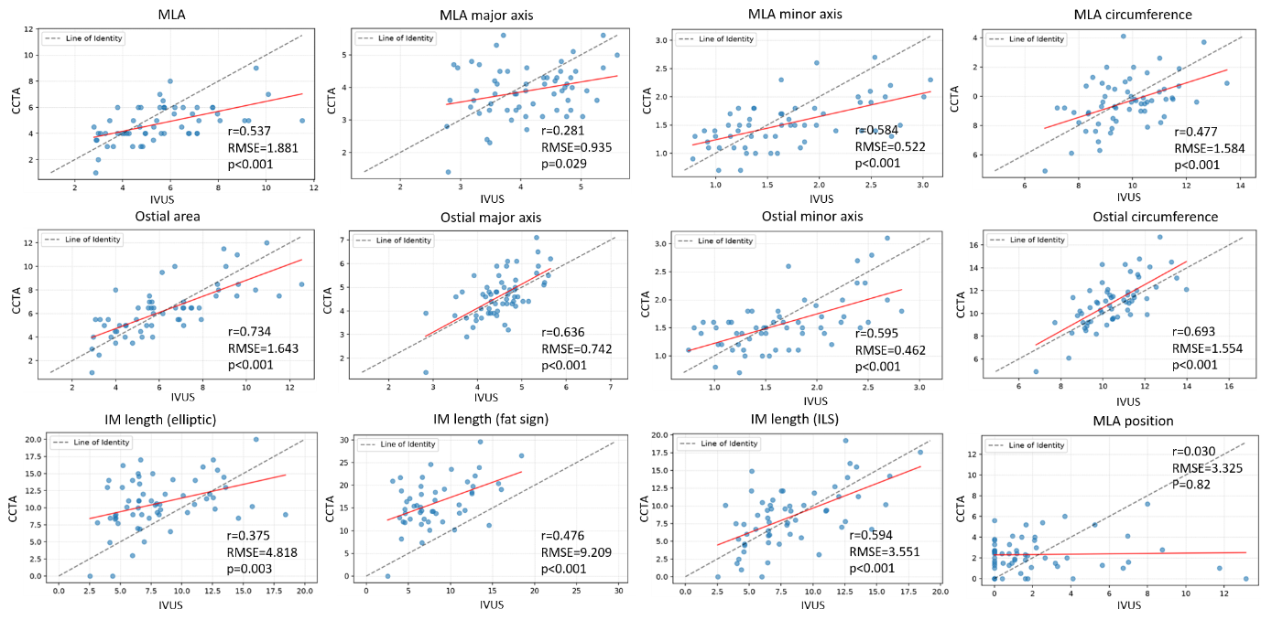

Supplemental Figure 2: Exclusion image quality blurry images

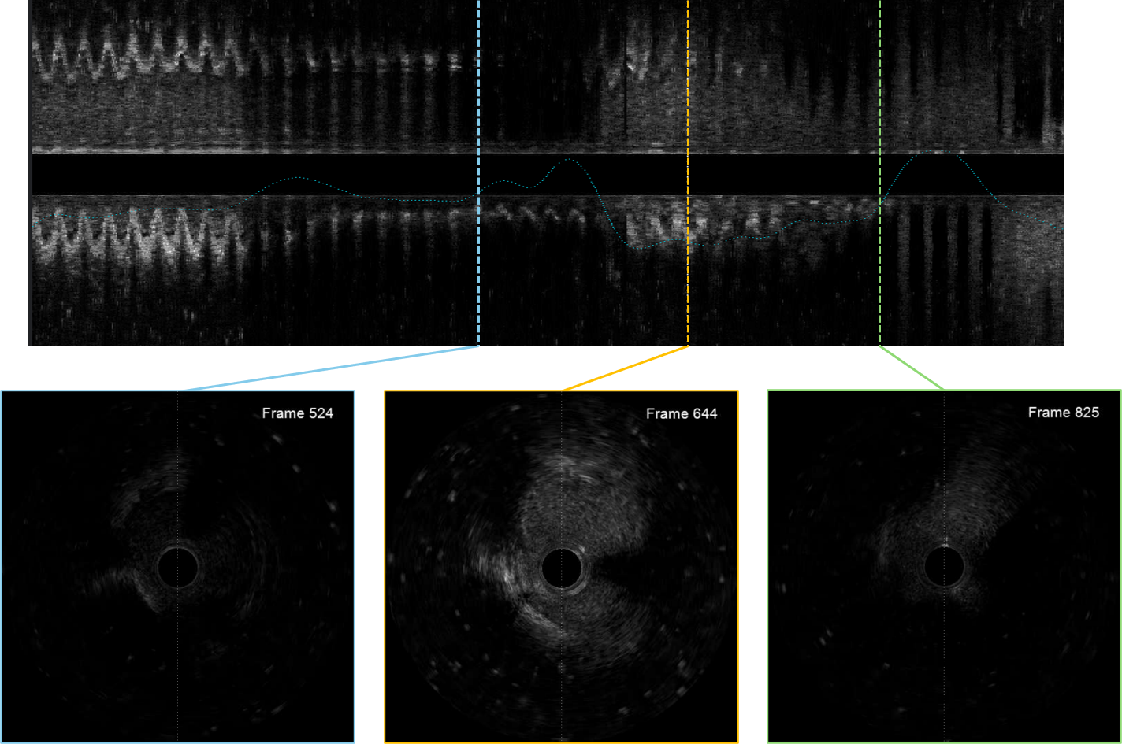
Exclusion criterion illustrated in a patient whose images were sufficiently blurry to preclude confident full-length segmentation along the entire vessel course.

Supplemental Figure 3: Exclusion image quality blurry wire in ostium, ostium cut-off

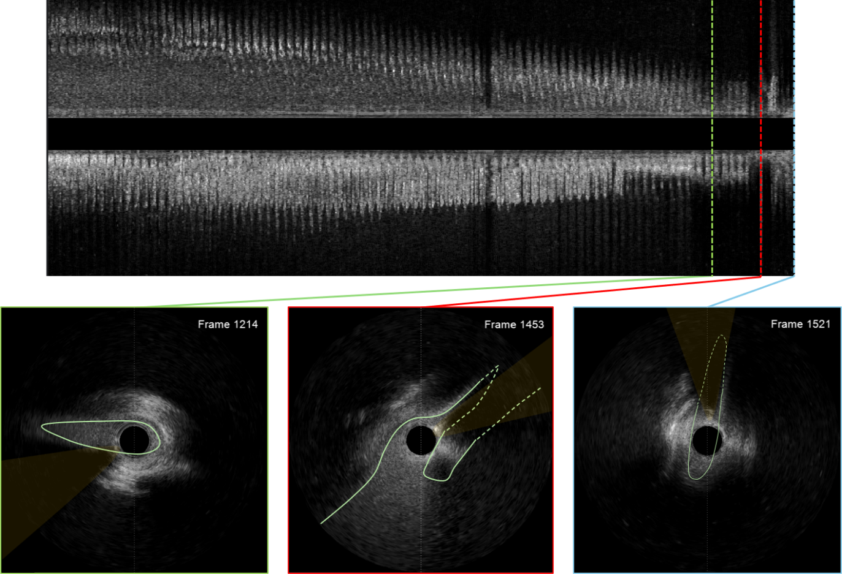
Case example illustrating two exclusion criteria. First, the most common issue: Wire position at the ostium casts a shadow over the entire major axis, precluding vessel estimation at this location (indicated by the dotted line). While clinical analysis remains feasible based on the high-quality lumen visible in frame 1214 (green), 3D reconstruction is not possible under these conditions.
The second issue in this pullback is that acquisition was stopped prematurely, such that the aorta is never visualized during the diastolic phase (compare with the systolic phase in red, where the ostium and aortic blood pool are clearly visible). Consequently, intramural length estimation is not possible.

Supplemental Figure 3: Cases not included in 9 cases figure

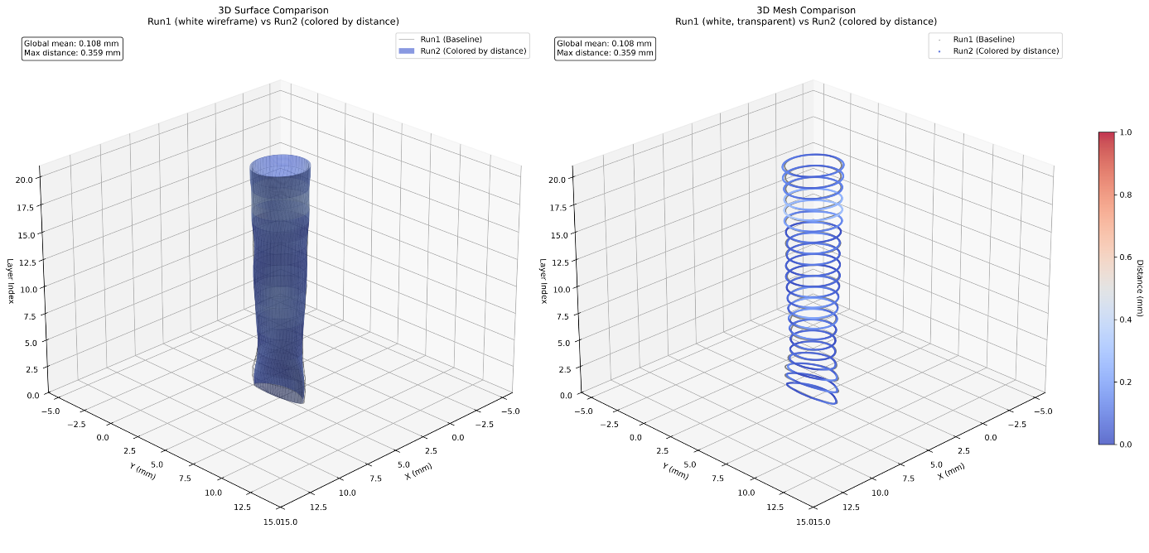

Supplemental Tables
Supplemental Table 1: Geometrical error by pointwise distance intrareader analysis.

Case | Median distance [mm] | 5th percentile distance [mm] | 25th percentile distance [mm] | 50th percentile distance [mm] | 75th percentile distance [mm] | 95th percentile distance [mm] | 99th percentile distance [mm]
Case 1 | 0.21 | 0.06 | 0.12 | 0.21 | 0.30 | 0.47 | 0.60
Case 2 | 0.25 | 0.09 | 0.17 | 0.25 | 0.33 | 0.52 | 0.67
Case 3 | 0.48 | 0.30 | 0.42 | 0.48 | 0.54 | 0.62 | 0.65
Case 4 | 0.28 | 0.05 | 0.13 | 0.28 | 0.47 | 0.65 | 0.72
Case 5 | 0.25 | 0.08 | 0.18 | 0.25 | 0.38 | 0.65 | 0.76
Case 6 | 0.05 | 0.01 | 0.03 | 0.05 | 0.09 | 0.14 | 0.19
Case 7 | 0.14 | 0.02 | 0.07 | 0.14 | 0.23 | 0.43 | 0.49
Case 8 | 0.09 | 0.02 | 0.05 | 0.09 | 0.18 | 0.30 | 0.38
Case 9 | 0.10 | 0.03 | 0.06 | 0.1 | 0.14 | 0.20 | 0.24
Case 10 | 0.09 | 0.02 | 0.06 | 0.09 | 0.14 | 0.27 | 0.32
Average | 0.19 | 0.07 | 0.13 | 0.19 | 0.28 | 0.43 | 0.50

Pointwise distance between first 3D reconstruction and second reconstruction. Points with the same ID are compared by Euclidean distance, and the averaged results over all points are reported (see also figure 6).
Supplemental Table 2: Repeated 3D reconstructed IVUS measurements from run 1 and run 2 and their difference by paired t-test.
Variable | Run 1 | Run 2 | p-value
Intramural length [mm] | 17.2 ± 5.8 | 15.4 ± 4.3 | 0.15
Ostial lumen area (diastole) [mm²] | 9.7 ± 2.3 | 8.8 ± 2.2 | 0.040
Ostial lumen area (systole) [mm²] | 10.0 ± 1.6 | 9.5 ± 1.9 | 0.086
Minimal lumen area (diastole) [mm²] | 5.4 ± 1.9 | 5.3 ± 2.2 | 0.69
Minimal lumen area (systole) [mm²] | 5.0 ± 1.9 | 4.6 ± 1.5 | 0.16
Ostial minor axis (diastole) [mm] | 3.2 ± 0.5 | 3.1 ± 0.5 | 0.24
Ostial minor axis (systole) [mm] | 3.4 ± 0.3 | 3.3 ± 0.4 | 0.16
Minimal lumen minor axis (diastole) [mm] | 1.5 ± 0.6 | 1.6 ± 0.6 | 0.67
Minimal lumen minor axis (systole) [mm] | 1.4 ± 0.6 | 1.4 ± 0.5 | 0.24
Ostial circumference (diastole) [mm] | 11.1 ± 1.2 | 10.5 ± 1.3 | 0.020
Ostial circumference (systole) [mm] | 11.3 ± 0.9 | 11.0 ± 1.0 | 0.10
Minimal lumen circumference (diastole) [mm] | 10.0 ± 0.9 | 9.7 ± 1.0 | 0.12
Minimal lumen circumference (systole) [mm] | 9.9 ± 1.1 | 9.7 ± 0.9 | 0.22
Reference area (diastole) [mm²] | 10.2 ± 2.1 | 9.2 ± 2.2 | 0.073
Reference area (systole) [mm²] | 10.1 ± 1.7 | 9.6 ± 2.1 | 0.13
Reference circumference (diastole) [mm] | 11.3 ± 1.2 | 10.7 ± 1.4 | 0.057
Reference circumference (systole) [mm] | 11.4 ± 1.0 | 11.0 ± 1.2 | 0.074
MLA position from ostium [mm] | 18.7 ± 7.0 | 16.0 ± 6.0 | 0.13

Abbreviations: MLA = Minimal lumen area

Supplemental Table 3: Intra-reader and inter-reader clinical IVUS measurements

Variable (n=10) | Intra-reader 3D-IVUS | p-value | Intra-reader clinical IVUS | p-value | Inter-reader 3D-IVUS versus clinical | p-value
Ostial lumen area [mm²] | 0.95 (0.82-0.99) | <0.001 | 0.91 (0.70-0.98) | <0.001 | 0.77 (0.33-0.94) | 0.002
Ostial lumen circumference [mm] | 0.87 (0.59-0.97) | <0.001 | 0.82 (0.46-0.95) | <0.001 | 0.77 (0.33-0.94) | 0.002
Ostial major axis length [mm] | 0.72 (0.24-0.92) | 0.002 | 0.84 (0.49-0.96) | <0.001 | 0.60 (0.02-0.88) | 0.022
Ostial minor axis length [mm] | 0.95 (0.82-0.99) | <0.001 | 0.96 (0.85-0.99) | <0.001 | 0.86 (0.55-0.96) | <0.001
Minimal lumen area (MLA) [mm²] | 0.94 (0.78-0.98) | <0.001 | 0.88 (0.62-0.97) | <0.001 | 0.86 (0.56-0.96) | <0.001
MLA circumference [mm] | 0.82 (0.46-0.95) | <0.001 | 0.70 (0.20-0.91) | <0.001 | 0.63 (0.07-0.89) | 0.016
MLA major axis length [mm] | 0.76 (0.32-0.93) | 0.004 | 0.67 (0.15-0.91) | <0.001 | 0.64 (0.10-0.90) | 0.013
MLA minor axis length [mm] | 0.96 (0.86-0.99) | <0.001 | 0.90 (0.66-0.97) | <0.001 | 0.86 (0.57-0.96) | <0.001
Intramural length [mm] | 0.96 (0.86-0.99) | <0.001 | 0.95 (0.83-0.99) | <0.001 | 0.86 (0.55-0.96) | <0.001
MLA position [mm] | 0.76 (0.31-0.93) | <0.001 | 0.44 (-0.19-0.82) | <0.001 | 0.14 (-0.02-0.50) | 0.66

Abbreviations: MLA = Minimal lumen area

Supplemental Table 4: Correlation results between CCTA measurements and 3D-IVUS measurements.

Variable | Pearson’s r | Slope | intercept | p-value
Ostial area [mm²] | 0.73 | 0.68 | 1.99 | <0.001
Ostial circumference [mm] | 0.69 | 1.02 | 0.28 | <0.001
Ostial major axis length [mm] | 0.64 | 1.02 | 0.04 | <0.001
Ostial minor axis length [mm] | 0.59 | 0.52 | 0.70 | <0.001
Minimal lumen area (MLA) [mm²] | 0.54 | 0.38 | 2.64 | <0.001
MLA circumference [mm] | 0.48 | 0.59 | 3.83 | <0.001
MLA major axis length [mm] | 0.28 | 0.31 | 2.62 | 0.030
MLA minor axis length [mm] | 0.58 | 0.41 | 0.83 | <0.001
MLA position [mm] | 0.03 | 0.02 | 2.29 | 0.82
Distal reference area [mm²] | 0.60 | 0.67 | 3.74 | <0.001
Distal reference circumference [mm] | 0.62 | 0.71 | 3.17 | <0.001
Intramural length (IML) (elliptic ratio >1.3) [mm] | 0.38 | 0.40 | 7.40 | <0.001
IML (interluminal space >atrial distance) [mm] | 0.39 | 0.61 | 9.76 | <0.001
IM (interluminal space >pulmonary distance) [mm] | 0.46 | 0.67 | 6.43 | <0.001
IM fat pad sign [mm] | 0.48 | 0.67 | 10.66 | <0.001
IM (interluminal space >1.5mm) [mm] | 0.59 | 0.69 | 2.72 | <0.001

Abbreviations: IML = Intramural length, MLA = Minimal lumen area

