Supplementary Figure S2: GNAS in the cAMP-PKA Pathway
A
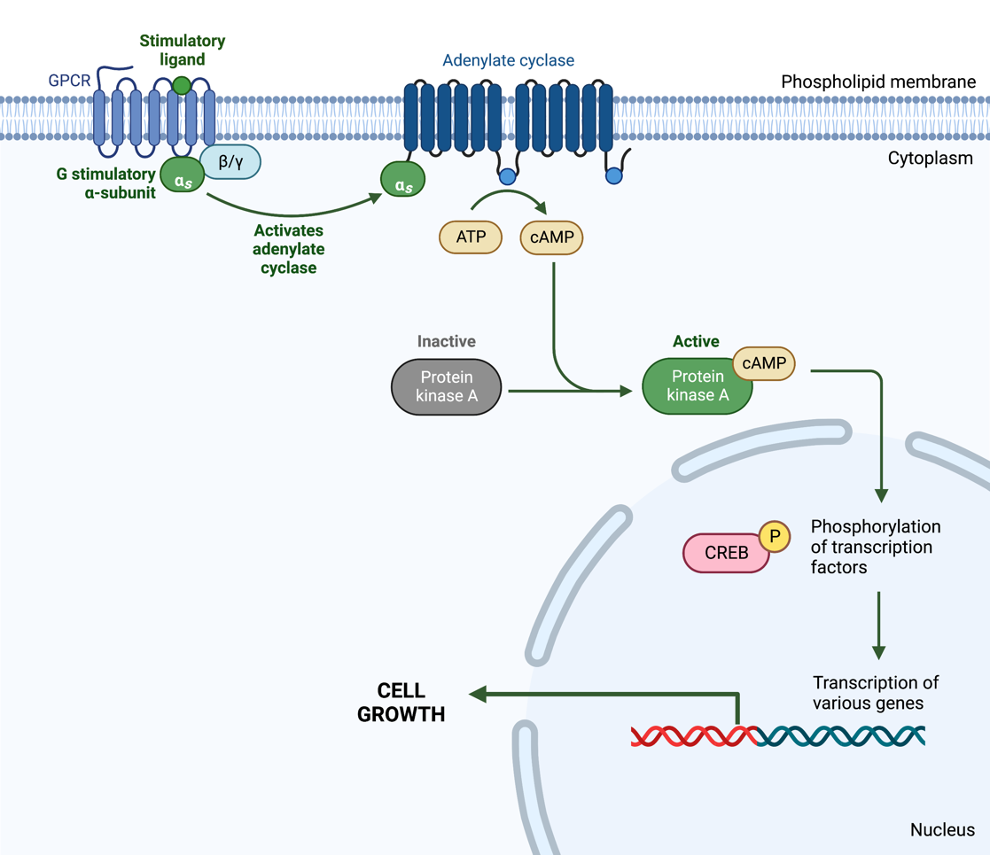

B
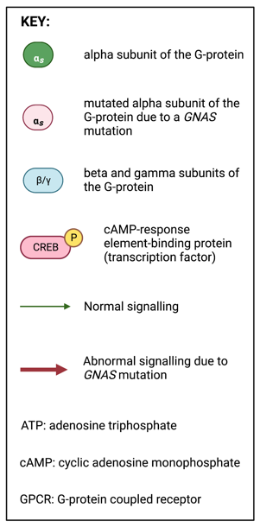
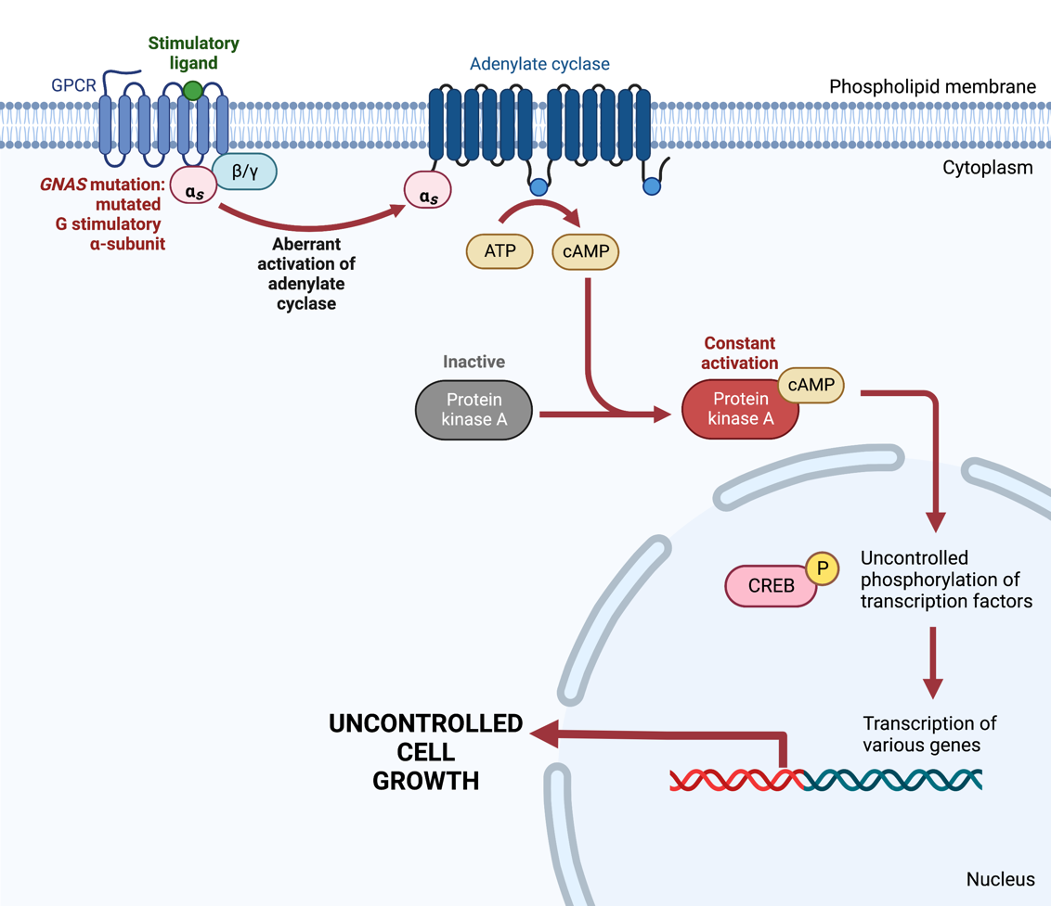

Supplementary Figure 2: GNAS in the cAMP-PKA pathway. (A) An extracellular ligand binds to the stimulatory part of the G-protein coupled receptor (GPCR) which activates the alpha-subunit of the G-protein. This activates adenylate cyclase which in turn activates cyclic adenosine monophosphate (cAMP), a second messenger. cAMP activates protein kinase A (PKA) which phosphorylates transcriptional factors in the nucleus. As a result, there is transcription of genes involved in cell growth. (B) A GNAS mutation codes for a mutated alpha-subunit of the G-protein which causes aberrant activation of adenylate cyclase. This leads to an increase in the downstream activation of cAMP resulting in the constant activation of PKA. Consequently, there is uncontrolled activation of transcription factors which results in the unregulated transcription of genes involved in cell growth. Based on the findings of Hannah-Shmouni et al.⁸¹ (Created with BioRender.com, accessed on 14 November 2022).

