Supplemental figure S1

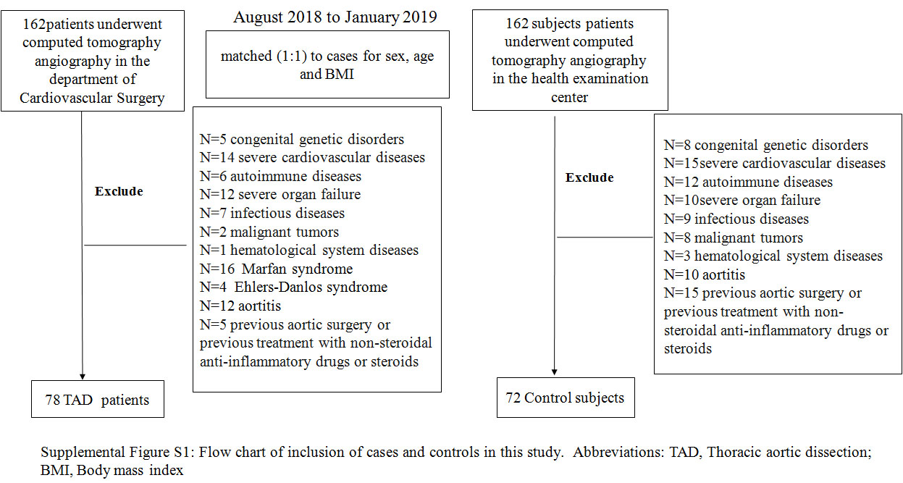

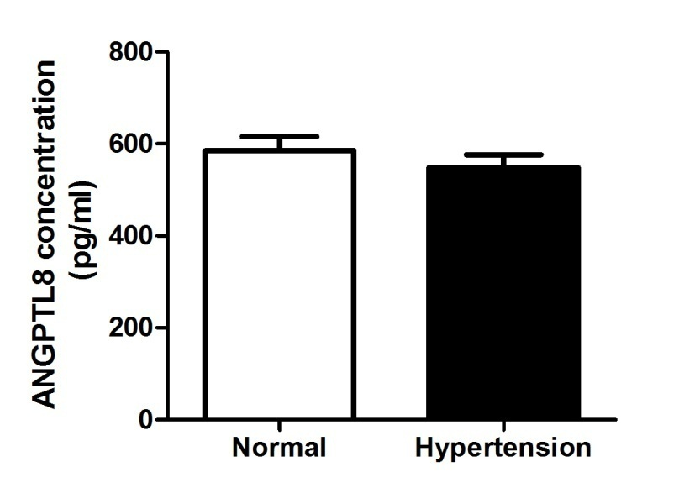

Supplemental firuge S2. Circulation level of ANGPTL8 in TAD patients with or without hypertension.
Plasma levels of ANGPTL8 in TAD subjects without hypertension vs. those with hypertension as measured by ELISA. * p < 0.05, as determined using Student’s t-test

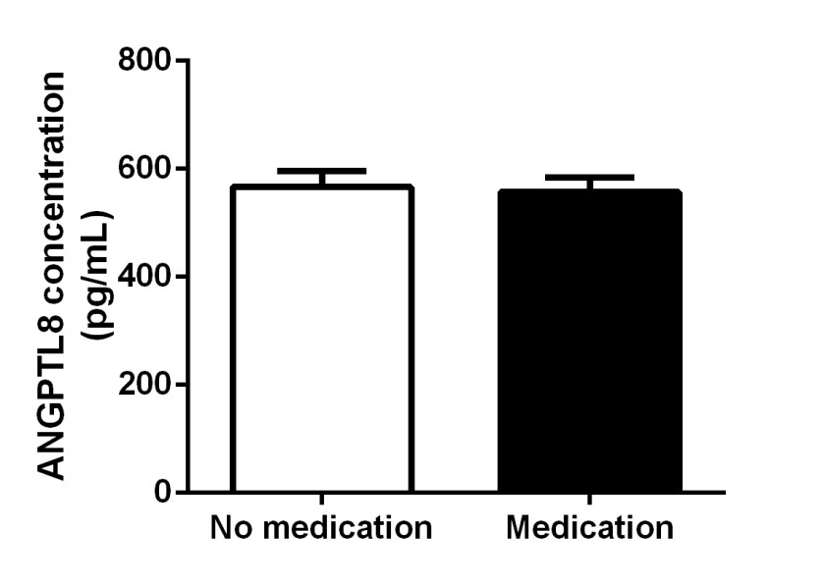

Supplemental Figure S3. Circulation level of ANGPTL 8 in hypertension patients with or without medication. Plasma levels of ANGPTL8 in TAD subjects without anti-hypertension medication vs. those with anti-hypertension medication as measured by ELISA. * p < 0.05, as determined using Student’s t-test

