Supplemental Table 1. Summary of adjustments to background statin therapy, and the reasons for those adjustments, made during ODYSSEY OLE by region (safety population)
n (%) | North America  (n = 176) | Western Europe  (n = 460) | Eastern Europe  (n = 105) | ROW  (n = 168) | All  (n = 909)
Any change in statinª | 37 (21.0) | 109 (23.7) | 14 (13.3) | 39 (23.2) | 199 (21.9)
Statin interruption | 22 (12.5) | 33 (7.2) | 3 (2.9) | 15 (8.9) | 73 (8.0)
Reason for statin interruption
Adverse event | 11 (6.3) | 14 (3.0) | 1 (1.0) | 4 (2.4) | 30 (3.3)
LDL-C too low^{b} | 0 (0.0) | 3 (0.7) | 1 (1.0) | 0 (0.0) | 4 (0.4)
Poor adherence | 1 (0.6) | 10 (2.2) | 1 (1.0) | 3 (1.8) | 15 (1.7)
Statin discontinuation | 12 (6.8) | 11 (2.4) | 3 (2.9) | 8 (4.8) | 34 (3.7)
Reason for statin discontinuation
Adverse event | 6 (3.4) | 7 (1.5) | 1 (1.0) | 4 (2.4) | 18 (2.0)
LDL-C too low^{b} | 0 (0.0) | 2 (0.4) | 1 (1.0) | 0 (0.0) | 3 (0.3)
Poor adherence | 0 (0.0) | 1 (0.2) | 1 (1.0) | 0 (0.0) | 2 (0.2)
Change in statin type | 7 (4.0) | 17 (3.7) | 2 (1.9) | 14 (8.3) | 40 (4.4)
Reason for change in statin type
Adverse event | 4 (2.3) | 10 (2.2) | 2 (1.9) | 3 (1.8) | 19 (2.1)
Statin dose increase | 5 (2.8) | 21 (4.6) | 6 (5.7) | 7 (4.2) | 39 (4.3)
Reason for statin dose increase
LDL-C too high^{b} | 2 (1.1) | 7 (1.5) | 4 (3.8) | 1 (0.6) | 14 (1.5)
Other | 3 (1.7) | 10 (2.2) | 2 (1.9) | 4 (2.4) | 19 (2.1)
Statin dose decrease | 11 (6.3) | 59 (12.8) | 10 (9.5) | 11 (6.5) | 91 (10.0)
Reason for statin dose decrease
Adverse event | 5 (2.8) | 13 (2.8) | 2 (1.9) | 3 (1.8) | 23 (2.5)
LDL-C too low^{b} | 3 (1.7) | 36 (7.8) | 7 (6.7) | 1 (0.6) | 47 (5.2)
Poor adherence | 0 (0.0) | 0 (0.0) | 1 (1.0) | 0 (0.0) | 1 (0.1)
Other | 2 (1.1) | 8 (1.7) | 1 (1.0) | 2 (1.2) | 13 (1.4)
ªData include any changes in dose, type or discontinuation at any visit after OLE entry, compared with previous recording.
^{b}As per investigator judgment.
LDL-C, low-density lipoprotein cholesterol; ROW, rest of world.

Supplemental Table 2. Summary of adjustments to background non-statin LLTs, and the reasons for those adjustments, made during ODYSSEY OLE by region (safety population)
n (%) | North America  (n = 176) | Western Europe  (n = 460) | Eastern Europe  (n = 105) | ROW  (n = 168) | All  (n = 909)
Any change in non-statin LLTª | 43 (24.4) | 110 (23.9) | 13 (12.4) | 22 (13.1) | 188 (20.7)
Non-statin LLT interruption | 9 (5.1) | 31 (6.7) | 4 (3.8) | 3 (1.8) | 47 (5.2)
Reason for non-statin LLT interruption
LDL-C too low^{b} | 0 (0.0) | 14 (3.0) | 2 (1.9) | 1 (0.6) | 17 (1.9)
Supply issue | 3 (1.7) | 4 (0.9) | 1 (1.0) | 1 (0.6) | 9 (1.0)
Poor adherence | 2 (1.1) | 3 (0.7) | 1 (1.0) | 1 (0.6) | 7 (0.8)
Non-statin LLT discontinuation | 37 (21.0) | 45 (9.8) | 6 (5.7) | 15 (8.9) | 103 (11.3)
Reason for non-statin LLT discontinuation
Adverse event | 4 (2.3) | 7 (1.5) | 1 (1.0) | 2 (1.2) | 14 (1.5)
LDL-C too low^{b} | 9 (5.1) | 30 (6.5) | 5 (4.8) | 5 (3.0) | 49 (5.4)
Change in non-statin LLT type | 4 (2.3) | 41 (8.9) | 2 (1.9) | 6 (3.6) | 53 (5.8)
Reason for change in non-statin LLT type
LDL-C too high^{b} | 3 (1.7) | 3 (0.7) | 1 (1.0) | 2 (1.2) | 9 (1.0)
Other | 0 (0.0) | 37 (8.0) | 1 (1.0) | 4 (2.4) | 42 (4.6)
Non-statin LLT dose increase | 1 (0.6) | 3 (0.7) | 1 (1.0) | 0 (0.0) | 5 (0.6)
Reason for non-statin LLT dose increase
LDL-C too high^{b} | 0 (0.0) | 3 (0.7) | 1 (1.0) | 0 (0.0) | 4 (0.4)
Non-statin LLT dose decrease | 3 (1.7) | 7 (1.5) | 1 (1.0) | 0 (0.0) | 11 (1.2)
Reason for non-statin dose decrease
Poor adherence | 0 (0.0) | 0 (0.0) | 1 (1.0) | 0 (0.0) | 1 (0.1)
ªData include any changes in dose, type or discontinuation at any visit after OLE entry, compared with previous recording.
^{b}As per investigator judgment.
LDL-C, low-density lipoprotein cholesterol; LLT, lipid-lowering therapy; ROW, rest of world.

Supplemental Table 3. Summary of patients with an alirocumab dose adjustment decision during ODYSSEY OLE, and the LDL-C levels used to guide those shared physician–patient decisions, by dose adjustment decision and region according to ASCVD status at OLE baseline (safety population)
Patients with ASCVD | North America |  | Western Europe |  | Eastern Europe |  | ROW |  | All
Patients with ASCVD | Yes  (n = 96) | No  (n = 80) | Yes  (n = 224) | No  (n = 236) | Yes  (n = 51) | No  (n = 54) | Yes  (n = 78) | No  (n = 90) | Yes  (n = 449) | No  (n = 460)
Patients with any dose decision to maintain on 75 mg Q2W, n (%) | 55  (57.3) | 48  (60.0) | 151  (67.4) | 174  (73.7) | 41  (80.4) | 43  (79.6) | 60  (76.9) | 63  (70.0) | 307 (68.4) | 328 (71.3)
LDL-C at time of decision, mean (SD), mmol/L | 1.7 (0.7) | 2.2 (1.1) | 1.5 (0.7) | 1.8 (0.6) | 1.9 (0.9) | 2.1 (1.3) | 1.8 (0.8) | 2.0 (0.7) | 1.7 (0.8) | 1.9 (0.8)
Patients with any dose decision to increase to 150 mg Q2W, n (%) | 54  (56.3) | 43  (53.8) | 101 (45.1) | 83  (35.2) | 8  (15.7) | 21  (38.9) | 36  (46.2) | 38  (42.2) | 199 (44.3) | 185 (40.2)
LDL-C at time of decision, mean (SD), mmol/L | 3.1 (1.3) | 3.4 (1.2) | 2.8 (1.2) | 3.4 (1.3) | 2.9 (0.6) | 4.0 (1.3) | 3.3 (1.2) | 4.2 (1.5) | 3.0 (1.2) | 3.6 (1.4)
Patients with any dose decision to maintain on 150 mg Q2W, n (%) | 50  (52.1) | 40  (50.0) | 101 (45.1) | 76  (32.2) | 8  (15.7) | 19  (35.2) | 33  (42.3) | 35  (38.9) | 192  (42.8) | 170 (37.0)
LDL-C at time of decision, mean (SD), mmol/L | 2.1 (1.4) | 2.4 (1.2) | 1.9 (1.0) | 2.5 (1.5) | 2.2 (0.7) | 2.9 (1.6) | 2.1 (1.1) | 3.0 (1.4) | 2.0 (1.1) | 2.6 (1.4)
ASCVD, atherosclerotic cardiovascular disease; LDL-C, low-density lipoprotein cholesterol; Q2W, every 2 weeks; ROW, rest of world; SD, standard deviation.

Supplemental Table 4. Percent changes in lipid parameters from parent study baseline to Week 96 of ODYSSEY OLE (modified intention-to-treat analysis)
Change from parent study baseline, % | North America | Western Europe | Eastern Europe | ROW | All
LDL-C, mean (SD) [n] | −46.8 (24.7) [64] | −49.9 (26.0) [378] | −44.4 (27.9) [83] | −44.0 (29.9) [135] | −47.7 (27.0) [660]
Non-HDL-C, mean (SD) [n] | −40.4 (26.5) [64] | −42.4 (23.9) [381] | −34.8 (29.0) [87] | −36.1 (28.3) [137] | −39.9 (25.9) [669]
ApoB, mean (SD) [n] | −38.7 (22.0) [63] | −39.4 (20.8) [376] | −34.1 (25.0) [87] | −33.4 (24.9) [135] | −37.4 (22.5) [661]
Lp(a), median (Q1:Q3) [n] | −30.2 (−45.5:−16.7) [63] | −25.0 (−42.8:−6.5) [377] | −28.6 (−50.0:−2.9) [87] | −32.7 (−45.5:−12.5) [135] | −26.7 (−45.0:−9.1) [662]
Fasting TGs, median (Q1:Q3) [n] | −5.7 (−29.4:21.8) [64] | −1.7 (−23.1:27.1) [379] | 1.6 (−18.7:33.3)  [86] | 1.9 (−19.3:40.5) [137] | −1.2 (−21.4:29.8) [666]
HDL-C, mean (SD) [n] | 6.5 (20.2) [64] | 7.7 (18.7) [381] | 5.1 (15.4) [87] | 6.3 (19.6) [137] | 7.0 (18.6) [669]
Total cholesterol, mean (SD) [n] | −30.0 (21.7) [64] | −30.8 (18.8) [381] | −24.7 (21.2) [87] | −26.8 (22.7) [137] | −29.1 (20.3) [669]
Apo, apolipoprotein; HDL-C, high-density lipoprotein cholesterol; LDL-C, low-density lipoprotein cholesterol; Lp(a), lipoprotein (a); ROW, rest of world; SD, standard deviation; TGs, triglycerides.

Supplemental Fig. 1. (A) Percent change in calculated LDL-C from baseline of parent studies to Week 8 and Week 96 of ODYSSEY OLE, and (B) mean (SE) LDL-C levels over time at Week 96, according to region and overall (modified intention-to-treat analysis)
(A)
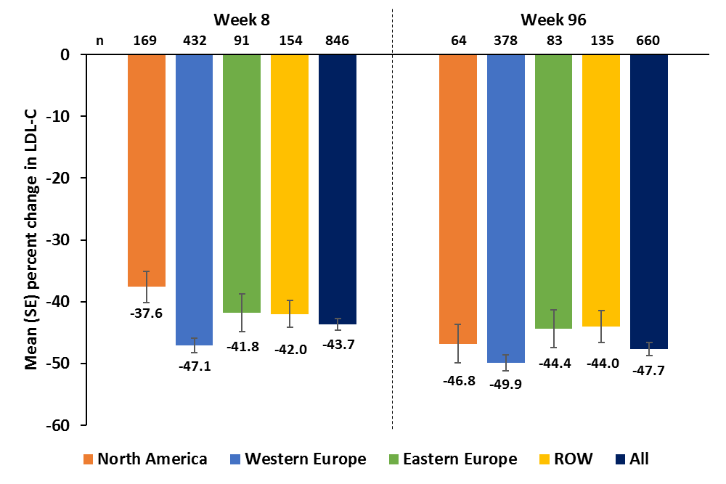

(B)
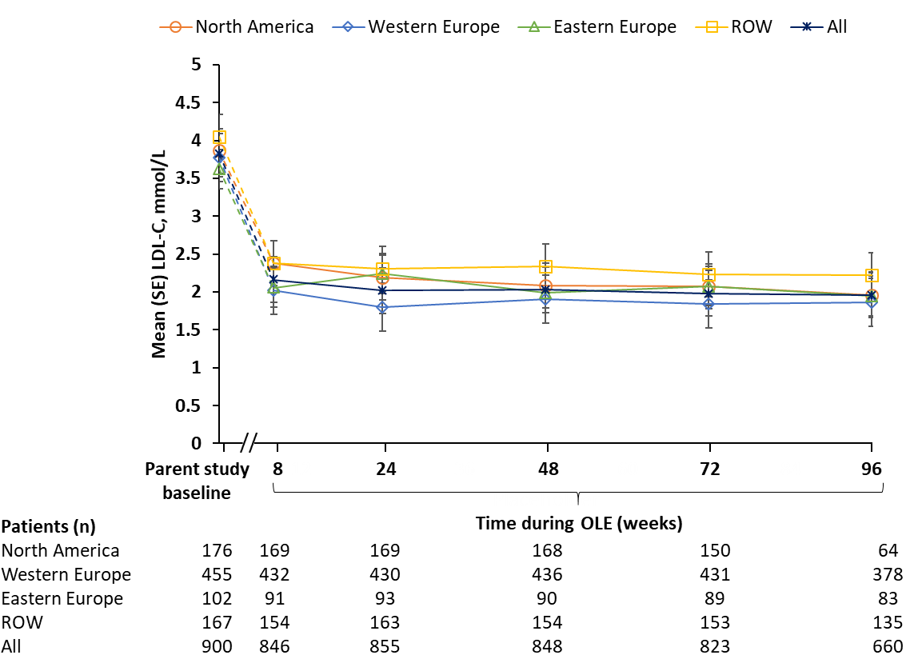
LDL-C, low-density lipoprotein cholesterol; ROW, rest of world; SE, standard error.

Supplemental Fig. 2. Proportion of patients achieving LDL-C goals by region during ODYSSEY OLE. (A) LDL-C <1.8 mmol/L (70 mg/dL), (B) LDL-C <2.6 mmol/L (100 mg/dL), and (C) LDL-C <1.8 mmol/L (70 mg/dL) and/or ≥50% reduction in LDL-C from parent study baseline (modified intention-to-treat analysis)ª
(A)
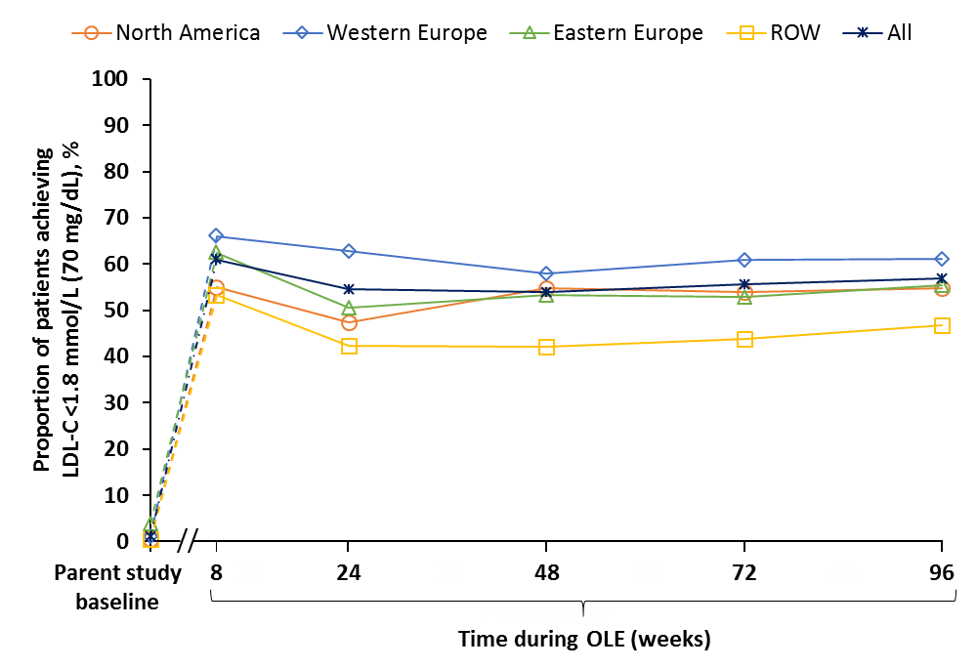

(B)
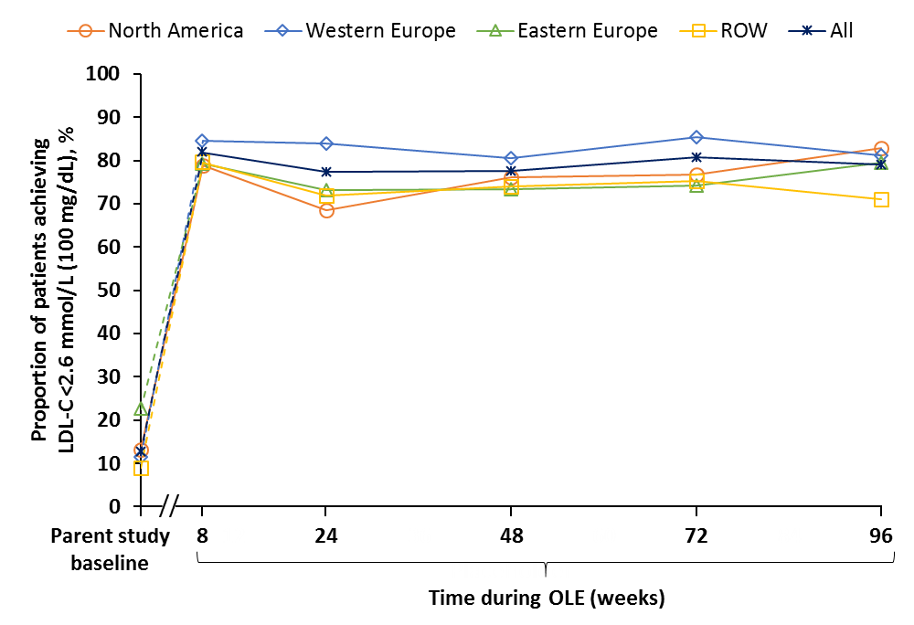

(C)
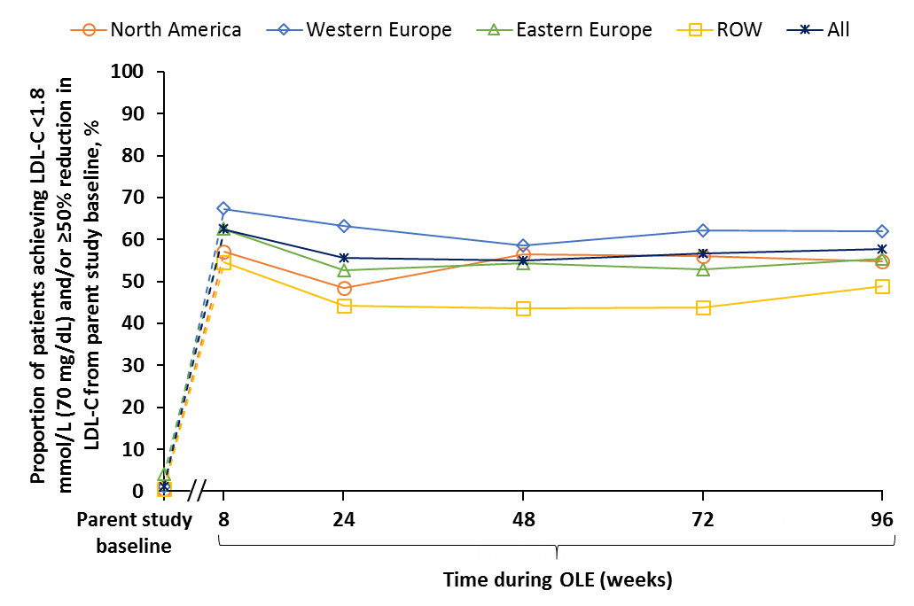
ªResults are reported up to Week 96 due to a decrease in patient numbers after this time point.
LDL-C, low-density lipoprotein cholesterol; ROW, rest of world.

Supplemental Fig 3. Graphical summary of the ODYSSEY OLE study design and key results
HeFH, heterozygous familial hypercholesterolemia; LDL-C, low-density lipoprotein cholesterol; Q2W, every 2 weeks; ROW, rest of world; SD, standard deviation.

