Supplementary material - Treatment regimens and duration

Table 4. Treatment distribution
 | Total Population  (n=350) | DAPT  (n=228) | Anticoagulants ± antiplatelets (n=122)
Overall Medication Use, n (%)
Antiplatelets
Aspirin | 309 (88.3) | 228 (100) | 83 (68)
Clopidogrel | 284 (81.1) | 204 (89.5) | 80 (65.7)
Prasugrel | 19 (5.4) | 17 (7.5) | 2 (1.6)
Ticagrelor | 7 (2) | 7 (3.1) | 0 (0)
Anticoagulants
Acenocoumarol |  |  | 47 (38.5)
Apixaban  - 5 mg BID  - 10 mg BID |  |  | 22 (18)  - 7 (5.7)  - 15 (12.3)
Rivaroxaban  - 5 mg QD  - 15 mg QD  - 20 mg QD |  |  | 29 (23.8)  - 6 (4.9)  - 8 (6.6)  - 15 (12.3)
Dabigatran  - 110 mg QD  - 220 mg QD  - 300 mg QD |  |  | 24 (19.7)  - 1 (0.8)  - 2 (2.5)  - 21 (16.4)
Treatment combinations, n(%)
DAPT combinations
Aspirin + clopidogrel |  | 204 (89.5)
Aspirin + prasugrel |  | 17 (7.5)
Aspirin + ticagrelor |  | 7 (3.1)
Patients in anticoagulants
Acenocoumarol alone |  |  | 3 (2.5)
Apixaban alone |  |  | 1 (0.8)
Rivaroxaban alone |  |  | 2 (1.6)
Dabigatran alone |  |  | 1 (0.8)
Acenocoumarol + aspirin |  |  | 20 (16.4)
Acenocoumarol + clopidogrel |  |  | 6 (4.9)
Acenocoumarol + ticagrelor |  |  | 0 (0)
Acenocoumarol + prasugrel |  |  | 0 (0)
DOAC + aspirin |  |  | 13 (11.5)
DOAC + clopidogrel |  |  | 26 (21.3)
DOAC + ticagrelor |  |  | 0 (0)
DOAC + prasugrel |  |  | 0 (0)
Patients in triple therapy
Any triple treatment (OAC + DAPT) |  |  | 50 (41)
- VKA + DAPT |  |  | 18 (14.7)
- DOAC + DAPT |  |  | 32 (26.2)

Table 5. Duration of treatment in days analysis with 59.1% of the population.
 | Total Population  (n=207) | DAPT  (n=98) | Anticoagulants ± antiplatelets (n=109)
DAPT | 493.5 (109 - 926) | 596 (147 - 1026) | 141 (70 - 340)
Any antiplatelets | 857 (284 - 1733) | 857 (195 - 904) | 861.5 (333 - 1555)
- Aspirin | 883 (195 - 1845) | 823 (195 - 1845) | 1021.5 (169 - 1781.5)
- Clopidogrel | 506 (181 - 934.5) | 596 (142 - 1038) | 445 (227 - 831)
- Ticagrelor | 1148 (753 - 1543) | 1148 (753 - 1543)
- Prasugrel | 436 (81 - 813) | 436 (81 - 813)
OAC |  |  | 1111 (341 - 1859)
- VKA |  |  | 1645.5 (1033 - 2141)
- Rivaroxaban |  |  | 272 (175 - 1104)
- Apixaban |  |  | 980 (461 - 1581)
- Dabigatran |  |  | 1122.5 (341 - 1909)
Triple therapy |  |  | 141 (70 - 638)

Supplementary Figure 1. Median treatment duration times by group

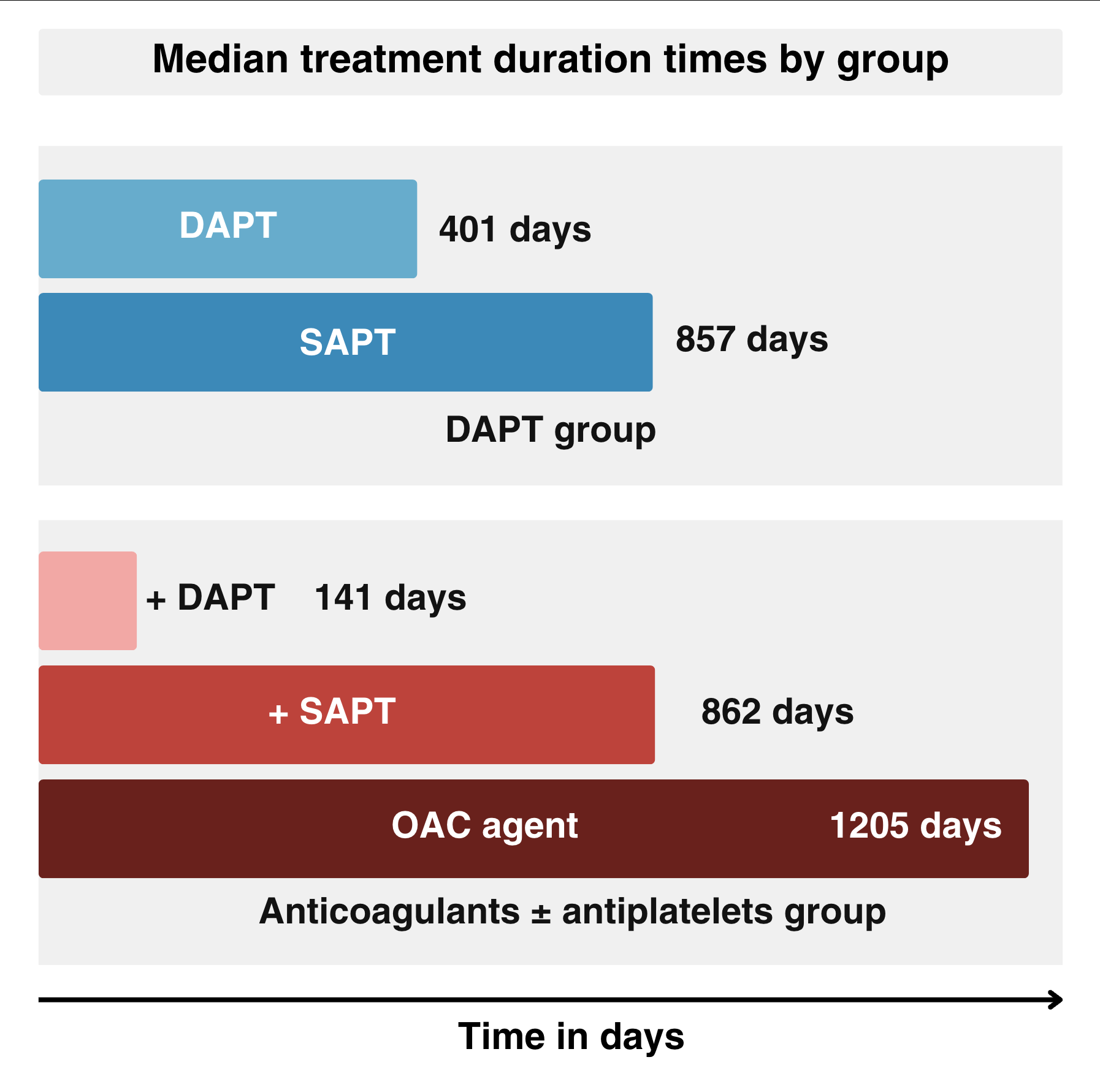

Supplementary Figure 2. Median antiplatelet agent duration times by group boxplot.

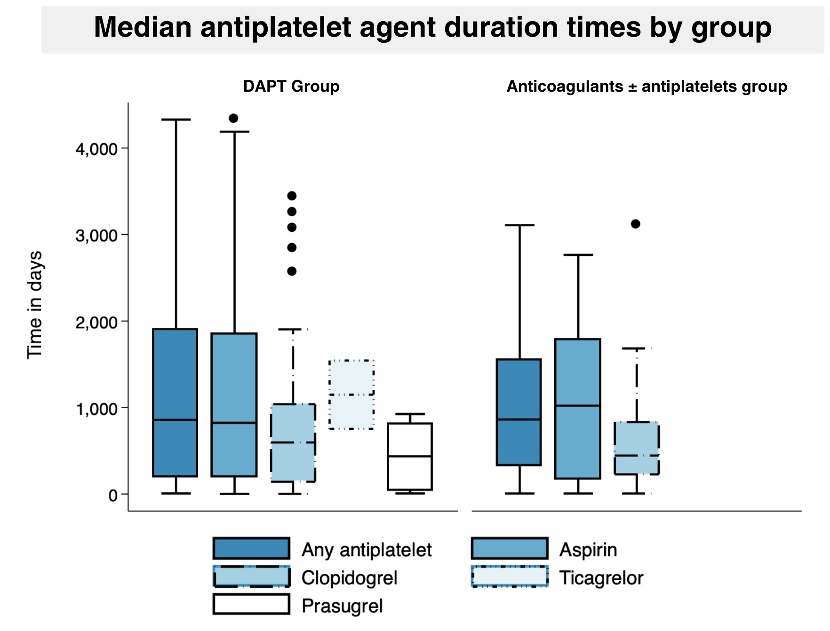

Supplementary Figure 3. Median anticoagulant agent duration times boxplot.
