Supplementary Material - Intention to Treat Analysis

Supplementary table 1. Baseline characteristics

 | Total Population  (n=403) | DAPT  (n=228) | Anticoagulants ± antiplatelets (n=175) | p-value
Demographics
Male sex, n ( %) | 358 (88.8) | 201 (88.2) | 157 (89.7) | 0.623
Age, mean (SD) | 57.9 (±11.5) | 59.2 (±11.8) | 56.1 (±10.7) | 0.006
Weight (kg), median (IQR) | 80 (71-90) | 79 (70-88) | 84 (75-94) | 0.001
Height (cm), median (IQR) | 170 (164-173) | 168 (164-172) | 170 (164-175) | 0.094
BMI, median (IQR) | 28 (25.5-31.7) | 27.6 (25-31.1) | 28.7 (26.4-32.7) | 0.004
Comorbidities, n (%)
Hypertension | 222 (55.1) | 132 (57.9) | 90 (51.4) | 0.196
Type 2 diabetes | 83 (20.7) | 58 (25.5) | 25 (14.3) | 0.006
Tobacco use | 236 (58.7) | 130 (57.3) | 106 (60.6) | 0.505
CAE characteristics
Markis Classification, n (%)
Markis 1 and 2 (High-grade) | 269 (66.7) | 125 (54.8) | 144 (82.3) | <0.001
Markis 3 and 4 (Low grade) | 134 (33.3) | 103 (45.2) | 31 (17.7) | <0.001
Location, n (%)
Left main coronary | 94 (23.3) | 43 (18.9) | 39 (31) | 0.033
Left descending artery | 271 (67.3) | 133 (58.3) | 138 (78.9) | <0.001
Left circumflex artery | 225 (55.8) | 101 (44.3) | 124 (70.9) | <0.001
Right coronary artery | 335 (83.1) | 181 (79.4) | 154 (88) | 0.060
Presentation, n (%)
STEMI | 261 (64.8) | 134 (58.8) | 127 (72.6) | 0.016
NSTEMI | 122 (30.3) | 81 (35.5) | 41 (23.4) | 0.016
Unstable angina | 20 (5) | 13 (5.7) | 7 (4) | 0.016
Follow up, median (IQR)
Maximum follow up in days | 1046 (329-1600) | 1027.5 (318-1600) | 1065 (329-1600) | 0.294
Time on treatment in days | 593 (123 - 1554) | 430 (54 - 1042) | 1008 (270 - 1600) | <0.001

Supplementary table 2. Treatment distribution
 | Total Population  (n=403) | DAPT  (n=228) | Anticoagulants ± antiplatelets (n=175) | p-value
Antiplatelets
Aspirin | 356 (88.3) | 228 (100) | 130 (74.3) | <0.001
Clopidogrel | 317 (78.6) | 204 (89.4) | 113 (64.6) | <0.001
Prasugrel | 19 (4.7) | 17 (7.5) | 2 (1.1) | 0.003
Ticagrelor | 7 (1.7) | 7 (3.1) | 0 (0) | 0.019
Anticoagulants
Acenocoumarol | 100 (24.8) |  | 100 (57.1) | <0.001
Apixaban | 22 (5.4) |  | 22 (12.6) | <0.001
Rivaroxaban | 29 (7.2) |  | 29 (16.6) | <0.001
Dabigatran | 24 (5.9) |  | 24 (13.7) | <0.001
Treatment combinations, n(%)
DAPT combinations
Aspirin + clopidogrel |  | 204 (89.4)
Aspirin + prasugrel |  | 17 (7.5)
Aspirin + ticagrelor |  | 7 (3.1)
Patients in anticoagulants + SAPT
Acenocoumarol + aspirin |  |  | 38 (9.4)
Acenocoumarol + clopidogrel |  |  | 8 (2)
Acenocoumarol + ticagrelor |  |  | 0 (0)
Acenocoumarol + prasugrel |  |  | 0 (0)
DOAC + aspirin |  |  | 14 (3.5)
DOAC + clopidogrel |  |  | 27 (6.7)
DOAC + ticagrelor |  |  | 0 (0)
DOAC + prasugrel |  |  | 0 (0)
Patients in triple treatment
Any triple treatment (OAC + DAPT) |  |  | 81 (46.3)
VKA + DAPT |  |  | 49 (28)
DOAC + DAPT |  |  | 32 (18.3)

Supplementary table 3. Outcomes
 | DAPT  (n=228) | Anticoagulants ± antiplatelets  (n=175) | p-value | HR (95%CI) | p-value²
Efficacy, composite n (%)
Composite of all-cause mortality, reinfarction, stroke | 33 (14.5) | 23 (13.1) | 0.809 | 0.847 (0.49 - 1.44) | 0.543
Efficacy, components of the composite outcome, n (%)
All-cause mortality | 10 (4.4) | 5 (2.9) | 0.422 | 0.63 (0.22 - 1.86) | 0.407
Reinfarction | 26 (11.4) | 20 (11.6) | 0.961 | 0.93 (0.53 - 1.67) | 0.817
Stroke | 2 (0.9) | 3 (1.7) | 0.458 | 1.82 (0.3 -10.93) | 0.610
Bleeding, composite outcome
Bleeding | 25 (11) | 25 (14.3) | 0.316 | 1.25 (0.72 - 2.19) | 0.422
Bleeding, components of the composite outcome, n (%)
GUSTO mild | 9 (4) | 29 (11.4) | 0.004 | 2.77 (1.27 - 6.1) | 0.011
GUSTO moderate | 15 (6.58) | 2 (1.2.29) | 0.044 | 0.33 (0.11 - 1.01) | 0.053
GUSTO severe or life-threatening | 1 (0.44) | 0 (0) | 0.380 | - | -

Kaplan Meier Survival Analyses
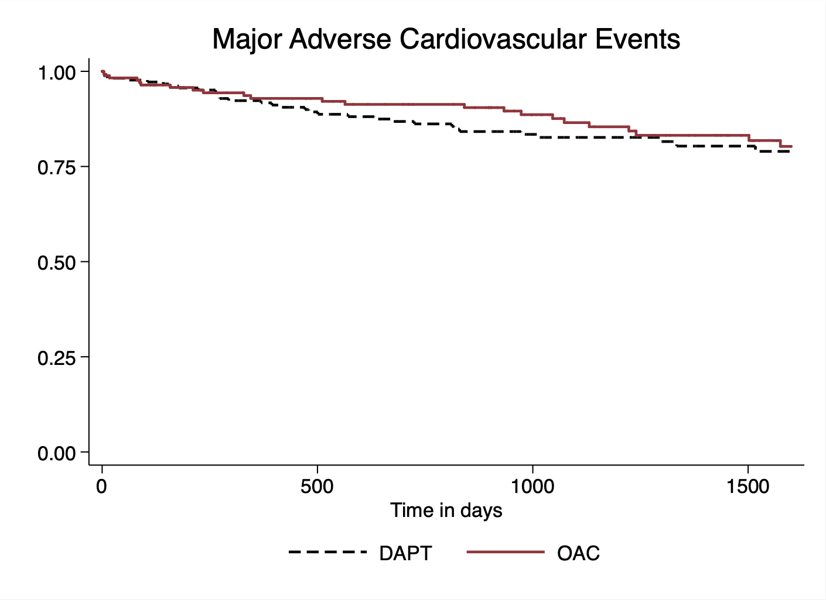
p-value=0.54
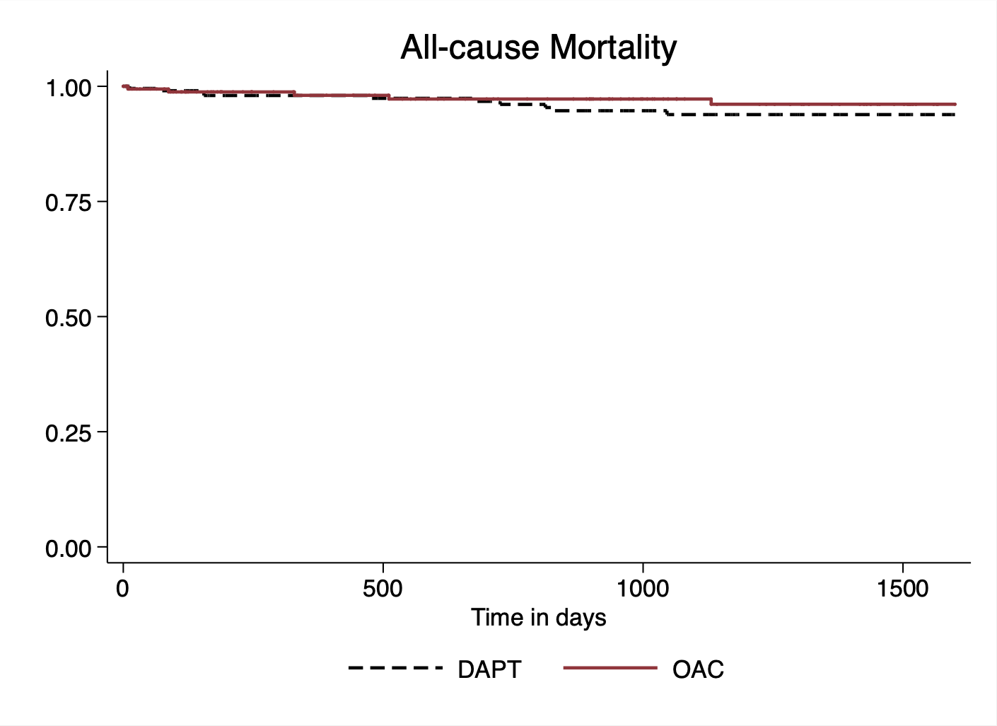
p-value=0.40
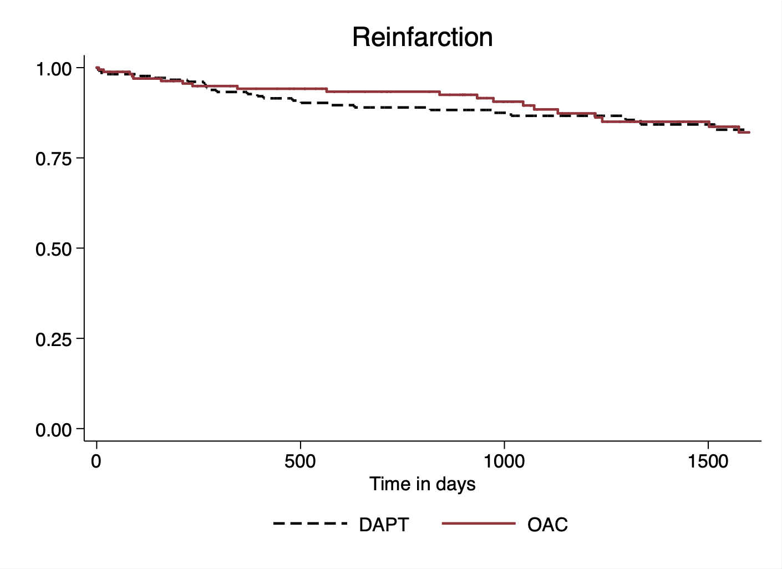
p-value=0.82
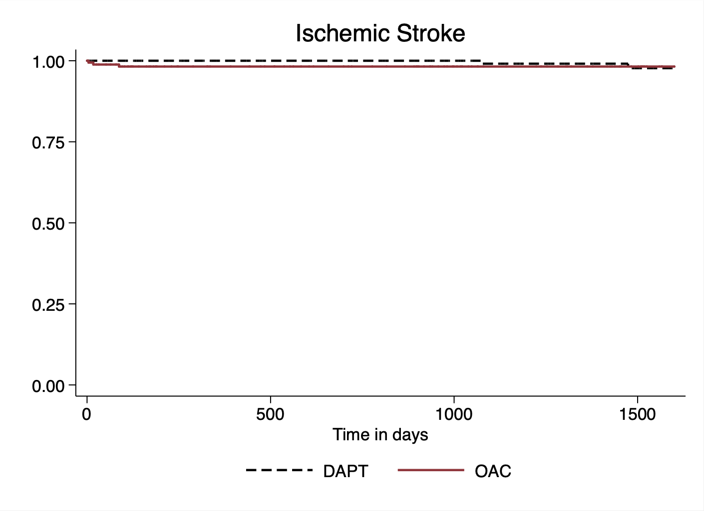
p-value=0.50
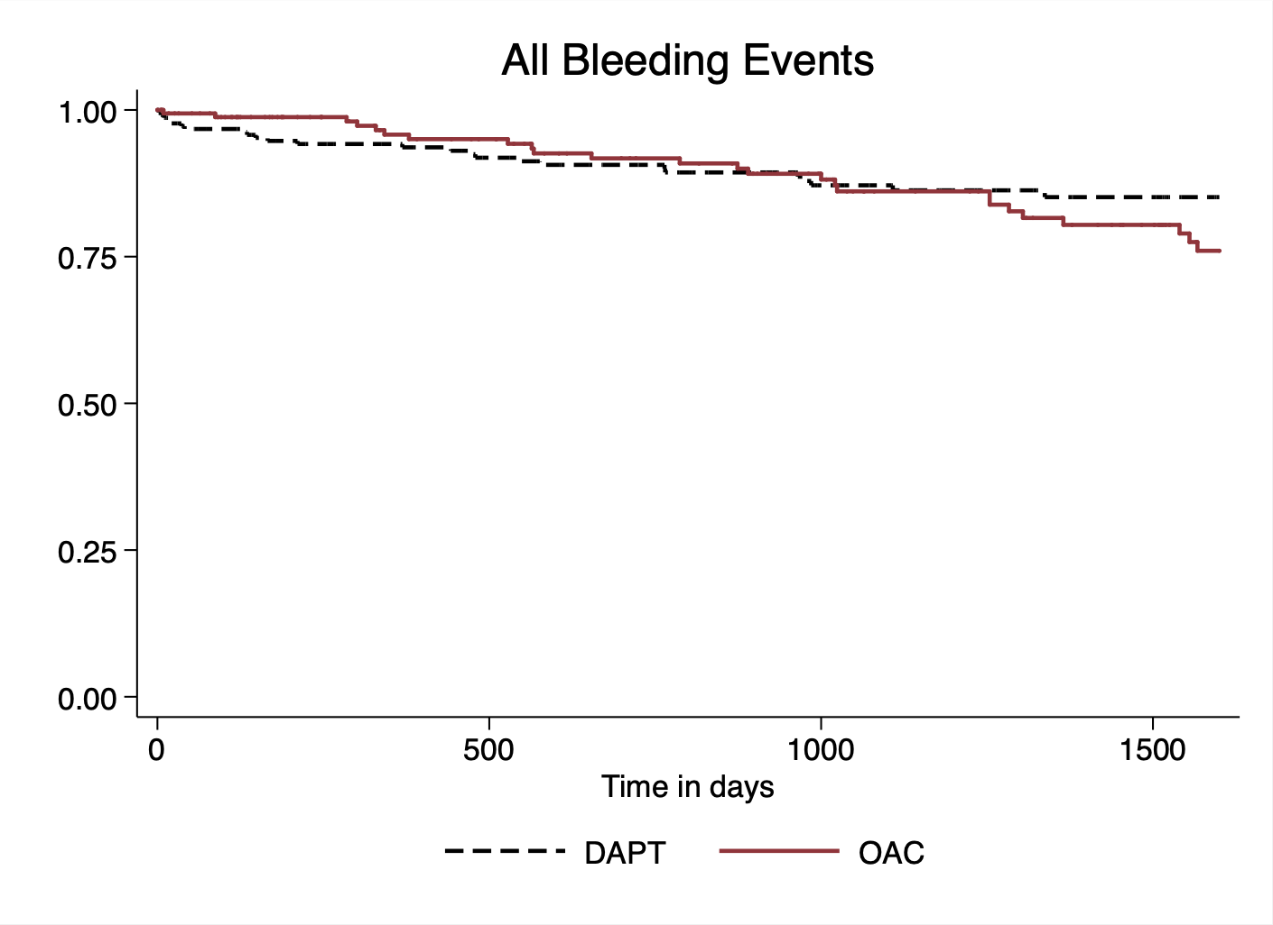
p-value=0.42

