Propensity Score Matching Analysis

Table 1. Logistic regression for treatment used.
 | Univariate analysis |  | Multivariate adjusted analysis
 | OR (95% CI) | p-value | OR (95% CI) | p-value
Demographic characteristics
Male sex | 0.96 (0.49 - 1.88) | 0.901
Age ≥ median (58) | 0.90 (0.58 - 1.39) | 0.624
Hypertension | 1.01 (0.65 - 1.58) | 0.948
Type 2 diabetes | 0.44 (0.24 - 0.80) | 0.008
Tobacco Use | 1.09 (0.70 - 1.71) | 0.701
BMI ≥ 30 | 1.61 (1.02 - 2.54) | 0.040
Markis ≤2 (High grade) | 4.2 (2.44 - 7.25) | <0.001 | 3.38 (1.88 - 6.06) | <0.001
Ectasia in culprit artery location:
Left main coronary | 1.94 (1.17 - 3.23) | 0.010
Left descending  - Diffuse LAD | 2.76 (1.65 - 4.62)  - 2.49 (1.47 - 4.22) | <0.001  - 0.001
Circumflex  - Diffuse LCX | 3.09 (1.92 - 4.97)  - 2.86 (1.77 - 4.63) | <0.001  - <0.001
Right coronary  - Diffuse RCA | 2.02 (1.07 - 3.85 )  - 1.32 (0.85 - 2.06) | 0.031  - 0.214
Clinical presentation and treatment
STEMI | 1.97 (1.22 - 3.19) | 0.006 | 2.31 (1.36 - 3.95) | 0.002
Stenting | 0.22 (0.14 - 0.36) | <0.001 | 0.27 (0.16 - 0.46) | <0.001
TIMI after stenting ≥2 | 0.43 (0.24 - 0.75) | 0.003
TMP ≥2 | 0.41 (0.22 - 0.76) | 0.005
LVEF at discharge below 50% | 1.16 (0.74 - 1.81) | 0.514

Table 2. Baseline characteristics of the matched population.
 | Total Population  (n=244) | DAPT  (n=122) | Anticoagulants ± antiplatelets  (n=122) | p-value
Demographics
Male sex, n ( %) | 210 (86.1) | 103 (84.4) | 107 (87.7) | 0.460
Age, mean (SD) | 57.7 (±10.7) | 57.7 (±11.2) | 57.7 (±10.2) | 0.958
BMI, median (IQR) | 28.1 (25.5 - 31.6) | 27.4 (24.5 - 30.8) | 28.7 (27.3 - 32.4) | <0.001
Comorbidities, n (%)
Hypertension | 141 (57.8) | 71 (58.2) | 70 (57.4) | 0.897
Type 2 diabetes | 49 (20.2) | 33 (27.3) | 16 (13.1) | 0.006
Tobacco use | 141 (57.8) | 68 (56.2) | 73 (59.8) | 0.566
CAE characteristics
Markis Classification, n (%)
Markis 1 and 2 (High grade) | 197 (80.7) | 95 (77.9) | 102 (83.6) | 0.256
Markis 3 and 4 (Low grade) | 47 (19.3) | 27 (22.1) | 20 (16.4) | 0.256
Location, n (%)
Left main coronary | 67 (27.5) | 29 (23.8) | 38 (31.2) | 0.197
Left descending artery  - Diffuse LAD | 183 (75.6)  - 64 (26.2) | 86 (71.7)  - 26 (21.3) | 97 (79.5)  - 38 (31.2) | 0.155  - 0.081
Left circumflex artery  - Diffuse LCX | 158 (65.3)  - 87 (35.7) | 70 (58.3)  - 35 (28.7) | 88 (72.1)  - 52 (42.6) | 0.024  - 0.023
Right coronary artery  - Diffuse RCA | 212 (87.6)  - 125 (51.2) | 104 (86.7)  - 63 (51.6) | 108 (88.5)  - 62 (50.8) | 0.661  - 0.898
Presentation, n (%)
STEMI | 178 (73) | 88 (72.1) | 90 (73.8) | 0.773
NSTEMI | 53 (21.7) | 27 (22.1) | 26 (21.3) | 0.877
Unstable angina | 13 (5.3) | 7 (5.7) | 6 (4.9) | 0.776
Clinical Scores
GRACE, median (IQR) | 110 (87 - 134) | 107 (87 - 130) | 112 (91 - 139) | 0.214
Killip-Kimball≥II, n (%) | 56 (23) | 29 (23.8) | 27 (22.1) | 0.761
TIMI, n (%)  - 0-2  - 3-7  - ≥8 | - 98 (40.2)  - 141 (57.8)  - 5 (2.1) | - 46 (37.7)  - 72 (59)  - 4 (3.3) | - 52 (42.6)  - 69 (56.6)  - 1 (0.8) | - 0.513  - 0.795  - 0.175
CRUSADE, median (IQR) | 22 (16 - 32) | 24 (16 - 34) | 21 (17 - 29) | 0.497
CHA₂DS₂-VASc≥2, n (%) | 141 (57.8) | 74 (60.7) | 67 (54.9) | 0.436
HAS-BLED≥2, n (%) | 114 (46.7) | 63 (51.6) | 51 (41.8) | 0.158
Treatment, n (%)
Thromboaspiration | 32 (13.2) | 13 (10.7) | 19 (15.6) | 0.266
GpIIa/IIIb inhibitor | 90 (36.9) | 41 (33.9) | 49 (40.2) | 0.377
Stenting
Stent in any artery | 81 (33.2) | 48 (39.3) | 33 (27.1) | 0.041
Stent in the culprit artery | 73 (29.9) | 45 (37.2) | 28 (23) | 0.010
Stent in other arteries | 18 (7.4) | 10 (8.2) | 8 (6.6) | 0.611
TIMI after stenting ≥2, n (%) | 194 (79.5) | 103 (84.4) | 91 (74.6) | 0.057
TMP ≥2, n (%) | 201 (82.4) | 105 (86.1) | 96 (78.7) | 0.130
Follow up
Follow-up in days, median (IQR) | 1046.5 (303 - 1759.5) | 1004 (264 - 1684) | 1111 (335 - 1799) | 0.506
CAE: coronary artery ectasia, CKD: chronic kidney disease, DAPT: double antiplatelet therapy, GFR: glomerular filtration rate, IQR: interquartile range, LCX: left circumflex artery, LAD: left descending artery, LVEF: left ventricular ejection fraction, NSTEMI: non-ST elevation myocardial infarction, RCA: right coronary artery, SD: standard deviation, STEMI: ST-elevation myocardial infarction.

Table 3. Outcome analysis with matched population.
 | DAPT  (n=122) | Anticoagulants ± antiplatelets  (n=122) | p-value | HR (95%CI) | p value²
Efficacy, composite n (%)
Composite of all-cause mortality, reinfarction, stroke | 21 (17.2%) | 15 (12.3%) | 0.279 | 0.65 (0.34 - 1.26) | 0.204
Efficacy, components of the composite outcome, n (%)
All-cause mortality | 7 (5.7%) | 1 (0.8%) | 0.031 | 0.14 (0.02 - 1.12) | 0.064
Reinfarction | 16 (13.1%) | 13 (10.7%) | 0.569 | 0.74 (0.35 - 1.53) | 0.413
Stroke | 0 (0%) | 2 (1.6%) | 0.159 | ---- | ---
Bleeding, composite outcome
Bleeding | 17 (13.9%) | 18 (14.8%) | 0.855 | 1.08 (0.59 - 1.96) | 0.806

CI: confidence interval, DAPT: double antiplatelet therapy, HR: hazard ratio.

Figure 1. Bias of relevant variables after propensity score matching.
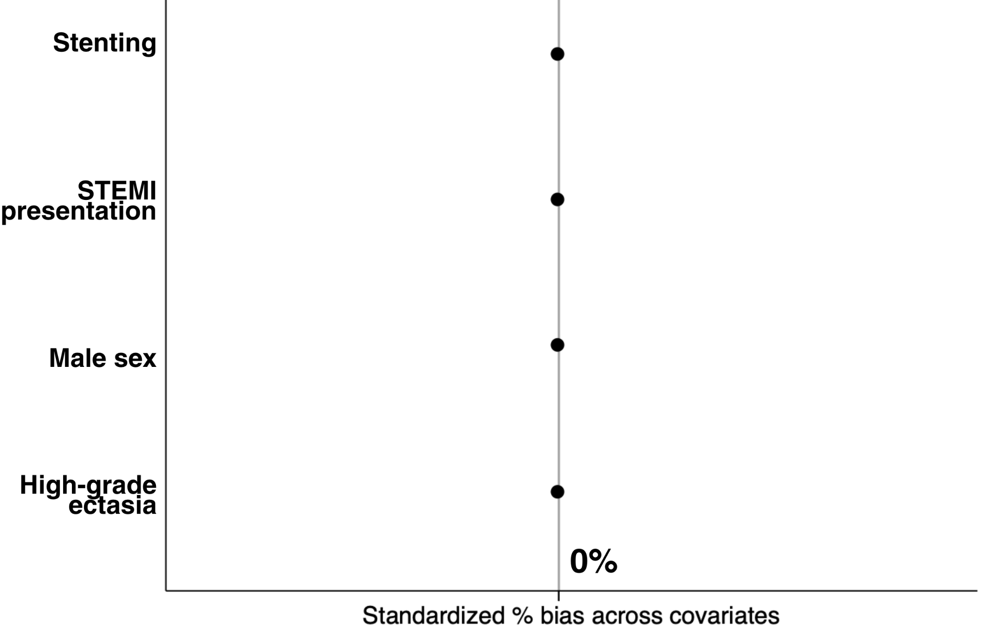

Figure 2. Kaplan Meier Curve of the primary component in matched population.
