Supplementary materials

Sup. Figure 1
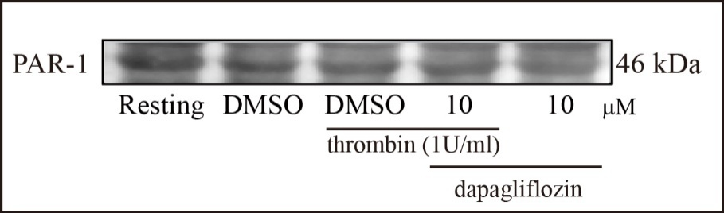

Sup. Figure 2
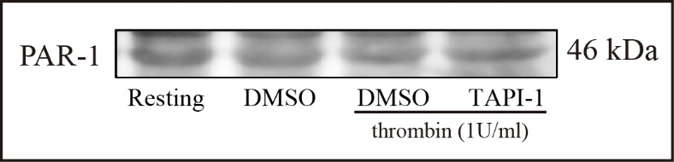

Sup. table 1. qPCR Analysis Reveals Markedly Lower SGLT2 mRNA Expression in A10 Cells Compared with Rat Renal Tissue
 | Target Name | Cт | ΔCт | ΔΔCт | 2^-ΔΔCт
rat renal tissue | SGLT2 | 16.39 | (6.600) | 0 | 1
A10 | SGLT2 | 32.42 | 17.610 | 24.21 | 5.153E-08
mouse renal tissue | GAPDH | 22.99
A10 | GAPDH | 14.81

Sup. Figure 3. Uncropped Western blot images corresponding to the main figures are provided to allow full visualization of band positions and surrounding background.
