Supplementary Table S1 Measurement invariance for the PHQ-9 and APS-R across the high-ability group (n = 1162) and typically developing group (n = 2793)
Model | χ²  (df) | CFI | TLI | RMSEA  (90%CI) | SRMR | Δχ²  (Δdf) | ΔCFI | ΔRMSEA
PHQ-9
M1: Configural | 451.819  (54) | 0.975 | 0.967 | 0.061  [0.056,0.066] | 0.024 | - | - | -
M2: Metric | 459.083  (62) | 0.975 | 0.971 | 0.057  [0.052,0.062] | 0.026 | 7.264  (8) | 0.000 | 0.004
M3: Scalar | 466.697 (70) | 0.975 | 0.975 | 0.054  [0.049,0.058] | 0.026 | 7.614  (8) | 0.000 | 0.003
M4: Residual | 583.252 (79) | 0.969 | 0.972 | 0.057  [0.053,0.061] | 0.030 | 116.555  (9) | 0.006 | 0.003
APS-R
The whole scale (three-factor model)
M1: Configural | 3518.217 (454) | 0.936 | 0.928 | 0.058  [0.057,0.060] | 0.046 | - | - | -
M2: Metric | 3594.744  (474) | 0.935 | 0.930 | 0.058  [0.056,0.059] | 0.049 | 76.527  (20) | 0.001 | 0.000
M3: Scalar | 3717.855 (494) | 0.932 | 0.931 | 0.057  [0.056,0.059] | 0.050 | 123.111  (20) | 0.003 | 0.001
M4: Residual | 4317.151 (517) | 0.920 | 0.922 | 0.061  [0.059,0.063] | 0.052 | 599.296  (23) | 0.012 | 0.004
The Discrepancy subscale
M1: Configural | 1194.071  (108) | 0.955 | 0.945 | 0.071  [0.068,0.075] | 0.031 | - | - | -
M2: Metric | 1230.778  (119) | 0.954 | 0.949 | 0.069  [0.065,0.072] | 0.035 | 36.707  (11) | 0.001 | 0.002
M3: Scalar | 1327.687  (130) | 0.951 | 0.950 | 0.068  [0.065,0.072] | 0.037 | 96.909  (11) | 0.003 | 0.001
M4: Residual | 1761.347  (142) | 0.933 | 0.938 | 0.076  [0.073,0.079] | 0.043 | 433.660  (12) | 0.018 | 0.008
The High Standards subscale
M1: Configural | 188.061 (28) | 0.986 | 0.978 | 0.054  [0.047,0.061] | 0.018 | - | - | -
M2: Metric | 217.710 (34) | 0.984 | 0.980 | 0.052  [0.046,0.059] | 0.028 | 29.649  (6) | 0.002 | 0.002
M3: Scalar | 238.498  (40) | 0.982 | 0.981 | 0.050  [0.044,0.056] | 0.030 | 20.788  (6) | 0.002 | 0.002
M4: Residual | 357.445  (47) | 0.972 | 0.975 | 0.058  [0.052,0.063] | 0.034 | 118.947  (7) | 0.010 | 0.008
The Order subscale
M1: Configural | 17.691  (4) | 0.997 | 0.992 | 0.042  [0.023,0.062] | 0.008 | - | - | -
M2: Metric | 22.129  (7) | 0.997 | 0.995 | 0.033  [0.018,0.049] | 0.013 | 4.438  (3) | 0.000 | 0.009
M3: Scalar | 24.179  (10) | 0.997 | 0.997 | 0.027  [0.013,0.041] | 0.014 | 2.050  (3) | 0.000 | 0.006
M4: Residual | 51.060  (14) | 0.993 | 0.994 | 0.037  [0.026,0.048] | 0.017 | 26.881  (4) | 0.004 | 0.010
Note. CFI = comparative fit index, TLI = Tucker-Lewis Index, CI = confidence interval, RMSEA = root-mean-square error of approximation, SRMR = standardized root-mean-square residual. ΔCFI < 0.01 and ΔRMSEA < 0.015 indicated good measurement invariance from the baseline model to the resulting model (An et al., 2017).

Supplementary Table S2 Measurement invariance for the PHQ-9 and APS-R across the Eastern sample (n = 1970) and Western sample (n = 1985)
Model | χ²  (df) | CFI | TLI | RMSEA  (90%CI) | SRMR | Δχ²  (Δdf) | ΔCFI | ΔRMSEA
PHQ-9
M1: Configural | 458.003  (54) | 0.974 | 0.965 | 0.062  [0.056,0.067] | 0.025 | - | - | -
M2: Metric | 481.632  (62) | 0.973 | 0.968 | 0.059  [0.054,0.063] | 0.031 | 23.629  (8) | 0.001 | 0.003
M3: Scalar | 594.360 (70) | 0.966 | 0.965 | 0.062  [0.057,0.066] | 0.037 | 112.781  (8) | 0.007 | 0.003
M4: Residual | 1023.171 (79) | 0.939 | 0.944 | 0.078  [0.074,0.082] | 0.049 | 488.811  (9) | 0.027 | 0.016
APS-R
The whole scale (three-factor model)
M1: Configural | 4111.793 (454) | 0.924 | 0.915 | 0.064  [0.062,0.066] | 0.054 | - | - | -
M2: Metric | 4232.095  (474) | 0.922 | 0.916 | 0.063  [0.062,0.065] | 0.056 | 120.302  (20) | 0.002 | 0.001
M3: Scalar | 4383.531 (494) | 0.919 | 0.917 | 0.063  [0.061,0.065] | 0.056 | 151.436  (20) | 0.003 | 0.000
M4: Residual | 4980.309 (517) | 0.907 | 0.909 | 0.066  [0.064,0.068] | 0.058 | 596.778  (23) | 0.012 | 0.008
The Discrepancy subscale
M1: Configural | 1314.990 (108) | 0.950 | 0.939 | 0.075  [0.072,0.079] | 0.032 | - | - | -
M2: Metric | 1422.661 (119) | 0.946 | 0.940 | 0.074  [0.071,0.078] | 0.047 | 107.671  (11) | 0.004 | 0.001
M3: Scalar | 1492.840 (130) | 0.944 | 0.943 | 0.073  [0.070,0.076] | 0.048 | 70.179  (11) | 0.002 | 0.003
M4: Residual | 1815.094 (142) | 0.931 | 0.936 | 0.077  [0.074,0.080] | 0.050 | 322.254  (12) | 0.013 | 0.007
The High Standards subscale
M1: Configural | 209.276 (28) | 0.984 | 0.976 | 0.057  [0.050,0.065] | 0.019 | - | - | -
M2: Metric | 227.372 (34) | 0.983 | 0.979 | 0.054  [0.047,0.060] | 0.025 | 18.096  (6) | 0.001 | 0.003
M3: Scalar | 290.738  (40) | 0.977 | 0.976 | 0.056  [0.050,0.062] | 0.030 | 63.366  (6) | 0.006 | 0.002
M4: Residual | 392.929  (47) | 0.969 | 0.972 | 0.061  [0.056,0.067] | 0.034 | 102.191  (7) | 0.008 | 0.005
The Order subscale
M1: Configural | 23.808  (4) | 0.996 | 0.989 | 0.050  [0.032,0.070] | 0.009 | - | - | -
M2: Metric | 37.049  (7) | 0.994 | 0.990 | 0.047  [0.032,0.062] | 0.021 | 13.241  (3) | 0.002 | 0.003
M3: Scalar | 55.344  (10) | 0.992 | 0.990 | 0.048  [0.036,0.061] | 0.024 | 18.295  (3) | 0.002 | 0.001
M4: Residual | 233.547  (14) | 0.959 | 0.965 | 0.089  [0.079,0.099] | 0.040 | 178.203  (4) | 0.033 | 0.041
Note. CFI = comparative fit index, TLI = Tucker-Lewis Index, CI = confidence interval, RMSEA = root-mean-square error of approximation, SRMR = standardized root-mean-square residual. ΔCFI < 0.01 and ΔRMSEA < 0.015 indicated good measurement invariance from the baseline model to the resulting model (An et al., 2017).

Supplementary Table S3 Sample edge‐weights and bootstrapped 95% confidence intervals (CIs) in the network of the high-ability group (n = 1162) and the typically developing group (n = 2793)
 | The high-ability group |  |  | The typically developing group
Edge | Sample edge-weight | 95% CI | CI width | Sample edge-weight | 95% CI | CI width
D1-D2 | 0.196 | [0.132, 0.260] | 0.128 | 0.130 | [0.088, 0.173] | 0.085
D1-D3 | 0.019 | [-0.035, 0.074] | 0.109 | 0.135 | [0.093, 0,177] | 0.084
D1-D4 | 0.171 | [0.106, 0.237] | 0.131 | 0.207 | [0.166, 0.249] | 0.083
D1-D5 | 0.090 | [0.028. 0.152] | 0.124 | 0.040 | [0.000, 0.080] | 0.080
D1-D6 | 0.130 | [0.068, 0.192] | 0.123 | 0.116 | [0.072, 0.159] | 0.087
D1-D7 | 0.182 | [0.122, 0.242] | 0.120 | 0.129 | [0.084, 0.175] | 0.091
D1-D8 | 0.013 | [-0.035, 0.062] | 0.097 | 0.107 | [0.063, 0.150] | 0.087
D1-D9 | 0.102 | [0.034, 0.170] | 0.136 | 0.064 | [0.023, 0.105] | 0.082
D2-D3 | 0.068 | [0.003, 0.133] | 0.130 | 0.048 | [0.008, 0.089] | 0.082
D2-D4 | 0.039 | [-0.020, 0.098] | 0.118 | 0.077 | [0.034, 0.119] | 0.085
D2-D5 | 0.099 | [0.039, 0.159] | 0.120 | 0.145 | [0.102, 0.189] | 0.087
D2-D6 | 0.203 | [0.136, 0.270] | 0.133 | 0.167 | [0.121, 0.214] | 0.093
D2-D7 | 0.091 | [0.023, 0.160] | 0.136 | 0.085 | [0.040, 0.130] | 0.089
D2-D8 | 0.098 | [0.028,0.169] | 0.140 | 0.098 | [0.051, 0.145] | 0.094
D2-D9 | 0.192 | [0.128, 0.256] | 0.128 | 0.230 | [0.185, 0.276] | 0.091
D3-D4 | 0.291 | [0.235, 0.347] | 0.112 | 0.230 | [0.189, 0.271] | 0.082
D3-D5 | 0.145 | [0.086, 0.204] | 0.118 | 0.122 | [0.078, 0.165] | 0.087
D3-D6 | 0.084 | [0.017, 0.150] | 0.133 | 0.101 | [0.056, 0.145] | 0.089
D3-D7 | 0.094 | [0.033, 0.155] | 0.122 | 0.093 | [0.050, 0.136] | 0.086
D3-D8 | 0.090 | [0.030, 0.149] | 0.119 | 0.024 | [-0.013, 0.062] | 0.076
D3-D9 | 0.038 | [-0.017, 0.094] | 0.111 | 0.075 | [0.034, 0.116] | 0.082
D4-D5 | 0.202 | [0.142, 0.263] | 0.122 | 0.185 | [0.142, 0.228] | 0.086
D4-D6 | 0.073 | [0.012, 0.133] | 0.122 | 0.104 | [0.060, 0.147] | 0.087
D4-D7 | 0.020 | [-0.028, 0.068] | 0.097 | 0.115 | [0.070, 0.159] | 0.089
D4-D8 | 0.036 | [-0.019, 0.091] | 0.110 | 0.016 | [-0.018, 0.050] | 0.068
D4-D9 | 0.000 | [-0.036, 0.036] | 0.073 | 0.000 | [-0.027, 0.027] | 0.055
D5-D6 | 0.081 | [0.016, 0.145] | 0.129 | 0.106 | [0.061, 0.150] | 0.089
D5-D7 | 0.092 | [0.028, 0.156] | 0.127 | 0.109 | [0.065, 0.153] | 0.088
D5-D8 | 0.102 | [0.038, 0.166] | 0.128 | 0.085 | [0.038, 0.132] | 0.094
D5-D9 | 0.062 | [0.003, 0.122] | 0.118 | 0.093 | [0.048, 0.139] | 0.091
D6-D7 | 0.133 | [0.066,0.200] | 0.134 | 0.091 | [0.045, 0.137] | 0.092
D6-D8 | 0.049 | [-0.011, 0.109] | 0.121 | 0.138 | [0.092, 0.185] | 0.093
D6-D9 | 0.147 | [0.079, 0.216] | 0.137 | 0.146 | [0.100, 0.192] | 0.092
D7-D8 | 0.203 | [0.143, 0.264] | 0.121 | 0.140 | [0.095, 0.185] | 0.091
D7-D9 | 0.084 | [0.015, 0.152] | 0.137 | 0.107 | [0.060, 0.154] | 0.095
D8-D9 | 0.211 | [0.149, 0.274] | 0.125 | 0.154 | [0.108, 0.200] | 0.092

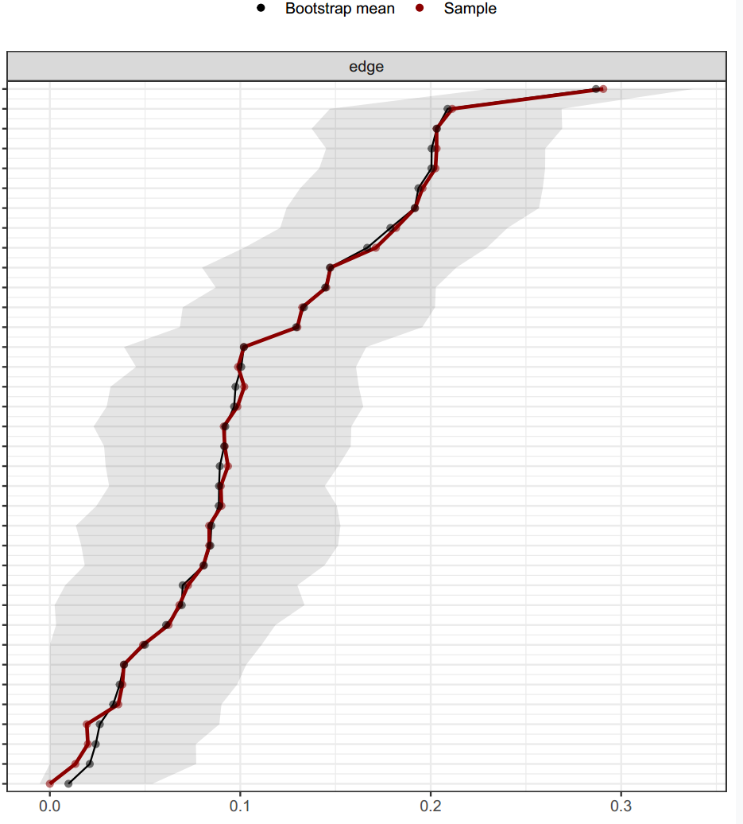
Supplementary Figure S1 Bootstrapped confidence intervals of estimated edge-weights in the network of the high-ability group (n = 1162)
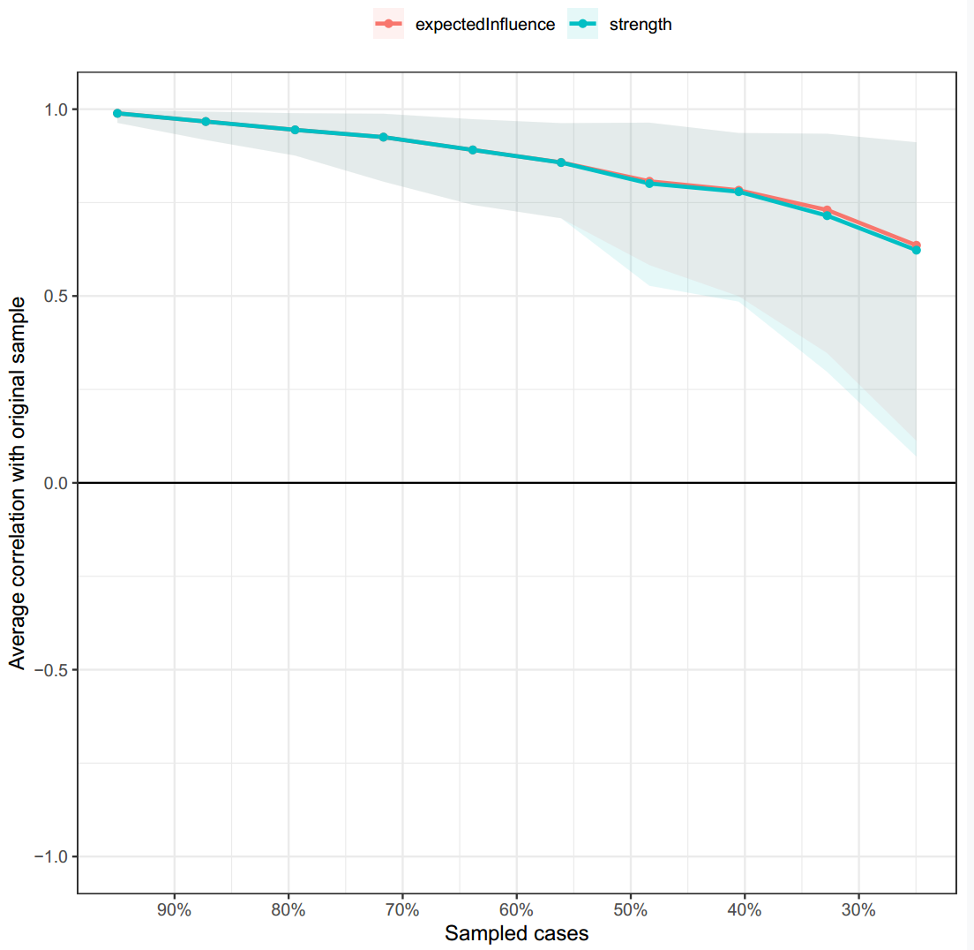
Supplementary Figure S2 Case-dropping bootstrap procedure for node centrality in the network of the high-ability group (n = 1162)

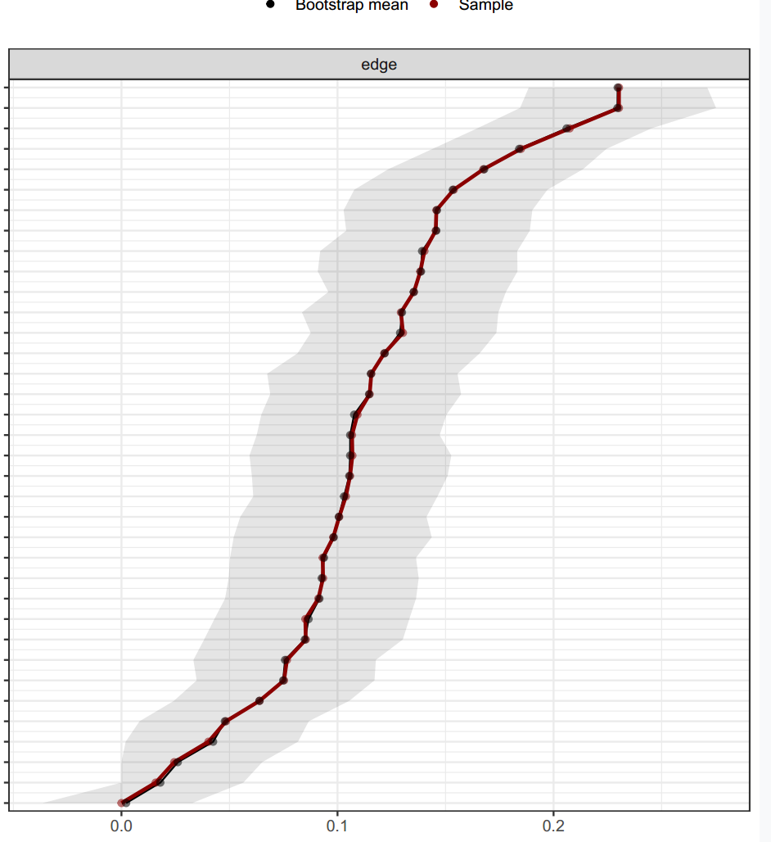
Supplementary Figure S3 Bootstrapped confidence intervals of estimated edge-weights in the network of the typically developing group (n = 2793)

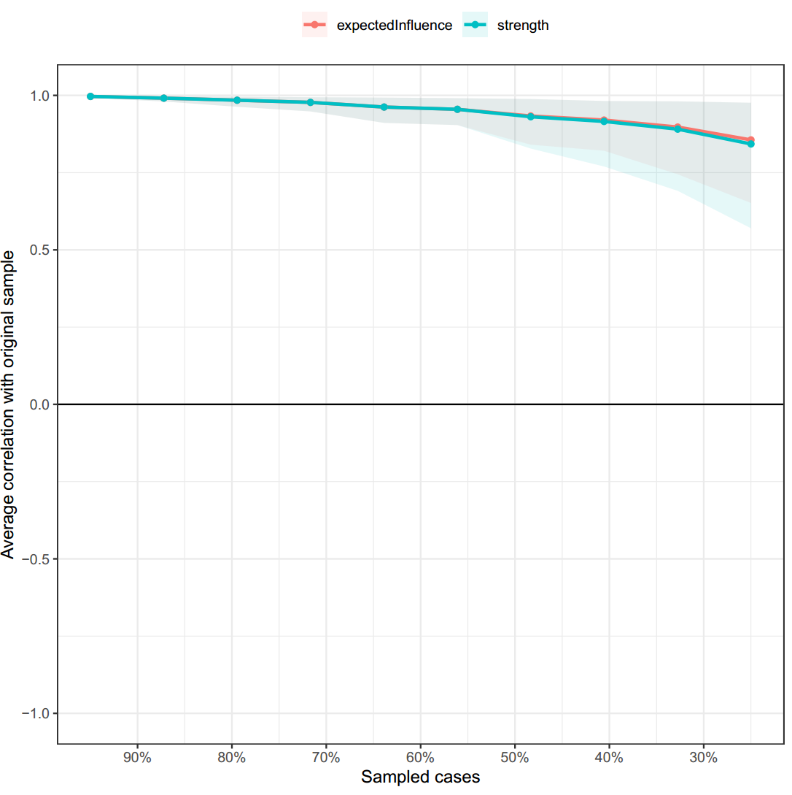
Supplementary Figure S4 Case-dropping bootstrap procedure for node centrality in the network of the typically developing group (n = 2793)

References
An, M., Kusurkar, R. A., Li, L., Xiao, Y., Zheng, C., Hu, J., & Chen, M. (2017). Measurement invariance of the strength of motivation for medical school: a multi-group confirmatory factor analysis. BMC Medical Education, 17(1), 116. https://doi.org/10.1186/s12909-017-0958-4

