Preliminary Validation of a Novel Digital Measure of Emotion Regulation (The Three Circles) in Adolescents – Supplementary Materials
Supplementary Methods – Qualtrics Information and Consent
Information sheet
Three Circles: Testing a new digital approach to measuring emotion systems
Complete a fun, interactive measure based on compassion focused therapy
Compassion focused therapy is an approach to promoting well-being, through supporting people to be more compassionate toward themselves and others. Being compassionate can lead to greater mood regulation, self-acceptance, and more positive relationships with others. We are hoping to have as many people participate as possible so we can see if the Three Circles can help in becoming aware of the emotion and motivation systems that we use in our daily lives. If you choose to participate we will ask you some questions about emotions, mood states, behaviour, and current functioning.

Information Statement for the Research Project:
Testing a new, digital measure of emotion functioning for use in compassion focused psychology
You are invited to participate in the research project identified above.
Why is the research being done?
The purpose of this research is to assess whether a brief digital measure of emotions based on compassion focused therapy (CFT) has potential to be a useful tool to help young people report and process feelings.
The app you will see is just a basic prototype, and it does not reflect the final version; we are simply interested in finding out whether the way our emotion systems are working right now can be represented through the simple activity of moving and resizing digital circles.
Who can participate in the research?
The main requirements are that you are 12 - 17, and that you are not colour-blind.
What would you be asked to do?
The study will be done in school time, and you may use your own device (eg. Phone, laptop, tablet); alternatively, your school will provide access to a device so you may participate. If you choose to participate, we will ask you some questions about your current mood, and your experience of positive and negative emotions.
We will also give you some information about the Three Circles Model, which will inform you about your ‘drive’, ‘threat’ and ‘soothing’ systems.
We will then ask you to report how these systems are functioning by moving and resizing the three circles on the screen.
Finally, we will ask you some questions about how easy or difficult it was to use and understand.
What choice do you have?
Participation in this research is entirely your choice. Whether or not you decide to participate, your decision will not disadvantage you. If you do decide to participate, you may withdraw from the project at any time. If you choose to withdraw, your data will be not be used.
How much time will it take?
Your involvement in this research will take approximately 20 minutes.
What are the risks and benefits of participating?
There are no anticipated risks associated with participating in this research.
As a participant, you will have the opportunity to become involved in the early testing of a new prototype that may be useful in socio-emotional learning contexts. Any feedback you provide will further inform its development and later use. Additionally you will learn a new model through which you can identify and process your emotions. If you have any concerns about your emotional well-being following participation in this study, please contact the following services:
- Beyond Blue (www.beyondblue.org, Info line: 1300 22 4636);
- Kid’s Helpline (Ph: 1800 55 1800)
- Lifeline (Ph: 13 11 14); or
How will your privacy be protected?
Participant data will be identified by numeric codes; please keep a record or take a screenshot of the unique code generated by the Three Circles so your data can be identified and removed if you wish to withdraw. It will not be possible to identify you from your answers during statistical testing or at any time afterwards. All information published will be deidentified, and data will not be discussed on an individual level.
Electronic data will be stored digitally on secure servers accessible only to the research team except as required by law. Data will be retained securely for a minimum period of 5 years from completion of the research; additional Queensland Government legislation may require data to be stored for 10 years from when the participant turns 16.
How will the information collected be used?
It is anticipated that the results of this research project will be published and/or presented in a variety of forms. In any publication and/or presentation, information will be provided in such a way that you cannot be identified, except with your expressed permission. You can request a summary of the results, which will be available after the completion of the project, by emailing the chief investigator.
What do you need to do to participate?
Please read this information statement and be sure you understand its contents before you consent to participate. If there is anything you do not understand, or you have questions, please contact the researcher listed below. If you would like to participate, please fill out the consent form provided.
Consent Form
I confirm that I have read and understood the information sheet regarding the project, "Three Circles: Testing a new digital approach to measuring emotion systems"

- I agree to participate in the above research project and give my consent freely.

- I understand that the project will be conducted as described in the information statement.

- I understand that I can withdraw from the project at any time. I do not have to give any reason for withdrawing.

- I consent to answering the questions provided and to using the Three Circles prototype on the available devices.

- I understand that my personal information will remain confidential to the researchers.

- I have had the opportunity to have questions answered to my satisfaction.

Your consent
By clicking the next button on your screen, you are indicating your consent to participate in the research project.
​​​​​​​
Tripartite Model Information Sheet
Please read this!

In this study you'll also be asked about your emotions using the Three Circles Model.

But what is the Three Circles Model?

The Three Circles Model is a way to understand our emotional systems. Across the study you will be asked to draw the size of your circles in that moment. The bigger the circle, the more you feel that system; the smaller it is, the less you feel. The size of the circles will change according to how you are feeling throughout the day and what you are doing. There is no right or wrong, just what you are experiencing in that moment.
The Red Circle: This emotion system is focused on threats and self-protection. It is responsible for your safety, making sure you avoid harm or fight to protect yourself. Threats can be physical ones, such as something dangerous like getting stung by a spider or road rage, but also social pains like being judged, rejected or excluded. Emotions that are experienced in this circle typically include anger, anxiety, fear, and disgust.
The Blue Circle: This emotion system, also known as the drive system, is focused on wanting and achieving things, such as status (e.g., promotion), praise, and to win or be the best at something. It can also be about wanting physiological satisfaction (food, drink, sex) as well as material things such as a car, a house, or a bigger TV. Emotions that are experienced in this circle typically include excitement, joy, happiness, or a sense of achievement.
The Green Circle: This emotion system, also known as the soothing system, is focused on being content, at ease, and calm. It is focused on non-wanting and having a sense of peacefulness. Emotions that are experienced in this circle typically include feeling calm, content, and peaceful.

Multiple Imputation Analysis Results – SPSS Output
Full dataset
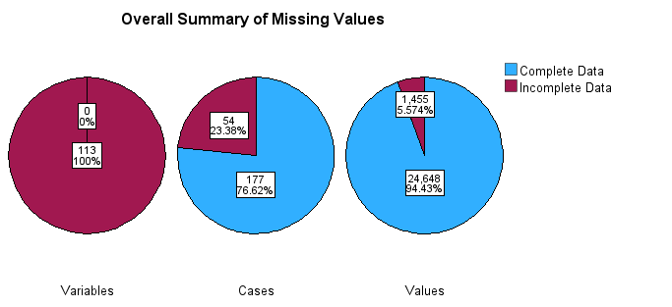
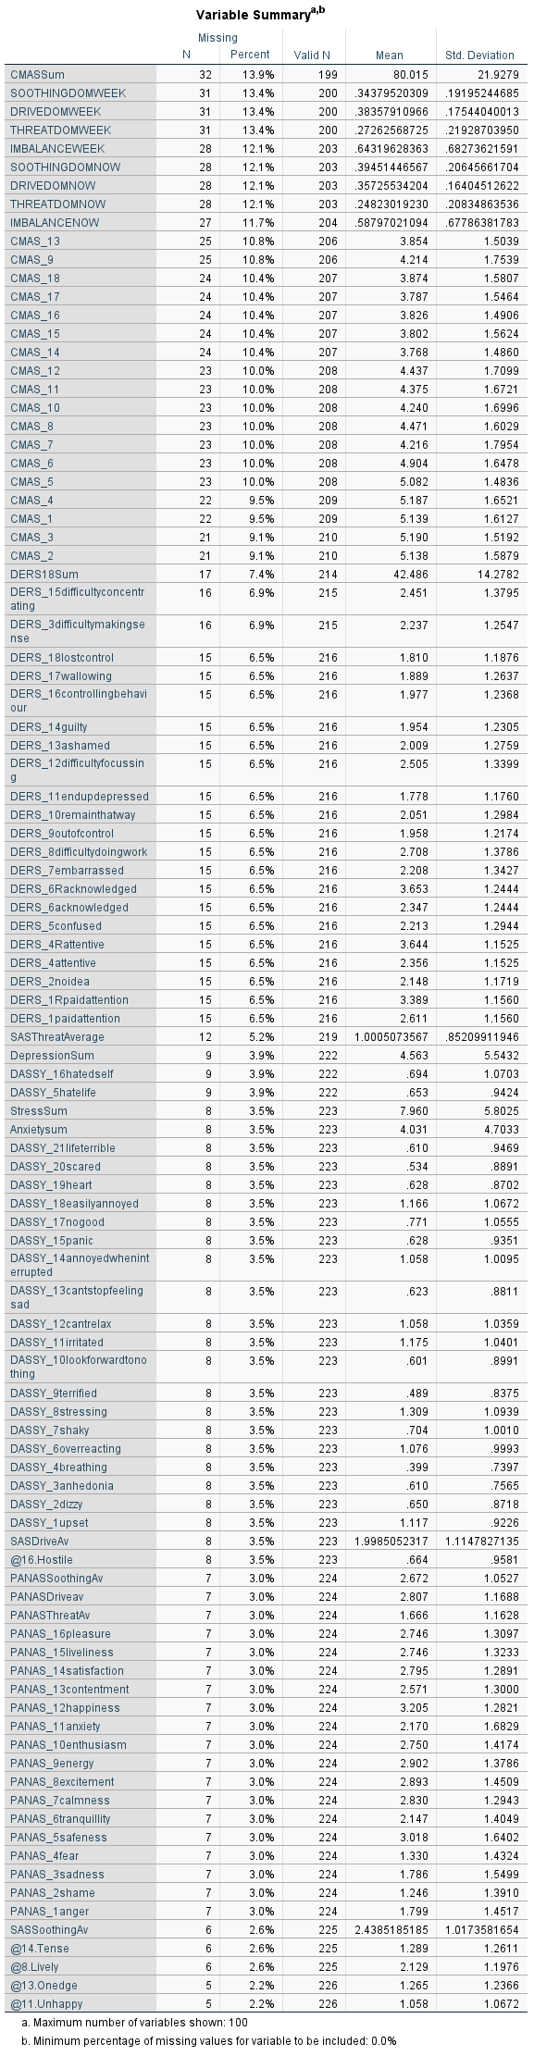
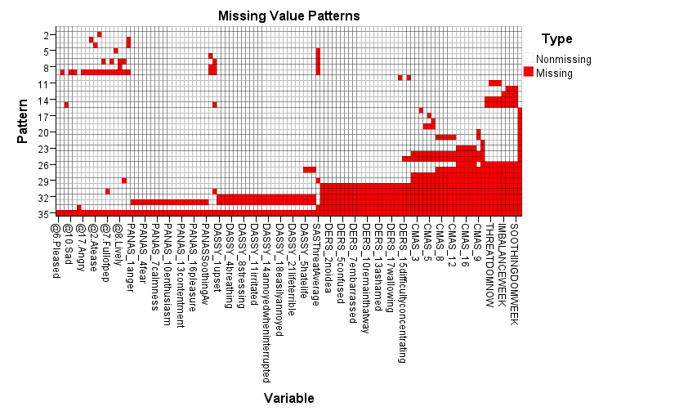
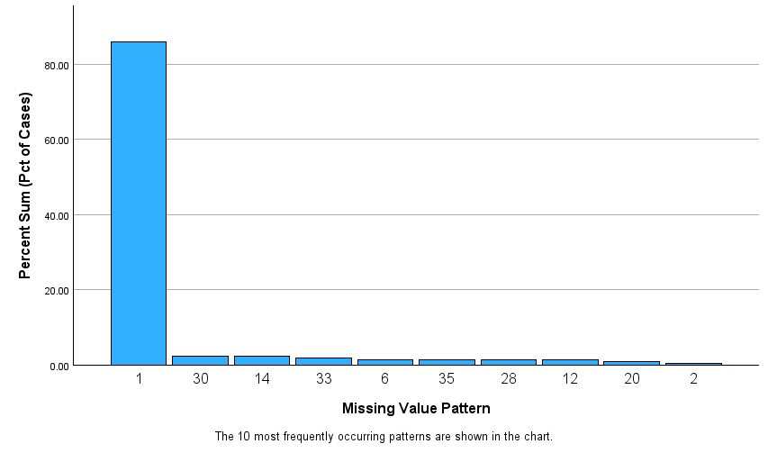
Final Dataset
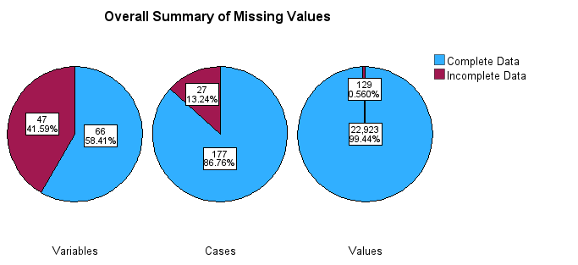
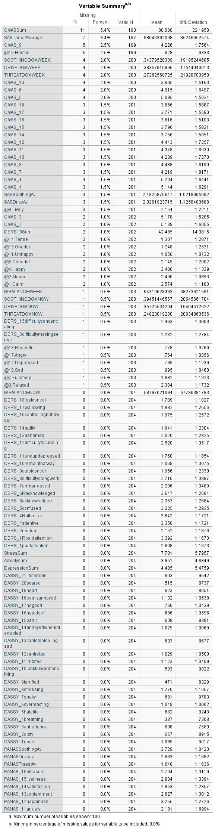
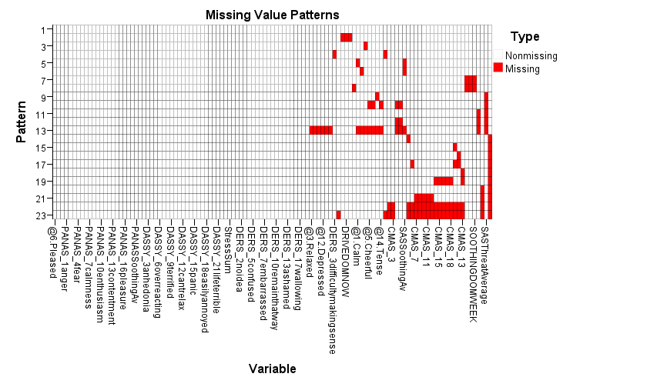
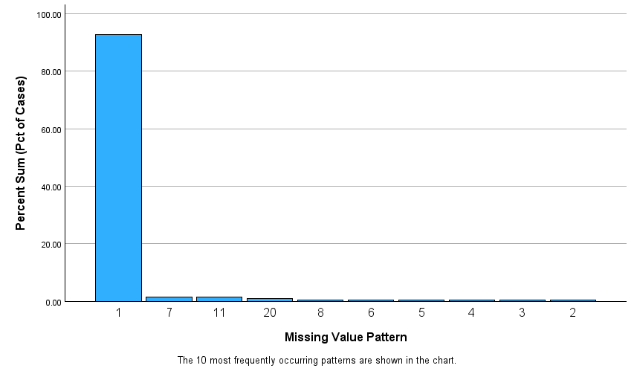
Ease of Use – Frequencies
Supplementary Table 1
Ease of Use Ratings
“Overall, the Three Circles tool was easy to use.”
Ratings (1 = “completely disagree”; 5 = “completely agree”) | Counts | % of Total | Cumulative %
1 | 19 | 10.9% | 10.9%
2 | 21 | 12.0% | 22.9%
3 | 69 | 39.4% | 62.3%
4 | 28 | 16.0% | 78.3%
5 | 38 | 21.7% | 100.0%

Supplementary Table 2
Ratings Regarding Difficulty Remembering Circle Representation
“I found it hard to remember what each of the three circles represented”
Ratings (1 = “completely disagree”; 5 = “completely agree”) | Counts | % of Total | Cumulative %
1 | 51 | 29.5% | 29.5%
2 | 34 | 19.7% | 49.1%
3 | 50 | 28.9% | 78.0%
4 | 16 | 9.2% | 87.3%
5 | 22 | 12.7% | 100.0%

Supplementary Table 3
Preference for a Rating Scale
“Rather than resizing circles, I would have preferred a simple rating scale for each one.”
Ratings (1 = “completely disagree”; 5 = “completely agree”) | Counts | % of Total | Cumulative %
1 | 30 | 17.2% | 17.2%
2 | 37 | 21.3% | 38.5%
3 | 49 | 28.2% | 66.7%
4 | 28 | 16.1% | 82.8%
5 | 30 | 17.2% | 100.0%

Supplementary Table 4
Preference for Being Able to Move the Three Circles
“I would have liked to move the circles closer together or further apart to reflect how I was feeling”
Ratings (1 = “completely disagree”; 5 = “completely agree”) | Counts | % of Total | Cumulative %
1 | 35 | 20.1% | 20.1%
2 | 36 | 20.7% | 40.8%
3 | 64 | 36.8% | 77.6%
4 | 17 | 9.8% | 87.4%
5 | 22 | 12.6% | 100.0%

