Supplementary Material

Parts-per-million (salen)Fe(III) homogeneous catalysts for the production of biodiesel from waste cooking oils.
Massimo Melchiorre,^{a,b} Angela Amoresano,ª Peter H.M. Budzelaar,ª Maria E. Cucciolito,^{a,c} Fabio Mocerino,ª Gabriella Pinto,ª Francesco Ruffo ^{a,c}, Angela Tuzi,ª Roberto Esposito,^{a,c,*}.
ªDipartimento di Scienze Chimiche, Università di Napoli Federico II, Complesso Universitario di Monte S. Angelo, via Cintia 21, 80126 Napoli, Italy; ^{b}ISUSCHEM, piazza Carità 32, 80134 Napoli, Italy; ^{c}Consorzio Interuniversitario di Reattività Chimica e Catalisi (CIRCC), via Celso Ulpiani 27, 70126 Bari, Italy.

Figure S1. IR spectrum of catalyst 5 in nujol mull.
Figure S2. HRMS (ESI/QTOF) of catalyst 5.
Figure S3. UV-Vis spectrum of catalyst 5 in methanol. Λ_{max} 232 nm
Paragraph S1. Method to quantify the yield of the reaction through NMR spectroscopy.
Figure S4. ¹H NMR spectrum in CDCl₃ at 25°C and 400 MHz of biodiesel produced from neutral soybean oil according to entry 10 of Table 3 (methanol:oil 10:1 mol:mol, catalyst 5 loading 0.10 mol %, 160°C, 2 h).
Table S1. Crystal data and refinement details for complex 5.
Figure S5. ORTEP view of complex 5 with ellipsoids drawn at 30 % probability level. The two splitted positions of carbonyl group and CHCl₃ molecule are drawn as bold bonds (0.89 refined occupancy factor) and dashed open bonds (0.11 refined occupancy factor).
Figure S6. Perspective view of complex 5 showing the highly deformed octahedral environment of Fe ion.
Figure S7. Crystal packing of complex 5 viewed along b axis direction showing sheets of complex and solvent chloroform molecules that alternate in the a axis direction.
Table S2. Bond lengths comparison in Fe(N,N’,O,O’)(OAc) complexes.

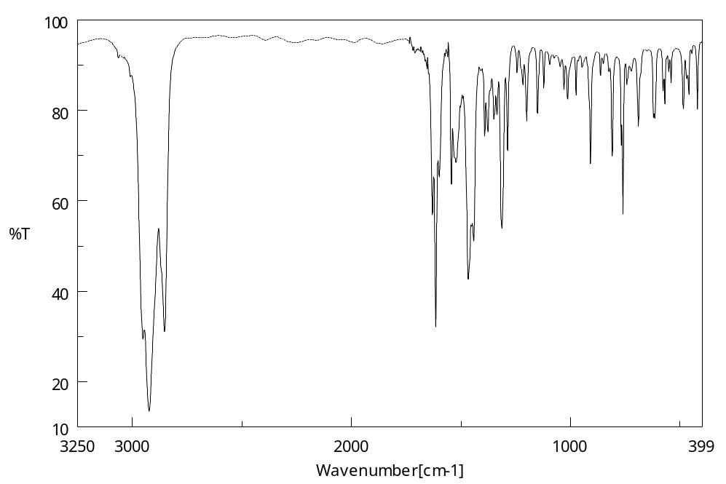
Figure S1. IR spectrum of catalyst 5 in nujol mull.

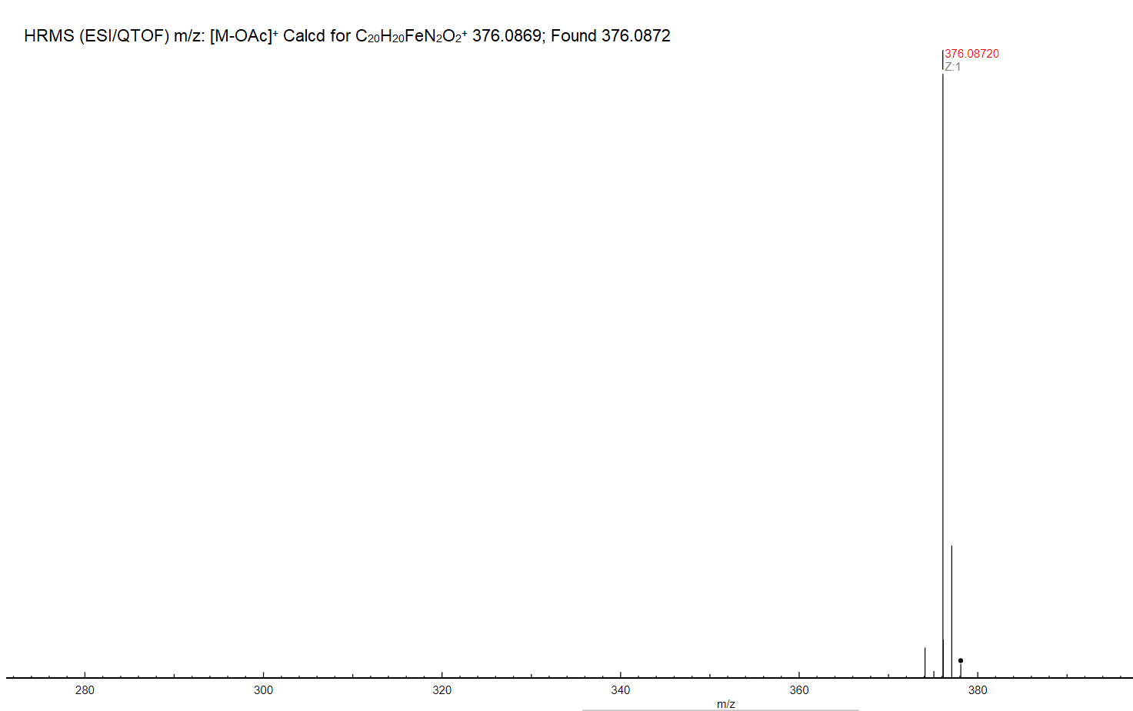

Figure S2. HRMS (ESI/QTOF) of catalyst 5.

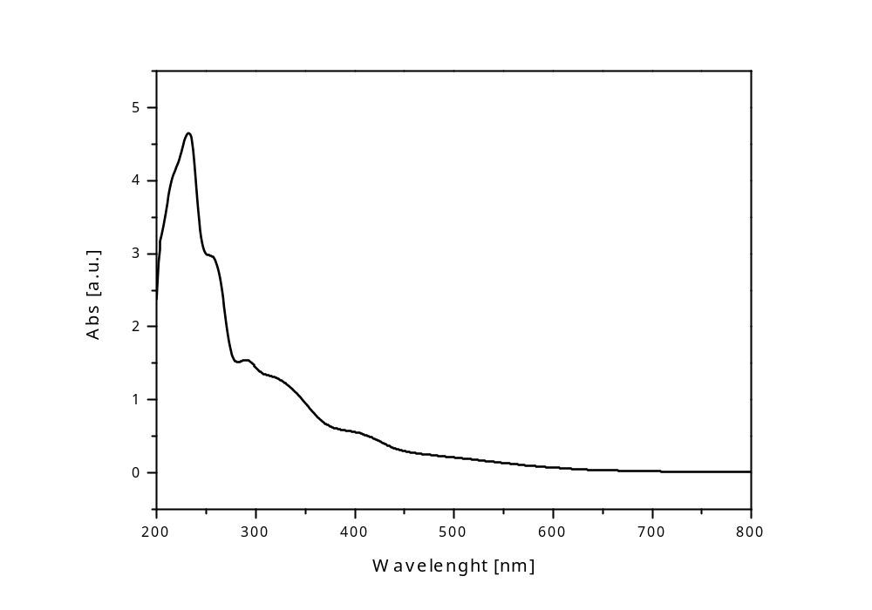
Figure S3. UV-Vis spectrum of catalyst 5 in methanol. Λ_{max} 232 nm

Paragraph S1. Method to quantify the yield of the reaction through NMR spectroscopy
The signals relevant to the quantification of the reaction yield are:
a) the singlet at δ 3.7 ppm, attributed to the methoxyl group, present only in the product.
b) the triplet at δ 2.3, attributed to the methylene group α to the carbonyl group, present both in the reagent and the product.
Thus, indicating with A₁ the integration area of the signal of the methoxyl group, and with A₂ the integration area of the signal of the methylene group, the yield is obtained using the following formula, where the ratio A₁/A₂ is multiplied by a factor 2/3, because areas A₁ and A₂ relates to 3 and 2 protons, respectively (see Figure S4 for reference).
$$Y(\%)=100 × \frac{{2A}_{1}}{{3A}_{2}}$$

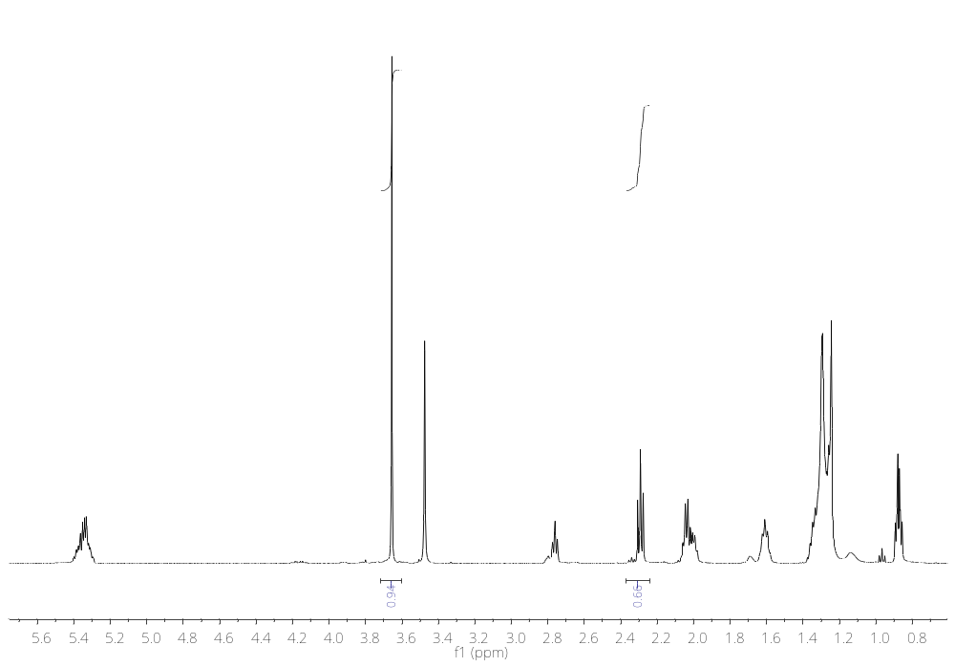
Figure S4. ¹H NMR spectrum in CDCl₃ at 25°C and 400 MHz of biodiesel produced from neutral soybean oil according to entry 10 of Table 3 (methanol:oil 10:1 mol:mol, catalyst 5 loading 0.10 mol %, 160°C, 2 h).

Table S1. Crystal data and refinement details for complex 5 _______________________________________________________
Empirical formula C₂₂H₂₃FeN₂O₄ · (CHCl₃)
Formula weight 554.64
Temperature 173(2) K
Wavelength 0.71073 Å
Crystal system, space group Monoclinic, P2₁/c
Unit cell dimensions a = 12.346(3) Å α = 90°
b = 10.2737(15) Å β = 105.999(18)°
c = 19.704(6) Å γ = 90°
Volume 2402.4(10) Å³
Z, Calculated density 4, 1.533 Mg/m³
Absorption coefficient 0.994 mm^{–1}
F(000) 1140
Crystal size 0.50 x 0.14 x 0.05 mm
Theta range for data collection 2.925 to 27.840°.
Reflections collected / unique 18918 / 5344 [R(int) = 0.0660]
Refinement method Full-matrix least-squares on F²
Data / restraints / parameters 5344 / 3 / 325
Goodness-of-fit on F^2 1.040
Final R indices [I>2sigma(I)] R1 = 0.0652, wR2 = 0.1362
R indices (all data) R1 = 0.1178, wR2 = 0.1578
Largest diff. peak and hole 0.787 and –0.433 eA^{–3}
______________________________________________________________

Figure S5. ORTEP view of complex 5 with ellipsoids drawn at 30 % probability level. The two splitted positions of carbonyl group and CHCl₃ molecule are drawn as bold bonds (0.89 refined occupancy factor) and dashed open bonds (0.11 refined occupancy factor).

Figure S6. Perspective view of complex 5 showing the highly deformed octahedral environment of Fe ion.

Figure S7. Crystal packing of complex 5 viewed along b axis direction showing sheets of complex and solvent chloroform molecules that alternate in the a axis direction.

Table S2. Bond lengths comparison in Fe(N,N’,O,O’)(OAc) complexes.
Bondª | Rangeª |  | Complex 5
Fe–O1 | 1.8572 – 1.900 | Å | 1.889 Å
Fe–O2 | 1.859 – 1.9081 | Å | 1.895 Å
Fe–N1 | 2.0885 – 2.399 | Å | 2.106 Å
Fe–N2 | 2.058 – 2.177 | Å | 2.087 Å
Fe–O3 | 2.0652 – 2.1124 | Å | 2.084 Å
Fe–O4 | 2.142 - 2.353 | Å | 2.128 Å

ª From Ref: O. J. Driscoll et al. “The synthesis, characterisation and application of iron(III)–acetate complexes for cyclic carbonate formation and the polymerisation of lactide”, Dalton Trans., 2019, 48, 15049.

