Supporting Information

Investigating Periodic Table Interpolation for the Rational Design of Nanoalloy Catalysts for Green Hydrogen Production from Ammonia Decomposition.

Luke A. Parker,^{1,2} Nia Richards,¹ Liam Bailey,¹ James H. Carter,¹ Ewa Nowicka,¹ Samuel Pattisson,¹ Nicholas F. Dummer,¹ Qian He,^{1,3} Li Lu,⁴ Christopher J. Kiely,^{1,4} Stanislaw E. Golunski,¹ Alberto Roldan,¹ Graham J. Hutchings¹ *
¹ Max Planck- Cardiff Centre on the Fundamentals of Heterogeneous Catalysis FUNCAT, Translational Research Hub, Maindy Road, Cardiff University, Cardiff, CF24 4HQ, UK.

² Now at: TNO Environmental Modelling, Sensing and Analysis, Princetonlaan 6, 3584 CB Utrecht, The Netherlands.

³ Now at: Department of Materials Science and Engineering, National University of Singapore, 9 Engineering Drive 1, Block EA #03-09, Singapore.

⁴ Department of Materials Science and Engineering, Lehigh University, 5 E Packer Avenue, Bethlehem, Pennsylvania, USA.

*Corresponding Author: hutch@cardiff.ac.uk
Keywords: Hydrogen Energy, Ammonia Decomposition, Catalyst Design, Nanoalloys

Fig. S1 Representative bright field TEM micrographs of 5 wt.% Ru/Al₂O₃ catalysts prepared by CVI (left) and wet impregnation (right).

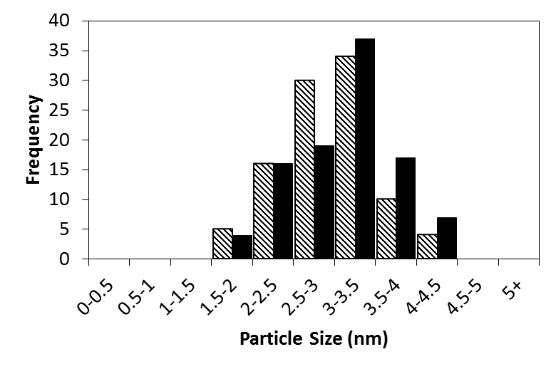
(%)
Fig. S2 Particle size distributions of 5 wt.% Ru/Al₂O₃ catalysts prepared by CVI (blocks) and wet impregnation (stripes). The region marked in blue indicates the optimum particle size range for Ru nanoparticles in NH₃ decomposition.

Fig. S3 XRD pattern of 5 wt.% FePt/Al₂O₃ materials prepared by sequential CVI. The sharper reflections at 39 ° and 47 ° () are due to presence of Pt and reflections marked () are due to the γ-Al2O3 support.

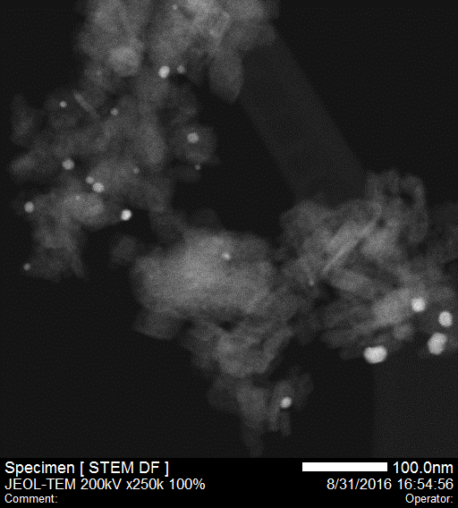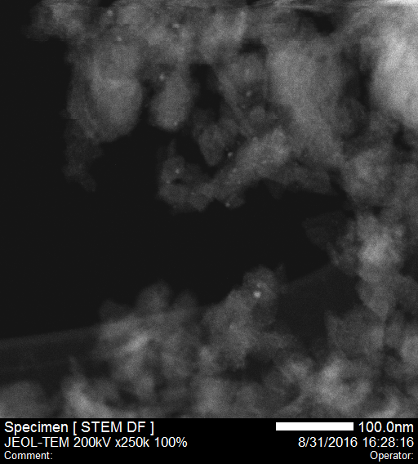
Fig. S4 Dark-field STEM micrographs of 5 wt.% Fe₂₀Pt₈₀/Al₂O₃ (left) prepared by sequential-CVI and 5 wt.% Fe₈₀Pt₂₀/Al₂O₃ (right) prepared by co-CVI.

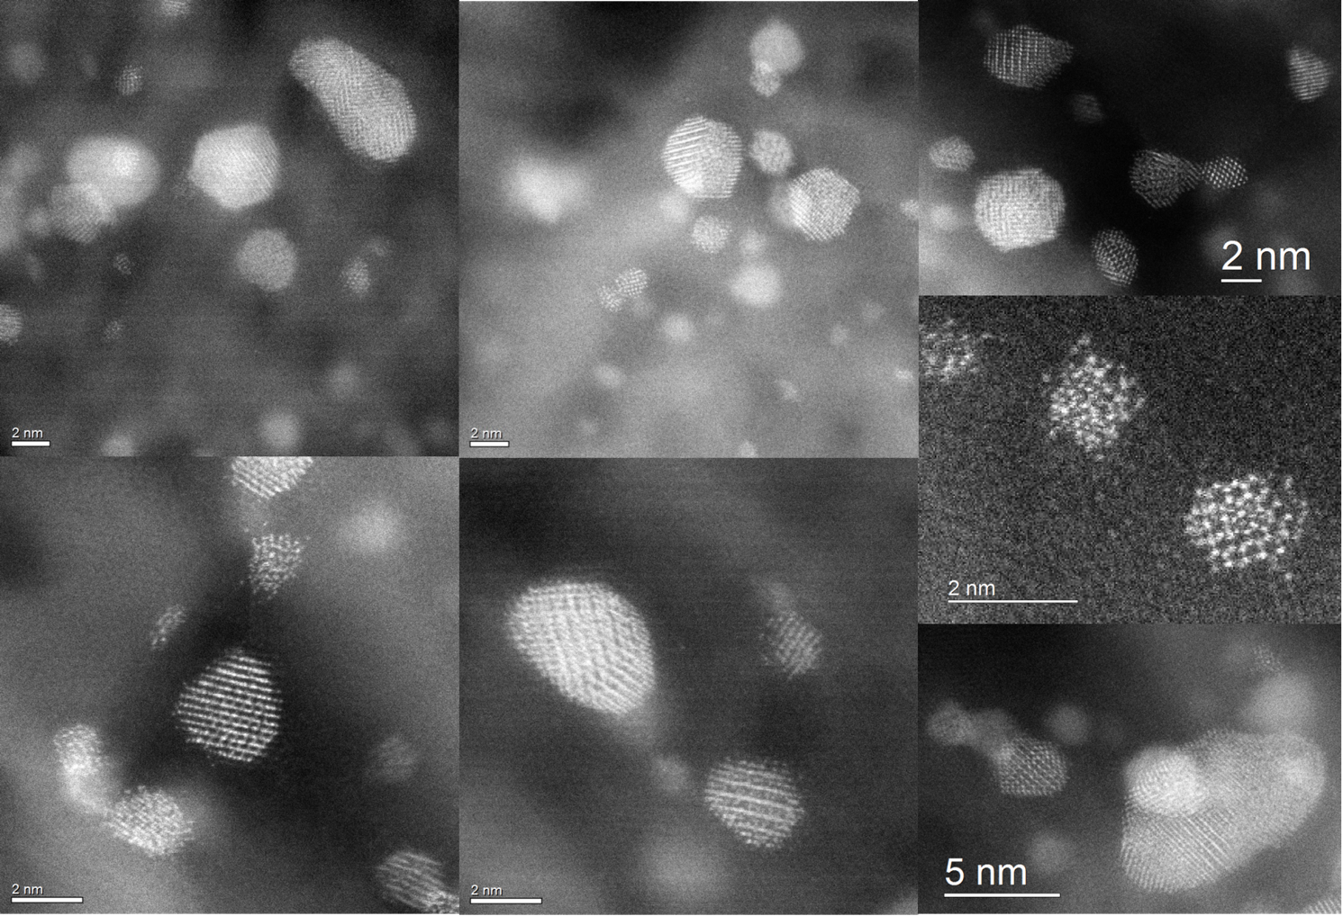
Fig. S5 Additional HAADF-STEM images of the unused Fe₈₀Pt₂₀/Al₂O₃ catalyst.

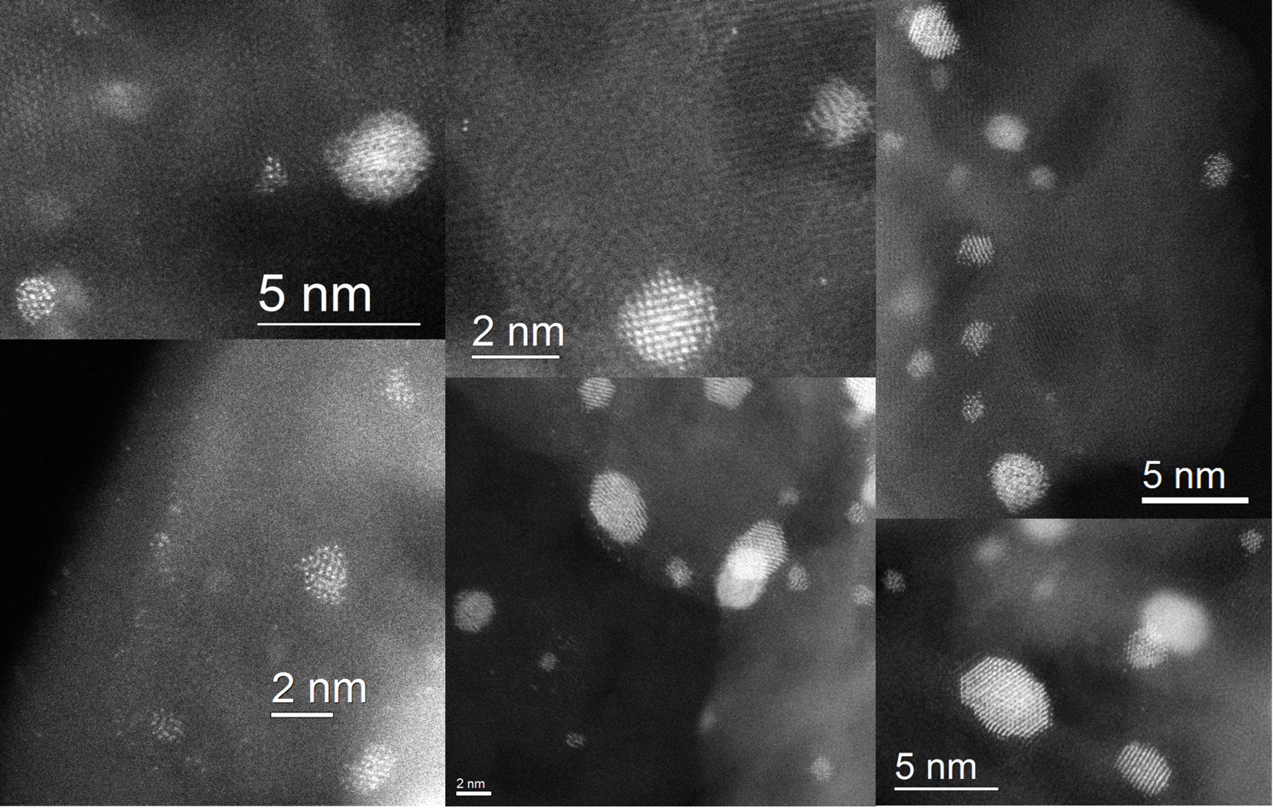
Fig. S6 Additional HAADF-STEM images of the used Fe₈₀Pt₂₀/Al₂O₃ catalyst.

