Supplementary Material
Effect of synthesis methods of ZnZrO_{x} oxides associated with SAPO-34 on the production of light olefins by CO₂ hydrogenation.

Ananda Vallezi Paladino Lino^{1*}, Elisabete Moreira Assaf², José Mansur Assaf¹ (in memorian)
¹Federal University of São Carlos, Chemical Engineering Department, São Carlos, SP 13565-905, Brazil
²University of São Paulo, São Carlos Institute of Chemistry, São Carlos, SP 13566-590, Brazil
*corresponding author: ananda.paladino@ufscar.br

Table S1 Main catalysts reported in literature for the CO₂ hydrogenation to light olefins through the methanol mediate route
Catalyst | T  (ºC) | P (bar) | H₂/CO₂ | GHSV  (mL.gcat⁻¹.h⁻¹) | X_{CO2}  (%) | S_{CO}  (%) | S_{CH4}  (%) | S_{C2=-C4=}  (%) | O/P | Reference
ZnO-Y₂O₃/  SAPO-34 | 390 | 40 | 4 | 1,800 | 27.6 | 85 | 0.3 | 12.6 | 6.5 | [S.1]
In₂O₃-ZrO₂/SAPO-34 | 400 | 15 | 3 | 3,000 | 20 | 88 | 0.6 | 10 | 9 | [S.2]
CuZnZr@  (Zn-)SAPO-34 | 400 | 20 | 3 | 3,000 | 19.6 | 58.6 | 6 | 25 | 3 | [S.3]
ZnZrO₂@  Al₂O₃@SAPO-34 | 380 | 30 | 3 | 3,500 | 13 | 78 | 0.9 | 16 | 4 | [S.4]
ZnZrO₂@ SAPO-34 | 380 | 30 | 3 | 3,500 | 13 | 55 | 23 | 9.5 | 1.1 | [S.5]
ZnZrO₂@ SAPO-34 | 380 | 30 | 3 | 3,500 | 20 | 27 | 1.6 | 58.4 | 3.3 | [S.5]
GaZrO_{x}/  SAPO-34 | 390 | 30 | 3 | 3,000 | 26 | 52 | 2.5 | 42 | 14 | [S.6]
CuCeO₂@  SAPO-34 | 360 | 20 | 3 | 18,600 | 8 | 41 | 1.5 | 41 | 2.8 | [S.7]
Mn₂O₃-ZnO/SAPO-34 | 380 | 30 | 3 | 3,600 | 25 | 55 | 1.3 | 36 | 6 | [S.8]
NiCu-CeO₂/SAPO-34 | 375 | 20 | 3 | 12,000 | 15 | 65 | 0.7 | 27 | 4 | [S.9]
CuZn-Kaolin/  SAPO-34 | 400 | 30 | 3 | 1,800 | 50.4 | 7.5 | 12.6 | 65.3 | 4.5 | [S.10]
CuZnAl/  SAPO-34 | 380 | 20 | 3 | 3,600 | 30 | 98 | 1.3 | 0.10 | 0.2 | [S.11]
ZnZr/SAPO-34 | 380 | 20 | 3 | 3,600 | 15 | 47 | 1.3 | 43 | 5.5 | [S.11]
Zn_{0,3}Ce_{0,2}Zr_{1,8}O_{0,4}/  SAPO-34 | 280 | 1 | 3 | 4,800 | 3 | 7.5 | 2.8 | 66 | 70 | [S.12]
InCrO_{x}/SAPO-34 | 350 | 35 | 3 | 1,140 | 30 | 60 | 1 | 30 | 4 | [S.13]
Ga_{0,15}CrO_{x}/SAPO-34 | 350 | 30 | 3 | 4,000 | 10 | 32 | 1.4 | 54 | 6 | [S.14]
ZnZrO₂@  SAPO-34 | 380 | 20 | 3 | 4,800 | 15 | 53 | 2.4 | 32.9 | 3.5 | [S.15]
ZnZrO_{x}&bio SAPO | 380 | 30 | 3 | 6,000 | 13.4 | 40.2 | 3 | 48.7 | 5 | [S.16]

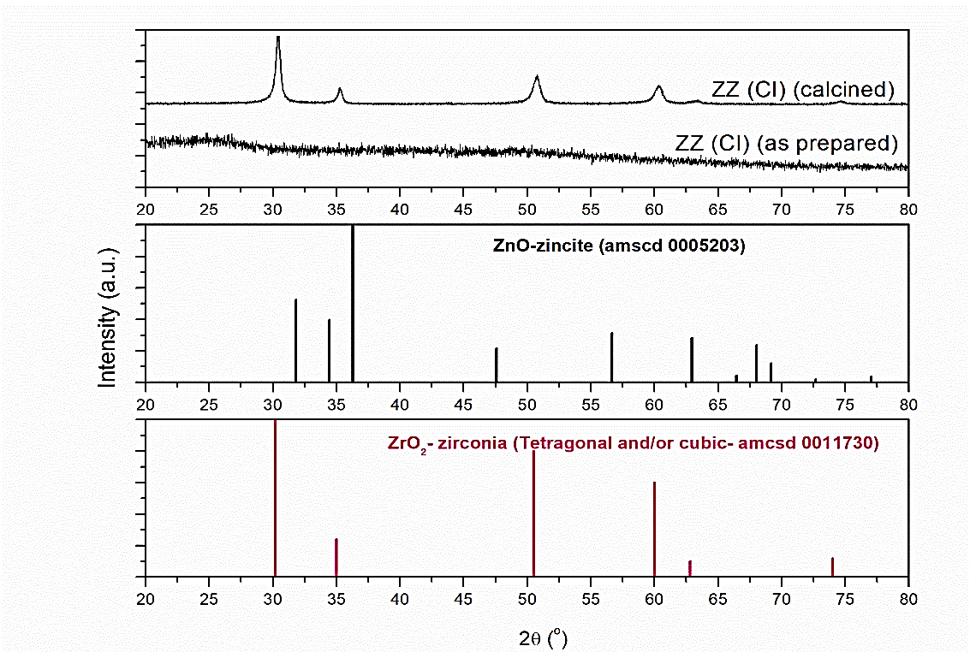
Fig. S1 X ray diffraction pattern of the ZZ(CI) sample, as prepared and after calcination, and the respective phase patterns

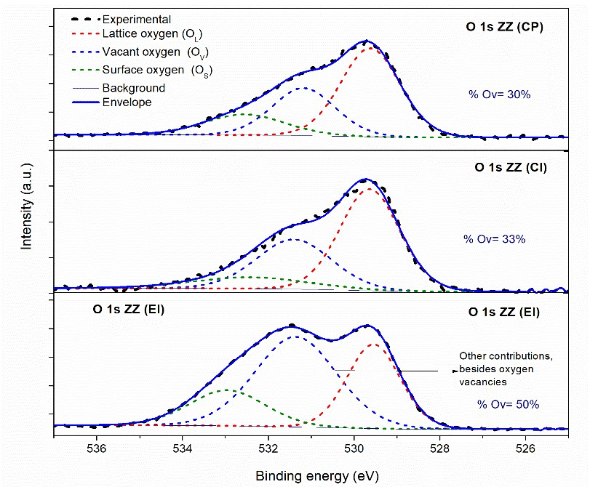
Fig. S2 O1s XPS spectra of the ZZ samples

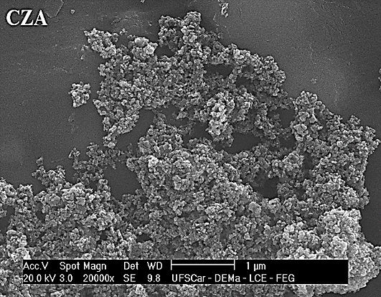
Fig. S3 SEM image of the CZA sample

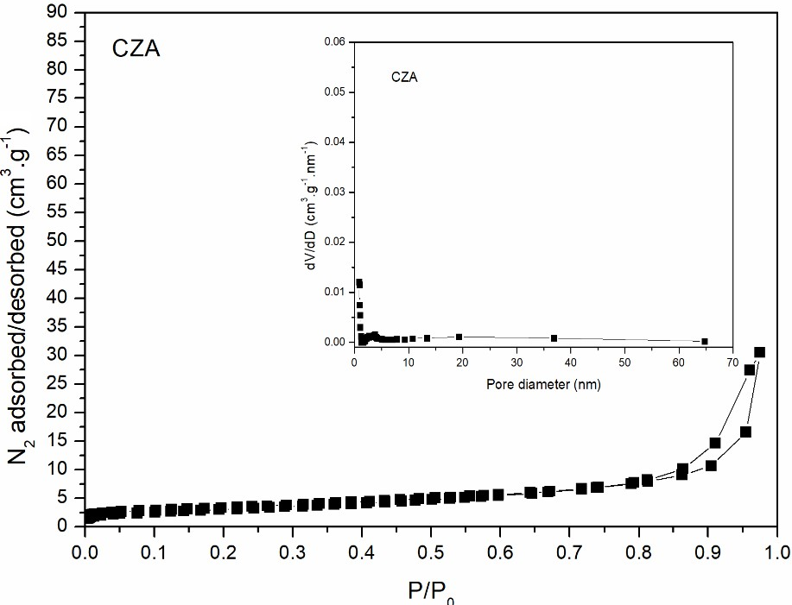
Fig.S4 N₂ adsorption/desorption isotherm and pore size distribution (inset) of CZA sample

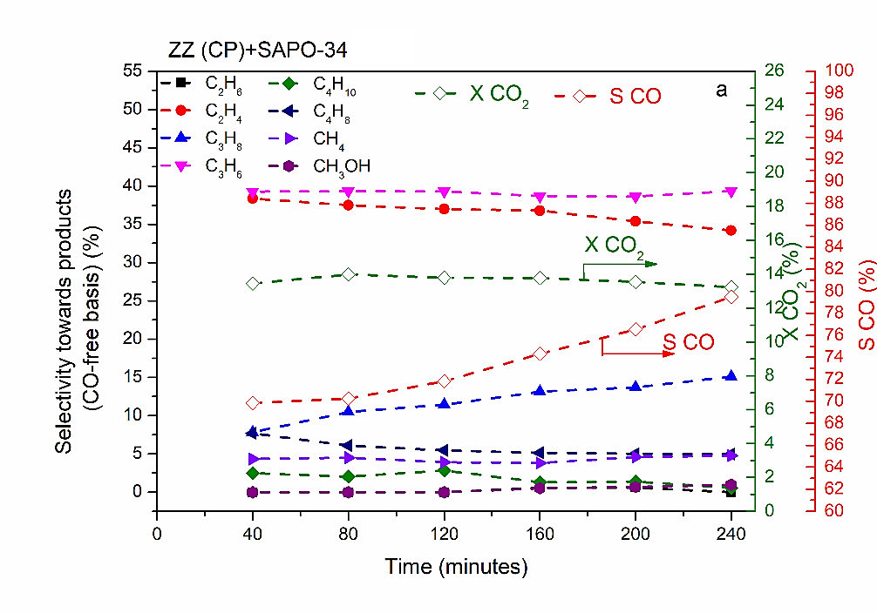
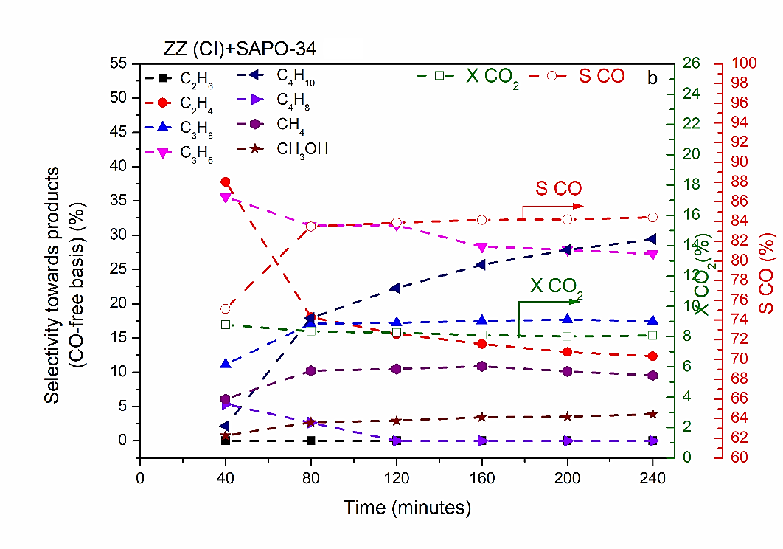
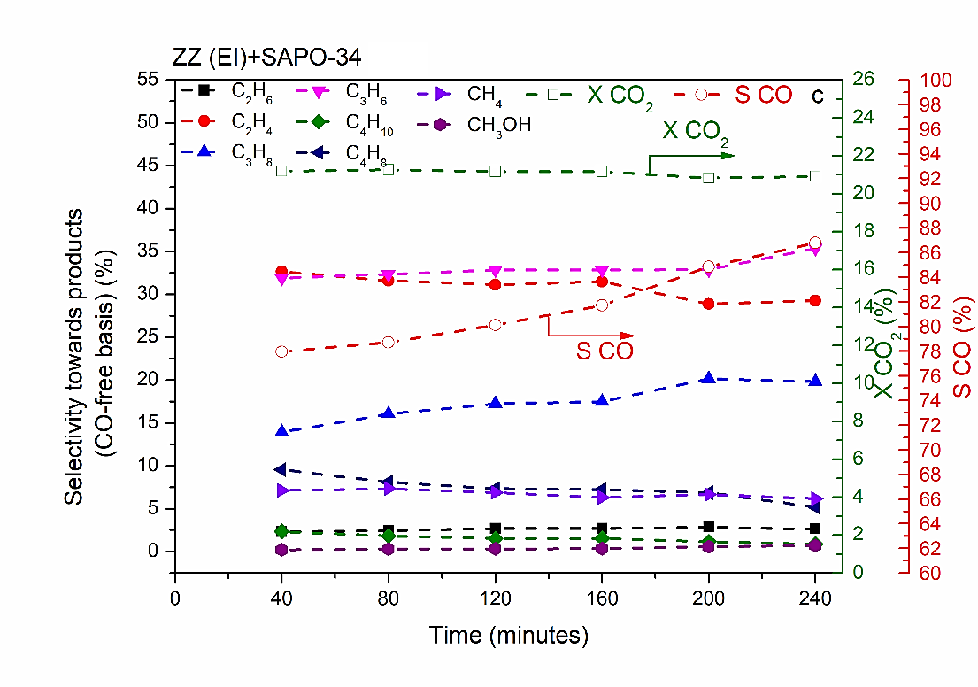
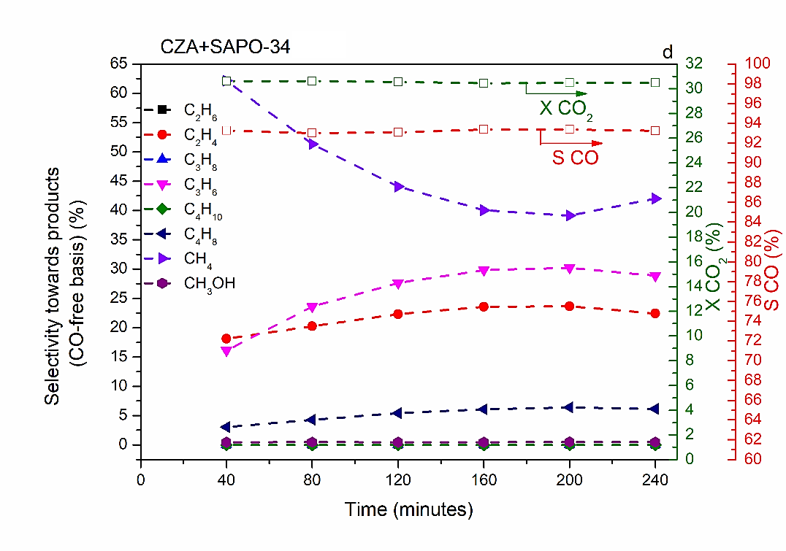
Fig. S5 Catalysts performances along TOS. P= 20 bar, T= 380º C, GHSV= 2,400 mL.h⁻¹.g⁻¹. ZZ or CZA/ SAPO-34 weight ratio: 3/1. Activation condition: 150º C, 1 h, N₂ (30 mL.min⁻¹), followed by reduction at 400º C, 1 h, H₂ (30 mL.min⁻¹).

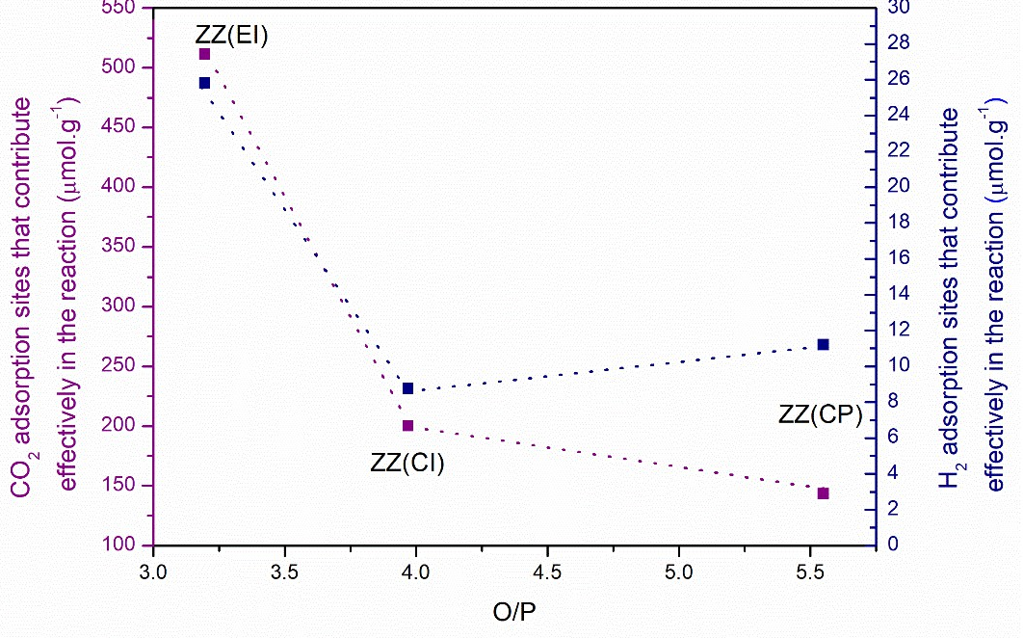

Fig. S6 Relationship between O/P ratio and physic-chemical properties.

Reference list
[S.1] Li J, Yu T, Miao D, Pan X, Bao X (2019) Carbon dioxide hydrogenation to light olefins over ZnO-Y₂O₃ and SAPO-34 bifunctional catalysts. Catal. Comm.. https://doi.org/10.1016/j.catcom.2019.105711
[S.2] Gao J, Jia C, Liu B (2017) Direct and selective hydrogenation of CO₂ to ethylene and propene by bifunctional catalysts. Catal Sci. Technol. https://doi.org/10.1039/C7CY01549F
[S.3] Chen J,Wang X, Wu D, Zhang J, Ma Q, Gao X, Lai X, Xia H, Fan S, Zhao TS (2019) Hydrogenation of CO₂ to light olefins on CuZnZr@(Zn-)SAPO-34 catalysts: Strategy for product distribution. Fuel. 44-52. https://doi.org/10.1016/j.fuel.2018.10.148
[S.4] Wang G, Wang Y, Cao J, Wang X, Yi Y, Liu F (2020) Fabrication of ZnZrO₂@Al₂O₃@SAPO-34 tandem catalyst for CO₂ conversion to hydrocarbons. Microporous Mesoporous Mater. https://doi.org/10.1016/j.micromeso.2019.109693
[S.5] Wang G, Zeng L, Cao J, Liu F, Lin Q, Yi Y, Pan H (2019) Highly selective conversion of CO₂ to hydrocarbons over composite catalysts of ZnO-ZrO₂ and SAPO-34. Microporous Mesoporous Mater. 284. https://doi.org/10.1016/j.micromeso.2019.04.023
[S.6] Zhang P, Ma L, Meng F, Wang L, Zhang R, Yang G, Li Z (2021) Boosting CO₂ hydrogenation performance for light olefin synthesis over GaZrO_{x} combined with SAPO-34. Appl. Catal. B: Environ. https://doi.org/10.1016/j.apcatb.2021.121042
[S.7] Sedighi M, Mohammadi M (2020) CO₂ hydrogenation to light olefins over Cu-CeO₂/SAPO-34 catalysts: Product distribution and optimization. J. CO₂ Util. https://doi.org/10.1016/j.jcou.2019.10.002
[S.8] Mou J, Fan X, Li F, Wang X, Zhao T, Chen P, Li Z, Yang C, Cao J (2021) CO₂ hydrogenation to lower olefins over Mn₂O₃-ZnO/SAPO-34 tandem catalysts. Chem. Eng. J. https://doi.org/10.1016/j.cej.2021.129978
[S.9] Ghasemi M, Mohammadi M, Sedighi M (2020) Sustainable production of light olefins from greenhouse gas CO₂ over SAPO-34 supported modified cerium oxide. Microporous Mesoporous Mater. https://doi.org/10.1016/j.micromeso.2020.110029
[S.10] Wang P, Zha F, Yao L, Chang Y (2018) Synthesis of light olefins from CO₂ hydrogenation over (CuO-ZnO)-kaolin/SAPO-34 molecular sieves, Appl. Clay Sci. https://doi.org/10.1016/j.clay.2018.06.038
[S.11] Li Z, Wang J, Qu Y, Liu H, Tang C, Miao S, Feng Z, An H, Li C (2017) Highly Selective Conversion of Carbon Dioxide to Lower Olefins. ACS Catal. https://doi.org/10.1021/acscatal.7b03251
[S.12] Zhang L, Geng B, Wang P, Kang H, Xiao H, Jia J, Wu H (2023) Highly efficient ZnCeZrO_{x}/SAPO-34 catalyst for the direct conversion of CO₂ into light olefins under mild reaction conditions. Appl. Catal. A: Gen. https://doi.org/10.1016/j.apcata.2023.119141
[S.13] Wang S, Wang P, Qin Z, Yan W, Dong M, Li J, Wang J, Fan W (2020) Enhancement of light olefin production in CO₂ hydrogenation over In₂O₃-based oxide and SAPO-34 composite. J. Catal. https://doi.org/10.1016/j.jcat.2020.09.010
[S.14] Zhang W, Wang S, Guo S, Qin Z, Dong M, Fan W, Wang J (2022) Ga_{m}CrO_{x}/H-SAPO-34(F), a highly efficient bifunctional catalyst for the direct conversion of CO₂ into ethene and propene. Fuel. https://doi.org/10.1016/j.fuel.2022.125475
[S.15] Lu P, Chang X, Yu W, Hu Q, Ali KM, Xing C, Du C, Yang Z, Chen S (2023) Synergistic effects of ZnO–ZrO₂@SAPO-34 core-shell catalyst in catalyzing CO₂ hydrogenation for the synthesis of light olefins. Renew. Energy. https://doi.org/10.1016/j.renene.2023.03.111
[S.16] Yang S, Song J, Yue Y, Chen B, Ali S, Tan KB, Tian J, Huang J, Li Q, Zhan G (2026) Tuning zeolite crystal size in bifunctional catalysts assembled on bio-SiO₂ for enhanced CO₂ hydrogenation to light olefins. Chem. Eng. Sci. https://doi.org/10.1016/j.ces.2025.122468

