Supplementary data
Fig. S1. The representative S (sense mRNA probe) and AS (antisense mRNA probe) pictures of kdm6bb in zebfafish PLL primordia at 32 hpf.

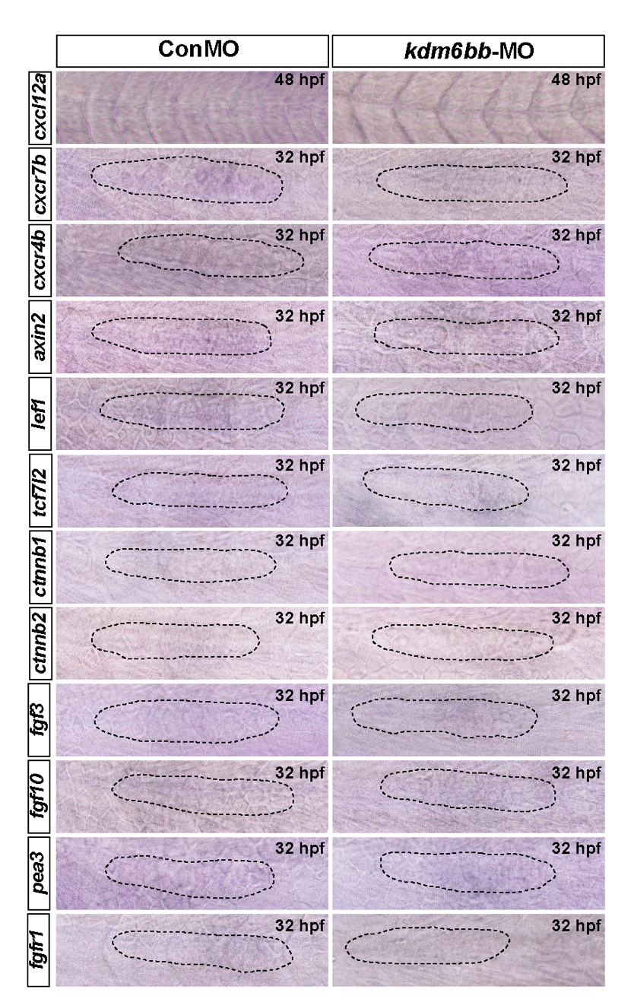
Fig. S2. The representative S (sense mRNA probe) pictures of all the chemokines and Wnt and Fgf signaling pathway members used in this study at 32 hpf in zebrafish PLL primordia.
Fig. S3. The relative mRNA levels of the indicated genes were normalized to the GAPDH level as determined by RT-qPCR. The results are expressed as the mean (minimum and maximum values) from three independent experiments (n=8 embryos in each group). *p < 0.05, ***p < 0.001.

Table. S1. Primers for Real-Time PCR detection.

