Role of NADPH oxidase 1 in alcohol-caused oxidative stress injury of intestinal epithelial cells

Liuying Chen¹, Huikuan Chu¹, Lilin Hu¹, Zhonglin Li¹, Ling Yang^{1#}, Xiaohua Hou^{1#}

Liuying Chen, Email: jinniuzuo400@126.com
Huikuan Chu, Email: 2012xh0827@hust.edu.cn
Lilin Hu, Email: hulilin95@163.com
Zhonglin Li, Email: 1479590989@qq.com
Ling Yang, Email: hepayang@163.com
Xiaohua Hou, Email: houxh@hust.edu.cn

¹Division of Gastroenterology, Union Hospital, Tongji Medical College, Huazhong University of Science and Technology, 1277 Jiefang Avenue, Wuhan 430022, China

#Correspondence
Xiao Hua Hou, M.D., Ph.D. Email: houxh@hust.edu.cn; Division of Gastroenterology, Union Hospital, Tongji Medical College, Huazhong University of Science and Technology, 1277 Jiefang Avenue, Wuhan, 430022, China; Phone +86 -2785726678, +8613035143646.
Ling Yang, M.D., Ph.D. Email: hepayang@163.com; Division of Gastroenterology, Union Hospital, Tongji Medical College, Huazhong University of Science and Technology, 1277 Jiefang Avenue, Wuhan, 430022, China; phone +86-2785726678, +8613971178791.

Supplemental table 1. Primers used in RT-PCR.
Gene name | Forward sequence | Reverse sequence
Mouse 18S | GTAACCCGTTGAACCCCATT | CCATCCAATCGGTAGTAGCG
Total bacteria | GTGSTGCAYGGYTGTCGTCA | ACGTCRTCCMCACCTTCCTC
Mouse IL-1β | TTGTTGATGTGCTGCTGTGA | TGTGAAATGCCACCTTTTGA
Mouse TGF-β | GGCACCATCCATGACATGAACC | CCGCACACAGCAGTTCTTCTCT
Mouse IL-6 | CTGCAAGAGACTTCCATCCAG | AGTGGTATAGACAGGTCTGTTGG
Mouse TNF-α | CTGAACTTCGGGGTGATCGG | GGCTTGTCACTCGAATTTTGAGA
Mouse MCP-1 | TTAAAAACCTGGATCGGAACCAA | GCATTAGCTTCAGATTTACGGGT
Mouse IFN-γ | ATGAACGCTACACACTGCATC | CCATCCTTTTGCCAGTTCCTC
Mouse HDAC2 | ATGGCGTACAGTCAAGGAGG | ATGAGGCTTCATGGGATGACC
Mouse HDAC4 | CACTGCATTTCCAGCGATCC | AAGACGGGGTGGTTGTAGGA
Mouse HDAC6 | GAGGAGCTGATGTTGGTTCAC | AGTTCGGATGCAGATACACTGA
Mouse HDAC9 | GCGGTCCAGGTTAAAACAGAA | GCCACCTCAAACACTCGCTT
Mouse HDAC11 | GTGTACTCACCACGTTACAACA | GCTCGTTGAGATAGCGCCTC
Mouse NOX1 | GGTTGGGGCTGAACATTTTTC | TCGACACACAGGAATCAGGAT
Mouse Gpx1 | AGTCCACCGTGTATGCCTTCT | GAGACGCGACATTCTCAATGA
Mouse Sod1 | AACCAGTTGTGTTGTCAGGAC | CCACCATGTTTCTTAGAGTGAGG
Mouse Cat | AGCGACCAGATGAAGCAGTG | TCCGCTCTCTGTCAAAGTGTG
Human GAPDH | GGAGCGAGATCCCTCCAAAAT | GGCTGTTGTCATACTTCTCATGG
Human  HDAC2 | ATGGCGTACAGTCAAGGAGG | TGCGGATTCTATGAGGCTTCA
Human  HDAC4 | CACGCACAGTCCTTGGTTGGT | TGCTGATGCTGCTGCTGGATG
Human  HDAC6 | ACCATCCAAGTCCATCGCAGAT | TCGTGTGGTCATCCGCTCAG
Human  HDAC9 | AGTAGAGAGGCATCGCAGAGA | GGAGTGTCTTTCGTTGCTGAT
Human  HDAC11 | ACCCAGACAGGAGGAACCATA | TGATGTCCGCATAGGCACAG
Human  NOX1 | CTGCTTCCTGTGTGTCGCAA | AGGCAGATCATATAGGCCACC
Human  FFAR2 | CCGTGCAGTACAAGCTCTCC | CTGCTCAGTCGTGTTCAAGTATT
Human  FFAR3 | TTCACCACCATCTATCTCACCG | GGAACTCCAGGTAGCAGGTC
Human  Gpx1 | CAGTCGGTGTATGCCTTCTCG | GAGGGACGCCACATTCTCG
Human  Sod1 | GGTGGGCCAAAGGATGAAGAG | CCACAAGCCAAACGACTTCC
Human  Cat | TGGGATCTCGTTGGAAATAACAC | TCAGGACGTAGGCTCCAGAAG

Supplemental table 2. Primers used in CHIP-PCR.
Gene name | Forward sequence | Reverse sequence
NOX1 primer1 | ACTCGGGTGGCTAAGGCATGA | GGTCTCACTCTGTCACCCAGGT
NOX1 primer2 | CCAACCTGGGTGACAGAGTGA | TTGAATCCACCTGGAGCTGATT
NOX1 primer3 | TAGGCTCAGAATAGGCTCTT | CTTCCTCTACATGCTTACCAA
NOX1 primer4 | GTTGGTAAGCATGTAGAGGA | CTACTGATGGATATGATGATGG
NOX1 primer5 | CATCATATCCATCAGTAGTAGG | TGTGTATGTATGCTTCTGTG
NOX1 primer6 | TGAAGGGAGATCACACCACTG | TGAATCCACCTGGAGCTGATT
NOX1 primer7 | GAGTGCTCTGCCTCTGTT | GGCTGGAAGGACAAGTGA
NOX1 primer8 | TCCAGCCAGTCAAGTTCTCC | GGAAGCGTGTGTGGTAAGGA
NOX1 primer9 | TCCCTCCCTACTTCTCCT | AGCATTGCCTTCCTAGATAA
NOX1 primer10 | CTAGGAAGGCAATGCTTCACAT | CCAGCCCTATCTATGAGAACCA

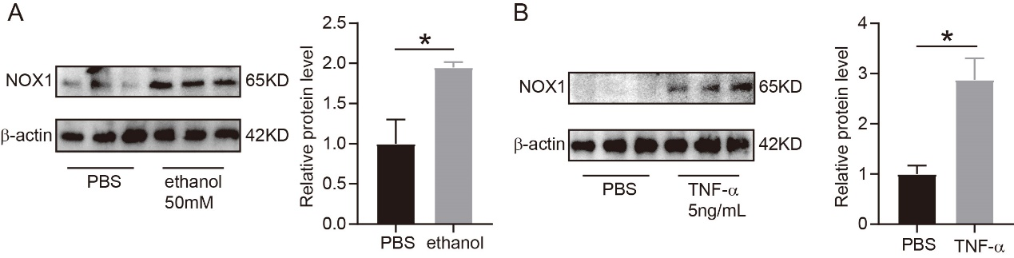
Supplemental figure 1. NOX1 expression of NCM460 cells treated with ethanol and TNF-α. A. NOX1 expression of NCM460 cells treated with ethanol (50mM) for 24h. B. NOX1 expression of NCM460 cells treated with TNF-α(5ng/mL) for 24h. N=3 of each group. *indicated p<0.05.

Supplemental figure 2. Inflammatory factors expression of colonic tissues from mice isocaloric-fed and ethanol-fed mice with and without propionate supplement by RT-PCR. N=6 of each group. n.s, no significant. *indicated p<0.05.

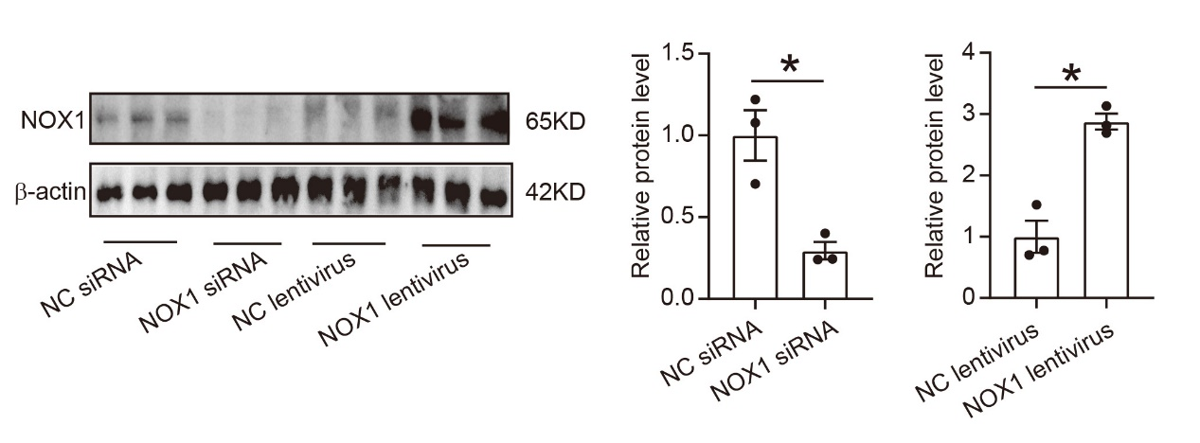
Supplemental figure 3. Evaluation of NOX1 intervention and overexpression by western blotting. N=3 of each group. *indicated p<0.05.

Supplemental figure 4. Propionate alleviated ROS injury of NCM460 cells treated with TNF-α. A. Tunel staining of NCM460 cells exposed to TNF-α with and without propionate. B, C. DCFH-DA fluorescent probe assay (B) and DHE staining (C) showed ROS formation in NCM460 cells from above groups. E. Immunoblotting images and quantification of Bax, Casp3, c-Casp3, Casp8, iNOS and NOX1 protein expressions from the above groups. N=3 of each group. n.s, no significant. *p value<0.05.

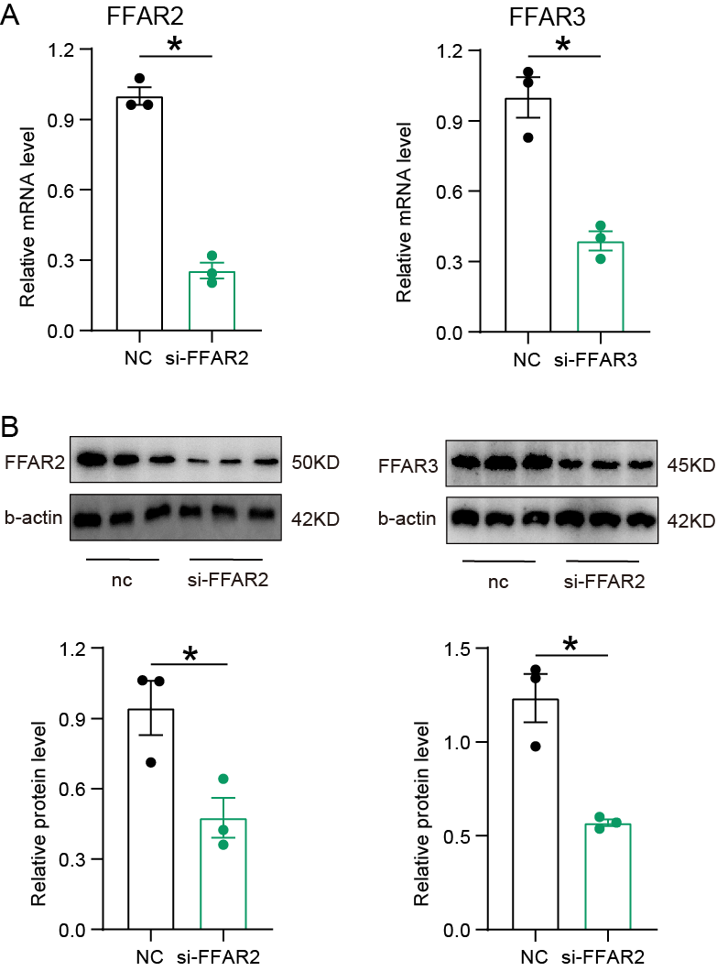

Supplemental figure 5. Effect of siRNA intervention. A. mRNA levels of FFAR2 and FFAR3 after siRNA interfering NCM460 cells. B. Protein levels of FFAR2 and FFAR3 after siRNA interfering NCM460 cells. N=3 of each group. *p value<0.05.

