Supplementary material

Administration of Gas6 attenuates lung fibrosis via inhibition of the epithelial-mesenchymal transition and fibroblast activation

Ye-Ji Lee • Minsuk Kim • Hee-Sun Kim • Jihee Lee Kang

*Correspondence should be addressed to:
jihee@ewha.ac.kr

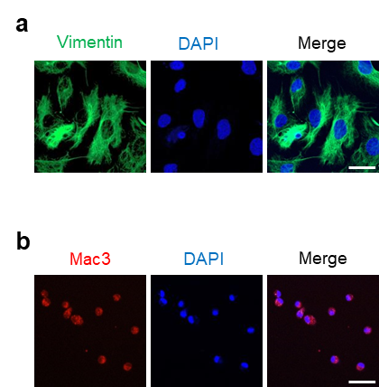

Supplementary Figure 1. Immunofluorescence staining for vimentin in primary isolated lung fibroblasts and for and Mac3 in alveolar macrophages from mice, respectively. Immunofluorescence staining for vimentin (green) in the isolated fibroblasts (a) and Mac3 (red) in alveolar macrophages (b) from naïve mice. Original magnification: 400×. Scale bars: 20 μm. Imaging medium: Vectashield fluorescent mounting medium containing DAPI. Results are representative of three independent experiments

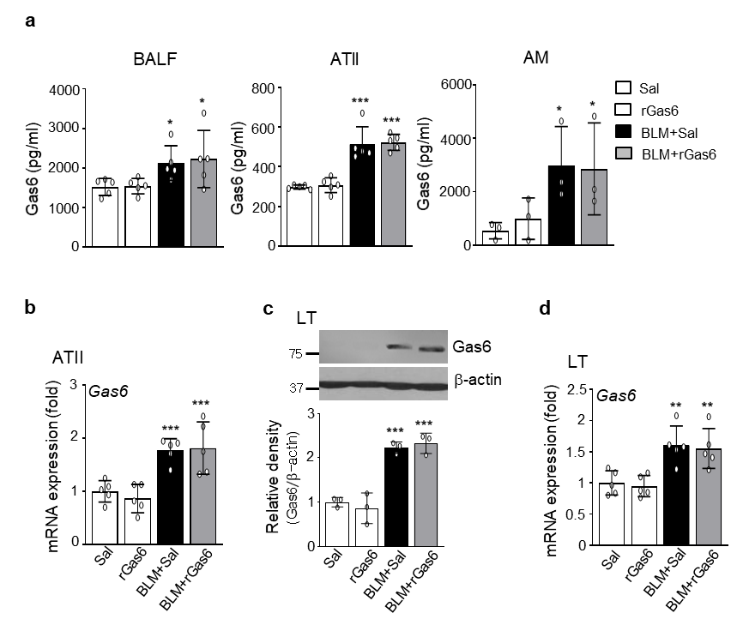
Supplementary Fig. 2. Enhanced Gas6 expression in BLM-induced lung fibrosis. Mice were intratracheally instilled with BLM (5 U/kg). Either rGas6 (50 μg/kg) or saline (Sal) was intraperitoneally administered 1 day before BLM treatment and once every 2 days thereafter. Mice were euthanized 14 days after BLM treatment. (a) ELISA of Gas6 in BAL fluid (BALF), culture supernatants from ATII cells, and alveolar macrophages (AM). (b) qRT-PCR of Gas6 in ATII cell samples. (c) Immunoblot analysis of Gas6 in lung tissue. Below: Densitometric analysis of each band normalized to that of β-actin. (d) qRT-PCR of Gas6 in lung tissue. *P < 0.05, **P < 0.01, ***P < 0.001 compared with Saline or rGas6. Data were obtained from three (a right) or five replicates (a middle, b) per condition with cells pooled from two mice per replicate (means ± SEM). Values represent the means ± SEM of results from three (c below) or five mice (a, d) per group.

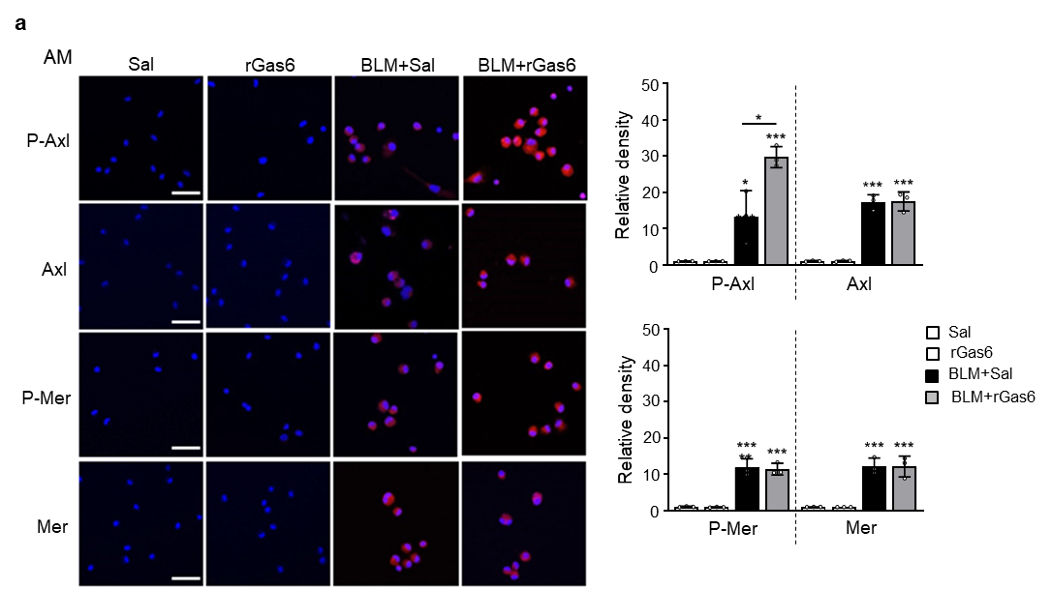
Supplementary Fig. 3. Enhanced activation of Axl in alveolar macrophages induced by rGas6 administration. Mice were intratracheally instilled with BLM (5 U/kg). Either rGas6 (50 μg/kg) or saline (Sal) was intraperitoneally administered 1 day before BLM treatment and once every 2 days thereafter. Mice were euthanized 14 days after BLM treatment. Left: Immunofluorescence staining for phospho-Axl (red), total Axl (red), phospho-Mer (red), and total Mer (red) in alveolar macrophages. Images were captured at 400× magnification. Right: Quantification of phospho-Axl, total Axl, phospho-Mer, and total Mer staining. Imaging medium: Vectashield fluorescence mounting medium containing DAPI. Scale bars: 20 μm. Data were obtained from three replicates per condition with cells pooled from two mice per replicate. Values represent the means ± SEM. *P < 0.05, ***P < 0.001 compared with saline control or rGas6.

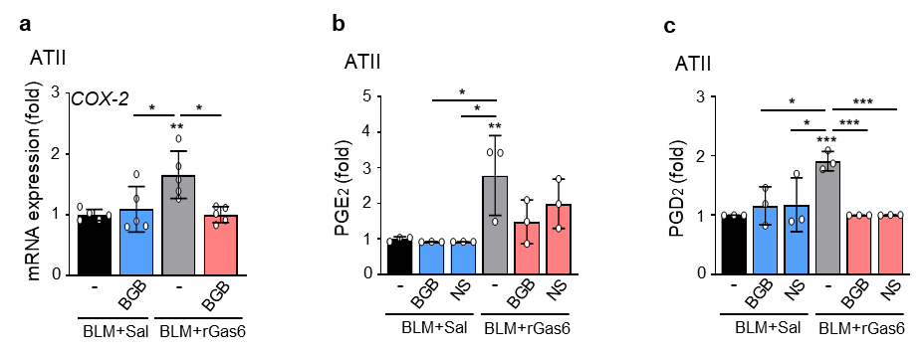
Supplementary Fig. 4. Enhanced COX-2-derived PGE₂ and PGD₂ production induced by Gas6-Axl signaling. Where indicated, the Axl inhibitor BGB324 (BGB, 5 mg/kg, i.o.) or COX-2 inhibitor NS-398 (NS, 5 mg/kg, i.o.) was co-administered with rGas6 1 day before BLM treatment and then administered once every 2 days thereafter. Mice were euthanized 14 days following BLM treatment. (a) qRT-PCR of COX-2 in ATII cells. (b, c) PGE₂ or PGD₂ levels in culture supernatants from ATII cells were measured using an enzyme immunoassay. Data were obtained from three (b, c) or five replicates (a) per condition with cells pooled from two mice per replicate. Values represent the means ± SEM. *P < 0.05, **P < 0.01, ***P < 0.001 compared with saline control or rGas6.

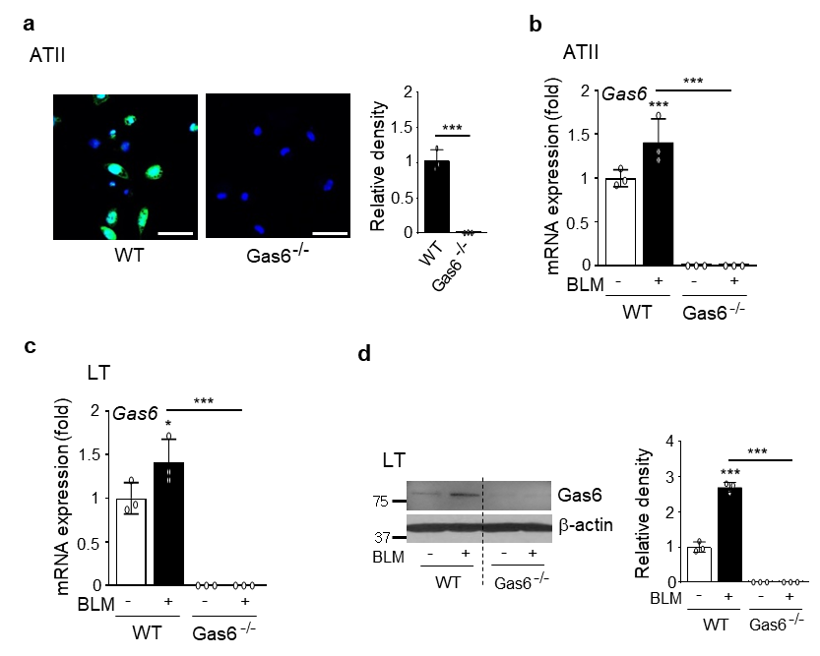
Supplementary Fig. 5. Gas6 expression in ATII cells and lung tissue in WT and Gas6^{−/−} mice. (a) Left: immunofluorescence staining for Gas6 (green) in primary ATII cells from WT and GAS6^{−/−} mice. Right: quantification of Gas6 staining. Original magnification: 400×. Scale bars: 20 μm. Imaging medium: Vectashield fluorescent mounting medium containing DAPI. (b) qRT-PCR of Gas6 in ATII cell samples. (c) Immunoblot analysis of Gas6 in lung tissue from WT and Gas6^{−/−} mice 14 days after BLM treatment. Right: Densitometric analysis of each band normalized to that of β-actin. (d) qRT-PCR of Gas6 in lung tissue. ***P < 0.001 compared with saline control or for WT vs. Gas6^{−/−} mice. Data were obtained from three replicates per condition with cells pooled from two mice per replicate (a right, b) or from three mice in each group (c right, d). The data are shown as the means ± SEM.

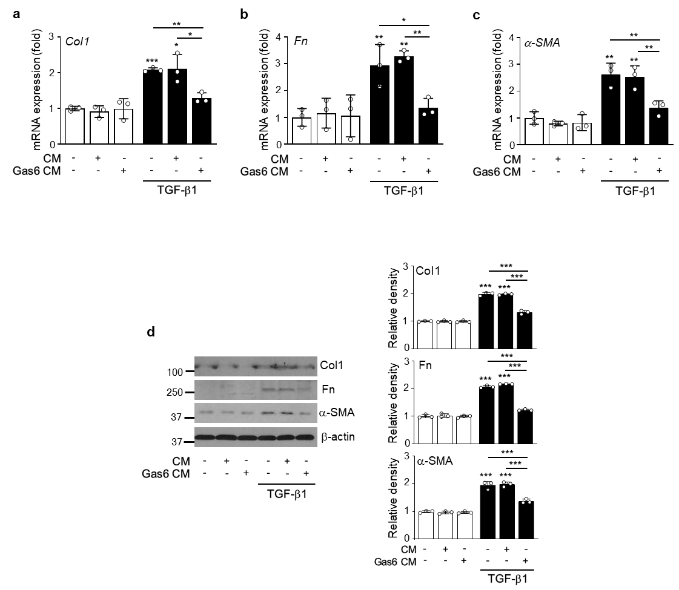

Supplementary Fig. 6. Conditioned medium from LA-4 cells exposed to rGas6 reduces myofibroblast phenotypic marker in lung fibroblasts. LA-4 cells were stimulated with rGas6 (400 ng/ml) for 20 h. Conditioned medium (CM) was added to MLg cells in the absence or presence of 10 ng/ml TGF-β1 for 24 h. (a-c) qRT-PCR of collagen type 1, fibronectin, and α-SMA in MLg cell samples. (d) Immunoblots of the indicated proteins in MLg cell lysates. Below: Densitometric analysis of each band normalized to that of β-actin. Values represent the means ± S.E.M. of three independent experiments. *P < 0.05, **P < 0.01, ***P < 0.001 compared with control.

Table S1. List of antibodies
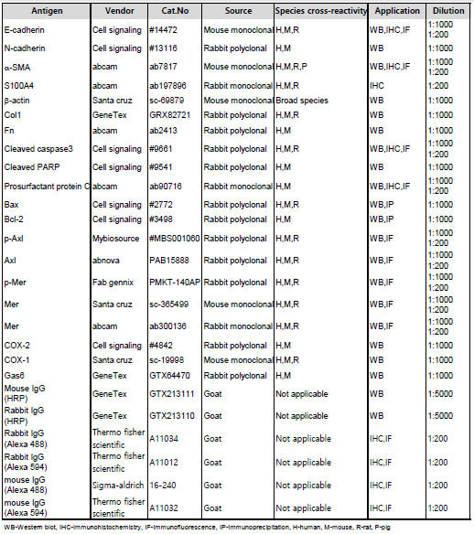

Table S2. Primer sequences
