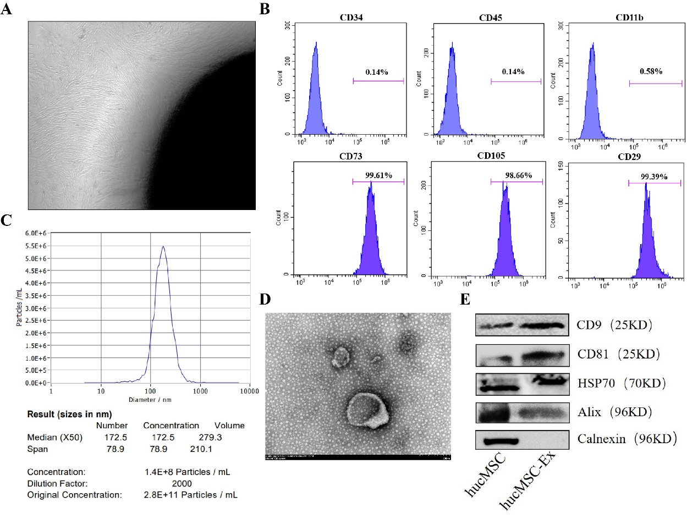
Figure S1 Identification of hucMSC-Ex. (A) Mesenchymal stem cells growing around human umbilical cord tissue. (B) Negative markers CD34, CD45, CD11b and positive markers CD73, CD105, and CD29 as identified by flow cytometry. (C) The diameter of hucMSC-Ex as measured by NanoSight nanoparticle tracking analyzer. (D) The morphology of hucMSC-Ex as observed by transmission electron microscopy. (E) Western-blot analysis of hucMSC-Ex protein markers.
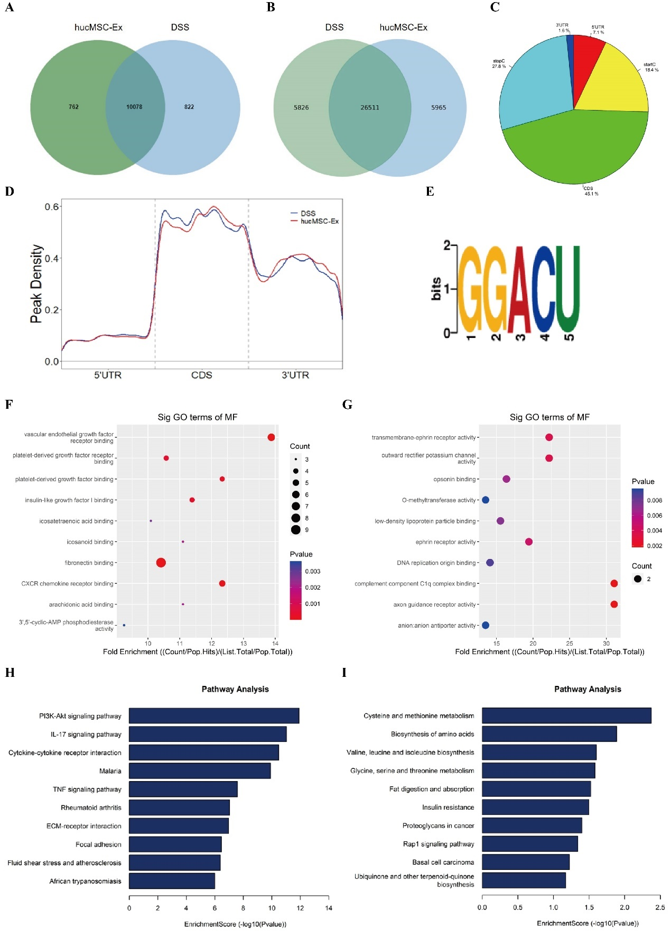
Figure S2 Analysis of differential m6A modification in mice colorectal tissues by MeRIP-Seq. (A) Venn chart of m6A-modified differential genes between hucMSC-Ex and DSS groups. (B) Venn chart of differential m6A peak between hucMSC-Ex and DSS groups. (C) Genomic map of m6A methylation region in hucMSC-Ex group. (D) MetaGene peak density map of hucMSC-Ex and DSS groups. (E) Motif of m6A methylation region up-regulated by hucMSC-Ex compared with the DSS group. (F) GO enrichment analysis of m6A down-regulated mRNA by hucMSC-Ex compared with the DSS group. (G) GO enrichment analysis of m6A up-regulated mRNA by hucMSC-Ex compared with the DSS group. (H) KEGG pathway of m6A down-regulated mRNA by hucMSC-Ex compared with the DSS group. (I) KEGG pathway of m6A up-regulated mRNA differentially modified by hucMSC-Ex compared with the DSS group.

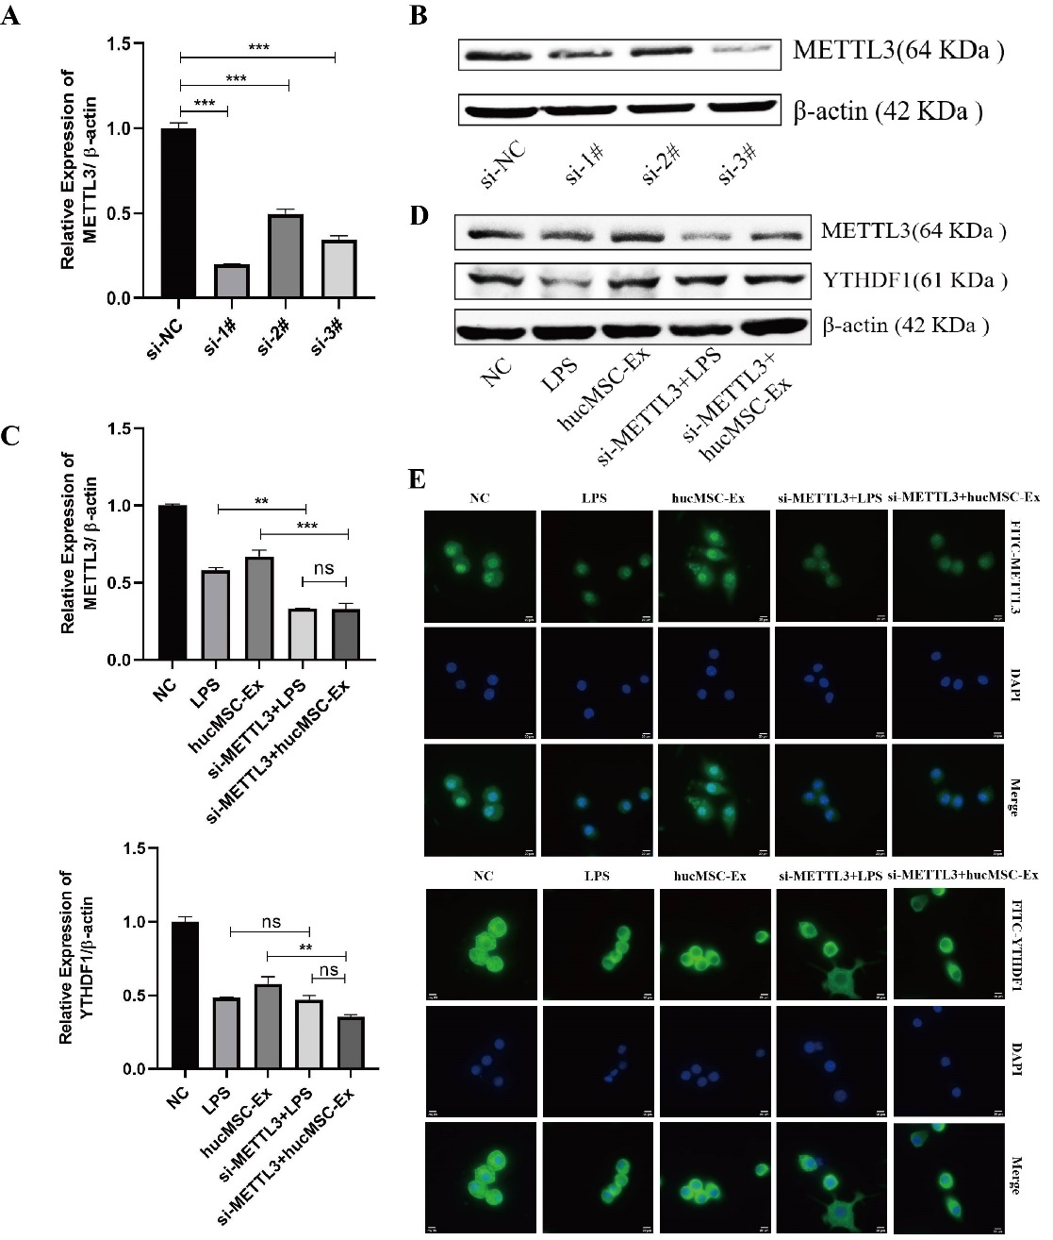
Figure S3 METTL3 is an important target of hucMSC-Ex exerting its regulatory role. (A, B) Efficiency verification of METTL3 si-RNA knockdown (transcription level and translation level). (C) Transcription level of METTL3 and YTHDF1 by qRT-PCR. (D) The expression of METTL3 and YTHDF1 by Werstern-blot. (E) The expression of METTL3 and YTHDF1 by immunofluorescence. **P < 0.01，***P < 0.001.
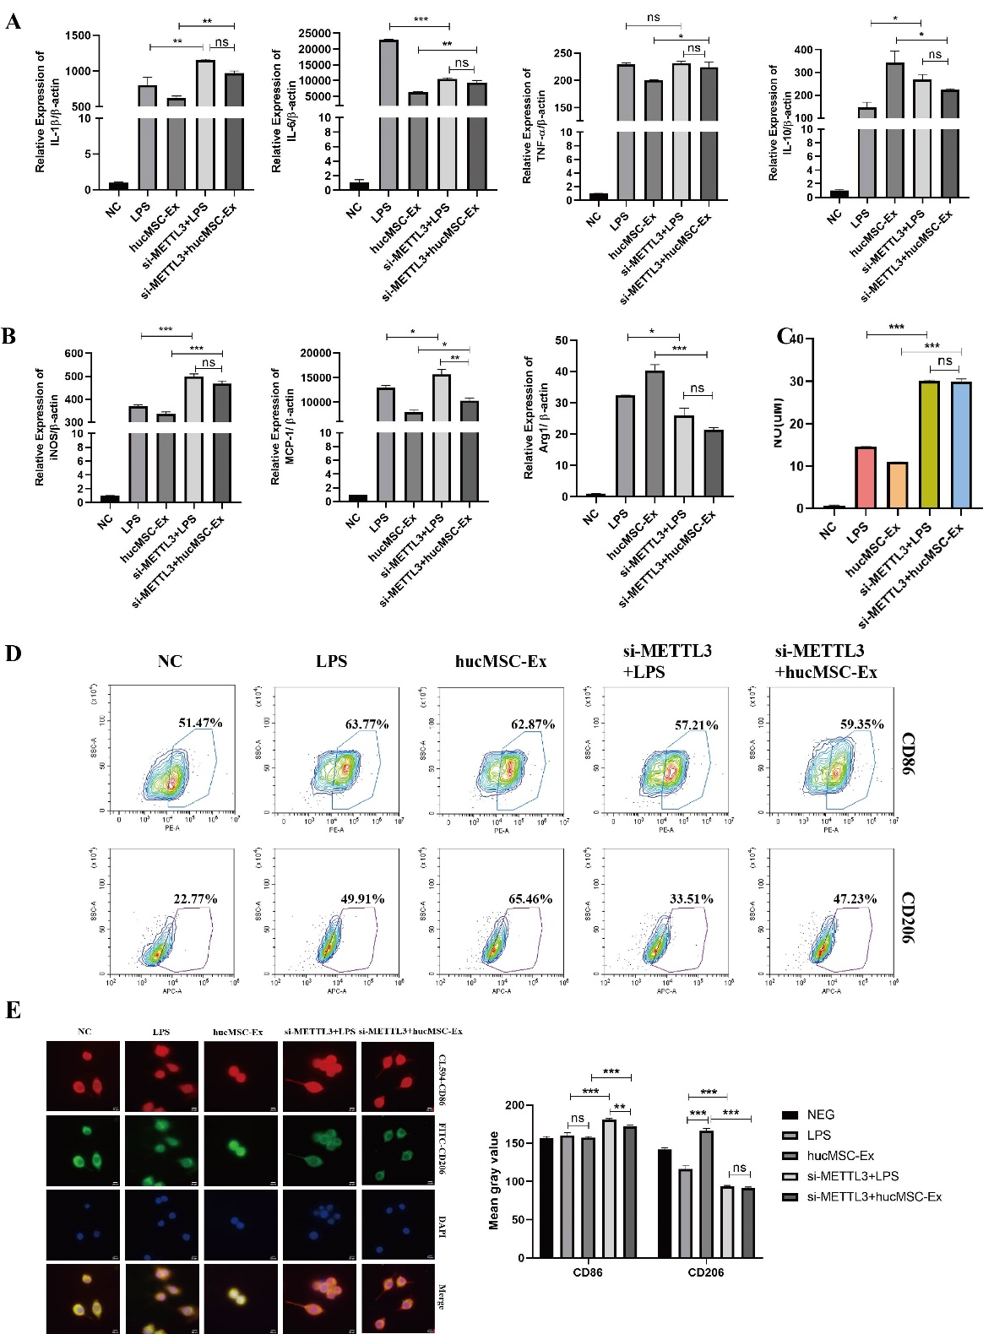
Figure S4 METTL3 knockdown in RAW264.7 cells prevents hucMSC-Ex-mediated alleviation of inflammation. (A) mRNA levels of IL-1β, IL-6, TNF-α and IL-10 by qRT-PCR. (B) The expression of iNOS, MCP-1, and Arg1 by qRT-PCR (n=3 independent experiments). (C) The concentration of NO in the supernatant of macrophage culture (n=3 independent experiments). (D) M1-type surface marker CD86 and M2-type surface marker CD206 by flow cytometry. (E) IF detection of macrophage cell surface markers CD86 and CD206. *P < 0.05，**P < 0.01，***P < 0.001.
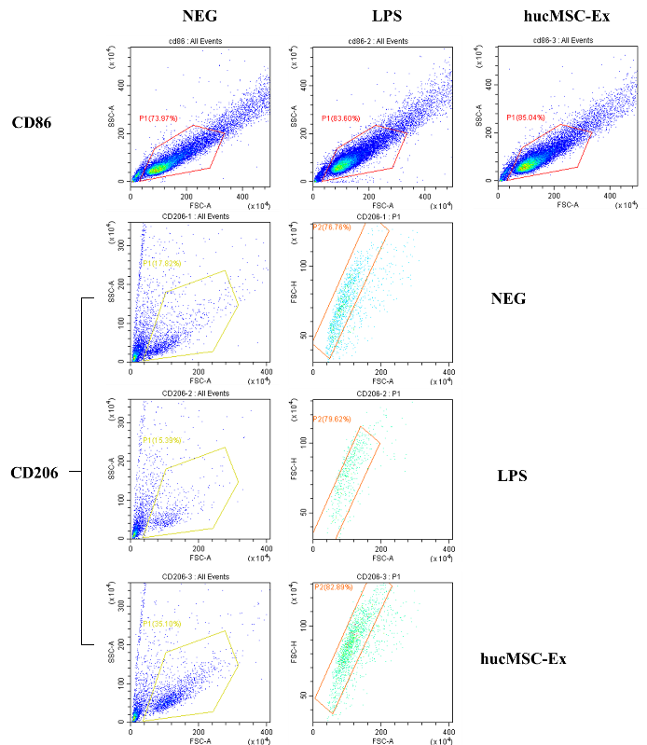
Figure S5 The diagram showing the gating process of flow cytometry in Figure1G.

